PATHOPHYSIOLOGY OF ENDOCRINE SYSTEM
 The endocrine system. The endocrine system contains a highly integrated and widely distributed group of organs that orchestrates a state of metabolic equilibrium, or homeostasis, between the various tissues of the body. Signaling by extracellular secreted molecules can be classified into three types: autocrine, paracrine, or endocrine, based on the distance over which the signal act. In endocrine signaling, the secreted molecules, which are frequently called hormones, act on target cells distant from their site of synthesis. An endocrine hormone is frequently carried by the blood from its site of release to its target. Increased activity of the target tissue often down-regulates the activity of the gland that secretes the stimulating hormone, a process known as feedback inhibition.
Hormones can be classified into several broad categories, based on the nature of their receptors:
- Hormones that trigger biochemical signals upon interacting with cell-surface receptors: This large class of compounds is composed of two groups: (1) peptide hormones, such as growth hormone and insulin, and (2) small molecules, such as epinephrine. Binding of these hormones to cell surface receptors leads to an increase in intracellular signaling molecules, termed second messengers, such as cyclic adenosine monophosphate (cAMP); production of mediators from membrane phospholipids (e.g., inositol 1,4,5-trisphosphate); and shifts in the intracellular levels of ionized calcium. The elevated levels of one or more of these can control proliferation, differentiation, survival, and functional activity of cells, mainly by regulating the expression of specific genes.
- Hormones that diffuse across the plasma membrane and interact with intracellular receptors: Many lipid-soluble hormones diffuse across the plasma membrane and interact with receptors in the cytosol or the nucleus. The resulting hormone-receptor complexes bind specifically to promoter and enhancer elements in DNA, thereby affecting the expression of specific target genes. Hormones of this type include the steroids (e.g., estrogen, progesterone , and glucocorticoids) and thyroxine.

Several processes may disturb the normal activity of the endocrine system, including impaired synthesis or release of hormones, abnormal interactions between hormones and their target tissues, and abnormal responses of target organs to their hormones. Endocrine diseases can be generally classified as:
(1) Diseases of underproduction or overproduction of hormones and their resulting biochemical and clinical consequences,
(2) Diseases associated with the development of mass lesions, which may be nonfunctional or may be associated with overproduction or underproduction of hormones.
The study of endocrine diseases requires integration of morphologic findings with biochemical measurements of the levels of hormones, their regulators, and other metabolites.
General pathogenetic mechanisms of hormonal imbalance
Hormones serve to regulate and to control organ functions. Their release is dependent on stimulation (or inhibition) through specific factors. Hormones act upon hormone-producing cells themselves (autocrine), they influence neighboring cells (paracrine), or the reach target cells in other organs via the blood (endocrine). In a stricter sense, hormones achieve their effects predominantly via an endocrine path. For endocrine action to be effective the hormones must not be inactivated before reaching their target cells. Some hormones require activation.
At the target cells the hormones bind to receptors and exert their effects via various mechanisms of cellular signal transduction. It is usually through a reduction of stimulating factors that these effects lead to a reduced release of the particular hormone, i.e., there is a regulating cycle with negative feedback. In a few cases there is positive feedback (of limited duration), i.e., the hormones cause an increased activity of stimuli and thus promote their own release. The term controlling is used when hormone release is influenced independently of hormonal effects. Several independent controling and regulating stimuli can act on the hormone-producing glands.
A reduced hormone effect (blue arrows) (Fig.1) can be due to abnormal hormone synthesis and storage. Other causes can be abnormalities of transport within the synthesizing cells or abnormalities of release. Hormone deficiency may also arise when the hormonal glands are not stimulated sufficiently to meet the needs of the organism, when the hormone-producing cells do not react sensitively enough to the stimuli, or when there are not enough hormone-producing cells (hypoplasia, aplasia;). Other possible causes are too rapid inactivation or accelerated breakdown of hormones. In the case of hormones that are bound to plasma proteins the duration of action depends on the proportion of bound hormones. In their bound form hormones cannot exert their effect; on the other hand, they escape being broken down or being excreted by the kidney. Some hormones must first be converted into their effective form at the site of their action. However, if this conversion is not possible, for example, due to enzyme defects, the hormone will have no effect. Hormonal action may also not occur because the target organ is unresponsive (e.g., due to defective hormone receptors or faulty intracellular transmission) or functional incapacity of the target cells or organs.
Causes of increased hormone effects (violet arrows) (Fig.1) include, first of all, increased hormonal release. This may be due to an excessive influence of individual stimuli, increased sensitivity, or too large a number of hormone-producing cells (hyperplasia, adenoma). Hormonal excess can also be caused by the production of hormones in undifferentiated tumor cells outside of hormonal glands (ectopic hormonal production). The small-cell bronchial carcinoma is particularly frequently active endocrinally. Raised hormonal action is also to be expected if a hormone is broken down or inactivated too slowly (in dysfunction of the inactivating organ [kidney or liver]). The breaking down can be delayed by binding to plasma proteins, but the protein-bound proportion would not be exerting any action either. Finally, hormonal effects can be increased by hypersensitivity of the target organ (too many hormone receptors or ones that are too sensitive), by increased intracellular transmission, or hyperfunction of the hormone-sensitive cells.
The clinical features, i.e., the sum of the pathophysiological changes in the organism, are the result of reduced or increased hormone-specific effects.
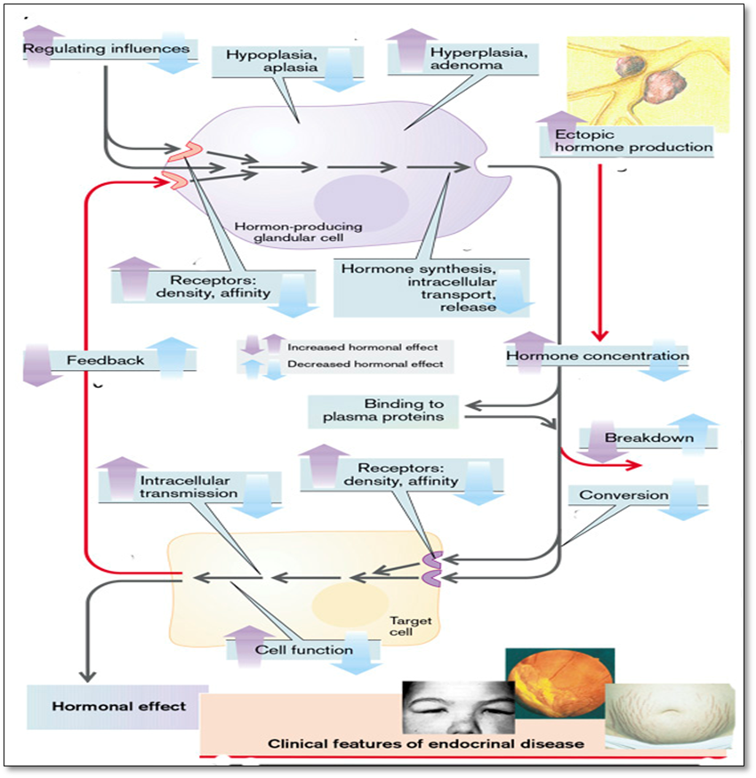
Fig.1. Excess and deficiency of hormones as disease-producing system (overview)
(From S. Silbernagl and F. Lang; Color Atlas of Pathophysiology)

Abnormalities of endocrinal regulatory circuit in pathogenesis of endocrine diseases
Hormones are usually part of regulatory circuits. Disorder of one element in such a circuit leads to characteristic changes in its other elements.
• Pituitary-independent release of hormones is usually regulated by those parameters that are influenced by the particular hormone, the latter acting on the target organs, whose functions in turn lead to a reduction in the stimuli leading to hormone release (regulatory circuit with negative feedback). Insulin release serves as an example: raised plasma glucose concentration stimulates the release of insulin, the effect of which on the target organ, for example, the liver (increased glycolysis; inhibition of gluconeogenesis and glycogen formation), leads to a reduction in plasma glucose concentration (Fig. 2, 1).
If the insulin release is inappropriately high for a given plasma glucose concentration (hyperinsulinism), this will lead to hypoglycemia. In addition to an insulin-producing tumor, the cause may be an overlap of regulatory circuits, in that some amino acids also stimulate insulin release, and some of the insulin effects (stimulation of protein synthesis, inhibition of proteolysis) can produce a reduction in the plasma concentration of amino acids. An abnormal breakdown of amino acids, for example, one due to an enzyme defect, can trigger hypoglycemia via a rise in amino acid concentration in the blood and subsequent stimulation of insulin release (Fig.2. 2).
If there is a defective hormonal gland, the hormone level and thus the hormonal effect is reduced. In the example illustrated an insufficiency of the beta cells results in hyperglycemia (Fig.2. 3).
In addition, when the responsiveness of the target organs is reduced (Fig.2. 4), the hormonal effect is decreased. In this way liver failure can result in hyperglycemia, which in turn will raise plasma insulin concentration. However, the abnormal breakdown of amino acids in liver failure can cause hypoglycemia through hyperaminoacidemia and by stimulating insulin release (Fig.2.2).
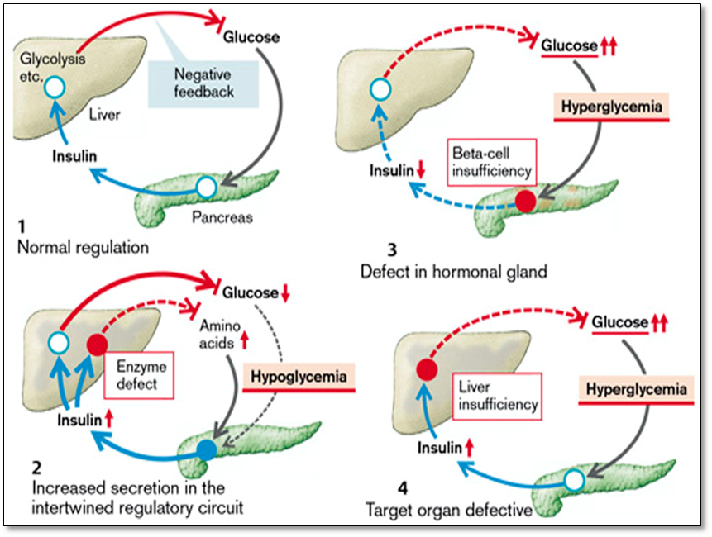
Fig.2. Abnormalities of simple endocrinal regulatory circuit
(From S. Silbernagl and F. Lang; Color Atlas of Pathophysiology)
• Hormone release regulated by the hypothalamus and pituitary.
Endocrine disorders in general can be divided into primary, secondary, and tertiary groups. Primary endocrine defects originate in the target gland responsible for producing the hormone. In secondary endocrine disorders the target gland is essentially normal, but its function is altered by defective levels of stimulating hormones (tropins) from the pituitary system. A tertiary endocrine disorder results from hypothalamic dysfunction (as may occur with craniopharyngiomas or cerebral irradiation).
The plasma concentration of hormones that are under the influence of the hypothalamus and pituitary gland is always regulated (Fig.3.1). Liberins (releasing hormones), formed in the hypothalamus, cause the release of tropins in the pituitary. These stimulate the release of the respective hormone in the periphery. The hormone and to some extent also the effect produced by the hormone finally inhibit the release of liberins in the hypothalamus and of tropins in the pituitary. The example illustrates the regulation of cortisol from the adrenal cortex.
Reduced release of peripheral hormones may be due to a loss of function in the hypothalamus, pituitary, or peripheral hormonal gland. The primary cause of an increased release of peripheral hormones can be an inadequately high orthotopic or ectopic release (Fig.3, 3) of liberins, tropins, or peripheral hormones.
If there is an increase in liberin release (Fig.3.2), liberin, tropin, and peripheral hormone concentrations are raised (tertiary endocrine disorders). If there is a primary increase in tropin release, the concentrations of tropins and of the peripheral hormone will be raised, but that of liberins reduced (secondary endocrine disorders) (Fig.3.3). If there is a primary rise in peripheral hormone release, the release of liberins and tropins is suppressed (Fig.3.4) (primary endocrine disorders).
In an analogous manner, a primary deficiency of liberins will lead to tropin and peripheral hormone deficiency (tertiary endocrine disorders), while a primary lack of tropins will result in a reduced release of peripheral hormones, with increased release of liberins (secondary endocrine disorders); a primary deficiency of peripheral hormones will lead to increased release of liberins and tropins (primary endocrine disorders).
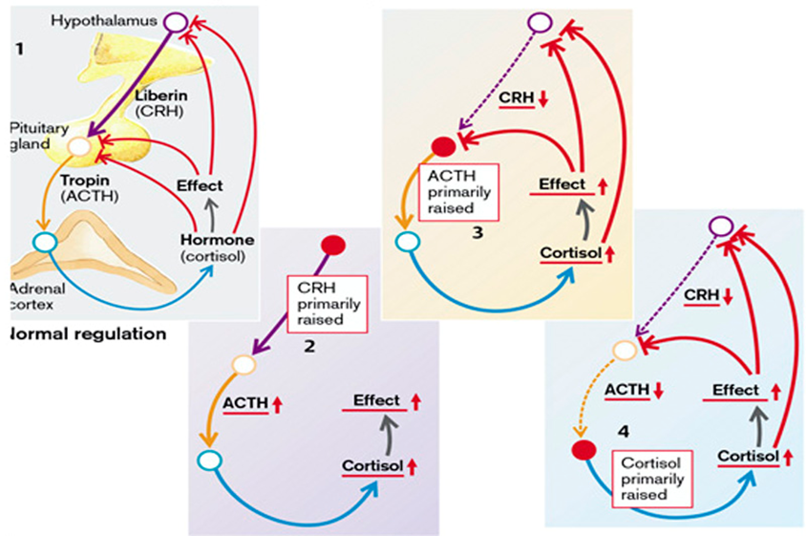
Fig3. Abnormalities of hypothalamus-regulated hormones
(From S. Silbernagl and F. Lang; Color Atlas of Pathophysiology)

DISTURBANCES IN SECRETION OF PITUITARY GLAND
 The pituitary gland is a small, bean-shaped structure that lies at the base of the brain within the confines of the sella turcica. It is intimately related to the hypothalamus, with which it is connected by both a "stalk," composed of axons extending from the hypothalamus, and a rich venous plexus constituting a portal circulation. Along with the hypothalamus, the pituitary has a central role in the regulation of most of the other endocrine glands. The pituitary is composed of two morphologically and functionally distinct components: the anterior lobe (adenohypophysis) and the posterior lobe (neurohypophysis).
Hypothalamic hormones. The synthesis and release of anterior pituitary hormones are largely regulated by the action of releasing or inhibiting hormones from the hypothalamus, which is the coordinating center of the brain for endocrine, behavioral, and autonomic nervous system function. It is at the level of the hypothalamus that emotion, pain, body temperature, and other neural input are communicated to the endocrine system. The posterior pituitary hormones, ADH and oxytocin, are synthesized in the cell bodies of neurons in the hypothalamus that have axons that travel to the posterior pituitary. The hypothalamic hormones that regulate the secretion of anterior pituitary hormones include: GH-releasing-hormone (GHRH), somatostatin, dopamine, thyrotropin-releasing- hormone (TRH), corticotropin-releasing hormone (CRH), and gonadotropin-releasing hormone (GnRH). With the exception of prolactin, most of the pituitary hormones are regulated by hypothalamic stimulatory hormones. GH secretion is stimulated by GHRH; thyroidstimulating hormone (TSH) by TRH; ACTH by CRH; and luteinizing hormone (LH) and FSH by GnRH. Somatostatin functions as an inhibitory hormone for GH and TSH. Prolactin secretion is inhibited by dopamine; thus, persons receiving antipsychotic drugs that block dopamine often have increased prolactin levels.
The activity of the hypothalamus is regulated by both hormonally mediated signals (e.g., negative feedback signals) and neuronal input from a number of sources. Neuronal signals are mediated by neurotransmitters such as acetylcholine, dopamine, norepinephrine, serotonin, γ-aminobutyric acid (GABA), and opioids. Cytokines that are involved in immune and inflammatory responses, such as the interleukins, also are involved in the regulation of hypothalamic function. This is particularly true of the hormones involved in the hypothalamic-pituitary-adrenal axis. Thus, the hypothalamus can be viewed as a bridge by which signals from multiple systems are relayed to the pituitary gland.
Pituitary hormones. The pituitary gland has been called the master gland because its hormones control the functions of many target glands and cells. The anterior pituitary gland contains five cell types: (1) thyrotrophs, which produce thyrotropin, also known as TSH; (2) corticotrophs, which produce corticotrophin, also called adrenocorticotropic hormone (ACTH); (3) gonadotrophs, which produce the gonadotropins LH and FSH; (4) somatotrophs, which produce GH; and (5) lactotrophs, which produce prolactin.

Hormones produced by the anterior pituitary control body growth and metabolism (GH), function of the thyroid gland (TSH), glucocorticoid hormone levels (ACTH), function of the gonads (FSH and LH), and breast growth and milk production (prolactin). Melanocyte-stimulating hormone (MSH), which is involved in the control of pigmentation of the skin, is produced by the pars intermedia of the pituitary gland.
Rarely, symptoms of pituitary disease may be caused by an excess or lack of the hypothalamic factors rather than a primary pituitary abnormality.
Diseases of the pituitary, accordingly, can be divided into those that primarily affect the anterior lobe and those that primarily affect the posterior lobe.
Symptoms of pituitary disease can be divided into the following:
• Hyperpituitarism: This disorder arises from excessive secretion of trophic hormones. It most often results from an anterior pituitary adenoma, but may also be caused by other pituitary and extra-pituitary lesions that are described below. The symptoms of hyperpituitarism are discussed later.
• Hypopituitarism: This is caused by deficiency of trophic hormones and results from a variety of destructive processes, including ischemic injury, surgery or radiation, and inflammatory reactions. In addition, nonfunctional pituitary adenomas may encroach upon and destroy adjacent native anterior pituitary parenchyma and cause hypopituitarism.
• Local mass effects: Among the earliest changes referable to mass effect are radiographic abnormalities of the sella turcica, including sellar expansion, bony erosion, and disruption of the diaphragma sellae. Because of the close proximity of the optic nerves and chiasm to the sella, expanding pituitary lesions often compress decussating fibers in the optic chiasm. This gives rise to visual field abnormalities, classically in the form of defects in the lateral (temporal) visual fields - a so-called bitemporal hemianopsia. In addition, a variety of other visual field abnormalities may be caused by asymmetric growth of many tumors. As in the case of any expanding intracranial mass, pituitary adenomas may produce signs and symptoms of elevated intracranial pressure, including headache, nausea, and vomiting. Pituitary adenomas that extend beyond the sella turcica into the base of the brain (invasive pituitary adenoma) produce seizures or obstructive hydrocephalus; involvement of cranial nerves can result in cranial nerve palsy. On occasion, acute hemorrhage into an adenoma is associated with clinical evidence of rapid enlargement of the lesion and depression of consciousness, a situation appropriately termed pituitary apoplexy. Acute pituitary apoplexy is a neurosurgical emergency, because it may cause sudden death.
HYPERPITUITARISM
The most common cause of hyperpituitarism is an adenoma arising in the anterior lobe. Other, less common causes include hyperplasia and carcinomas of the anterior pituitary, secretion of hormones by some extra-pituitary tumors, and certain hypothalamic disorders. Pituitary adenomas are classified on the basis of hormone(s) produced by the neoplastic cells.
- Prolactin cell (lactotroph) adenoma
- Growth hormone cell (somatotroph) adenoma
- Thyroid-stimulating hormone cell (thyrotroph) adenomas
- ACTH cell (corticotroph) adenomas
- Gonadotroph cell adenomas
- Mixed (plurihormonal) adenomas
- Hormone-negative adenomas
Pituitary adenomas can be functional (i.e., associated with hormone excess and clinical manifestations) or silent (without clinical manifestations of hormone excess). Both functional and silent pituitary adenomas are usually composed of a single cell type and produce a single predominant hormone, although exceptions are known to occur. Some pituitary adenomas can secrete two hormones (growth hormone and prolactin being the most common combination); rarely, pituitary adenomas are plurihormonal. Pituitary adenomas are designated, somewhat arbitrarily, microadenomas if less than 1 cm in diameter and macroademomas if they exceed 1 cm in diameter. Silent and hormone-negative adenomas are likely to come to clinical attention at a later stage than those associated with endocrine abnormalities and are therefore more likely to be macroadenomas; in addition, these adenomas may cause hypopituitarism as they encroach on and destroy adjacent anterior pituitary parenchyma.
Clinically diagnosed pituitary adenomas are responsible for about 10% of intracranial neoplasms. They are discovered incidentally in as many as 25% of routine autopsies. In fact, the most recent data using high-resolution computed tomography or magnetic resonance imaging suggest that approximately 20% of "normal" adult pituitary glands harbor an incidental lesion measuring 3 mm or more in diameter, usually a silent adenoma. Pituitary adenomas are usually found in adults, with a peak incidence from the 30s to the 50s.
HYPERSECRETION OF PROLACTIN
Prolactin is formed in the anterior lobe of the pituitary gland. It stimulates growth and differentiation of the mammary gland as well as milk production. It inhibits the pulsatile, but not the basal, release of the gonadotropins (luteinizing hormone [LH] and follicle-stimulating hormone [FSH]). It also inhibits cellular glucose uptake and the cellular immune defenses. Touching the nipple of a lactating woman and estrogens promote the release of prolactin. Its release is also stimulated by thyroliberin (thyroid-releasing hormone [TRH]), endorphins, vasoactive intestinal peptide (VIP), oxytocin, and angiotensin II as well as by stress, non–rapid eye-movement (NREM) sleep, or hypoglycemia. Dopamine inhibits prolactin release. As prolactin increases dopamine metabolism in the hypothalamus, it inhibits its own release (negative feedback).
Excess prolactin can be caused by hormone-producing tumors (prolactinomas), or by administration of antidopaminergic drugs (reserpine) or high-dose estrogen therapy. Renal and liver failure can also result in an excess of prolactin, possibly via a lack of dopamine. Hypothyroidism raises prolactin release via correspondingly increased TRH secretion (Fig.4.). In addition, any mass in the suprasellar compartment may disturb the normal inhibitory influence of hypothalamus on prolactin secretion, resulting in hyperprolactinemia, known as the stalk effect. It should be kept in mind, therefore, that mild elevations of serum prolactin (<200 μg/L) in an individual with a pituitary adenoma do not necessarily indicate a prolactin-secreting neoplasm.
The effects of excess prolactin are milk flow (galactorrhea), tendency toward hyperglycemia, and an inhibition of gonadotropin release, accompanied by hypogonadism, amenorrhea, loss of libido, infertility and impotence (Fig.4.).
Because many of the manifestations of hyperprolactinemia (e.g., amenorrhea) are more obvious in premenopausal females than in males or postmenopausal females, prolactinomas are usually diagnosed at an earlier stage in females of reproductive age than in other individuals. In contrast, hormonal manifestations may be quite subtle in men and older women, in whom the tumors may reach considerable size before coming to clinical attention.
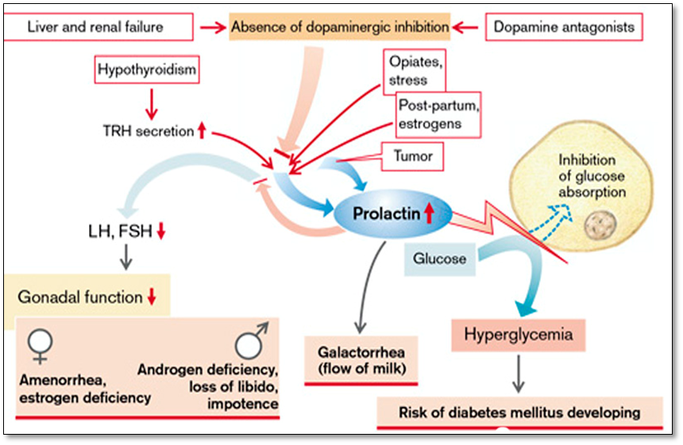
Fig.4. Causes and effects of prolactin excess
(From S. Silbernagl and F. Lang; Color Atlas of Pathophysiology)
Hypersecretion of Growth Hormone
 Growth hormone. Growth hormone, also called somatotropin, is a 191–amino acid polypeptide hormone synthesized and secreted by special cells in the anterior pituitary called somatotropes. For many years, it was thought that GH was produced primarily during periods of growth. However, this has proved to be incorrect because the rate of GH production in adults is almost as great as in children. GH is necessary for growth and contributes to the regulation of metabolic functions. All aspects of cartilage growth are stimulated by GH; one of the most striking effects of GH is on linear bone growth, resulting from its action on the epiphyseal growth plates of long bones. The width of bone increases because of enhanced periosteal growth; visceral and endocrine organs, skeletal and cardiac muscle, skin, and connective tissue all undergo increased growth in response to GH. In many instances, the increased growth of visceral and endocrine organs is accompanied by enhanced functional capacity. For example, increased growth of cardiac muscle is accompanied by an increase in cardiac output. In addition to its effects on growth, GH facilitates the rate of protein synthesis by all of the cells of the body; it enhances fatty acid mobilization and increases the use of fatty acids for fuel; and it maintains or increases blood glucose levels by decreasing the use of glucose for fuel. GH has an initial effect of increasing insulin levels. However, the predominant effect of prolonged GH excess is to increase glucose levels despite an insulin increase. This is because GH induces a resistance to insulin in the peripheral tissues, inhibiting the uptake of glucose by muscle and adipose tissues.
Many of the effects of GH depend on a family of peptides called insulin-like growth factors (IGF), also called somatomedins, which are produced mainly by the liver. GH cannot directly produce bone growth; instead, it acts indirectly by causing the liver to produce IGF. These peptides act on cartilage and bone to promote their growth. At least four IGFs have been identified; of these, IGF-1 (somatomedin C) appears to be the more important in terms of growth, and it is the one that usually is measured in laboratory tests. The IGFs have been sequenced and have structures that are similar to that of proinsulin. This undoubtedly explains the insulin-like activity of the IGFs and the weak action of insulin on growth. IGF levels are themselves influenced by a family of at least six binding factors called IGF-binding proteins (IGFBPs).
GH is carried unbound in the plasma and has a half-life of approximately 20 to 50 minutes. The secretion of GH is regulated by two hypothalamic hormones: GH-releasing hormone (GHRH or somatoliberine), which increases GH release, and somatostatin, which inhibits GH release. A third hormone, the recently identified ghrelin, also may be important. These hypothalamic influences (i.e., GHRH and somatostatin) are tightly regulated by neural, metabolic, and hormonal factors. The secretion of GH fluctuates over a 24-hour period, with peak levels occurring 1 to 4 hours after onset of sleep (i.e., during sleep stages 3 and 4). The nocturnal sleep bursts, which account for 70% of daily GH secretion, are greater in children than in adults. GH secretion is stimulated by hypoglycemia, fasting, starvation, increased blood levels of amino acids (particularly arginine), and stress conditions such as trauma, excitement, emotional stress, and heavy exercise. GH is inhibited by increased glucose levels, free fatty acid release, cortisol, and obesity. Impairment of secretion, leading to growth retardation, is not uncommon in children with severe emotional deprivation.
Somatotropin (growth hormone) is formed in the anterior lobe of the pituitary gland. GH has two types of effects in the human body: metabolic and organogenetic (osteogenetic, chondrogenetic, miogenetic and viscerogenetic). It inhibits the uptake of glucose in fat and muscle cells and promotes lipolysis, glycolysis, collagen synthesis, and the formation of erythropoietin. One of the most potent effect of GH is stimulation of protein synthesis from aminoacids in all cells of the body with inhibition of proteolysis such establishing a positive nitrogen balance. Somatotropin stimulates the enteric absorption of calcium and phosphates as well as the renal excretion of calcium. It also promotes bone growth (before the end of epiphyseal fusion and thus longitudinal growth) as well as soft tissue growth (target tissue for GH are particularly the bones, the cartilage and the muscles). Somatotropin promotes T-cell proliferation, interleukin 2 (IL-2) formation and the activity of natural killer cells, cytotoxic T cells, and macrophages. In this way it strengthens immune defense. Estrogens inhibit the formation of somatomedins and thus also reduce the effects of somatotropin.
An excess of somatotropin is usually due to uncontrolled formation of the hormone, for example, by a pituitary adenoma or, in rare cases, by an ectopic tumor. Growth hormone-producing (somatotroph cell) neoplasms, including those that produce a mixture of growth hormone and other hormones (e.g., prolactin), are the second most common type of functional pituitary adenoma. Because the clinical manifestations of excessive growth hormone may be subtle, somatotroph cell adenomas may be quite large by the time they come to clinical attention. Increased stimulation of hormone synthesis by somatoliberin is equally rare. Finally, uncontrolled therapeutic administration of somatotropin can also result in an iatrogenic excess of somatotropin.
Massive somatotropin excess before epiphyseal fusion (in childhood) leads to gigantism (height up to 2.6 m). In adults it results in acromegaly (enlarged cheek bones, mandibula, feet and hands, and supraorbital bulge), cartilage hypertrophy with arthropathy and calcification of cartilage and intervertebral disks. Enlargement of the jaw results in its protrusion (prognathism), with broadening of the lower face and separation of the teeth. At the same time there is an increase in the size of soft tissues, for example, tongue, heart, liver, kidneys, thyroid, salivary glands, and skin (splanhnomegaly). This increase in organ size can lead to further complications. If, for example, vascularization does not increase with myocardial hypertrophy, impaired coronary oxygen delivery will result (angina pectoris). Arterial hypertension occurs relatively frequently (in 30% of cases). Thickening of the skin is associated with increased sweat and sebum production. Sleep apnea syndrome is present in up to 90% of patients. The pathogenesis of the sleep apnea syndrome is obstructive in the majority of patients, owing to increased pharyngeal soft tissue accumulation. Paresthesias may develop because of nerve entrapment and compression caused by excess soft tissue and accumulation of subcutaneous fluid. Compression of the median nerve can lead to carpal tunnel syndrome.
The metabolic effects of excess levels of GH include alterations in fat and carbohydrate metabolism. GH causes increased release of free fatty acids from adipose tissue, leading to increased concentration of free fatty acids in the blood (transport hyperlipidemia). In addition, GH enhances the formation of ketones and the utilization of free fatty acids for energy in preference to use of carbohydrates and proteins. GH exerts multiple effects on carbohydrate metabolism, including decreased glucose uptake by tissues such as skeletal muscle and adipose tissue, increased glucose production by the liver (increased glycogenolysis), and increased insulin secretion. Each of these changes results in GH-induced insulin resistance. This leads to glucose intolerance with hyperglycemia, which stimulates the beta cells of the pancreas to produce additional insulin. Longterm elevation of GH results in overstimulation of the beta cells, causing them literally to “burn out.” Impaired glucose tolerance occurs in as many as 50% to 70% of persons with acromegaly; overt diabetes mellitus subsequently can result. Increased intestinal absorption results in calcium excess followed by hypercalciuria. The latter may cause precipitation of calcium salts in urine (nephrolithiasis). Somatotropin excess also promotes the development of tumors.
A somatotropin-producing pituitary tumor often causes enlargement of the sella turcica; pressure on the optic chiasma can give rise to visual field defects (typically bitemporal hemianopia, as though the patient were wearing blinkers). Displacement of other endocrine cells can lead to gonadotropin deficiency, and thus to amenorrhea as well as loss of libido, and impotence. Conversely, somatotropin-producing tumors can also release other hormones, such as prolactin. Prolactin is demonstrable in a number of growth hormone-producing adenomas and in some cases may be released in sufficient quantities to produce signs and symptoms of hyperprolactinemia. The hypogonadism in acromegalic patients can result from direct damage to the hypothalamic or pituitary system, or indirectly from the hyperprolactinemia that can occur due to prevention of the prolactin inhibitory factor (dopamine) from reaching pituitary lactotrophs (cells which secrete prolactin) due to damage by the pituitary tumor.
The mortality rate of patients with acromegaly is two to three times the expected rate, mostly from cardiovascular diseases and cancer. The cardiovascular disease results from the combination of cardiomyopathy, hypertension, insulin resistance and hyperinsulinemia, and hyperlipidemia.
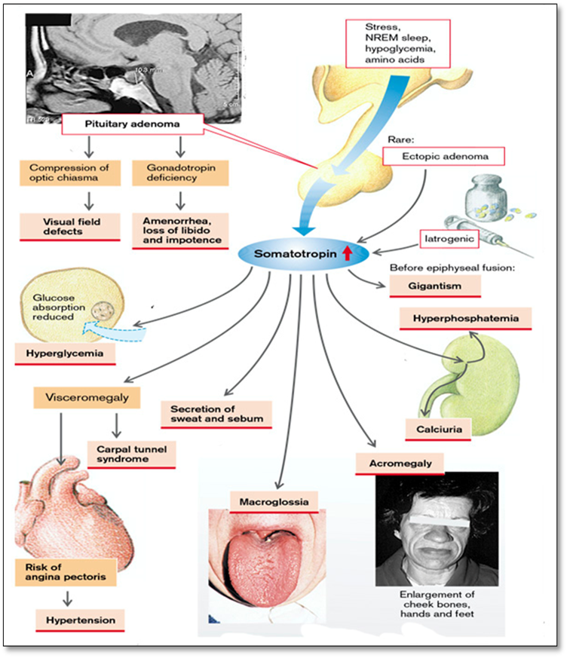
Fig.5. Hypersecretion of growth hormone
(From S. Silbernagl and F. Lang; Color Atlas of Pathophysiology)
Hypersecretion of ACTH
Most corticotroph cell adenomas are small (microadenomas) at the time of diagnosis, although some tumors may be quite large. Corticotroph cell adenomas may be clinically silent or may cause secondary hypercortisolism because of the stimulatory effect of ACTH on the adrenal cortex. When the hypercortisolism is caused by excessive production of ACTH by the pituitary, the process is designated Cushing disease, because it is the pattern of hypercortisolism originally described by Dr. Harvey Cushing. Large, clinically aggressive corticotroph adenomas may develop after surgical removal of the adrenal glands for treatment of Cushing syndrome. This condition, known as Nelson syndrome, occurs in most cases because of a loss of the inhibitory effect of adrenal corticosteroids on a preexisting corticotroph microadenoma. Because the adrenals are absent in individuals with Nelson syndrome, hypercortisolism does not develop. Instead, patients present with the mass effects of the pituitary tumor. In addition, because ACTH is synthesized as part of a larger prohormone that includes melanocyte-stimulating hormone (MSH), there may also be hyperpigmentation.
Hypersecretion of LH and FSH
Gonadotroph adenomas (luteinizing hormone [LH]-producing and follicle-stimulating hormone [FSH]-producing) can be difficult to recognize, because they secrete hormones inefficiently and variably, and the secretory products usually do not cause a recognizable clinical syndrome. Gonadotroph adenomas are most frequently found in middle-aged men and women when the tumors have become large enough to cause neurologic symptoms, such as impaired vision, headaches, diplopia, or pituitary apoplexy. FSH is usually the predominant secreted hormone.
Hypersecretion of TSH. Thyrotroph adenomas (thyroid-stimulating hormone [TSH]-producing) account for about 1% of all pituitary adenomas and are a rare cause of secondary hyperthyroidism.
HYPOPITUITARISM
Hypofunction of the anterior pituitary may occur with loss or absence of 75% or more of the anterior pituitary parenchyma. This may be congenital (exceedingly rare) or may result from a wide range of acquired abnormalities that are intrinsic to the pituitary. Less frequently, disorders that interfere with the delivery of pituitary hormone-releasing factors from the hypothalamus, such as hypothalamic tumors, may also cause hypofunction of the anterior pituitary. Hypopituitarism accompanied by evidence of posterior pituitary dysfunction in the form of diabetes insipidus is almost always of hypothalamic origin. Most cases of anterior pituitary hypofunction are caused by the following:
- Ischemic necrosis of the anterior pituitary is an important cause of pituitary insufficiency. In general, the anterior pituitary tolerates ischemic insults fairly well; loss of as much as half of the anterior pituitary parenchyma causes no clinical consequences. However, with destruction of larger amounts of the anterior pituitary (75%), signs and symptoms of hypopituitarism develop. Sheehan syndrome, or postpartum necrosis of the anterior pituitary, is the most common form of clinically significant ischemic necrosis of the anterior pituitary. During pregnancy the anterior pituitary enlarges considerably, largely because of an increase in the size and number of prolactin-secreting cells. However, this physiologic enlargement of the gland is not accompanied by an increase in blood supply from the low-pressure portal venous system. The enlarged gland is thus vulnerable to ischemic injury, especially in women who develop significant hemorrhage and hypotension during the peripartum period. The posterior pituitary, because it receives its blood directly from arterial branches, is much less susceptible to ischemic injury in this setting and is therefore usually not affected. Clinically significant pituitary necrosis may also be encountered in conditions other than pregnancy, including disseminated intravascular coagulation, sickle cell anemia, elevated intracranial pressure, traumatic injury, and shock of any origin. The residual gland is shrunken and scarred.
- Ablation of the pituitary by surgery or radiation.
- Other, less common causes of anterior pituitary hypofunction include inflammatory lesions such as sarcoidosis or tuberculosis, trauma, and metastatic neoplasms involving the pituitary.
The clinical manifestations of anterior pituitary hypofunction depend on the specific hormone(s) that are lacking. The term panhypopituitarism refers to conditions that cause a deficiency of all of the anterior pituitary hormones. Children can develop growth failure (pituitary dwarfism) as a result of growth hormone deficiency. Gonadotropin or gonadotropin-releasing hormone (GnRH) deficiency leads to amenorrhea and infertility in women and decreased libido, impotence, and loss of pubic and axillary hair in men. TSH and ACTH deficiencies result in symptoms of secondary hypothyroidism and secondary hypoadrenalism, respectively, and are discussed later. Prolactin deficiency results in failure of postpartum lactation. The anterior pituitary is also a rich source of MSH, synthesized from the same precursor molecule that produces ACTH; therefore, one of the manifestations of hypopituitarism is pallor from loss of stimulatory effects of MSH on melanocytes.
Hyposecretion of growth hormone
Hyposecretion of growth hormone can be the cause of different pathological processes at the level of the hypothalamus or hypophysis: disorders of cerebrospinal fluid dynamics with hydrocephalia, brain trauma, intoxications, neuroinfections, tumoral processes, surgery or radiotherapy at the level of hypothalamo-pituitary area. Should be mentioned that secretion of GH is the first affected in patients with ischemic stoke. Clinical studies the same showed that hyposecretion of GH can be induced by visceral obesity, aging.
Clinical and biochemical manifestations (metabolic and organogenetic manifestations) in GH deficiency are different in function of age when the disease started.
- Growth hormone deficiency in adults
There are two categories of GH deficiency in adults: (1) GH deficiency that was present in childhood, and (2) GH deficiency that developed during adulthood, mainly as the result of hypopituitarism (see above) resulting from a pituitary tumor or its treatment. GH levels also can decline with aging, and there has been interest in the effects of declining GH levels in elderly persons (described as somatopause).
Deficiency of GH in adults is characterised by lack of it metabolic and organogenetic effects. There is characteristic increase in adipose tissue especially at the level of the trunk (due to lack or diminished lipolytic effects of GH), hypoglycemia (lack of glycogenolysis) as well as changes in lipidic spectrum in the blood (deficiency of FFA due to reduced mobilization from the adipose tissue). Lack of organogenic effects of GH is characterised by resorption and atrophy of bones (osteopenia due to lack of osteogenetic effect), hypotrophy of internal organs (lack of viscerogenetic function), hypotrophy of conjunctive tissue, muscle mass reduction (lack of miogenetic effect) with decreased physical performance.
The GH deficiency syndrome is associated with a cluster of cardiovascular risk factors, including central adiposity (increased waist-to-hip ratio), increased visceral fat and dyslipidemia. In addition to these so-called traditional cardiovascular risk factors, nontraditional cardiovascular risk factors (e.g., C-reactive protein and interleukin-6, which are markers of the inflammatory pathway) also are elevated. Several studies have shown that cardiovascular mortality is increased in GH-deficient adults. Increased arterial intima–media thickness and a higher prevalence of atherosclerotic plaques and endothelial dysfunction have been reported in both childhood and adult GH deficiency.
GH therapy can improve many of these factors. The diagnosis of GH deficiency in adults is made by finding subnormal serum GH responses to two provocative stimuli (this is the “official” response; however, in reality, at least one stimulation test is needed). Measurements of the serum IGF-1 or basal GH do not distinguish reliably between normal and subnormal GH secretion in adults. Insulin-induced hypoglycemia is the gold standard test for GH reserve. The L-dopa test probably is the next best test. Other stimulation tests involve the use of arginine or arginine plus GHRH, clonidine (an α-adrenergic agonist), glucagon, or GHRH.
The approval of several recombinant human GH preparations (e.g., Humatrope, Genotropin) for treating adults with GH deficiency allows physicians elsewhere to prescribe this treatment. GH replacement therapy may lead to increased lean body mass and decreased fat mass, increased bone mineral density, increased glomerular filtration rate, decreased lipid levels, increased exercise capacity, and improved sense of well-being in GH-deficient adults.
- Growth hormone deficiency in children
There are several forms of GH deficiency that present in childhood. Children with idiopathic GH deficiency lack the hypothalamic GHRH but have adequate somatotropes, whereas children with pituitary tumors or agenesis of the pituitary lack somatotropes. In a rare condition called Laron type dwarfism, GH levels are normal or elevated, but there is a hereditary defect in IGF production that can be treated directly with IGF-1 replacement.
Hyposecretion of GH in children is characterised by metabolic changes (similar to that of adults) plus some specific morphogenic features.
Congenital GH deficiency is associated with normal birth length, followed by a decrease in growth rate that can be identified by careful measurement during the first year and that becomes obvious by 1 to 2 years of age. Persons with classic GH deficiency have normal intelligence, short stature (dwarfism), obesity with immature facial features (reduced lipolysis), and some delay in skeletal maturation. Puberty often is delayed, and males with the disorder have microphallus (abnormally small penis), especially if the condition is accompanied by gonadotropin-releasing hormone (GnRH) deficiency. In the neonate, GH deficiency can lead to hypoglycemia and seizures. Acquired GH deficiency develops in later childhood; it may be caused by a hypothalamic-pituitary tumor, particularly if it is accompanied by other pituitary hormone deficiencies.
When short stature is caused by a GH deficiency, GH replacement therapy is the treatment of choice. GH is species specific, and only human GH is effective in humans.
GH previously was obtained from human cadaver pituitaries but now is produced by recombinant DNA technology and is available in adequate supply. GH is administered subcutaneously in multiple weekly doses during the period of active growth and can be continued into adulthood. Children with short stature due to Turner’s syndrome and chronic renal insufficiency also are treated with GH. GH therapy may be considered for children with short stature but without GH deficiency. Several studies suggest that short-term treatment with GH increases the rate of growth in these children. Although the effect of GH on adult height is not great, it can result in improved psychological well-being. There are concerns about misuse of the drug to produce additional growth in children with normal GH function who are of near-normal height. Guidelines for use of the hormone continue to be established.
POSTERIOR PITUITARY SYNDROMES
The posterior pituitary, or neurohypophysis, is composed of modified glial cells (termed pituicytes) and axonal processes extending from nerve cell bodies in the supraoptic and paraventricular nuclei of the hypothalamus. The hypothalamic neurons produce two peptides: antidiuretic hormone (ADH) and oxytocin. They are stored in axon terminals in the neurohypophysis and released into the circulation in response to appropriate stimuli. Oxytocin stimulates the contraction of smooth muscle in the pregnant uterus and those surrounding the lactiferous ducts of the mammary glands. Abnormal oxytocin synthesis and release has not been associated with significant clinical abnormalities.
The clinically important posterior pituitary syndromes involve ADH production. They include diabetes insipidus and secretion of inappropriately high levels of ADH (see also hydroelectrolytic imbalance).
ADH is a nonapeptide hormone synthesized predominantly in the supraoptic nucleus. In response to several different stimuli, including increased plasma osmotic pressure, left atrial distention (Herring reflex), exercise, and certain emotional states. ADH is released from axon terminals in the neurohypophysis into the general circulation. The hormone acts on the collecting tubules of the kidney to promote the resorption of free water. ADH deficiency causes diabetes insipidus, a condition characterized by excessive urination (polyuria) caused by an inability of the kidney to properly resorb water from the urine. Diabetes insipidus can result from several causes, including head trauma, neoplasms, and inflammatory disorders of the hypothalamus and pituitary, and from surgical procedures involving the hypothalamus or pituitary. The condition sometimes arises spontaneously ("idiopathic") in the absence of an underlying disorder. Diabetes insipidus from ADH deficiency is designated as central, to differentiate it from nephrogenic diabetes insipidus as a result of renal tubular unresponsiveness to circulating ADH. The clinical manifestations of both diseases are similar and include the excretion of large volumes of dilute urine with an inappropriately low specific gravity. Serum sodium and osmolality are increased as a result of excessive renal loss of free water (hypertonic dehydration), resulting in thirst and polydipsia. Patients who can drink water can generally compensate for urinary losses; patients who are obtunded, bedridden, or otherwise limited in their ability to obtain water may develop life-threatening dehydration (Fig.6.).
In the syndrome of inappropriate ADH (SIADH) secretion, ADH excess is caused by several extracranial and intracranial disorders. It causes resorption of excessive amounts of free water, with resultant hyponatremia and hypervolemia (hypotonic hyperhydration). The most common causes of SIADH include the secretion of ectopic ADH by malignant neoplasms (particularly small-cell carcinomas of the lung), non-neoplastic diseases of the lung, and local injury to the hypothalamus and/or neurohypophysis. The clinical manifestations of SIADH are dominated by hyponatremia, cerebral edema, and resultant neurologic dysfunction (Fig.6.).
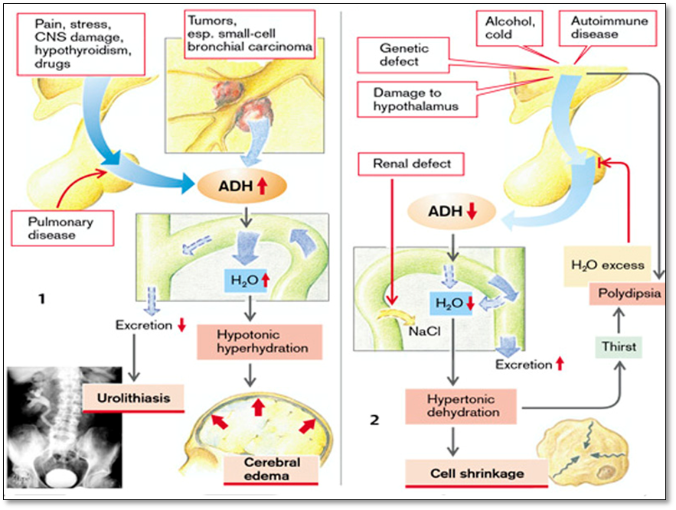
Fig.6. Causes and manifestations of deficiency and oversecretion of ADH
(From S. Silbernagl and F. Lang; Color Atlas of Pathophysiology)
DISORDERS OF ADRENAL CORTEX SECRETION
 The adrenal glands are small, bilateral structures that weigh approximately 5 g each and lie retroperitoneally at the apex of each kidney. The adrenal glands are paired endocrine organs consisting of both cortex and medulla, which differ in their development, structure, and function. The cortex consists of three layers of distinct cell types. Beneath the capsule of the adrenal is the narrow layer of zona glomerulosa. An equally narrow zona reticularis abuts the medulla. Intervening is the broad zona fasciculata, which makes up about 75% of the total cortex. The adrenal cortex synthesizes three different types of steroids: (1) glucocorticoids (principally cortisol), which are synthesized primarily in the zona fasciculata with a small contribution from the zona reticularis; (2) mineralocorticoids, the most important being aldosterone, which is generated in the zona glomerulosa; and (3) sex steroids (estrogens and androgens), which are produced largely in the zona reticularis. The adrenal medulla is composed of chromaffin cells, which synthesize and secrete catecholamines, mainly epinephrine .
CONTROL OF ADRENAL CORTICAL FUNCTION. The medulla or inner portion of the gland secretes epinephrine and norepinephrine and is part of the sympathetic nervous system. The cortex forms the bulk of the adrenal gland and is responsible for secreting three types of hormones: the glucocorticoids, the mineralocorticoids, and the adrenal sex hormones. Because the sympathetic nervous system also secretes epinephrine and norepinephrine, adrenal medullary function is not essential for life, but adrenal cortical function is. The total loss of adrenal cortical function is fatal in 4 to 14 days if untreated.
More than 30 hormones are produced by the adrenal cortex. Of these hormones, aldosterone is the principal mineralocorticoid, cortisol (hydrocortisone) is the major glucocorticoid, and androgens are the chief sex hormones. All of the adrenal cortical hormones have a similar structure in that all are steroids and are synthesized from acetate and cholesterol. Each of the steps involved in the synthesis of the various hormones requires a specific enzyme. The secretion of the glucocorticoids and the adrenal androgens is controlled by the ACTH secreted by the anterior pituitary gland. Cortisol and the adrenal androgens are secreted in an unbound state and bind to plasma proteins for transport in the circulatory system. Cortisol binds largely to corticosteroid-binding globulin and to a lesser extent to albumin. Aldosterone circulates mostly bound to albumin. It has been suggested that the pool of protein-bound hormones may extend the duration of their action by delaying metabolic clearance. The main site for metabolism of the adrenal cortical hormones is the liver, where they undergo a number of metabolic conversions before being conjugated and made water soluble. They are then eliminated in either the urine or the bile.
Adrenal sex hormones. The adrenal sex hormones are synthesized primarily by the zona reticularis and the zona fasciculata of the cortex. These sex hormones probably exert little effect on normal sexual function. There is evidence, however, that the adrenal sex hormones (the most important of which is dehydroepiandrosterone [DHEA]) contribute to the pubertal growth of body hair, particularly pubic and axillary hair in women. They also may play a role in the steroid hormone economy of the pregnant woman and the fetal-placental unit. Dehydroepiandrosterone sulfate (DHEAS) is increasingly being used in the treatment of both Addison’s disease and adults who have decreased levels of DHEAS. Adrenal androgens are physiologically important in women with Addison’s disease, and replacement with 25 to 50 mg of DHEAS daily should be considered. Because the testes produce these hormones, there is no rationale for using it in men. The levels of DHEAS decline to approximately one sixth the levels of a 20-year-old by 60 years of age (adrenopause). The significance if this is unknown, but replacement may improve general well-being and sexuality, and have other important effects in women. The value of routine replacement of DHEAS during adrenopause is largely unproved.
Mineralocorticoids. The mineralocorticoids play an essential role in regulating potassium and sodium levels and water balance. They are produced in the zona glomerulosa, the outer layer of cells of the adrenal cortex. Aldosterone secretion is regulated by the renin-angiotensin mechanism and by blood levels of potassium. Increased levels of aldosterone promote sodium retention by the distal tubules of the kidney while increasing urinary losses of potassium and hydrogen ions.
Glucocorticoids. The glucocorticoid hormones, mainly cortisol, are synthesized in the zona fasciculata and the zona reticularis of the adrenal gland. The blood levels of these hormones are regulated by negative feedback mechanisms of the hypothalamic-pituitary-adrenal (HPA) system. Just as other pituitary hormones are controlled by releasing factors from the hypothalamus, corticotropin-releasing hormone (CRH) is important in controlling the release of ACTH. Cortisol levels increase as ACTH levels rise and decrease as ACTH levels fall. There is considerable diurnal variation in ACTH levels, which reach their peak in the early morning (around 6:00 to 8:00 AM) and decline as the day progresses. This appears to be due to rhythmic activity in the CNS, which causes bursts of CRH secretion and, in turn, ACTH secretion. This diurnal pattern is reversed in people who work during the night and sleep during the day. The rhythm also may be changed by physical and psychological stresses, endogenous depression, manic-depressive psychosis, and liver disease or other conditions that affect cortisol metabolism. One of the earliest signs of Cushing’s syndrome, a disorder of cortisol excess, is the loss of diurnal variation in CRH and ACTH secretion. This is why late-night (between 11:00 PM and midnight) serum or salivary cortisol levels can be inappropriately elevated, aiding in the diagnosis of Cushing’s syndrome.
The glucocorticoids perform a necessary function in response to stress and are essential for survival. When produced as part of the stress response, these hormones aid in regulating the metabolic functions of the body and in controlling the inflammatory response. Many of the antiinflammatory actions attributed to cortisol result from the administration of pharmacologic levels of the hormone.
Metabolic effects. Cortisol stimulates glucose production by the liver, promotes protein breakdown, and causes mobilization of fatty acids. As body proteins are broken down, amino acids are mobilized and transported to the liver, where they are used in the production of glucose (i.e., gluconeogenesis). Mobilization of fatty acids converts cell metabolism from the use of glucose for energy to the use of fatty acids instead. As glucose production by the liver rises and peripheral glucose use falls, a moderate resistance to insulin develops. In persons with diabetes and those who are diabetes prone, this has the effect of raising the blood glucose level.
Psychological effects. The glucocorticoid hormones appear to be involved directly or indirectly in emotional behavior. Receptors for these hormones have been identified in brain tissue, which suggests that they play a role in the regulation of behavior. Persons treated with adrenal cortical hormones have been known to display behavior ranging from mildly aberrant to psychotic.
Immunologic and inflammatory effects. Cortisol influences multiple aspects of immunologic function and inflammatory responsiveness. Large quantities of cortisol are required for an effective antiinflammatory action. This is achieved by the administration of pharmacologic rather than physiologic doses of synthetic cortisol. The increased cortisol blocks inflammation at an early stage by decreasing capillary permeability and stabilizing the lysosomal membranes so that inflammatory mediators are not released. Cortisol suppresses the immune response by reducing humoral and cell-mediated immunity. With this lessened inflammatory response comes a reduction in fever. During the healing phase, cortisol suppresses fibroblast activity and thereby lessens scar formation. Cortisol also inhibits prostaglandin synthesis, which may account in large part for its antiinflammatory actions.
HYPERSECRETION OF ADRENAL CORTEX (HYPERADRENALISM)
Just as there are three basic types of corticosteroids elaborated by the adrenal cortex (glucocorticoids, mineralocorticoids, and sex steroids), so there are three distinctive hyperadrenal clinical syndromes: (1) Cushing syndrome, characterized by an excess of cortisol; (2) hyperaldosteronism; and (3) adrenogenital or virilizing syndromes, caused by an excess of androgens. The clinical features of some of these syndromes overlap somewhat because of the overlapping functions of some of the adrenal steroids.
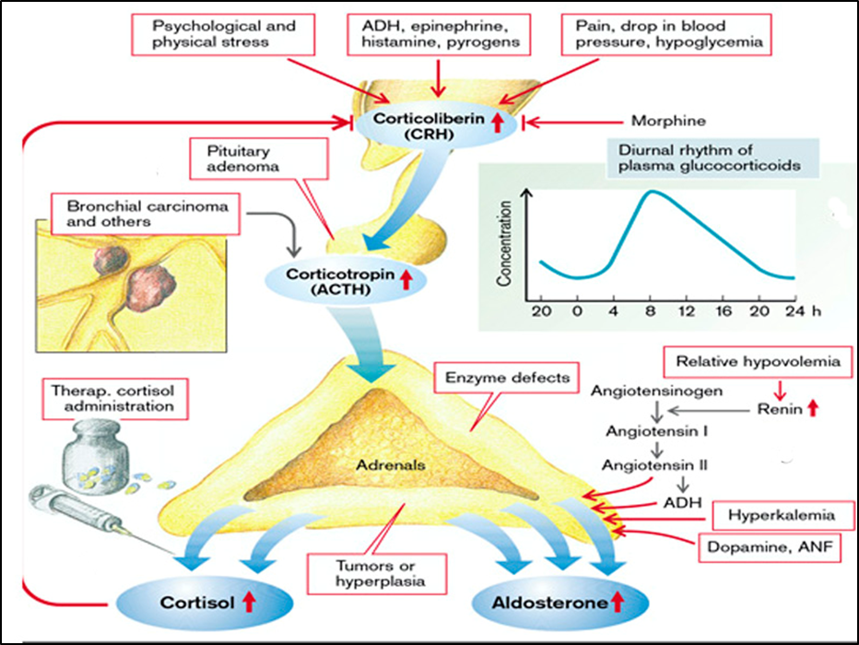
Fig.7. Causes of glucocorticoid and mineralocorticoid hypersecretion
(From S. Silbernagl and F. Lang; Color Atlas of Pathophysiology)
Hypersecretion of glucocorticoids (hypercortisolism)
This disorder is caused by any condition that produces an elevation in glucocorticoid levels. In clinical practice, most cases of Cushing syndrome are caused by the administration of exogenous glucocorticoids. The remaining cases are endogenous and caused by one of the following:
- Hypothalamic-pituitary diseases associated with hypersecretion of CRH or ACTH (tertiary and secondary hypercorticosolism);
- Primary adrenocortical hyperplasia or neoplasia (primary hypercorticosolism);
- The secretion of ectopic ACTH by non-endocrine neoplasms; (Fig.7)
Hypothalamic-pituitary disease associated with oversecretion of ACTH, also known as Cushing disease, accounts for more than half of the cases of spontaneous, endogenous Cushing syndrome. The disorder affects women about five times more frequently than men, and it occurs most frequently during the 20s and 30s. In the vast majority of cases, the pituitary gland contains an ACTH-producing microadenoma that does not produce mass effects in the brain; some corticotroph tumors qualify as macroadenomas (>10 mm). Corticotroph cell hyperplasia may be primary, or arise secondarily from excessive stimulation of ACTH release by a hypothalamic corticotropin-releasing hormone-producing tumor. The adrenal glands in patients with Cushing disease are characterized by variable degrees of bilateral nodular cortical hyperplasia, caused by elevated levels of ACTH. The cortical hyperplasia, in turn, is responsible for the hypercortisolism.
Primary adrenal neoplasms, such as adrenal adenoma and carcinoma, and primary cortical hyperplasia, are responsible for about 10% to 20% of cases of endogenous Cushing syndrome. This form of Cushing syndrome is also designated ACTH-independent Cushing syndrome or adrenal Cushing syndrome because the adrenals function autonomously. In most cases, adrenal Cushing syndrome is caused by a unilateral adrenocortical neoplasm, which may be either benign (adenoma) or malignant (carcinoma).
Secretion of ectopic ACTH by non-endocrine tumors accounts for most of the remaining cases of endogenous Cushing syndrome. Commonly, the responsible tumor is a small-cell carcinoma of the lung, although other neoplasms, including carcinoid tumors, medullary carcinomas of the thyroid, and islet cell tumors of the pancreas, have also been associated with the syndrome. In addition to tumors that elaborate ectopic ACTH, an occasional neoplasm produces ectopic CRH, which in turn causes ACTH secretion and hypercortisolism. Cushing’s syndrome also can result from long-term therapy with one of the potent pharmacologic preparations of glucocorticoids; this form is called iatrogenic Cushing’s syndrome.
Clinical features in hypersecretion of glucocorticoid. The signs and symptoms of Cushing syndrome are an exaggeration of the known actions of glucocorticoids.
Glucocorticoids (especially cortisol) stimulate gluconeogenesis in the liver and inhibit glucose uptake in peripheral cells, finally leading to hyperglycemia and insulin resistence. They also stimulate lipolysis, the breakdown of proteins in the periphery (released aminoacids are involved in the process of gluconeogenesis), and the formation of plasma proteins (e.g., angiotensinogen) in the liver. They promote the formation of erythrocytes, thrombocytes, and neutrophil granulocytes (neutrophils). At the same time they reduce the number of eosinophil granulocytes (eosinophils) and basophil granulocytes (basophils), lymphocytes, and monocytes. They also, via the formation of the proteins lipocortin and vasocortin, suppress the release of histamine, interleukins, and lymphokines. By inhibiting phospholipase A₂ they suppress the formation of prostaglandins and leukotrienes. They diminish antibody formation and thus act as immunosuppressives. Glucocorticoids suppress inflammation by inhibiting connective tissue proliferation, but at the same time impede collagen synthesis and repair. They stimulate the secretion of acids and pepsin in the stomach and slow down mucus production. In addition, they decrease the plasma levels of calcium and phosphate, in part by inhibiting calcitriol formation. They also sensitize blood vessels and the heart to catecholamines (permissive effect), partly by inhibiting prostaglandin synthesis, stimulate the release of norepinephrine, and increase the excitability of the nervous system. At high plasma levels cortisol also exerts a significant mineralocorticoid effect.
Cushing syndrome usually develops gradually and, like many other endocrine abnormalities, may be quite subtle in its early stages. Early manifestations of Cushing syndrome include hypertension and weight gain.
High level of glucocorticoids induces gluconeogenesis and inhibits the uptake of glucose by cells, with resultant hyperglycemia, glucosuria, and polydipsia, mimicking diabetes mellitus (steroid diabetes), in which the release of insulin is increased. The free fatty acids formed by stimulated lipolysis are utilized in the liver to generate very low density lipoproteins (VLDL) which are passed into the blood. In addition, the liver forms ketone bodies from fatty acids. A redistribution of fat tissue occurs due to differing sensitivities of peripheral fatty tissue for glucocorticoids and insulin. This results in centripetal fat stores, rounded or moon faces and fat deposits in the neck (“buffalo” hump), while the limbs are noticeably thin. Peripheral protein breakdown leads to muscle wasting, osteoporosis (loss of bone matrix), striae (breakdown of subcutaneous connective tissue), and purpura (increased vascular fragility). Hypercortisolism causes selective atrophy of fast-twitch (type II) myofibers, with resultant decreased muscle mass and proximal limb weakness. Because repair is impeded, wound healing is delayed. The effect on bone is aggravated by CaHPO₄ deficiency and in children results in delayed growth.
The effects on blood lead to polycythemia, thrombocytosis, and raised coagulability. Weakened immune defenses encourage infections. Sensitization of the circulation to catecholamines causes, among other things, an increase in cardiac contractility as well as peripheral vasoconstriction, and thus leads to hypertension, which, together with hyperlipidemia and raised coagulability of blood, promotes the development of atherosclerosis, thrombosis, and vascular occlusions. Due to stimulation of hydrochloric acid and pepsin secretion and the inhibition of mucus secretion in the stomach, gastric and/or duodenal ulcers develop (peptic effect of glucocorticoids). The effects on the nervous system can trigger an endocrine psychogenic syndrome. An increased mineralcorticoid effect causes hypervolemia, which in turn leads to hypertension (retention of sodium ions with osmotic retention of water in the kidneys); it also causes hypokalemia, hypomagnesemia, and alkalosis (loss of hydrogen ions through the kidneys), which in turn lead to increased neuromuscular excitability. The effects are, among others, abnormal action potential formation and conduction in the heart.
An excess of androgens can lead to masculinization and amenorrhea (virilism) in women, and to an accelerated onset of sexual characteristics in male children (incomplete precocious puberty).
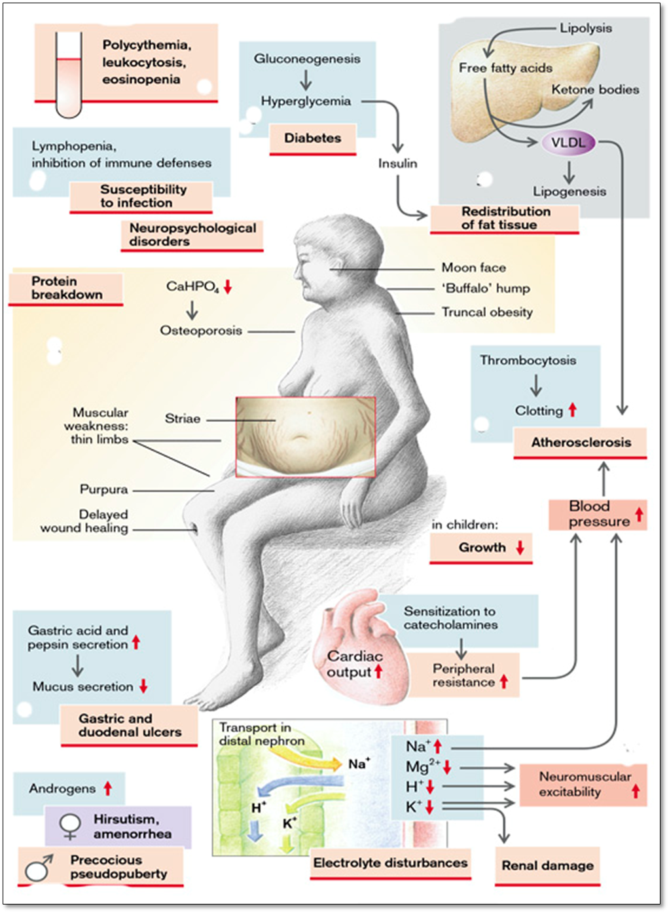
Fig.8. Clinical features in glucocorticoid hypersecretion
(From S. Silbernagl and F. Lang; Color Atlas of Pathophysiology)
Hypersecretion of mineralocorticoids
An important stimulus for the release of the mineralocorticoid aldosterone is angiotensin II, which is formed in increased amounts via the renin–angiotensin system when the renal perfusion pressure is reduced. Aldosterone release is also stimulated by ADH, whose secretion is stimulated by angiotensin II. Aldosterone release is increased by hyperkalemia, but decreased by dopamine and the atrial natriuretic factor (ANF) (Fig.7).
Primary hyperaldosteronism, indicates a primary, autonomous overproduction of aldosterone, with resultant suppression of the renin-angiotensin system and decreased plasma renin activity. Primary hyperaldosteronism is caused either by an aldosterone-producing adrenocortical neoplasm, usually an adenoma, or by primary adrenocortical hyperplasia. Some cases are idiopathic; these may be caused by overactivity of the aldosterone synthase gene, CYP₁₁B₂. In roughly 80% of cases, primary hyperaldosteronism is caused by an aldosterone-secreting adenoma in one adrenal gland, a condition referred to as Conn syndrome. Conn syndrome occurs most frequently in middle adult life and is more common in females than in males (2:1). Although aldosterone-producing adenomas account for less than 1% of cases of hypertension, it is important to recognize them, because they cause a surgically correctable form of hypertension.
In secondary hyperaldosteronism, aldosterone release occurs in response to activation of the renin-angiotensin system. It is characterized by increased levels of plasma renin and is encountered in conditions associated with: decreased renal perfusion (arteriolar nephrosclerosis, renal artery stenosis); arterial hypovolemia and edema (congestive heart failure, cirrhosis, nephrotic syndrome); pregnancy (caused by estrogen-induced increases in plasma renin substrate). In hypovolemia (ex. dehydration) the increased release of aldosterone is adequate for controlling volume, but usually too high for K⁺ balance. Even if blood volume is normal or increased, renal perfusion may be impaired and thus renin release increased in a number of renal diseases. If the pumping action of the heart is reduced, or in peripheral vasodilation (e.g., in sepsis or liver failure) the blood pressure can be maintained only by massive activation of the sympathetic system, resulting in renal vasoconstriction, renin release, and hyperaldosteronism.
Excessive levels of aldosterone cause sodium retention and potassium and hydrogen excretion, with resultant hypernatremia, hypertension, hypokalemia and metabolic alkalosis. Hypertension is cased by hydroelectrolytic retention (hypertonic hyperhydration). In hypernatremia, the sodium ions enter into the cells leading to intracellular hyperosmolarity accompanied by shift of water into the cells (cell swelling or intracellular edema), inclusive in endothelial cells, such narrowing the vascular lumen. Hypokalemia is responsible for a cluster of clinical manifestations (see hydroelectrolytic imbalance) like: heart arrhythmias, muscular weakness, paresthesia etc. Hyperaldosteronism is associated with oliguria (reduced urine output), decreased urine osmolarity and pH.
The treatment of secondary hyperaldosteronism rests on correcting the underlying cause of the stimulation of the renin-angiotensin system.
HYPOSECRETION OF GLUCOCORTICOIDS (hypocortisolism)
A deficiency of glucocorticoids (as well as other hormones released from the cortex of adrenal glands) can be the consequence of adrenal insufficiency or of enzyme defects in adrenal hormone synthesis (primary hypocortisolism). In addition, there may be insufficient stimulation by ACTH, as in damage to the pituitary gland (secondary hypocortisolism) or injury of the hypothalamus with decreased secretion of CRH (tertiary hypocortisolism). Aldosterone release can also be reduced as a result of hypokalemia or decreased angiotensin II formation (Fig.9).
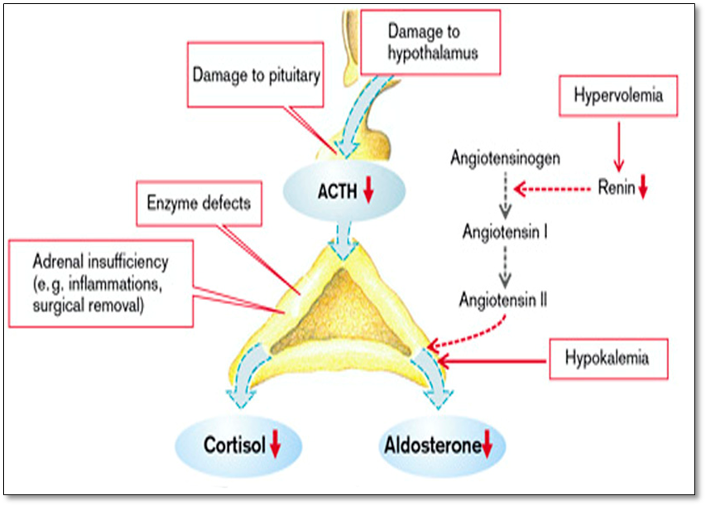
Fig.9. Causes of glucocorticoids and mineralocorticoid hyposecretion
(From S. Silbernagl and F. Lang; Color Atlas of Pathophysiology)
Primary adrenocortical insufficiency (Addison disease), is an uncommon disorder resulting from progressive destruction of the adrenal cortex. More than 90% of all cases are attributable to one of four disorders: autoimmune adrenalitis, tuberculosis, the acquired immune deficiency syndrome (AIDS) or metastatic cancers. Autoimmune adrenalitis accounts for 60% to 70% of cases and is by far the most common cause of primary adrenal insufficiency in developed countries. As the name implies, there is autoimmune destruction of steroid-producing cells, and autoantibodies to several key steroidogenic enzymes have been detected in these patients. Infections, particularly tuberculosis and those produced by fungi, may also cause primary chronic adrenocortical insufficiency. Tuberculous adrenalitis, which once accounted for as many as 90% of cases of Addison disease, has become less common with the advent of anti-tuberculous therapy. However, with the resurgence of tuberculosis in many urban centers, this cause of adrenal deficiency must be borne in mind. Metastatic neoplasms involving the adrenals are another potential cause of adrenal insufficiency. The adrenals are a fairly common site for metastases in persons with disseminated carcinomas. Although adrenal function is preserved in most such patients, the metastatic growths sometimes destroy sufficient adrenal cortex to produce a degree of adrenal insufficiency.
Any disorder of the hypothalamus and pituitary, such as metastatic cancer, infection, infarction, or irradiation, that reduces the output of ACTH or CRH leads to a syndrome of hypocortisolism having many similarities to Addison disease (secondary and tertiary adrenocortical insufficiency). ACTH deficiency may occur alone, but in some instances, it is only one part of panhypopituitarism, associated with multiple tropic hormone deficiencies. In patients with primary disease, serum ACTH levels may be normal, but the destruction of the adrenal cortex does not permit a response to exogenously administered ACTH in the form of increased plasma levels of cortisol. By contrast, secondary adrenocortical insufficiency is characterized by low serum ACTH and a prompt rise in plasma cortisol levels in response to ACTH administration.
Clinical features in hyposecretion of glucocorticoids. In general, clinical manifestations of adrenocortical insufficiency do not appear until at least 90% of the adrenal cortex has been compromised. The initial manifestations often include progressive weakness and easy fatigability, which may be dismissed as nonspecific complaints.
Glucocorticoid deficiency frequently leads to hypoglycemia as a result of disinhibited glycolysis and reduced gluconeogenesis. This is especially marked in secondary deficiency of adrenocorticoid hormones due to pituitary insufficiency, because it is associated with decreased somatotropin secretion, the hyperglycemic effect of which will be absent. The hypoglycemia activates the sympathetic nervous system and inhibits the release of insulin, and thus also of its influence on lipolysis and protein breakdown. The reduced lipolytic and proteolytic action of cortisol is more than compensated by decreased insulin and an increased epinephrine effect. Lipolysis and protein breakdown are thus stimulated. Further effects of the raised epinephrine release are tachycardia and sweating. The reduced sensitivity to catecholamines of the heart and blood vessels leads to a fall in blood pressure despite the release of epinephrine. Due to the diminished secretion of hydrochloric acid, pathogens that have been swallowed will be less effectively killed in the stomach and more commonly cause gastrointestinal infections. Diarrhea and vomiting occur with corresponding loss of water and electrolytes. The lack in glucocorticoid effect on blood-forming cells results in anemia, neutropenia, eosinophilia, and lymphocytosis. Other symptoms are fatigue and weakness. Furthermore, depression is caused by the lack of glucocorticoid action on the brain. However, while cortisol deficiency persists, sensitivity of the target cells is raised and they thus delay the onset of symptoms.
In primary adrenocorticoid insufficiency the diminished negative feedback from cortisol leads to a massive rise in the synthesis of pro-opiomelanocortin (POMC), the precursor of ACTH. This increases formation not only of ACTH, but also of "melanotropin" (MSH or melanocortin). MSH as well as ACTH itself causes brown discoloration of the skin, because of which Addison’s disease has been called “bronze disease”. The face, axillae, nipples, areolae, and perineum are particularly common sites of hyperpigmentation
If one adrenal cortex is absent, ACTH causes hypertrophy of the intact adrenal cortex. If both adrenals are absent, ACTH can even cause the ectopic formation of adrenocorticoid hormones, but this is usually inadequate. In secondary adrenocorticoid insufficiency skin pigmentation is decreased because of a lack of MSH and ACTH.
Mineralocorticoid deficiency (hypoaldosteronism) leads to renal salt loss and renal retention of K⁺, Mg²⁺ and H⁺. Na⁺ reabsorption in the sweat glands and gut is also impaired. This result in salt deficiency (hyponatremia), hypotonic dehydration, hypovolemia, drop in blood pressure, and in the increase of intracellular volume (due to blood hypoosmolarity). This can lead to a decrease in renal perfusion and glomerular filtration rate, causing an increase of plasma creatine concentration. Other electrolytic changes are represented by hyperkalemia and increased level of hydrogen ions with metabolic acidosis. The retention of K⁺, Mg²⁺ and H⁺ leads to reduced neuromuscular excitability as well as abnormalities of action potential formation and conduction in the heart due to hyperkalemia, hypermagnesemia, and acidosis. Hypoaldosteronism is characterised by polyuria and urine hyperosmolarity.
A lack of androgens manifests itself especially in sparse pubic hair as well as muscle wasting and loss of libido. However, lack of adrenal androgens is of no consequence in men, as long as testosterone production in the testes is normal.
Individuals with chronic adrenocortical insufficiency may develop an acute crisis after any stress that taxes their limited physiologic reserves. In patients maintained on exogenous corticosteroids, rapid withdrawal of steroids or failure to increase steroid doses in response to an acute stress may precipitate a similar adrenal crisis, because of the inability of the atrophic adrenals to produce glucocorticoid hormones. Massive adrenal hemorrhage may destroy the adrenal cortex sufficiently to cause acute adrenocortical insufficiency. This condition may occur in patients maintained on anticoagulant therapy, in postoperative patients who develop disseminated intravascular coagulation, during pregnancy, and in patients suffering from overwhelming sepsis (Waterhouse-Friderichsen syndrome). This catastrophic syndrome is classically associated with Neisseria meningitidis septicemia but can also be caused by other organisms, including Pseudomonas species, pneumococci, and Haemophilus influenzae. The pathogenesis of the Waterhouse-Friderichsen syndrome remains unclear, but it probably involves endotoxin-induced vascular injury with associated disseminated intravascular coagulation.
Acute worsening of the symptoms leads to so-called Addisonian crisis with extreme weakness, fall in blood pressure, tachycardia, diarrhea, hypoglycemia, hyponatremia, hyperkalemia, acidosis and oliguria. Death follows rapidly unless corticosteroids are replaced immediately.
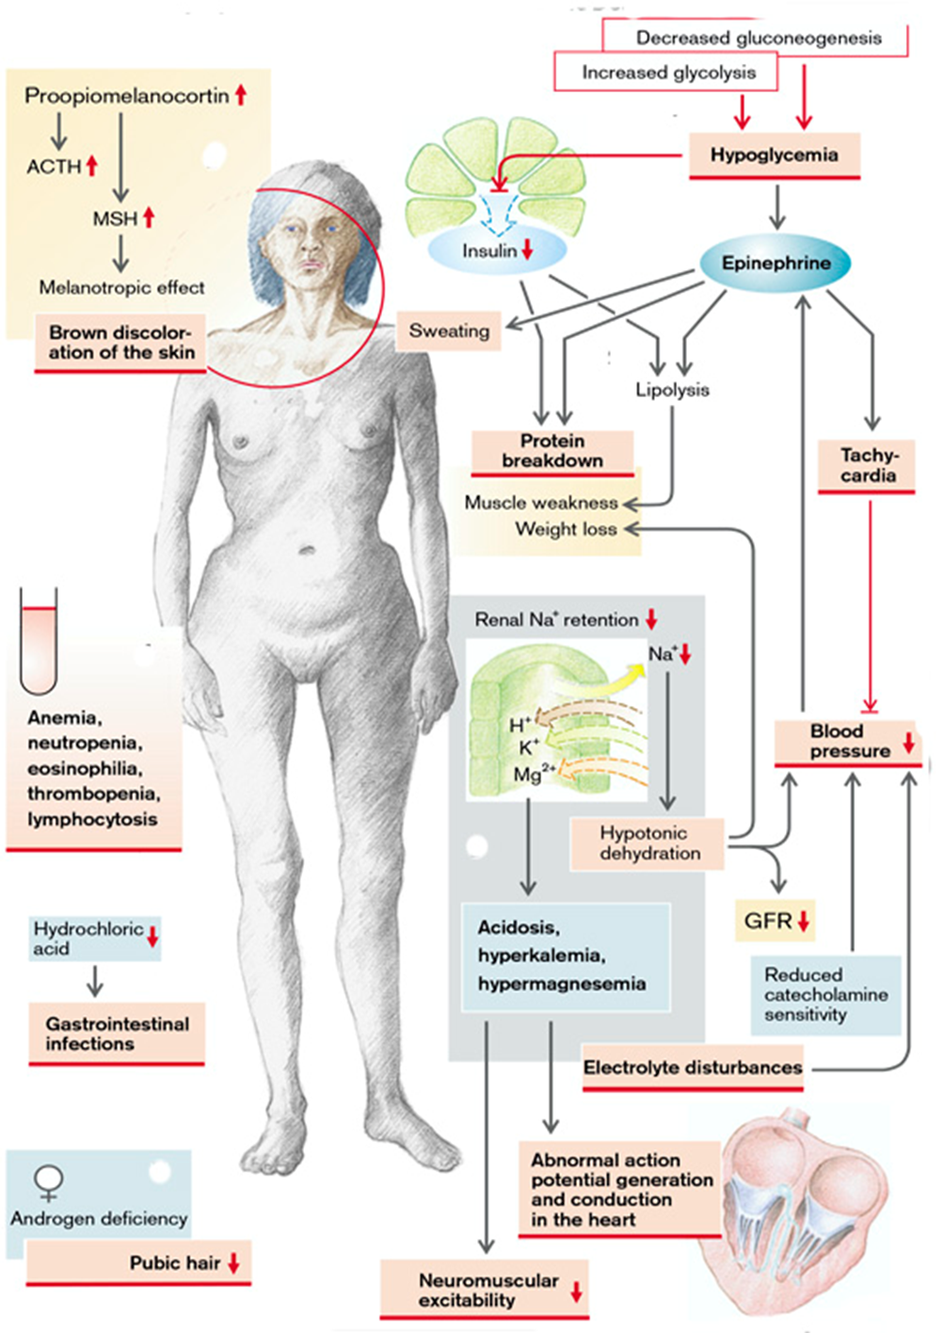
Fig.10. Manifestations of adrenocortical insufficiency
(From S. Silbernagl and F. Lang; Color Atlas of Pathophysiology)
DISORDERS OF THYROID GLAND SECRETION
The thyroid gland consists of two bulky lateral lobes connected by a relatively thin isthmus, usually located below and anterior to the larynx. The thyroid gland develops embryologically from an evagination of the developing pharyngeal epithelium that descends from the foramen cecum at the base of the tongue to its normal position in the anterior neck. This pattern of descent explains the occasional presence of ectopic thyroid tissue, most commonly located at the base of the tongue (lingual thyroid) or at other sites abnormally high in the neck. The thyroid is divided into lobules, each composed of about 20 to 40 evenly dispersed follicles. The follicles range from uniform to variable in size and are lined by cuboidal to low columnar epithelium, which is filled with thyroglobulin, the iodinated precursor protein of active thyroid hormone. In response to trophic factors from the hypothalamus, TSH (thyrotropin) is released by thyrotrophs in the anterior pituitary into the circulation. The binding of TSH to its receptor on the thyroid follicular epithelium results in activation and conformational change in the receptor, allowing it to associate with a stimulatory G-protein. Activation of the G-protein eventually results in an increase in intracellular cAMP levels, which stimulates thyroid hormone synthesis and release via cAMP-dependent protein kinases. Thyroid follicular epithelial cells convert thyroglobulin into thyroxine (T₄) and lesser amounts of triiodothyronine (T₃). T₄ and T₃ are released into the systemic circulation, where most of these peptides are reversibly bound to circulating plasma proteins, such as T₄-binding globulin, for transport to peripheral tissues. The binding proteins serve to maintain the serum unbound ("free") T₃ and T₄ concentrations within narrow limits while ensuring that the hormones are readily available to the tissues. In the periphery the majority of free T₄ is de-iodinated to T₃; the latter binds to thyroid hormone nuclear receptors in target cells with 10-fold greater affinity than T₄, and has proportionately greater activity. The interaction of thyroid hormone with its nuclear thyroid hormone receptor (TR) results in the formation of a hormone-receptor complex that binds to thyroid hormone response elements (TREs) in target genes, regulating their transcription. Thyroid hormone has diverse cellular effects, including up-regulation of carbohydrate and lipid catabolism and stimulation of protein synthesis in a wide range of cells. The net result of these processes is an increase in the basal metabolic rate.
Actions of thyroid hormones. All the major organs in the body are affected by altered levels of thyroid hormone. Thyroid hormone has two major functions: it increases metabolism and protein synthesis, and it is necessary for growth and development in children, including mental development and attainment of sexual maturity.
Metabolic rate. Thyroid hormone increases the metabolism of all body tissues except the retina, spleen, testes, and lungs. The basal metabolic rate can increase by 60% to 100% above normal when large amounts of T₄ are present. As a result of this higher metabolism, the rate of glucose, fat, and protein use increases. Lipids are mobilized from adipose tissue, and the catabolism of cholesterol by the liver is increased. Blood levels of cholesterol are decreased in hyperthyroidism and increased in hypothyroidism. Muscle proteins are broken down and used as fuel, probably accounting for some of the muscle fatigue that occurs with hyperthyroidism. The absorption of glucose from the gastrointestinal tract is increased. Because vitamins are essential parts of metabolic enzymes and coenzymes, an increase in metabolic rate “speeds up” the use of vitamins and tends to cause vitamin deficiency.
Cardiovascular function. Cardiovascular and respiratory functions are strongly affected by thyroid function. With an increase in metabolism, there is a rise in oxygen consumption and production of metabolic end products, with an accompanying increase in vasodilatation. Blood flow to the skin, in particular, is augmented as a means of dissipating the body heat that results from the higher metabolism. Blood volume, cardiac output, and ventilation all are increased as a means of maintaining blood flow and oxygen delivery to body tissues. Heart rate and cardiac contractility are enhanced as a means of maintaining the needed cardiac output. On the other hand, blood pressure is likely to change little because the increase in vasodilatation tends to offset the increase in cardiac output.
Gastrointestinal function. Thyroid hormone enhances gastrointestinal function, causing an increase in motility and production of gastrointestinal secretions that often results in diarrhea. An increase in appetite and food intake accompanies the higher metabolic rate that occurs with increased thyroid hormone levels. At the same time, weight loss occurs because of the increased use of calories.
Neuromuscular effects. Thyroid hormone has marked effects on neural control of muscle function and tone. Slight elevations in hormone levels cause skeletal muscles to react more vigorously, and a drop in hormone levels causes muscles to react more sluggishly. In the hyperthyroid state, a fine muscle tremor is present. The cause of this tremor is unknown, but it may represent an increased sensitivity of the neural synapses in the spinal cord that control muscle tone. In the infant, thyroid hormone is necessary for normal brain development. The hormone enhances cerebration; in the hyperthyroid state, it causes extreme nervousness, anxiety, and difficulty in sleeping. Evidence suggests a strong interaction between thyroid hormone and the sympathetic nervous system. Many of the signs and symptoms of hyperthyroidism suggest overactivity of the sympathetic division of the autonomic nervous system, such as tachycardia, palpitations, and sweating. Tremor, restlessness, anxiety, and diarrhea also may reflect autonomic nervous system imbalances. Drugs that block sympathetic activity have proved to be valuable adjuncts in the treatment of hyperthyroidism because of their ability to relieve some of these undesirable symptoms.

It is important to recognize diseases of the thyroid, because most are amenable to medical or surgical management. These diseases include conditions associated with excessive release of thyroid hormones (hyperthyroidism), those associated with thyroid hormone deficiency (hypothyroidism), and mass lesions of the thyroid.
Goiter is an increase in the size of the thyroid gland. It can occur in hypothyroid, euthyroid, and hyperthyroid states. Goiters may be diffuse, involving the entire gland without evidence of nodularity, or they may contain nodules. Diffuse goiters usually become nodular. Goiters may be toxic, producing signs of extreme hyperthyroidism, or thyrotoxicosis, or they may be nontoxic. Diffuse nontoxic and multinodular goiters are the result of compensatory hypertrophy and hyperplasia of follicular epithelium from some derangement that impairs thyroid hormone output. The degree of thyroid enlargement usually is proportional to the extent and duration of thyroid deficiency. Multinodular goiters produce the largest thyroid enlargements and often are associated with thyrotoxicosis. When sufficiently enlarged, they may compress the esophagus and trachea, causing difficulty in swallowing, a choking sensation, and inspiratory stridor. Such lesions also may compress the superior vena cava, producing distention of the veins of the neck and upper extremities, edema of the eyelids and conjunctiva, and syncope with coughing.
HYPERSECRETION OF THYROID HORMONES
Thyrotoxicosis is a hypermetabolic state caused by elevated circulating levels of free T₃ and T₄. Because it is caused most commonly by hyperfunction of the thyroid gland, it is often referred to as hyperthyroidism. The common practice is using the terms thyrotoxicosis and hyperthyroidism interchangeably.
The most common cause of an increased release of thyroid hormone (hyperthyroidism) is thyroid-stimulating immunoglobulin (TSI), an IgG that apparently “fits” into the TSH receptor (Graves’ disease). This result, among other effects, in stimulation of hormonal release and thyroid enlargement. TSH release is suppressed by a high T₃/T₄ level.
Other causes of hyperthyroidism are:
- Orthotopic or ectopic thyroid hormone–producing tumors;
- Inflammation of the thyroid (thyroiditis);
- Increased release of TSH (TSH-secreting pituitary adenoma) or TRH (secondary and tertiary hyperthyroidism),
- Excessive supply of exogenous thyroid hormones (factitious thyrotoxicosis - exogenous thyroxine intake)
Graves disease is an autoimmune disorder in which a variety of antibodies may be present in the serum, including antibodies to the TSH receptor, thyroid peroxisomes, and thyroglobulin. Of these, autoantibodies to the TSH receptor are central to disease pathogenesis, and include:
Thyroid-stimulating immunoglobulin: An IgG antibody that binds to the TSH receptor and mimics the action of TSH, stimulating adenylcyclase, with resultant increased release of thyroid hormones. Almost all persons with Graves disease have detectable amounts of this autoantibody to the TSH receptor. This antibody is relatively specific for Graves disease, in contrast to thyroglobulin and thyroid peroxidase antibodies.
Thyroid growth-stimulating immunoglobulins (TGIs): Also directed against the TSH receptor, TGIs have been implicated in the proliferation of thyroid follicular epithelium.
Graves disease may be associated with other autoimmune disorders such as myasthenia gravis and pernicious anemia. The disease is associated with human leukocyte antigen (HLA)-DR₃ and HLA-B₈, and a familial tendency is evident. The onset usually is between the ages of 20 and 40 years, and women are five times more likely to develop the disease than men.
Effects and symptoms of hyperthyroidism
The clinical manifestations of thyrotoxicosis are truly protean and include changes referable to the hypermetabolic state induced by excessive amounts of thyroid hormone as well as those related to overactivity of the sympathetic nervous system. The fact that many of the signs and symptoms of hyperthyroidism resemble those of excessive sympathetic nervous system activity suggests that thyroid hormone may heighten the sensitivity of the body to the catecholamines or that it may act as a pseudocatecholamine.
Metabolic effects: in many tissues the thyroid hormones (T₃, T₄) increase enzyme synthesis, Na⁺/K⁺-ATPase activity and oxygen consumption, leading to an increase in basal metabolism and a rise in body temperature. Basal metabolism can nearly double. The affected patients prefer cold ambient temperature; in a hot environment they tend to break into a sweat (heat intolerance). By stimulating glycogenolysis and gluconeogenesis, the thyroid hormones cause an increase in blood glucose concentration, while on the other hand also increasing glycolysis. When glucose is given (glucose tolerance test), plasma glucose concentration rises more quickly and more markedly than in healthy people; the rise is followed by a rapid fall (abnormal glucose tolerance). They stimulate lipolysis, the breakdown of VLDL and LDL as well the excretion of bile acids in the bile. The raised lipolysis leads to weight loss, on the one hand, and to hyperlipidacidemia, on the other. At the same time, the concentrations of VLDL, LDL, and cholesterol are diminished. They stimulate, via increased oxygen consumption, the release of erythropoietin and thus erythropoiesis. The high 2,3-bisphosphoglycerate (DPG) content in newly formed erythrocytes decreases O₂ affinity and thus favors the peripheral release of O₂. The increased O₂ demand requires hyperventilation and stimulates erythropoiesis. Although the thyroid hormones promote protein synthesis, hyperthyroidism increases proteolytic enzymes, and thus causes excess proteolysis with an increase in urea formation and excretion. Muscle mass is reduced. Breakdown in bone matrix can lead to osteoporosis, hypercalcemia, and hypercalciuria.
Constitutional symptoms: The skin of thyrotoxic individuals tends to be soft, warm, and flushed; heat intolerance and excessive sweating are common. Increased sympathetic activity and hypermetabolism result in weight loss despite increased appetite. Patients frequently experience nervousness, tremor, irritability and insomnia. Nearly 50% develop proximal muscle weakness (thyroid myopathy). Thyroid hormones sensitize the target organs to catecholamines (especially by an increase in β-receptors) and thus increase, for example, cardiac contractility and heart rate. As a result of the stimulating action on the heart, cardiac output (CO) and systolic blood pressure are raised. Atrial fibrillation may occasionally occur. The peripheral vessels are dilated. In addition, they raise intestinal motility (diarrhea) and stimulate the transport processes in the gut and kidneys. The glomerular filtration rate (GFR), renal plasma flow (RPF), and tubular transport are increased in the kidneys, while in the liver the breakdown of steroid hormones and drugs is accelerated.
In children, accelerated growth may sometimes occur because thyroid hormones promote physical (e.g., longitudinal growth) and mental (especially intellectual) development.
T₃ and T₄ act mainly through enhanced gene expression, which takes several days. Beyond this their prolonged action is due to the long half-life in blood (T₃ = one day; T₄ = seven days). Maternal T₃ and T₄ are largely inactivated in the placenta and thus have only a slight effect on the fetus.
Ocular manifestations: a wide, staring gaze and lid lag are present in patients because of sympathetic overstimulation of the levator palpebrae superioris (false ophthalmopathy). However, true thyroid ophthalmopathy (infiltrative ophthalmopathy) associated with proptosis is a feature seen only in Graves disease. This represents a T-cell-mediated autoimmune phenomenon - an immune reaction against retrobulbar antigens that are apparently similar to the TSH receptors. In Graves ophthalmopathy the volume of the retro-orbital connective tissues and extra-ocular muscles is increased as a result of several causes, including: (1) marked infiltration of the retro-orbital space by mononuclear cells, predominantly T cells; (2) inflammatory edema and swelling of extra-ocular muscles; (3) accumulation of extracellular matrix components, specifically hydrophilic glycosaminoglycans such as hyaluronic acid and chondroitin sulfate; and (4) increased numbers of adipocytes (fatty infiltration). Other mechanism of ophthalmopathy is thought to result from a cytokine-mediated activation of fibroblasts in orbital tissue behind the eyeball. Sometimes similar changes can be found in the pretibial region (dermopathy, or pretibial myxedema). These changes displace the eyeball forward and can interfere with the function of the extraocular muscles; protrusion of the eyes with diplopia, excessive tear flow, and increased photophobia also occur. The ophthalmopathy of Graves’ disease can cause severe eye problems, including paralysis of the extraocular muscles; involvement of the optic nerve, with some visual loss; and corneal ulceration because the lids do not close over the protruding eyeball (due to the exophthalmos). The exophthalmos may persist or progress despite successful treatment of the thyrotoxicosis, sometimes resulting in corneal injury.
T₃ and T₄ promote the expression of their receptors and thereby sensitize their target organs to their actions, thus increasing the effects of hyperthyroidism.
Thyroid storm is used to designate the abrupt onset of severe hyperthyroidism. Thyroid storm, or crisis, is an extreme and life-threatening form of thyrotoxicosis, rarely seen today because of improved diagnosis and treatment methods. This condition occurs most commonly in individuals with underlying Graves disease, probably resulting from an acute elevation in catecholamine levels, as might be encountered during stress. When it does occur, it is seen most often in undiagnosed cases or in persons with hyperthyroidism who have not been adequately treated. It often is precipitated by stress such as an infection (usually respiratory), by diabetic ketoacidosis, by physical or emotional trauma, or by manipulation of a hyperactive thyroid gland during thyroidectomy. Thyroid storm is manifested by a very high fever, extreme cardiovascular effects (i.e., tachycardia, congestive failure, and angina), and severe CNS effects (i.e., agitation, restlessness, and delirium). Thyroid storm is a medical emergency: a significant number of untreated patients die of cardiac arrhythmias.
Apathetic hyperthyroidism refers to thyrotoxicosis occurring in the elderly, in whom old age and various co-morbidities may blunt the typical features of thyroid hormone excess seen in younger patients. The diagnosis of thyrotoxicosis in these individuals is often made during laboratory work-up for unexplained weight loss or worsening cardiovascular disease.

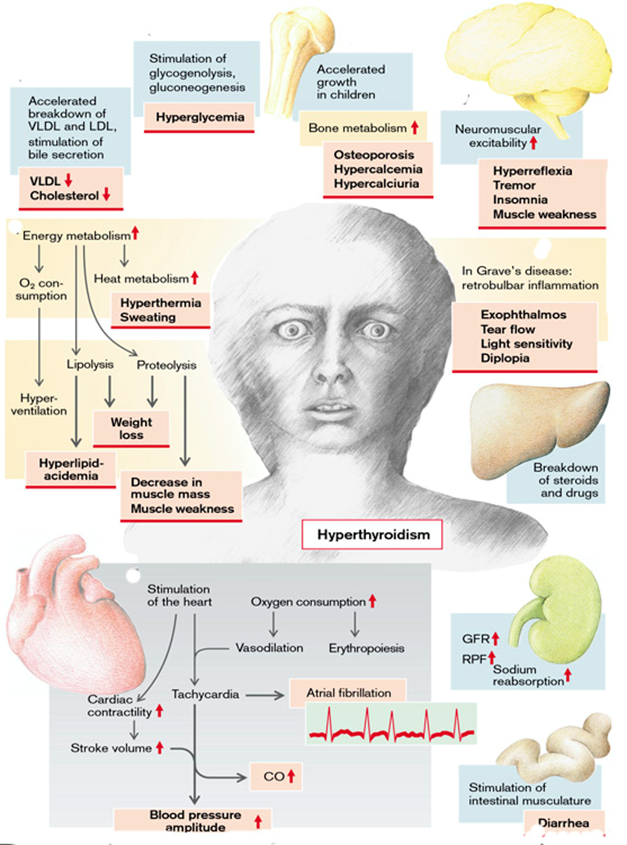
Fig. 11. Effects and symptoms of hyperthyroidism
(From S. Silbernagl and F. Lang; Color Atlas of Pathophysiology)

HYPOSECRETION OF THYROID HORMONES
Hypothyroidism is caused by any structural or functional derangement that interferes with the production of adequate levels of thyroid hormone.
The causes of a lowered release of thyroid hormone (hypothyroidism) are usually found in the thyroid itself (primary hypothyroidism). Abnormal synthesis of thyroid hormones can be brought about by any one of the following steps in their synthesis (Fig.12):
1. Decreased iodine intake in food;
2. Impaired iodine uptake in the thyroid cells (genetically defective carrier or inhibition of transport by perchlorate, nitrate, thiocyanate (rhodanate);
3. Peroxidase deficiency (genetic) or peroxidase inhibition by thiouracil or iodine excess (inhibition of H₂O₂ formation by excessive I–);
4. Abnormal breakdown of thyreoglobulin;
5. Defective iodine incorporation (peroxidase is involved in this, too);
6. Defective coupling of two iodinated tyrosine residues;
7. Inability to release thyroxine and triiodothyronine, from thyroglobulin (genetically determined or lithium);
8. Lack of sensitivity of the target organs due to receptor defects or inadequate conversion into the more effective T₃ decreases T₃/ T₄ effectiveness even if T₃/T₄ release is normal or even raised.
Furthermore, mutations of the TSH receptors can change the degree to which the thyroid can be stimulated by TSH. However, genetic defects of receptors and enzymes of T₃/T₄ synthesis are rare. \
Two very common causes of hypothyroidism are inflammatory damage to the thyroid gland or surgical removal of the gland (due to thyroid cancer). The most common cause of hypothyroidism is Hashimoto’s thyroiditis, an autoimmune disorder in which the thyroid gland may be totally destroyed by an immunologic process. It is the major cause of goiter and hypothyroidism in children and adults. Hashimoto’s thyroiditis is predominantly a disease of women, with a female-to-male ratio of 5:1.
More rarely hypothyroidism is due to a deficiency of TSH (e.g., in pituitary insufficiency; secondary hypothyroidism) or of TRH (e.g., in damage to the hypothalamus; tertiary hypothyroidism).
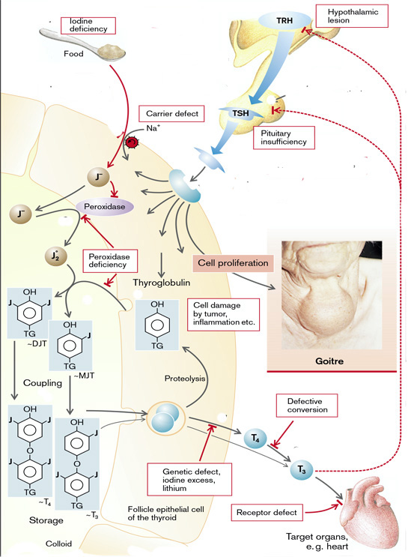
Fig.12. Causes of hypothyroidism
(From S. Silbernagl and F. Lang; Color Atlas of Pathophysiology)
Congenital hypothyroidism
Thyroid hormone is essential for normal brain development and growth, almost half of which occurs during the first 6 months of life. The thyroid hormones are necessary for the full development of dendrites and axons, the formation of synapses, myelination, and glial formation - all processes that are absolutely essential for brain development in the fetus and up to two years after birth. Intrauterine deficiency of thyroid hormones thus massively impairs this development. Hypothyroidism in the infant may result from a congenital lack of the thyroid gland or from abnormal biosynthesis of thyroid hormone or deficient TSH secretion. With congenital lack of the thyroid gland, the infant usually appears normal and functions normally at birth because hormones have been supplied in utero by the mother. If there is maternal thyroid deficiency before the development of the fetal thyroid gland, mental retardation is severe.
If substitution with thyroid hormones after birth is omitted, brain damage occurs that cannot be reversed by later thyroid hormone administration. Affected children are often deaf. Furthermore, bone growth is delayed in these children. Retarded growth and impaired mental capacity lead to the typical feature of cretinism. Other clinical features of cretinism include short stature, coarse facial features, a protruding tongue, and umbilical hernia. It affects approximately 1 of 5000 infants. However, the term does not apply to the normally developing infant in whom replacement thyroid hormone therapy was instituted shortly after birth.
Long-term studies show that closely monitored T₄ supplementation begun in the first 6 weeks of life results in normal intelligence. Fortunately, neonatal screening tests have been instituted to detect congenital hypothyroidism during early infancy. Screening usually is done in the hospital nursery. In this test, a drop of blood is taken from the infant’s heel and analyzed for T₄ and TSH.
Transient hypothyroidism may be caused by maternal or infant exposure to substances such as povidone-iodine used as a disinfectant (i.e., vaginal douche or skin disinfectant, in the nursery). Antithyroid drugs, such as propylthiouracil and methimazole, can cross the placenta and block fetal thyroid function. Congenital hypothyroidism is treated by hormone replacement. Evidence indicates that it is important to normalize T₄ levels as rapidly as possible because a delay is accompanied by poorer psychomotor and mental development. When early and adequate treatment regimens are followed, the risk for mental retardation in infants detected by screening programs essentially is nonexistent.
Effects and symptoms of hypothyroidism
Hypothyroidism developing in older children and adults results in a condition known as myxedema. Myxedema, or Gull disease, was first linked with thyroid dysfunction in 1873 by Sir William Gull in a paper addressing the development of a "cretinoid state" in adults.The manifestations of the disorder are related largely to two factors: the hypometabolic state resulting from thyroid hormone deficiency, and myxedematous involvement of body tissues. Although the myxedema is most obvious in the face and other superficial parts, it also affects many of the body organs and is responsible for many of the manifestations of the hypothyroid state
Manifestations of myxedema include generalized apathy and mental sluggishness that in the early stages of disease may mimic depression. Metabolism and heat production are reduced in hypothyroidism. Basal metabolic rate may fall by half, and the patients easily feel cold (cold intolerance). Oxygen consumption, ventilation, and erythropoiesis are diminished. In addition, the development of anemia is encouraged by the impaired absorption in the gut of iron, folic acid, and vitamin B₁₂. Reduced lipolysis promotes weight increase and hyperlipidemia (VLDL, LDL), while the reduced breakdown of cholesterol to bile acids quickly lead to hypercholesterolemia, and thus favors the development of atherosclerosis. Impairment of glycogenolysis and gluconeogenesis can result in hypoglycemia. Reduced breakdown of glycosaminoglycans (mucopolysaccharides, mucin) causes them to be deposited in various tissues and a dough-like consistency of the skin, which is why the disease has been called myxedema. In addition, fibronectin, collagen, and plasma albumin are deposited in the skin. Reduced transformation of carotene into vitamin A causes hyperkeratosis. Also, because of reduced sweat and sebaceous secretion, the skin is dry and the reduced heat production makes it feel cold. The patient often has a hoarse voice.
Reduced stimulation of the heart by thyroid hormones decreases contractility, heart rate, stroke volume, cardiac output and occasionally also the systolic blood pressure. Mucopolysaccharide deposits in the heart cause generalized cardiac dilatation, bradycardia, and other signs of altered cardiac function. In marked thyroid hormone deficiency heart failure can develop. Pleural and pericardial effusions are common. The rate of breathing is slowed and the ventilatory reaction to hypercapnia and hypoxia is impaired.
The glomeruli and tubules in the kidneys are smaller. Glomerular filtration rate, renal plasma flow, and tubular transport capacity are reduced. Decreased renal elimination leads to water and NaCl retention. Due to the accumulation of fat, glycosaminoglycans, NaCl, and water, the patient may look somewhat bloated. In addition, protein synthesis in the liver is impaired and the breakdown of steroid hormones and drugs is delayed. The reduced stimulation of the intestinal musculature leads to constipation. Impaired function of the esophageal musculature and of the gastroesophageal sphincter may cause gastric reflux and esophagitis.
The activity and effectiveness of the autonomic nervous system is reduced in hypothyroidism. Neuromuscular excitability is also reduced, resulting in abnormal sensory functions, hyporeflexia, loss of appetite, loss of memory, depression, and clouding of consciousness progressing even to coma. These defects are reversible in adults.
A T₃/T₄ deficiency disinhibits the formation of TRH and TSH (positive feed-back). TSH not only stimulates the formation of TSH, but also of prolactin, and can thus trigger hyperprolactinemia. TSH also promotes the growth of the thyroid gland, causing goiter. Lastly, abnormal release of gonadotropins can impair fertility.
The hypothyroid state may be mild, with only a few signs and symptoms, or it may progress to a life-threatening condition called myxedematous coma. Myxedematous coma is a life-threatening, end-stage expression of hypothyroidism. It is characterized by coma, hypothermia, cardiovascular collapse, hypoventilation, and severe metabolic disorders that include hyponatremia, hypoglycemia, and lactic acidosis. The pathophysiology of myxedema coma involves three major aspects: (1) carbon dioxide retention and hypoxia, (2) fluid and electrolyte imbalance, and (3) hypothermia. It occurs most often in elderly women who have chronic hypothyroidism from a spectrum of causes. The fact that it occurs more frequently in winter months suggests that cold exposure may be a precipitating factor. The severely hypothyroid person is unable to metabolize sedatives, analgesics, and anesthetic drugs, and buildup of these agents may precipitate coma.
Laboratory evaluation has a vital role in the diagnosis of suspected hypothyroidism because of the nonspecific nature of symptoms. Measurement of the serum TSH is the most sensitive screening test for this disorder. The serum TSH is increased in primary hypothyroidism because of a loss of feedback inhibition of thyrotropin-releasing hormone (TRH) and TSH production by the hypothalamus and pituitary, respectively. The TSH concentration is not increased in persons with hypothyroidism caused by primary hypothalamic or pituitary disease. Serum T₄ is decreased in individuals with hypothyroidism of any origin.

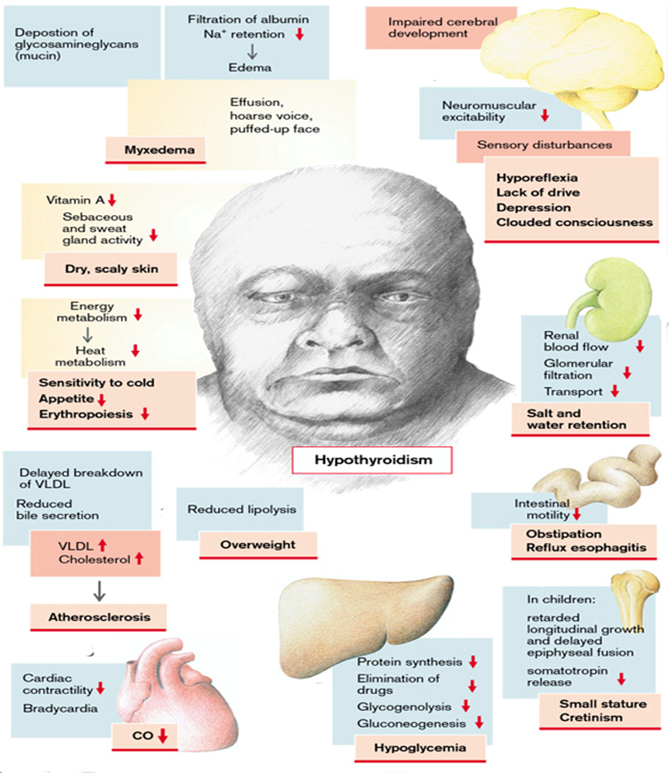
Fig.13. Manifestations of hypothyroidism
(From S. Silbernagl and F. Lang; Color Atlas of Pathophysiology)

DISORDERS OF INSULIN SECRETION
Endocrine pancreas. The endocrine pancreas consists of about 1 million microscopic clusters of cells, the islets of Langerhans, which contain four major cell types-β, α, δ, and PP (pancreatic polypeptide) cells. The cells can be differentiated morphologically by their staining properties, by the ultrastructural structure of their granules, and by their hormone content. The β cell produces insulin, which is the most potent anabolic hormone known, with multiple synthetic and growth-promoting effects; the α cell secretes glucagon, inducing hyperglycemia by its glycogenolytic activity in the liver; δ cells contain somatostatin, which suppresses both insulin and glucagon release; and PP cells contain a unique pancreatic polypeptide (vasoactive intestinal peptide, VIP) that exerts several gastrointestinal effects, such as stimulation of secretion of gastric and intestinal enzymes and inhibition of intestinal motility.
Normal insulin physiology and glucose homeostasis. Normal glucose homeostasis is tightly regulated by three interrelated processes: (1) glucose production in the liver, (2) glucose uptake and utilization by peripheral tissues, chiefly skeletal muscle, and, (3) actions of insulin and counter-regulatory hormones (e.g., glucagon). The principal metabolic function of insulin is to increase the rate of glucose transport into certain cells in the body. These are the striated muscle cells (including myocardial cells) and, to a lesser extent, adipocytes, representing collectively about two-thirds of the entire body weight. Glucose uptake in other peripheral tissues, most notably the brain, is insulin independent. In muscle cells, glucose is then either stored as glycogen or oxidized to generate adenosine triphosphate (ATP). In adipose tissue, glucose is primarily stored as lipid. Besides promoting lipid synthesis (lipogenesis), insulin also inhibits lipid degradation (lipolysis) in adipocytes. Similarly, insulin promotes amino acid uptake and protein synthesis while inhibiting protein degradation. Thus, the metabolic effects of insulin can be summarized as anabolic, with increased synthesis and reduced degradation of glycogen, lipid, and protein. In addition to these metabolic effects, insulin has several mitogenic functions, including initiation of DNA synthesis in certain cells and stimulation of their growth and differentiation.
Insulin reduces the production of glucose from the liver. Insulin and glucagon have opposing regulatory effects on glucose homeostasis. During fasting states, low insulin and high glucagon levels facilitate hepatic gluconeogenesis and glycogenolysis (glycogen breakdown) while decreasing glycogen synthesis, thereby preventing hypoglycemia. Thus, fasting plasma glucose levels are determined primarily by hepatic glucose output. Following a meal, insulin levels rise and glucagon levels fall in response to the large glucose load. The most important stimulus that triggers insulin release is glucose itself, which initiates insulin synthesis in the pancreatic β cells. Other agents, including intestinal hormones and certain amino acids (leucine and arginine), stimulate insulin release but not its synthesis. In peripheral tissues (skeletal muscle and adipose tissue), secreted insulin binds to the insulin receptor, triggering a number of intracellular responses that promote glucose uptake and post-prandial glucose utilization, thereby maintaining glucose homeostasis. Abnormalities at various points along this complex signaling cascade, from synthesis and release of insulin by β cells to insulin receptor interactions in peripheral tissues, can result in the diabetic phenotype.
The active form of insulin is composed of two polypeptide chains—an A chain and a B chain. Active insulin is formed in the beta cells from a larger molecule called proinsulin. In converting proinsulin to insulin, enzymes in the beta cell cleave proinsulin at specific sites to form two separate substances: active insulin and abiologically inactive C-peptide (connecting peptide) chain that joined the A and B chains before they were separated. Active insulin and the inactive C-peptide chain are packaged into secretory granules and released simultaneously from the beta cell. The C-peptide chains can be measured clinically, and this measurement can be used to study beta cell activity. Amylin is a 37-amino acid peptide that is co-secreted with insulin from the pancreatic beta cells in response to glucose and other beta-cell stimulators. Studies indicate that amylin acts as a neuroendocrine hormone, with several effects that complement the actions of insulin in regulating postprandial blood glucose levels. These include a suppression of glucagon secretion and a slowing of the rate at which glucose is delivered to the small intestine for absorption.
The release of insulin from the pancreatic beta cells is regulated by blood glucose levels, increasing as blood glucose levels rise and decreasing when blood glucose levels decline. Blood glucose enters the beta cell by means of the glucose transporter, is phosphorylated by an enzyme called glucokinase, and is metabolized to form the adenosine triphosphate (ATP) needed to close the potassium channels and depolarize the cell. Depolarization, in turn, results in opening of the calcium channels and insulin secretion. Secretion of insulin occurs in an oscillatory or pulsatile fashion. After exposure to glucose, which is a nutrient secretagogue, a first-phase release of stored preformed insulin occurs, followed by a second-phase release of newly synthesized insulin. Diabetes may result from dysregulation or deficiency in any of the steps involved in this process (e.g., impaired function of the glucose transporters, intracellular metabolic defects, glucokinase deficiency). Serum insulin levels begin to rise within minutes after a meal, reach a peak in approximately 3 to 5 minutes, and then return to baseline levels within 2 to 3 hours.
Insulin secreted by the beta cells enters the portal circulation and travels directly to the liver, where approximately 50% is used or degraded. Insulin, which is rapidly bound to peripheral tissues or destroyed by the liver or kidneys, has a half-life of approximately 15 minutes once it is released into the general circulation. To initiate its effects on target tissues, insulin binds to a membrane receptor. The insulin receptor is a combination of four subunits – a pair of larger α subunits that extend outside the cell membrane and are involved in insulin binding, and a smaller pair of β subunits that are predominantly inside the cell membrane and contain a kinase enzyme that becomes activated during insulin binding. Activation ofthe kinase enzyme results in autophosphorylation of theβ subunit itself. Phosphorylation of the β subunit in turnactivates some enzymes and inactivates others, thereby directingthe desired intracellular effect of insulin on glucose,fat, and protein metabolism.
Because cell membranes are impermeable to glucose, they require a special carrier, called a glucose transporter, to move glucose from the blood into the cell. These transporters move glucose across the cell membrane at a faster rate than would occur by diffusion alone. Considerable research has revealed a family of glucose transporters termed GLUT-1, GLUT-2, and so forth. GLUT-4 is the insulindependent glucose transporter for skeletal muscle and adipose tissue. It is sequestered inside the membrane of these cells and thus is unable to function as a glucose transporter until a signal from insulin causes it to move from its inactive site into the cell membrane, where it facilitates glucose entry. GLUT-2 is the major transporter of glucose into beta cells and liver cells. It has a low affinity for glucose and acts as a transporter only when plasma glucose levels are relatively high, such as after a meal. GLUT-1 is present in all tissues. It does not require the actions of insulin and is important in transport of glucose into the nervous system
Diabetes mellitus is not a single disease entity but rather a group of metabolic disorders sharing the common underlying feature of hyperglycemia. Hyperglycemia in diabetes results from defects in insulin secretion, insulin action, or, most commonly, both. The chronic hyperglycemia and attendant metabolic dysregulation of diabetes mellitus may be associated with secondary damage in multiple organ systems, especially the kidneys, eyes, nerves, and blood vessels. Diabetes affects an estimated 21 million people in the United States (or nearly 7% of the population), as many as a third of whom are undiagnosed. Diabetes is a leading cause of end-stage renal disease, adult-onset blindness, and non-traumatic lower extremity amputations in the United States, underscoring the impact of this disease on the burden of health care costs. It also greatly increases the risk of developing coronary artery disease and cerebrovascular disease. In concert with great technologic advances, there have been pronounced changes in human behavior, with increasingly sedentary life styles and poor eating habits. This has contributed to the simultaneous escalation of diabetes and obesity worldwide, which some have termed the "diabesity" epidemic.
Blood glucose levels are normally maintained in a very narrow range, usually 70 to 120 mg/dL.
Individuals with serum fasting glucose values less than 110 mg/dL, or less than 140 mg/dL following an oral glucose tolerance test, are considered to be euglycemic. However, those with serum fasting glucose greater than 110 but less than 126 mg/dL, or oral glucose tolerance test values of greater than 140 but less than 200 mg/dL, are considered to have impaired glucose tolerance. Individuals with impaired glucose tolerance have a significant risk of progressing to overt diabetes over time, with as many as 5% to 10% advancing to full-fledged diabetes mellitus per year. In addition, those with impaired glucose tolerance are at risk for cardiovascular disease, due to abnormal carbohydrate metabolism and the coexistence of other risk factors.
The diagnosis of diabetes is established by elevation of blood glucose by any one of three criteria:
1. A random blood glucose concentration of 200 mg/dL or higher, with classical signs and symptoms;
2. A fasting glucose concentration of 126 mg/dL or higher on more than one occasion;
3. An abnormal oral glucose tolerance test (OGTT), in which the glucose concentration is 200 mg/dL or higher 2 hours after a standard carbohydrate load (75 g of glucose ).
Although all forms of diabetes mellitus share hyperglycemia as a common feature, the underlying causes of hyperglycemia vary widely. The vast majority of cases of diabetes fall into one of two broad classes:
Type 1diabetes is characterized by an absolute deficiency of insulin secretion caused by pancreatic β-cell destruction, usually resulting from an autoimmune attack. Type 1 diabetes accounts for approximately 10% of all cases.
Type 2 diabetes is caused by a combination of peripheral resistance to insulin action and an inadequate compensatory response of insulin secretion by the pancreatic β cells ("relative insulin deficiency"). Approximately 80% to 90% of patients have type 2 diabetes.
Other causes of hyperglycemia are:
Even without any genetic disposition, diabetes can occur in the course of other diseases, such as pancreatitis, with destruction of the beta cells (pancreas-deprived diabetes;), or by toxic damage to these cells. The development of diabetes mellitus is promoted by an increased release of antagonistic hormones. Among these are somatotropin (in acromegaly), glucocorticoids (in Cushing’s disease or stress [so-called steroid diabetes]), epinephrine (in stress), progestogens and choriomammotropin (in pregnancy), ACTH, thyroid hormone, and glucagon. Severe infections increase the release of several of the above hormones and thus the manifestation of diabetes mellitus. A somatostatinoma can cause diabetes because the stomatostatin secreted by it inhibits the release of insulin.
Pathogenesis of absolute insulin deficiency (Type 1 diabetes mellitus)
Type 1 diabetes (absolute insulin deficiency) is an autoimmune disease in which islet destruction is caused primarily by immune effector cells reacting against endogenous β-cell antigens. Type 1 diabetes most commonly develops in childhood, becomes manifest at puberty, and progresses with age. Since the disease can develop at any age, including late adulthood, the appellation “juvenile diabetes” has been excluded from the recent classification of diabetes because insulin dependence is not a consistent distinguishing feature. Nevertheless, most patients with type 1 diabetes depend on insulin for survival; without insulin they develop serious metabolic complications such as ketoacidosis and coma. A rare form of “idiopathic” type 1 diabetes has been described in which the evidence for autoimmunity is not definitive.
As with most autoimmune diseases, the pathogenesis of type 1 diabetes represents interplay of genetic susceptibility and environmental factors (Fig.14).
- Genetic susceptibility
Epidemiologic studies, such as those demonstrating higher concordance rates for disease in monozygotic vs dizygotic twins, have convincingly established a genetic basis for type 1 diabetes. Over a dozen susceptibility loci for type 1 diabetes are now known. Of these, by far the most important is the HLA locus on chromosome 6p21; according to some estimates, the HLA locus contributes as much as 50% of the genetic susceptibility to type 1 diabetes.
- Role of environmental factors in development of absolute insulin deficiency
There is evidence that environmental factors, especially viral infections, may be involved in triggering islet cell destruction in type 1 diabetes. Epidemiologic associations have been reported between type 1diabetes and infection with mumps, rubella, coxsackie B, or cytomegalovirus, among others. At least three different mechanisms have been proposed to explain the role of viruses in the induction of autoimmunity. The first is “bystander” damage, wherein viral infections induce islet injury and inflammation, leading to the release of sequestered β-cell antigens and the activation of autoreactive T cells. The second possibility is that the viruses produce proteins that mimic β-cell antigens, and the immune response to the viral protein cross-reacts with the self-tissue (“molecular mimicry”). The third hypothesis suggests that viral infections incurred early in life (predisposing virus”) might persist in the tissue of interest, and subsequent re-infection with a related virus (“precipitating virus”) that shares antigenic epitopes leads to an immune response against the infected islet cells. This last mechanism, also known as “viral déja vu” might explain the latency between infections and the onset of diabetes. It is unclear whether any of these mechanisms contribute to β-cell damage, and no causative viral infection is established. In fact, some epidemiologic data and studies of experimental models suggestthat infections may be protective; the underlying mechanisms of such a protective effect are unknown.
Mechanisms of β-cell destruction in absolute insulin deficiency
Although the clinical onset of absolute insulin deficiency is often abrupt, the autoimmune process usually starts many years before the disease becomes evident, with progressive loss of insulin reserves over time. The classic manifestations of the disease (hyperglycemia and ketosis) occur late in itscourse, after more than 90% of the β cells have been destroyed. Many of the advances in type 1 diabetes pathogenesis have emerged from studies of the non-obese diabetic mouse model, which shares features of autoimmune islet destruction observed in the human disease.
The fundamental immune abnormality in type 1 diabetes is a failure of self-tolerance in T-cells. This failure of tolerance may be a result of some combination of defective clonal deletion of self-reactive T cells in the thymus, as well as defects in the functions of regulatory T cells or resistance of effector T cells to suppression by regulatory cells. Thus, autoreactive T-cells not only survive but are poised to respond to self-antigens.
The initial activation of these cells is thought to occur in the peripancreatic lymph nodes, perhaps in response to antigens that are released from damaged islets. The activated T cells then traffic to the pancreas, where they cause β cell injury. Multiple T-cell populations have been implicated in this damage, including Th₁ cells (which may injure β cells by secreted cytokines, including IFN-γ and TNF), and CD₈⁺ CTLs (which directly kill β cells). The islet auto-antigens that are the targets of immune attack may include insulin itself, as well as the β-cell enzyme glutamic acid decarboxylase (GAD).
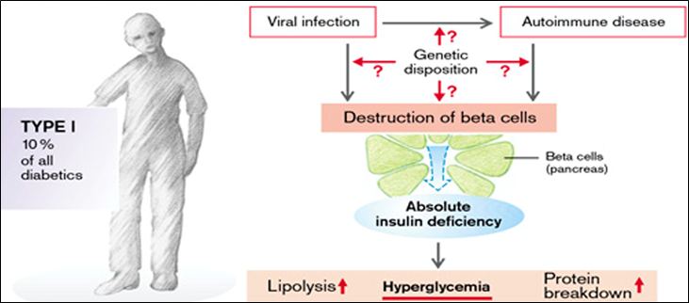
Fig.14. Pathogenesis of absolute insulin deficiency
(From S. Silbernagl and F. Lang; Color Atlas of Pathophysiology)
Pathogenesis of relative insulin deficiency (Type 2 diabetes mellitus)
While much has been learned in recent years, the pathogenesis of relative insulin deficiency remains enigmatic. Environmental influences, such as a sedentary life style and dietary habits, clearly have a role, as will become evident when obesity is considered. Nevertheless, genetic factors also may play a role, with linkage demonstrable to multiple "diabetogenic" genes. Among identical twins, the concordance rate is 50% to 90%, while among first-degree relatives with type 2 diabetes (including fraternal twins) the risk of developing the disease is 20% to 40%, as compared with 5% to 7% in the population at large. Unlike type 1 diabetes, however, the disease is not linked to genes involved in immune tolerance and regulation, and there is no evidence to suggest an autoimmune basis to type 2 diabetes.
The two metabolic defects that characterize relative insulin deficiency are:
(1) Decreased ability of peripheral tissues to respond to insulin (insulin resistance);
(2) β-cell dysfunction that is manifested as inadequate insulin secretion in the face of insulin resistance and hyperglycemia.
In most cases, insulin resistance is the primary event and is followed by increasing degrees of β-cell dysfunction (Fig.15).
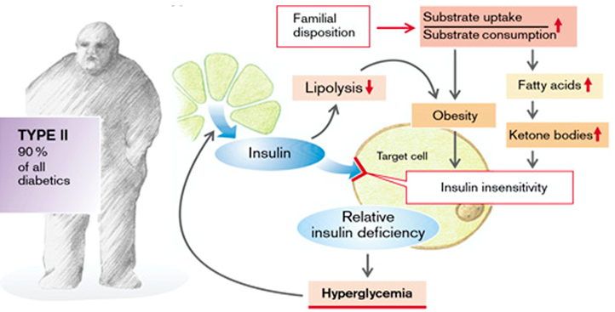
Fig.15. Pathogenesis of relative insulin deficiency
(From S. Silbernagl and F. Lang; Color Atlas of Pathophysiology)
Mechanisms of insulin resistance
Insulin resistance is defined as resistance to the effects of insulin on glucose uptake, metabolism, or storage. It leads to decreased uptake of glucose in muscle, reduced glycolysis and fatty acid oxidation in the liver, and an inability to suppress hepatic gluconeogenesis. Studies in tissue-specific insulin receptor knockout mice suggest that loss of insulin sensitivity in the hepatocytes is likely to be the largest contributor to the pathogenesis of insulin resistance in vivo. Few factors play an important role in the development of insulin resistance as obesity. Insulin resistance is a characteristic feature of most individuals with relative insulin deficiency and is an almost universal finding in diabetic individuals who are obese.
It is recognized that insulin resistance is a complex phenomenon, influenced by a variety of genetic and environmental factors:
- Genetic defects of the insulin receptor and insulin signaling pathway
Loss-of-function abnormalities of either the insulin receptor or its down-stream signaling molecules are obvious candidates for mediating insulin resistance in type 2 diabetes. Much of the role of genetic defects in the insulin signaling pathway has been elucidated from targeted disruption of these genes in knockout mouse models of diabetes. Unfortunately, the extrapolation of these single-gene knockout models to human disease has been less than gratifying, underscoring the multifactorial etiology of insulin resistance in humans. Point mutations of the insulin receptor are relatively rare, accounting for no more than 1% to 5% of patients with insulin. A variety of functional defects have been reported in the insulin signaling pathway in states of insulin resistance (for example, reduced tyrosine phosphorylation and increased serine phosphorylation of the insulin receptor and IRS proteins), which attenuate signal transduction.
Role of obesity in development of insulin resistance
The epidemiologic association of obesity with relative insulin deficiency has been recognized for decades, with visceral obesity observed in greater than 80% of patients. Obesity has profound effects on sensitivity of tissues to insulin, and as consequence, on systemic glucose homeostasis. Insulin resistance is present even in simple obesity unaccompanied by hyperglycemia, indicating a fundamental abnormality of insulin signaling in states of fatty excess. The risk for diabetes increases as the body mass index (a measure of body fat content) increases. It is not only the absolute amount but also the distribution of body fat that has an effect on insulin sensitivity: central obesity (abdominal fat) is more likely to be linked with insulin resistance than are peripheral (gluteal/subcutaneous) fat depots. The new terminology that is emerging for persons with obesity and type 2 diabetes is diabesity. Obesity can adversely impact insulin sensitivity in numerous ways (Fig.16):
- - Role of nonesterified fatty acids (NEFAs) in development of insulin resistance;
The level of intracellular triglycerides is often markedly increased in muscle and liver tissues of obese individuals, presumably because excess circulating NEFAs are deposited in these organs. Central adipose tissue (abdominal obesity) is more “lipolytic” than peripheral sites, which might explain the particularly deleterious consequences of this pattern of fat distribution.
High amount of NEFAs has several consequences leading to insulin resistance:
- NEFAs act at the level of the beta cell to stimulate insulin secretion, which, with excessive and chronic stimulation, causes beta cell failure (lipotoxicity);
- NEFAs act at the level of the peripheral tissues to cause insulin resistance and glucose underutilization by inhibiting glucose uptake and glycogen storage through a reduction in muscle glycogen synthetase activity.
- Excess intracellular NEFAs overwhelm the fatty acid oxidation pathways, leading to accumulation of cytoplasmic intermediates like diacylglycerol (DAG) and ceramide. These “toxic” intermediates can activate serine/threonine kinases, which cause aberrant serine phosphorylation of the insulin receptor and IRS proteins. Phosphorylation at serine residues attenuates insulin signaling.
- Excess NEFAs compete with glucose for substrate oxidation, leading to feedback inhibition of glycolytic enzymes, and thereby further exacerbating the existing glucose imbalance.
- Accumulation of NEFAs and triglycerides reduce hepatic insulin sensitivity, leading to increased hepatic glucose production and hyperglycemia, especially fasting plasma glucose levels.

- - Role of adipokines in development of insulin resistance;
It is recognized that adipose tissue is not merely a passive storage depot for fat but is afunctional endocrine organ that releases hormones in response to changes in the metabolic status. A variety of proteins secreted into the systemic circulation by adipose tissue have been identified, and these are collectively termed adipokines (or adipose cytokines). Both pro-hyperglycemic adipokines (e.g., resistin, retinol binding protein 4) and anti-hyperglycemic adipokines (leptin, adiponectin) have been identified. Leptin and adiponectin improve insulin sensitivity by directly enhancing the activity of the AMP activated protein kinase (AMPK), an enzyme that promotes fatty acid oxidation, in liver and skeletal muscle. Adiponectin levels are reduced in obesity, thus contributing to insulin resistance.
- - Role of inflammation in development of insulin resistance;
Adipose tissue also secretes a variety of pro-inflammatory cytokines like tumor necrosis factor, interleukin-6, and macrophage chemoattractant protein-1, the last attracting macrophages to fat deposits. Studies in experimental models have demonstrated that reducing the levels of pro-inflammatory cytokines enhances insulin sensitivity. These cytokines induce insulin resistance by increasing cellular “stress” which in turn, activates multiple signaling cascades that antagonize insulin action on peripheral tissues.
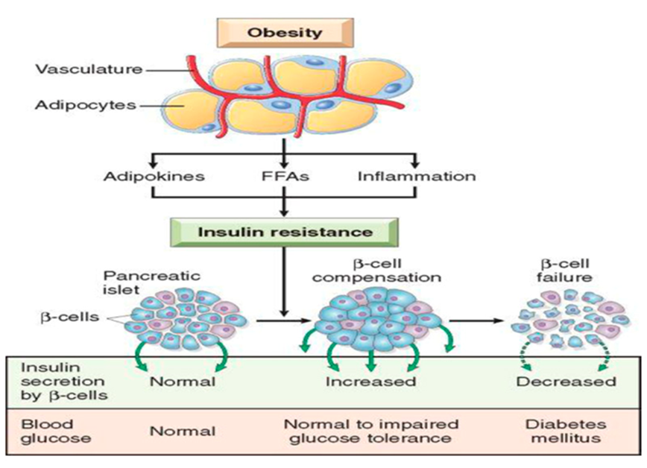
Fig.16. Mechanisms of insulin resistance in obesity.
(From Robbins and Cotran; Pathologic basis of disease)
- β-Cell dysfunction in relative insulin deficiency
β-cell dysfunction in relative insulin deficiency reflects the inability of these cells to adapt themselves to the long-term demands of peripheral insulin resistance and increased insulin secretion.
Specific causes of beta cell dysfunction in patients with relative insulin deficiency may include:
(1) an initial decrease in the beta cell mass (this may be related to genetic factors responsible for beta cell differentiation and function, and environmental factors such as the presence of maternal diabetes during pregnancy or in utero factors such as the presence of intrauterine growth retardation);
(2) Increased beta cell apoptosis/decreased regeneration;
(3) Long-standing insulin resistance leading to beta cell exhaustion;
(4) Chronic hyperglycemia can induce beta cell desensitization termed glucotoxicity;
(5) Chronic elevation of free fatty acids can cause toxicity to beta cells termed lipotoxicity;
(6) Amyloid deposition in the beta cell can cause dysfunction.
Clinical manifestations in insulin deficiency
Insulin acts to create energy reserves. It promotes the uptake of amino acids and glucose, especially in the muscle and fat cells. In hepatic, muscle, and fat cells (among others) insulin stimulates protein synthesis and inhibits protein breakdown; in the liver and muscles it promotes glycogen synthesis, inhibits its breakdown, stimulates glycolysis, and inhibits gluconeogenesis from amino acids. Also in the liver, insulin promotes the formation of triglycerides and lipoproteins as well as the hepatic release of VLDL. At the same time it stimulates lipoprotein lipase and thus accelerates the splitting of triglycerides from lipoproteins in blood (especially chylomicrons). The free fatty acids and glycerol are then taken up by the fat cells and stored again as triglycerides. Insulin stimulates lipogenesis and inhibits lipolysis in the fat cells. Lastly, it promotes cell growth, increases renal tubular absorption of Na⁺, and cardiac contractility. Part of insulin action is mediated by cell swelling (especially anti-proteolysis) and intracellular alkalosis (stimulation of glycolysis, increased cardiac contractility). Insulin achieves this effect by activating the Na⁺/H⁺ exchanger (cell swelling and alkalinization), the Na⁺-K⁺-2Cl– co-transporter (cell swelling), and Na⁺-K⁺-ATPase. This results in K+ uptake by the cell and hypokalemia. As glucose is coupled to phosphate in the cell, insulin also reduces plasma phosphate concentration. It further stimulates the cellular uptake of Mg²⁺. Insulin also paracrinally inhibits the release of glucagon and thus diminishes its stimulating action on glycogenolysis, gluconeogenesis, lipolysis, and ketogenesis.
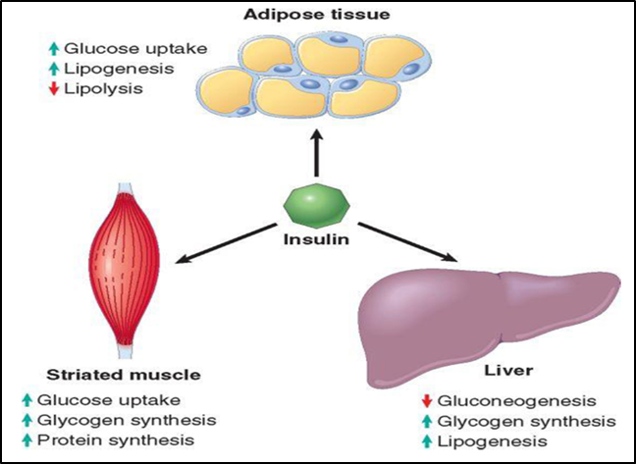
Fig.17. Metabolic action of insulin in striated muscle, adipose tissue and liver.
(From Robbins and Cotran; Pathologic basis of disease)
It is difficult to sketch with brevity the diverse clinical presentations of insulin deficiency. Only a few characteristic patterns will be presented.
In the initial 1 or 2 years following the onset of overt absolute insulin deficiency (type 1 diabetes), the exogenousinsulin requirements may be minimal because of ongoing endogenous insulin secretion (referred to asthe honeymoon period). Thereafter, any residual β-cell reserve is exhausted and insulin requirements increase dramatically. Although β-cell destruction is a prolonged process, the transition from impaired glucose tolerance to overt diabetes may be abrupt, and is often brought on by an event, such as infection, that is also associated with increased insulin requirements.The onset is marked by polyuria, polydipsia, polyphagia, and in severe cases, ketoacidosis, all resulting from metabolic derangements.
Since insulin is a major anabolic hormone in the body, deficiency of insulin results in a catabolic state that affects not only glucose metabolism but also fat and protein metabolism. Unopposed secretion of counter-regulatory hormones (glucagon, growth hormone, epinephrine) also plays a role in these metabolic derangements.
The assimilation of glucose into muscle and adipose tissue is sharply diminished or abolished. Not only does storage of glycogen in liver and muscle cease, but also reserves are depleted by enhancedglycogenolysis. The resultant hyperglycemia exceeds the renal threshold for reabsorption, and glycosuria ensues. The glycosuria induces an osmotic diuresis and thus polyuria, causing a profound loss of water and electrolytes (dehydration). The obligatory renal water loss combined with the hyperosmolarity resulting from the increased levels of glucose in the blood tends to deplete intracellular water, triggering the osmoreceptors of the thirst centers of the brain. In this manner, intense thirst (polydipsia) appears. Despite the renal loss of K⁺, there is no hypokalemia because the cells give up K⁺ as a result of reduced activity of Na⁺-K⁺-2Cl–cotransport and of Na⁺-K⁺-ATPase. The extracellular K⁺ concentration, which is therefore more likely to be high, disguises the negative K⁺ balance. Administration of insulin then causes a life-threatening hypokalemia. Dehydration leads to hypovolemia with corresponding impairment of the circulation. The resulting release of aldosterone increases the K⁺ deficiency, while the release of epinephrine and glucocorticoids exacerbates the catabolism. The reduced renal blood flow diminishes the renal excretion of glucose and thus encourages the hyperglycemia (Fig. 18.) The cells further lose phosphate and magnesium that are also excreted by the kidney.
With a deficiency of insulin, the scales swing from insulin-promoted anabolism to catabolism of proteins and fats. Proteolysis follows, and the gluconeogenic amino acids are removed by the liver and used as building blocks for glucose (enhanced gluconeogenesis). The catabolism of proteins and fats tends to induce a negative energy balance, which in turn leads to increasing appetite (polyphagia), thus completing the classic triad of diabetes: polyuria, polydipsia, and polyphagia. Despite the increased appetite, catabolic effects prevail, resulting in weight loss and muscle weakness. The combination of polyphagia and weight loss is paradoxical and should always raise the suspicion of diabetes. In individuals with absolute insulin deficiency, deviations from normal dietary intake, unusual physical activity, infection, or any other forms of stress may rapidly influence the treacherously fragile metabolic balance, predisposing one to diabetic ketoacidosis.
In relative insulin deficiency may also be present polyuria and polydipsia, but unlike absolute insulin deficiency, patients are often older (>40 years) and frequently obese. However, with the increase in obesity and sedentary life style in our society, type 2 diabetes is now seen in children and adolescents with increasing frequency. In some cases medical attention is sought because of unexplained weakness or weight loss. Most frequently, however, the diagnosis is made after routine blood or urine testing in asymptomatic persons.The infrequency of ketoacidosis and milder presentation in type 2 diabetes is presumably because of higher portal vein insulin levels in these patients than in type 1 diabetics, whichprevents unrestricted hepatic fatty acid oxidation and keeps the formation of ketone bodies in check.In the decompensated state, individuals with relative insulin deficiency may develop hyperosmolar nonketotic coma, a syndrome engendered by the severe dehydration resulting from sustained osmotic diuresis in patients who do not drink enough water to compensate for urinary losses from chronic hyperglycemia. Typically, the person is an elderly diabetic who is disabled by a stroke or an infection and is unable to maintain adequate water intake. Furthermore, the absence of ketoacidosis and its symptoms (nausea, vomiting, respiratory difficulties) delays the seeking of medical attention in these patients until severe dehydration and coma occur.
Diabetic ketoacidosis is a serious complication of absolute insulin deficiency but may also occur in relative insulin deficiency, though not as commonly and not to as marked an extent. These patients have marked insulin deficiency, and the release of the catecholamine hormone epinephrine blocks any residual insulin action and stimulates the secretion of glucagon. The insulin deficiency coupled with glucagon excess decreases peripheral utilization of glucose while increasing gluconeogenesis, severely exacerbating hyperglycemia (the plasma glucose levels are usually in the range of 500 to 700 mg/dL). The hyperglycemia causes an osmotic diuresis and dehydration characteristic of the ketoacidotic state. The second major effect of an alteration in the insulin-to-glucagon ratio is activation of the ketogenic machinery. Insulin deficiency stimulates lipolysis, with resultant breakdown of adipose stores, and an increase in levels of free fatty acids. When these free fatty acids reach the liver, they are esterified to fatty acyl coenzyme A. Oxidation of fatty acyl coenzyme A molecules within the hepatic mitochondria produces ketone bodies (acetoacetic acid, acetone and β-hydroxybutyric acid). Increased production of ketone bodies is due also to deficiency of oxalacetate and inability of acetyl-CoA to be involved in the Krebs cycle, as well as inability to use Acetyl-CoA in resynthesis of fatty acids (deficiency of NADPH because disturbed pentozophosphate cycle). Ketogenesis is an adaptive phenomenon in times of starvation, generating ketones as a source of energy for consumption by vital organs (e.g., brain). The rate at which ketone bodies are formed may exceed the rate at which acetoacetic acid and β-hydroxybutyric acid can be utilized by peripheral tissues, leading to ketonemia and ketonuria. If the urinary excretion of ketones is compromised by dehydration, systemic metabolic ketoacidosis results. Release of ketogenic amino acids by protein catabolism aggravates the ketotic state.Accumulation of ketone bodies lead to acidosis, which forces the patient to breathe deeply (Kussmaul breathing). In addition, triglycerides are formed in the liver from fatty acids and incorporated into VLDL. As the insulin deficiency delays the breakdown of lipoproteins, the hyperlipidemia is further aggravated. Some of the triglycerides remain in the liver and a fatty liver will develop (Fig.18).

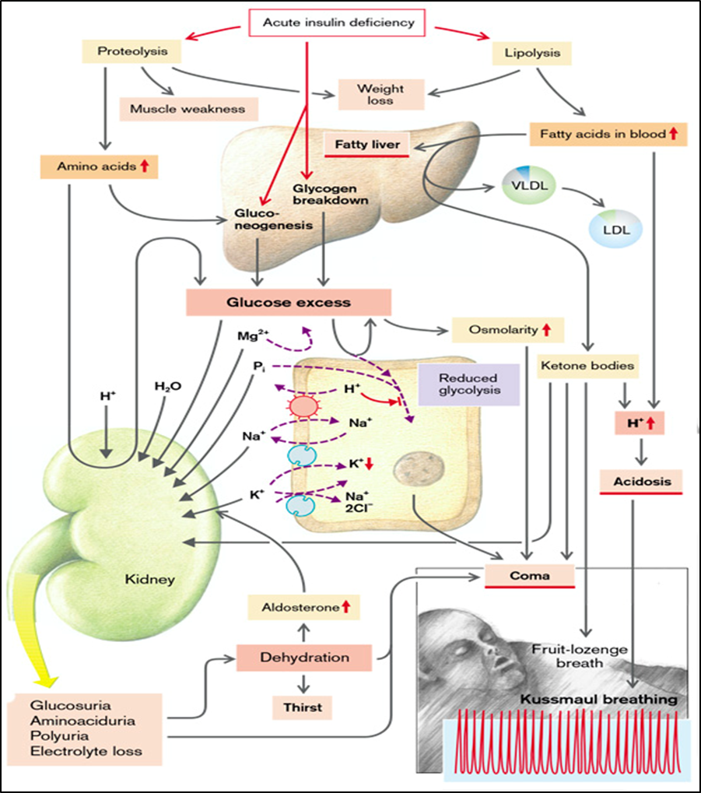
Fig. 18. Sequence of metabolic derangements underlying the clinical manifestations of diabetes.
(From S. Silbernagl and F. Lang; Color Atlas of Pathophysiology)
- Late complications of prolonged hyperglycemia
The morbidity associated with long-standing diabetes of either type results from several serious complications, caused mainly by lesions involving both large- and medium-sized muscular arteries (macrovascular disease) and capillary dysfunction in target organs (microvascular disease). Macrovascular disease causes accelerated atherosclerosis among diabetics, resulting in increased risk of myocardial infarction, stroke, and lower extremity gangrene. The effects of microvascular disease are most profound in the retina, kidneys, and peripheral nerves, resulting in diabetic retinopathy, nephropathy, and neuropathy, respectively. The pathogenesis of the long-term complications of diabetes is multifactorial, although persistent hyperglycemia (glucotoxicity) seems to be a key mediator.
At least three distinct metabolic pathways have been implicated in the deleterious effects of persistent hyperglycemia on peripheral tissues, although the primacy of any one over the others is unclear. The pathways are discussed below.
1 - Formation of advanced glycation end products
Advanced glycation end products (AGEs) are formed as a result of non-enzymatic reactions between intracellular glucose-derived precursors (glyoxal, methylglyoxal, and 3-deoxyglucosone) with the amino groups of both intracellular and extracellular proteins. The natural rate of AGE formation is greatly accelerated in the presence of hyperglycemia.
AGEs bind to a specific receptor (RAGE), which is expressed on inflammatory cells (macrophages and T cells), endothelium, and vascular smooth muscle. The detrimental effects of the AGE-RAGE signaling axis within the vascular compartment include:
(1) release of pro-inflammatory cytokines and growth factors from intimal macrophages;
(2) generation of reactive oxygen species in endothelial cells;
(3) increased procoagulant activity on endothelial cells and macrophages;
(4) enhanced proliferation of vascular smooth muscle cells and synthesis of extracellular matrix.
In addition to receptor-mediated effects, AGEs can directly cross-link extracellular matrix proteins. Cross-linking of collagen type I molecules in large vessels decreases their elasticity, which may predispose these vessels to shear stress and endothelial injury. Similarly, AGE-induced cross-linking of type IV collagen in basement membrane decreases endothelial cell adhesion and increases extravasation of fluid. Proteins cross-linked by AGEs are resistant to proteolytic digestion. Thus, cross-linking decreases protein removal while enhancing protein deposition. AGE-modified matrix components also trap non-glycated plasma or interstitial proteins. In large vessels, trapping of LDL, for example, retards its efflux from the vessel wall and enhances the deposition of cholesterol in the intima, thus accelerating atherogenesis. In capillaries, including those of renal glomeruli, plasma proteins such as albumin bind to the glycated basement membrane, accounting in part for the basement membrane thickening that is characteristic of diabetic microangiopathy.The formation of connective tissue is in part stimulated via transforming growth factor β (TGF-β). Additionally, however, the collagen fibers can be changed by glycosylation. Both changes produce thickening of the basement membranes with reduced permeability and luminal narrowing (microangiopathy). Changes occur in the retina, also as a result of microangiopathies, that ultimately may lead to blindness (retinopathy). In the kidney, glomerulosclerosis (Kimmelstiel–Wilson) develops, which can result in proteinuria, reduced glomerular filtration rate due to a loss of glomeruli, hypertension, and renal failure. Because of the high amino acid concentration in plasma, hyperfiltration takes place in the remaining intact glomeruli, which as a result are also damaged.
Glucose can react with hemoglobin (HbA) to form HbA₁c (glycosylated hemoglobin), whose increased concentration in blood points to a hyperglycemia that has been present for some time. HbA₁c has a higher oxygen affinity than HbA and thus releases oxygen in the periphery less readily. The persisting insulin deficiency further leads to a reduction in the erythrocytic concentration of 2,3-bisphosphoglycerate (BPG), which, as allosteric regulator of hemoglobin, reduces its oxygen affinity. The BPG deficiency also results in an increased oxygen affinity of HbA.
Hyperglycemia promotes the formation of sugar-containing plasma proteins such as fibrinogen, haptoglobin, α₂-macroglobulin as well as clotting factors V–VIII. In this way clotting tendency and blood viscosity may be increased and thus the risk of thrombosis raised (Fig.19).
2 - Activation of Protein Kinase C
Activation of intracellular protein kinase C (PKC) by Ca²⁺ ions and the second messenger diacylglycerol (DAG) is an important signal transduction pathway in many cellular systems. Intracellular hyperglycemia stimulates the de novo synthesis of DAG from glycolytic intermediates, and hence causes activation of PKC. The downstream effects of PKC activation are numerous and include the following.
• Production of proangiogenic vascular endothelial growth factor (VEGF), implicated in the neovascularization characterizing diabetic retinopathy;
• Elevated levels of the vasoconstrictor endothelin-1 and decreased levels of the vasodilator NO, due to decreased expression of endothelial nitric oxide synthase;
• Production of profibrogenic factors like TGF-β, leading to increased deposition of extracellular matrix and basement membrane material
• Production of PAI-1, leading to reduced fibrinolysis and possible vascular occlusive episodes;
• Production of pro-inflammatory cytokines by the vascular endothelium;
It should be evident that some effects of AGEs and activated PKC are overlapping, and both contributeto the long-term complications of diabetic microangiopathy.
3 - Intracellular hyperglycemia and disturbances in polyol pathways
In some tissues that do not require insulin for glucose transport (e.g., nerves, lenses, kidneys, blood vessels), persistent hyperglycemia in the extracellular milieu leads to an increase in intracellular glucose. This excess glucose is metabolized by the enzyme aldosereductase to sorbitol, a polyol, and eventually to fructose, in a reaction that uses NADPH (the reduced form of nicotinamide dinucleotide phosphate) as a cofactor. NADPH is also required by the enzyme glutathione reductase in a reaction that regenerates reduced glutathione (GSH) - one of the important antioxidant mechanisms in the cell. So, any reduction in GSH increases cellular susceptibility to oxidative stress. In the face of sustained hyperglycemia, progressive depletion of intracellular NADPH by aldosereductase compromises GSH regeneration, increasing cellular susceptibility to oxidative stress. Other mechanism of injury is due to the fact that sorbitol is a hexahydric alcohol which cannot pass across the cell membrane, as a result of which its cellular concentration increases and the cell swells. Due to an accumulation of sorbitol in the lens of the eye, water is incorporated, impairing lenticular transparency (clouding of the lens [cataract]). Accumulation of sorbitol in the Schwann cells and neurons reduces nerve conduction (polyneuropathy), affecting mainly the autonomic nervous system, reflexes, and sensory functions. To avoid swelling, the cells compensate by giving off myoinositol which then, however, will not be available for other functions (Krebs cycle).
In neurons, persistent hyperglycemia appears to be the major underlying cause of diabetic neuropathy (glucose neurotoxicity).
Cells that do not take up glucose in sufficient amounts will shrink as a result of extracellular hyperosmolarity. The functions of lymphocytes that have shrunk are impaired (e.g., the formation of superoxides, which are important for immune defense). Diabetics are thus more prone to infection, for example, of the skin (boils) or kidney (pyelonephritis). These infections, in turn, increase the demand for insulin, because they lead to an increased release of insulin-antagonistic hormones (Fig.19).
Diabetic mothers have a statistically higher chance of giving birth to a heavier than normal baby. This may be the result of an increased concentration of amino acids in blood, producing an increased release of somatotropin.
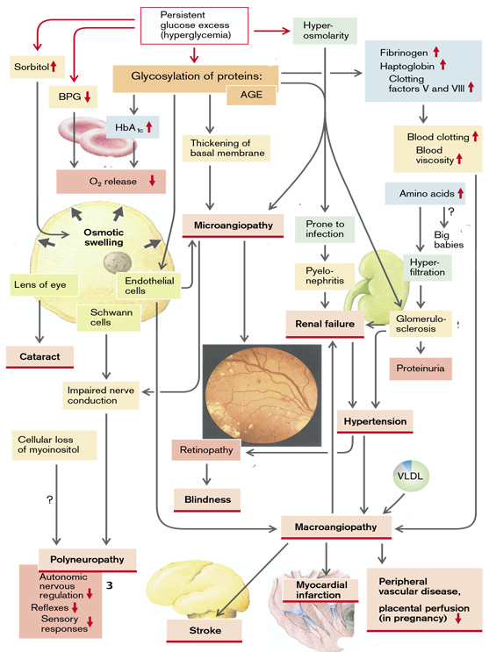
Fig.19. Late complications of prolonged hyperglycemia
(From S. Silbernagl and F. Lang; Color Atlas of Pathophysiology)
Hyperinsulinism
Insulin release is, first and foremost, regulated by glucose. Glucose is taken up by the beta cells of the pancreas and metabolized in them. The resulting ATP inhibits the ATP-sensitive K⁺ channels. Subsequent depolarization opens voltage-dependent Ca²⁺ channels so that Ca²⁺ enters the cell. The rise in intracellular Ca²⁺ concentration then triggers insulin release.
Insulin release is stimulated not only by glucose but also by amino acids and a number of gastrointestinal hormones (glucagon, secretin, gastrin, glucose-dependent insulin-releasing peptide [GIP], and cholecystokinin [CCK]) as well as by somatotropin. The action of gastrointestinal hormones is responsible for the fact that oral intake of glucose results in a greater insulin release than the same amount of glucose introduced parenterally.
Insulin excess is usually the result of too high a dose of insulin or of an oral antidiabetic drug during treatment of diabetes mellitus. As a rule overdosage becomes manifest when insulin requirement falls on physical activity. Insulin excess also often occurs in newborn babies of diabetic mothers. The high glucose and amino acid concentrations in the mother’s blood will lead intrauterinely to stimulation and hyperplasia of the child’s beta cells, so that after birth an inappropriately large amount of insulin is released.
In some people insulin release is delayed, so that the hyperglycemia that develops after the intake of a carbohydrate-rich meal is especially marked. This results in an overshoot of insulin release, which after four to five hours causes hypoglycemia. Frequently such patients later develop diabetes.
In rare cases hypoglycemia is caused by insulin-binding autoantibodies. As a result, insulin is released with some delay from its binding to the antibodies. In even rarer cases, stimulating autoantibodies against the insulin receptors can produce hypoglycemia.
In a number of, altogether rare, genetic defects of amino acid breakdown the concentrations of amino acids in blood are markedly raised (e.g., in hyperleucinemia). The insulin release stimulated by the amino acids is then too high for the particular glucose concentration and hypoglycemia results. In liver failure the reduced breakdown of amino acids can cause hypoglycemia. Abnormalities of carbohydrate metabolism, such as some glycogen storage diseases, fructose intolerance or galactosemia, can also bring about hypoglycemia.
In the dumping syndrome after a gastric resection, sugar taken orally reaches the gut without delay, abruptly stimulates the release of gastrointestinal hormones, and is quickly absorbed. The gastrointestinal hormones and the steeply rising glucose concentration lead to an excessive release of insulin, so that hypoglycemia occurs after an interval of one to two hours.
In rare cases an excess of insulin is caused by an insulin-producing tumor.
Relative insulin excess can also occur with normal insulin release if the release and/or the action of the insulin-antagonistic hormones (glucocorticoids, epinephrine, glucagon, somatotropin) is impaired. This is especially so if the glucose reserves are low and gluconeogenesis from amino acids is limited, as in liver failure, after starvation or alcoholism, but also on increased glucose utilization, as during heavy work or in tumors.
The most important effect of absolute orrelative insulin excess is hypoglycemia, which causes a voracious appetite and leads to massive sympathetic nervous stimulation with tachycardia, sweating, and tremors. The impaired energy supply of the nervous system, which requires glucose, can result in seizures and loss of consciousness. Ultimately, the brain may be irreversibly damaged.
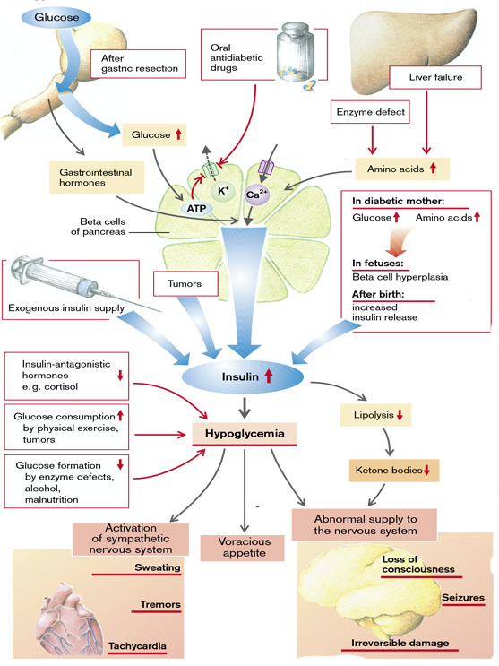
Fig.20. Causes and manifestations of hyperinsulinism
(From S. Silbernagl and F. Lang; Color Atlas of Pathophysiology)

Causes and effects of androgen excess and deficiency
Follitropin (FSH) and lutropin (LH) are released in the anterior pituitary, stimulated by pulsatile release of gonadoliberin (gonadotropin-releasing hormone, GnRH). The pulsatile secretion of these gonadotropins is inhibited by prolactin. LH controls the release of testosterone from the Leydig cells in the testes. Testosterone, by means of a negative feedback, inhibits the release of GnRH and LH. The formation of inhibin, which inhibits the release of FSH, and of androgen-binding protein (ABP) is promoted by FSH in the testicular Sertoli cells.
Testosterone or dihydrotestosterone (5α-DHT) which is formed from testosterone in the Sertoli cells and in some organs, promotes the growth of the penis, seminiferous tubules, and scrotum. Testosterone and FSH are both necessary for the formation and maturation of spermatozoa. In addition, testosterone stimulates the secretory activity of the prostate (reduced viscosity of the ejaculate) and the seminal vesicle (admixture of fructose and prostaglandins), as well as the secretory activity of the sebaceous and sweat glands in the axillae and the genital region. Testosterone increases skin thickness, scrotal pigmentation, and erythropoiesis. It also influences height and stature by promoting muscle and bone growth (protein anabolism), longitudinal growth, and bone mineralization as well as fusion of the epiphyseal plates. Testosterone stimulates laryngeal growth (deepening of the voice), hair growth in the pubic and axillary regions, on the chest and in the face (beard); its presence is essential for hair loss in the male. The hormone stimulates libido and aggressive behavior. Lastly, it stimulates the renal retention of electrolytes, reduces the concentration of high density lipoprotein (HDL) in blood, and influences fat distribution.
Decreased release of androgens can be due to a lack of GnRH. Even non-pulsatile GnRH secretion stimulates androgen formation inadequately. Both can occur with damage to the hypothalamus (tumor, radiation, abnormal perfusion, genetic defect) as well as psychological or physical stress. Persistently high concentrations of GnRH (and its analogs) decrease gonadotropin release by down-regulation of the receptors. Other causes are inhibition of pulsatile gonadotropin release by prolactin as well as damage to the hypophysis (trauma, infarct, autoimmune disease, tumor, hyperplasia) or to the testes (genetic defect, severe systemic disease). Lastly, androgen effects can be impaired by enzyme defects in hormone synthesis, for example, genetic reductase deficiency or by a defect of the testosterone receptors. The generative function of the testes can also be impaired without appreciable abnormality of the sex hormones, as in undescended testis (cryptorchidism), genetic defects, or damage to the testes (e.g., inflammation, radiation, abnormal blood perfusion due to varices)
Effects of deficient testosterone action in the male fetus are absent sexual differentiation; in juveniles they are failure of the voice to break and absence of adult body hair, delayed bone growth, but also ultimately excess longitudinal growth of the limbs due to delayed epiphyseal fusion. Other effects (in juveniles and adults) are infertility, decreased libido and aggressiveness, reduced muscle and bone mass, and slightly decreased hematocrit. If there is no androgen effect at all, there will not even be any feminine pubic and axillary hair (Fig.21).
Possible causes of androgen excess are enzyme defects in steroid hormone synthesis, a testosterone-producing tumor, or iatrogenic androgen supply. Effects of testosterone excess are male sex differentiation and hair growth, even in the female, an increase in erythropoiesis, muscle and bone mass as well as of libido and aggressiveness. Amenorrhea and impaired fertility are caused by inhibition of GnRH and gonadotropin release (Fig.21).
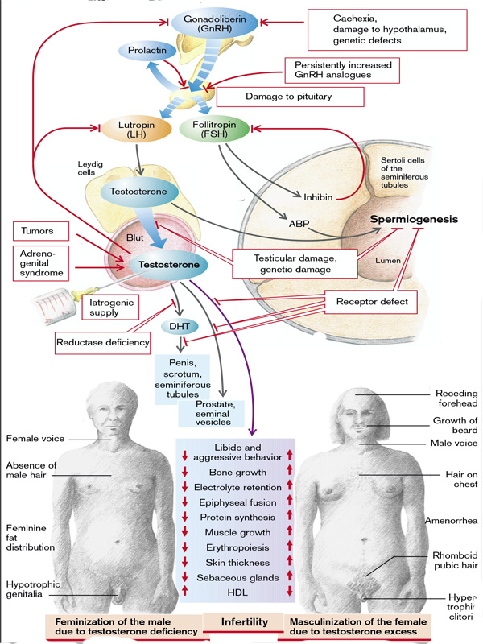
Fig.21. Causes and effects of androgen excess and deficiency
(From S. Silbernagl and F. Lang; Color Atlas of Pathophysiology)
Effects of excess and deficiency of female sexual hormones
The gonadotropic hormones FSH and LH are released from the anterior lobe of the pituitary gland in a pulsative manner (every 60 to 90 min for 1 min) after pulsatile stimulation by GnRH from the hypothalamus at the same frequency. FSH and LH are essential for the maturing of the follicles and for the temporal coordination of the production of female sex hormones. In the female organism FSH promotes the maturation of the follicles and estrogen production in the granulosa cells of the follicles. The estrogens (estrone, estradiol, estriol) at first stimulate the further release of gonadotropins (positive feedback) until the maturation of a follicle leads to ovulation and corpus luteum formation.
Progestogens (progesterone and analogs), formed by the corpus luteum under the influence of LH, and the estrogens (after ovulation) inhibit further release of gonadotropins. The concentration of gonadotropins falls again, as does, after some delay, that of the estrogens and progestogens. As a rule this cycle takes 28 days, although the interval between menstruation and ovulation varies greatly. The granulosa cells also form inhibin and activin, while the theka cells form the androgens androstenedione and testosterone. Activin promotes gonadotropin release, while inhibin suppresses it. Prolactin produced in the anterior pituitary inhibits the pulsatile release of gonadotropins. It also decreases the ovary’s responsiveness to gonadotropins.

Estrogens promote the development of the female sex characteristics, the transformation of the Müller ducts into Fallopian tubes, uterus and vagina, as well as the secondary sexual characteristics (e.g., development of the mammary glands and female fat distribution). They require the cooperation of androgens in order to stimulate axillary and pubic hair growth. Estrogens also influence the psychological development of women. In sexually mature women estrogens and progestogens have partly opposite actions. Estrogens promote the proliferation of the uterine mucosa. In the cervix and vagina they reduce the viscosity of the cervical mucus and accelerate the exfoliation of the vaginal epithelium, whose glycogen is broken down by the vaginal flora to lactic acid. The resulting fall in pH stops pathogens from penetrating. Estrogens stimulate the formation of ducts in the mammary glands. They promote protein anabolism and increase the formation of HDL and VLDL. Conversely, they reduce the concentration of low density lipoproteins (LDL), and thus lower the risk of atherosclerosis. On the other hand, estrogens increase the coagulability of blood. Additionally, they raise electrolyte retention in the kidneys as well as the mineralization of the bones via hydroxylation of vitamin D3 and the inhibition of parathyroid hormone (PTH). In children they promote bone growth and maturation and accelerate epiphyseal fusion.
Progesterone. In the uterus progesterone promotes the maturation and secretory activity of the uterine mucosa and decreases the contractility of the uterine muscle. When estrogen concentration falls at the end of the menstrual cycle, the mucosa is shed (menstruation). In the cervix and vagina progestogens raise the viscosity of cervical mucosa, narrow the cervical orifice, and inhibit fallopian motility. Furthermore, they inhibit the proliferation and exfoliation of vaginal epithelium. They also promote the formation of alveoli in the mammary glands. Progestogens (progesterone and its analogs) raise the body’s metabolism and temperature, trigger hyperventilation, and reduce sensitivity to insulin in the periphery. Additionally, they have moderate glucocorticoid and antimineralocorticoid (natriuretic) actions. They lower the production of cholesterol and the plasma concentration of HDL and LDL.

An excess of female sex hormones is usually due to an exogenous supply (contraceptive pills). In addition, some tumors produce sex hormones.
In excess of female sex hormones gonadotropin release is inhibited, there is no maturation of the follicles, no regular shedding of the uterine mucosa, and the woman will be infertile. An excess of estrogens can cause thrombosis due to a raised clotting tendency. In children high estrogen concentrations lead to premature sexual maturation and accelerate growth. However, premature epiphyseal fusion may eventually result in short stature. Increased progestogen action causes natriuresis, a rise in body temperature and hyperventilation, and via insulin resistance it can promote the development of diabetes mellitus (Fig.22).
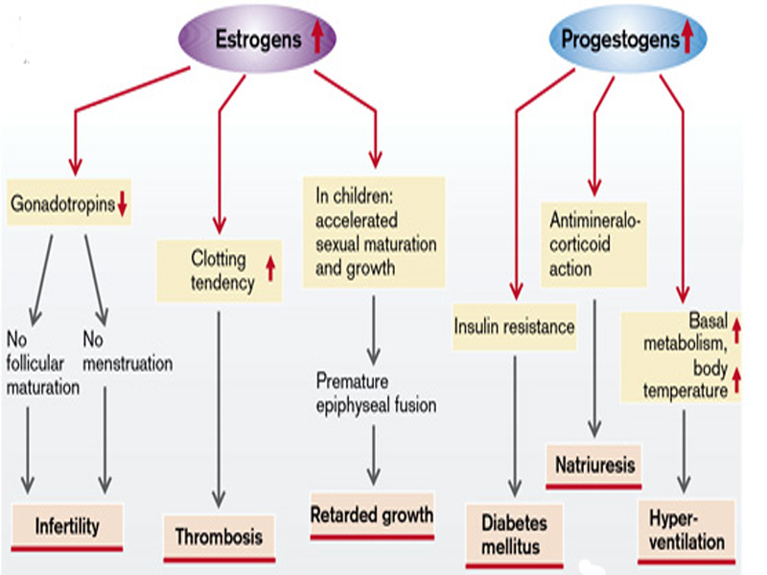
Fig.22. Effects of excessive release of female sex hormones
(From S. Silbernagl and F. Lang; Color Atlas of Pathophysiology)
A lack of estrogens and progestogens is frequently the result of a decreased GnRH release in severe psychological or physical stress (malnutrition, serious systemic disease, high performance sport). GnRH release can also be reduced through the influence of the neurotransmitters norepinephrine, dopamine, serotonin, and endorphins. However, it is not only reduced, but also persistently high concentrations of GnRH (or its analogs) that decrease the release of gonadotropins (down-regulation of the GnRH receptors). Even if the hypothalamus is undamaged, gonadotropin release can be impaired by damage to the pituitary (hemorrhage, ischemia, inflammation, trauma), by displacement of gonadotropin-producing cells by tumors, or by inhibition due to a raised concentration of sex hormones (ovulation inhibitors, anabolic substances with androgen action, tumors, adrenogenital syndrome).
If androgen production is raised, the release of FSH is inhibited and follicle maturation is thus interrupted. Polycystic ovaries are formed.
Some of the androgens are transformed into estrogens which, via stimulation of LH release, promote further formation of ovarian androgens. It is relatively common for a reduction in gonadotropin release to be due to raised prolactin secretion, for example, as a result of the absence of inhibition of pituitary secretion of prolactin or a prolactin-producing pituitary tumor. Gonadotropin release can be inhibited by dopaminergic drugs that cause a rise in prolactin secretion. Lastly, gonadotropin release can be inhibited by damage to the pituitary through head trauma, abnormal maturation, radiation, tumors, degenerative or inflammatory disease, or defective biosynthesis.
The formation of estrogens and/or progestogens can be impaired by ovarian insufficiency caused by an abnormal development or by damage (e.g., radiation, chemotherapeutic agents). Inadequate follicular maturation or transformation in the corpus luteum (corpus luteum insufficiency) can cause the deficiency. Lack of estrogen can also be due to an enzyme defect. In the resistant ovary syndrome the ovaries are refractory to the action of gonadotropins. This may be caused by defective receptors or inactivating antibodies. The result is a lack of estrogens despite an increased release of gonadotropins.
A deficiency of female sex hormones, like their excess, means that a normal menstrual cycle is not possible. In estrogen deficiency the phase of uterine proliferation is absent and the progestogens are not able to bring about maturation; in progestogen deficiency the uterine mucosa does not mature. In both these cases the woman is infertile and there is no menstrual bleeding (amenorrhea).
The lack of estrogens also expresses itself in reduced manifestation of the external sex characteristics, in a tendency toward vaginal infections, in osteoporosis, and in an increased risk of atherosclerosis. In children there will be a delayed epiphyseal fusion that, despite slowed growth, may ultimately lead to tall stature. The reproductive functions of a woman can also be abnormal independently of the sex hormones, for example, due to malformations or disease of the ovaries, fallopian tubes, or uterus (Fig.23).
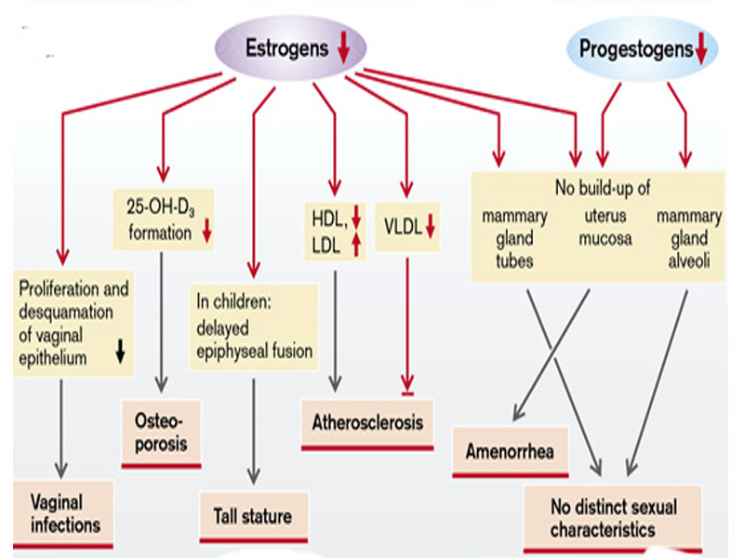
Fig.23. Effects of deficient release of female sex hormones
(From S. Silbernagl and F. Lang; Color Atlas of Pathophysiology)

