ELECTROLYTIC DYSHOMEOSTASIS

Sodium dyshomeostasis
Sodium represents one of the most important ions in the body and is necessary for all most important vital functions. From entire sodium amount in the body the extracellular liquid contains about 50%, bone tissue and cartilages – 40% and less than 10% is localized inside the cell in association with chloride ions. Homeostatic parameters of sodium are: plasma concentration – 140 mEq/l (1 mEq = 23 mg of sodium), extracellular concentration 147 mEq/l and inside the cells – 35 mEq/l.
In normal physiological condition, sodium equilibrium is regulated by cation excretion with urine, feces and sweat. Sodium (and chloride) excretion through skin and digestive tract in norm is not important by will increases significantly during abundant transpiration. Sodium is lost as well in case of bleeding.

Hypernatremia represents increases sodium concentration in the blood plasma above 152 mEq/l.
Main causes of hypernatremia are:
- Excessive sodium intake with food;
- Excessive parenteral infusions (saline infusion);
- Water deprivation;
- General dehydration (abundant sweating, vomiting, diarrhea, pulmonary hyperventilation, polyuria, edemas);
- Hypersecretion of glucocorticoids (Cushing syndrome).
Relative hypernatremia is due to reduced blood volume and hemoconcentration like in dehydration. Absolute hypernatremia is when increased level of sodium is because of increased intake or retention of this in the body like happening in renal disorders.
Manifestations. Hypernatremia enhances osmotic pressure of the blood and interstitial fluid, leading to translocation of fluid from cells into extracellular space and development of cellular dehydration. Surplus of sodium and water deficit in the body lead to oliguria, weight loss, cell dehydration, especially at the level of neurons.
Every severe hypernatremia, indifferently of cause is accompanied by unbearable thirst, fever, tachycardia, tachypnea, motor excitation, hyperreflexia, convulsions, anxiety, depression, loss of consciousness and coma. In these situations the life prognostic is unfavorable.

Hyponatremia represents decreased sodium concentration in the blood plasma below 135 mEq/l.
Because sodium represents the main extracellular ion, hyponatremia always is associated with hypoosmolarity in the extracellular space. In consequence, the water will move into cells with development of cell edema, which is especially dangerous for nervous cells – increased risk for intracerebral hypertension with all characteristic neurological symptoms.
Causes and pathogeny of hyponatremia are:
- Increased secretion of ADH with increased renal reabsorbtion of water, hyperhydration, hemodilution and relative hyponatremia;
- Disturbances in the filtration function of the kidneys (acute renal failure) with fluid retention in the body, hyperhydration and relative hyponatremia;
- Excessive water intake or excessive administration of fluids without electrolytes (ex, glucose solutions);
- Diarrhea and sodium losses with isotonic intestinal fluid (absolute hyponatremia);
- Chronic insufficiency of adrenal glands (Addison disease);
- Long usage of diuretics, which block the carbo anhydrase – a key enzyme in the process of acidogenesis in the kidneys.
Main pathogenetic mechanisms of hyponatremia are:
- Considerable sodium losses in case of kidney disorders, gastrointestinal disorders, endocrine diseases which lead to development of absolute hyponatremia;
- Water retention in the body with development of hyperhydration and hypervolemia and development of relative hyponatremia;
Manifestation of hyponatremia. Decreased total sodium amount in the body leads to disorders in the activity of Na-K/ATP-aze, which leads to disorders in the formation of membranary active potential in excitable cells (neurons and cardiomyocytes). In the brain there is reduced synthesis of inhibitory neuromediators (glycin and gamma-aminobutiric acid / GABA), apart from these, there is blockage of receptors at the level of post-synaptic membrane. Severe hyponatremia manifests by CNS disorders – weakness, drowsiness, development of psychosis. There is characteristic headache which becomes more intense in vertical position. Inhibition of Na/K ATP-aze at the level of nervous cells can lead to development of foci with epileptic activity and convulsions. There also can be found reduced appetite, lack of thirst sensation, nausea and vomiting.
Because sodium is involved in the maintenance of blood vessels sensibility for sympathetic influences, sodium lack can lead to decreased systemic blood pressure, vascular insufficiency (reduction of blood pressure till development of vascular collapse with severe tachycardia).

Potassium dyshomeostasis
Potassium represents the main intracellular ion and has a high role in the formation of rest potential in nervous cells and muscular cells. This potential reflects the uneven distribution of ions between intra-and extracellular compartments. So, intra- and extracellular potassium concentrations is respectively 155 and 5 mEq/l. Potassium ions dilate the coronary arteries such intensifying the coronary blood flow, reduce the heart rate. In general aspects potassium ions have similar effects with parasympathetic system. Potassium participates as well in the process of protein synthesis and assimilation of aminoacids by the body. Potassium homeostasis in the body is maintained by ratio between alimentary intake and its excretion with urine.

Hyperkalemia represents increased plasma concentration of potassium above 5,5mEq/l.
Causes and pathogenic mechanism of this are:
- Excessive alimentary intake or parenteral administration of solutions which contain potassium; (absolute hyperkalemia)
- Disorders in the potassium excretion from the body (renal failure);
- Destruction of cells (traumatic shock, burns, massive bleedings);
- Intense protein catabolism (diabetes mellitus, stress);
Hyperkalemia changes substantially activity of excitable cells, mainly that of cardiomyocytes. Reduced trans-membranary gradient of potassium concentration (by increasing extracellular concentration of potassium) leads to reduction of resting potential and reduction of action potential amplitude. The same processes at the level of heart pacemakers (sinoatrial node) lead to development of tachycardia followed by bradycardia. In the result of diminished electro-mechanic association and difficult release of calcium ions from sarcoplasmic reticulus will diminish force of heart contractions till cardiac arrest in diastole. Hyperkalemia as well can manifest by pain at the level of limb muscles and muscle paresis, as well as with intestinal atony.

Hypokalemia represents reduced plasma potassium concentration bellow 3,5mEq/l. Hypokalemia leads to severe disorders in the body.
Causes of hypokalemia are:
- Insufficient potassium intake (minimal daily requirements are 2-4 g);
- Excessive loss of potassium by gastrointestinal tube (diarrhea and vomiting);
- Losses of potassium with urine in kidney disorders, in hypersecretion of glucocorticoids, hypersecretion of mineralocorticoids, in dehydrations;
- Treatment with insulin.
Pathogeny of hypokalemia depends on cause which provokes it, the main pathogenic link being high potassium loss which exceeds potassium intake or redistribution of the potassium ions between blood and intercellular /extracellular compartments of the body. A high role in pathogeny of hypokalemia has acido-base disbalance in the body. So, in metabolic alkalosis there is translocation of potassium ions inside the cells in exchange with hydrogen ions with concomitant hypokalemia. Treatment with insulin enhances synthesis of protein with abundant consumption of potassium and consecutive hypokalemia. Potassium loss with urine is increased in case of administration of osmotic diuretics as well as in diabetic glucosuria.
Manifestations of hypokalemia are characterized by disorders in neuro-muscular conductibility, myasthenia (especially at the level of muscles of inferior limbs); there is characteristic paresthesia, reduction of reflexes. In case of severe hypokalemia as well can be affected respiratory muscles with disturbances of external respiration. From cardiovascular system there can be attested decreases systemic blood pressure and high risk for heart arrhythmias. There can be found disorders in functioning of gastrointestinal system (reduction of intestinal motility, vomiting sometimes can be found a clinical manifestations of intestinal occlusion.

ALTERATIONS IN CALCIUM BALANCE
 Calcium enters the body through the gastrointestinal tract, is absorbed from the intestine under the influence of vitamin D, is stored in bone, and is excreted by the kidney. Approximately 99% of body calcium is found in bone, where it provides the strength and stability for the skeletal system and serves as an exchangeable source to maintain extracellular calcium levels. Most of the remaining calcium (approximately 1%) is located inside cells, and only approximately 0.1% to 0.2% (approximately 8.5 to 10.5 mg/dL) of the remaining calcium is present in the ECF. The extracellular concentrations of calcium and phosphate are reciprocally regulated such that calcium levels fall when phosphate levels are high, and vice versa. The ECF calcium exists in three forms: protein bound, complexed, and ionized. Approximately 40% of ECF calcium is bound to plasma proteins, mostly albumin, and cannot diffuse or pass through the capillary wall to leave the vascular compartment. Another 10% is complexed (chelated) with substances such as citrate, phosphate, and sulfate. This form is not ionized. The remaining 50% of ECF calcium is present in the ionized form. It is the ionized form of calcium that is free to leave the vascular compartment and participate in cellular functions. The total plasma calcium level fluctuates with changes in plasma albumin and pH. As a rule, the total plasma calcium level is decreased 0.75 to 1.0 mg/dL for every 1g/dL decrease from normal in the plasma albumin level, and by 0.16 mg/dL for each 0.1-unit rise in pH.
Ionized calcium serves a number of functions. It participates in many enzyme reactions; exerts an important effect on membrane potentials and neuronal excitability; is necessary for contraction in skeletal, cardiac, and smooth muscle; participates in the release of hormones, neurotransmitters, and other chemical messengers; influences cardiac contractility and automaticity by way of slow calcium channels; and is essential for blood clotting.
The major sources of calcium are milk and milk products. Only 30% to 50% of dietary calcium is absorbed from the duodenum and upper jejunum; the remainder is eliminated in the stool. There is a calcium influx of approximately 150 mg/day into the intestine from the blood. Net absorption of calcium is equal to the amount that is absorbed from the intestine less the amount that moves into the intestine. Calcium balance can become negative when dietary intake (and calcium absorption) is less than intestinal secretion. A dietary intake of less than 400 mg/day can be associated with negative calcium balance.
Calcium is stored in bone and excreted by the kidney. Approximately 60% to 65% of filtered calcium is passively reabsorbed in the proximal tubule, driven by the reabsorption of sodium chloride; 15% to 20% is reabsorbed in the thick ascending loop of Henle, driven by the Na⁺/K⁺-2Cl⁻ cotransport system; and 5% to 10% is reabsorbed in the distal convoluted tubule. The distal convoluted tubule is an important regulatory site for controlling the amount of calcium that enters the urine. PTH and possibly vitamin D stimulate calcium reabsorption in this segment of the nephron. Other factors that may influence calcium reabsorption in the distal convoluted tubule are phosphate levels and glucose and insulin levels.

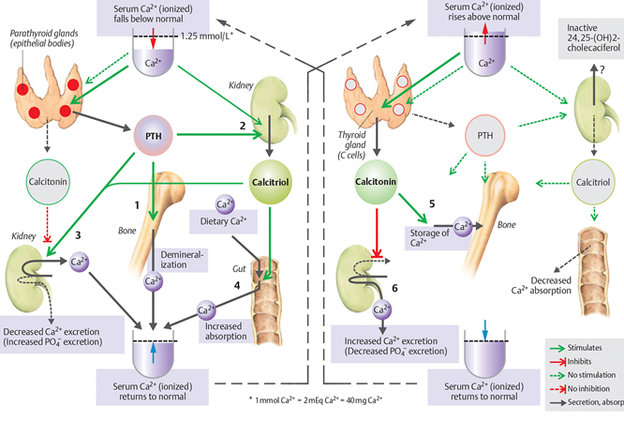
Fig.1 Compensatory mechanisms in hypocalcemia and hypercalcemia
(From S. Silbernagl and F, Lang; Color Atlas of Pathophysiology)

Hypocalcemia
Hypocalcemia represents a total serum calcium level of less than 8.5 mg/dL (2.1 mmol/L) and an ionized calcium level of less than 4.6 mg/dL (1.2 mmol/L).
A pseudohypocalcemia is caused by hypoalbuminemia. It results in a decrease in protein-bound, rather than ionized, calcium and usually is asymptomatic. Thus, before a diagnosis of hypocalcemia can be made, the total calcium should be corrected for low albumin levels.
Causes. The most common causes of hypocalcemia are:
- Abnormal losses of calcium from the kidney;
- Impaired ability to mobilize calcium from bone;
- Increased protein binding or chelation such that greater proportions of calcium are in the nonionized form.
An important cause of hypocalcemia is renal failure, which decreased production of activated vitamin D and hyperphosphatemia both play a role. Because of the inverse relation between calcium and phosphate, serum calcium levels fall as phosphate levels rise in renal failure.
The ability to mobilize calcium from bone depends on PTH levels. Decreased levels of PTH with accompanied hypocalcemia may result from primary or secondary forms of hypoparathyroidism.
Hypocalcemia is also a common problem in acute pancreatitis in which fat necrosis and precipitation of calcium soaps produce a decrease in serum calcium. Since only the ionized form of calcium is able to leave the capillary and participate in body functions, conditions that alter the ratio of protein-bound to ionized calcium can also produce signs of hypocalcemia. This can occur in situations where the increase in pH that occurs with alkalosis produces a decrease in ionized calcium. For example, hyperventilation sufficient to cause respiratory alkalosis can produce a decrease in ionized calcium sufficient to cause tetany. Free fatty acids also increase protein binding, causing a reduction in ionized calcium.
Manifestations. Hypocalcemia can manifest as an acute or chronic condition. Most persons with mild hypocalcemia are asymptomatic, whereas large or abrupt changes in ionized calcium lead to increased neuromuscular excitability and cardiovascular effects (see Table). Ionized calcium stabilizes neuromuscular excitability, thereby making nerve cells less sensitive to stimuli. Nerves exposed to low ionized calcium levels show decreased thresholds for excitation, repetitive responses to a single stimulus, and, in extreme cases, continuous activity. The severity of the manifestations depends on the underlying cause, rapidity of onset, accompanying electrolyte disorders, and extracellular pH. Increased neuromuscular excitability can manifest as paresthesias (tingling around the mouth and in the hands and feet), tetany (muscle spasms of the muscles of the face, hands, and feet), and, in severe hypocalcemia, laryngeal spasm and seizures. Cardiovascular effects of acute hypocalcemia include hypotension, cardiac insufficiency, cardiac arrhythmias (particularly heart block and ventricular fibrillation), and failure to respond to drugs such as digitalis, norepinephrine, and dopamine that act through calcium-mediated mechanisms.

Hypercalcemia represents a total serum calcium concentration greater than 10.5 mg/dL (2.6 mmol/L).
Causes. Hypercalcemia occurs when calcium movement into the circulation overwhelms calcium regulatory hormones or the ability of the kidney to remove excess calcium ions.
The two most common causes of hypercalcemia are:
- Increased bone resorption due to neoplasms;
- Hyperparathyroidism.
A number of malignant tumors, including carcinoma of the lungs, have been associated with hypercalcemia. Some tumors destroy the bone, while others produce humoral agents that stimulate bone resorption or inhibit bone formation.
Less common causes of hypercalcemia include:
- Prolonged immobilization;
- Increased intestinal absorption of calcium,
- Excessive doses of vitamin D;
- Effects of drugs such as lithium and thiazide diuretics.
Prolonged immobilization and lack of weight bearing cause demineralization of bone and release of calcium into the bloodstream.
Intestinal absorption of calcium can be increased by excessive doses of vitamin D or as a result of a condition called the milk-alkali syndrome. The milk-alkali syndrome is caused by excessive ingestion of calcium (often in the form of milk) and absorbable antacids. A variety of drugs elevate calcium levels, like thiazide diuretics which increase calcium reabsorption in the distal convoluted tubule of the kidney.
Manifestations. The signs and symptoms of calcium excess reflect a decrease in neural excitability, alterations in cardiac and smooth muscle function, and exposure of the kidneys to high concentrations of calcium (see table below). There may be a dulling of consciousness, stupor, weakness, and muscle flaccidity due to a decrease in neural excitability. Behavioral changes may range from subtle alterations in personality to acute psychoses. The heart responds to elevated levels of calcium with increased contractility and ventricular arrhythmias. Digitalis accentuates these responses. Gastrointestinal symptoms reflect a decrease in smooth muscle activity and include constipation, anorexia, nausea, and vomiting. High calcium concentrations in the urine impair the ability of the kidneys to concentrate urine by interfering with the action of ADH (an example of nephrogenic DI). This causes salt and water diuresis and an increased sensation of thirst. Hypercalciuria also predisposes to the development of renal calculi. Pancreatitis is another potential complication of hypercalcemia and is probably related to stones in the pancreatic ducts.

Manifestations of hypocalcemia and hypercalcemia
(From C. Porth and G. Matfin; Pathophysiology. Concepts of altered health states)
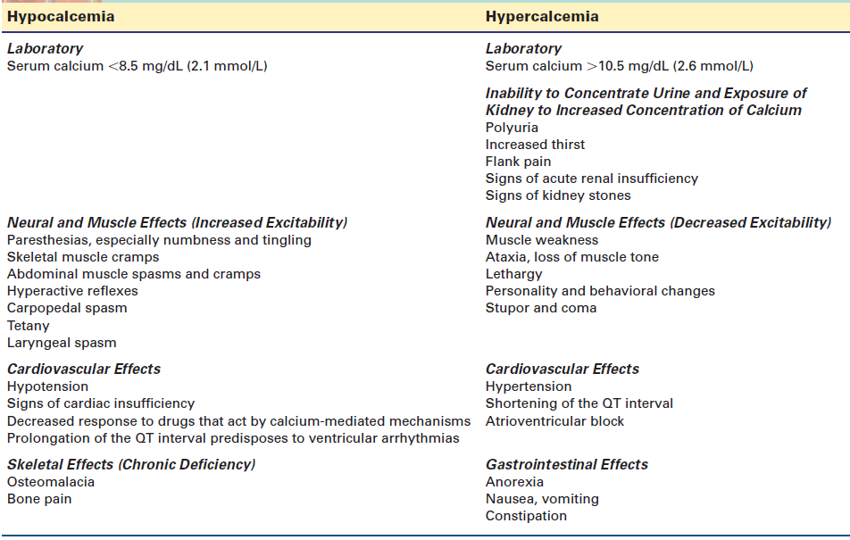

ALTERATIONS IN PHOSPHATE BALANCE
Phosphorus is mainly an intracellular anion. It is the fourth most abundant element in the body after carbon, nitrogen, and calcium. Phosphate is essential to many bodily functions. It plays a major role in bone formation; is essential to certain metabolic processes, including the formation of ATP and the enzymes needed for metabolism of glucose, fat, and protein; is a necessary component of several vital parts of the cell, being incorporated into the nucleic acids of DNA and RNA and the phospholipids of the cell membrane; and serves as an acid-base buffer in the ECF and in the renal excretion of hydrogen ions. Delivery of oxygen by the red blood cell depends on organic phosphates in ATP and 2,3-diphosphoglycerate. Phosphate is also needed for normal function of other blood cells, including the white blood cells and platelets.
Approximately 85% of phosphate is contained in bone, and most of the remainder (14%) is located in cells. Only approximately 1% is in the ECF compartment, and of that, only a minute proportion is in the plasma. ECF phosphorus exists mainly as phosphate, although laboratory measurements are often reported as elemental phosphorus.
Most of the intracellular phosphorus (approximately 90%) is in the organic form (nucleic acids, phosphoproteins, ATP). Entry of phosphate into cells is enhanced after glucose uptake because phosphorus is incorporated into the phosphorylated intermediates of glucose metabolism. Cell injury or atrophy leads to a loss of cell components that contain organic phosphate; regeneration of these cellular components results in withdrawal of inorganic phosphate from the extracellular compartment.
Phosphate is ingested in the diet and eliminated in the urine. Phosphate is derived from many dietary sources, including milk and meats. Approximately 80% of ingested phosphate is absorbed in the intestine, primarily in the jejunum. Absorption is diminished by concurrent ingestion of substances that bind phosphate, including calcium, magnesium, and aluminum.
The overall elimination of phosphate by the kidney involves glomerular filtration and tubular reabsorption. Essentially all of the phosphate that is present in the plasma is filtered in the glomerulus. Renal elimination of phosphate is then regulated by an overflow mechanism in which the amount of phosphate lost in the urine is directly related to phosphate concentrations in the blood.
Essentially all the filtered phosphate is reabsorbed when phosphate levels are low. When plasma phosphate levels rise above a critical level, the rate of phosphate loss in the urine reflects the excess plasma phosphate levels. Phosphate is reabsorbed from the filtrate into the proximal tubular epithelial cells through the action of a sodiumphosphate cotransporter, NPT2a. PTH also plays a significant role in regulating phosphate concentration. It does this by promoting bone resorption, which dumps large amounts of phosphate into the ECF, and it increases the renal threshold for phosphate reabsorption. Thus, whenever PTH is increased, tubular phosphate reabsorption is decreased, and more phosphate is lost in the urine (because PTH decreases the synthesis and expression of the NPT2a transporter on the luminal surface of the proximal tubular cell).

In the adult, the normal plasma phosphate level ranges from 2.5 to 4.5 mg/dL. Changing the plasma phosphate levels to as high as three to four times the normal value does not seem to have an immediate effect on body function.

Hypophosphatemia
Hypophosphatemia is commonly defined by a plasma phosphorus level of less than 2.5 mg/dL in adults; it is considered severe at concentration of less than 1.0 mEq/L.
Causes. The most common causes of hypophosphatemia are (see table below):
- Depletion of phosphate because of insufficient intestinal absorption;
- Transcompartmental shifts;
- Increased renal losses.
Often, more than one of these mechanisms is active. Unless food intake is severely restricted, dietary intake and intestinal absorption of phosphorus are usually adequate. Intestinal absorption may be inhibited by administration of glucocorticoids, high dietary levels of magnesium, and hypothyroidism. Prolonged ingestion of antacids may also interfere with intestinal absorption of phosphate and lead to decreased plasma level. Alcoholism is a common cause of hypophosphatemia. The mechanisms underlying hypophosphatemia in the person addicted to alcohol may be related to malnutrition, increased renal excretion rates, or hypomagnesemia. Malnutrition and diabetic ketoacidosis increase phosphate excretion and phosphate loss from the body. Urinary losses of phosphate may be caused by drugs, such as theophylline, corticosteroids, and loop diuretics that increase renal excretion.
Manifestations. Many of the manifestations of phosphorus deficiency result from a decrease in cellular energy stores due to deficiency in ATP and impaired oxygen transport due to a decrease in red blood cell 2,3-diphosphoglycerate (see table below). Hypophosphatemia results in altered neural function, disturbed musculoskeletal function, and hematologic disorders.
Red blood cell metabolism is impaired by phosphate deficiency; the cells become rigid, undergo increased hemolysis, and have diminished ATP and 2,3-diphosphoglycerate levels. Chemotaxis and phagocytosis by white blood cells are impaired. Platelet function also is disturbed. Respiratory insufficiency resulting from impaired function of the respiratory muscles can develop in patients with severe hypophosphatemia.
Neural manifestations include intention tremors, paresthesia, hyporeflexia, stupor, coma, and seizures. Anorexia and dysphagia can occur. Muscle weakness, which is common in hypophosphatemia, is related to a reduction in 2,3-diphosphoglycerate. Chronic phosphate depletion interferes with mineralization of newly formed bone matrix. In growing children, this process causes abnormal endochondral growth and clinical manifestations of rickets.
In adults, the condition leads to joint stiffness, bone pain, and skeletal deformities consistent with osteomalacia.

Causes and manifestations of hypophosphatemia
(From C. Porth and G. Matfin; Pathophysiology. Concepts of altered health states)
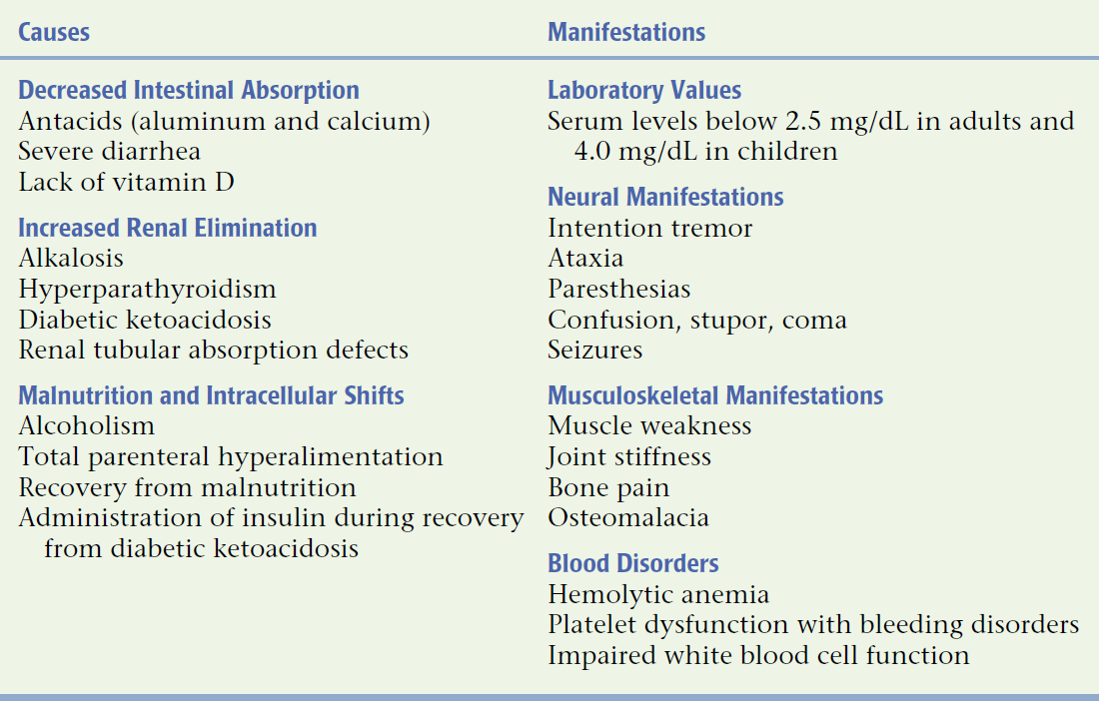

Hyperphosphatemia
Hyperphosphatemia represents a plasma phosphorus concentration in excess of 4.5 mg/dL in adults. Growing children normally have plasma phosphate levels higher than those of adults.
Causes. Hyperphosphatemia results from:
- Failure of the kidneys to excrete excess phosphate;
- Rapid redistribution of intracellular phosphate to the extracellular compartment;
- Excessive intake of phosphate.
The most common cause of hyperphosphatemia is impaired renal function (see table below).
Hyperphosphatemia is a common electrolyte disorder in persons with chronic renal failure. A reduction in glomerular filtration rate to less than 30 to 50 mL/minute results in a reduction of phosphate elimination. Release of intracellular phosphate can result from conditions such as massive tissue injury, rhabdomyolysis, heat stroke, potassium deficiency, and seizures. Chemotherapy can raise plasma phosphate levels because of the rapid destruction of tumor cells (tumor lysis syndrome).
The administration of excess phosphate-containing antacids, laxatives, or enemas can be another cause of hyperphosphatemia, especially when there is a decrease in vascular volume and a reduced glomerular filtration rate. Phosphate-containing laxatives and enemas predispose to hypovolemia and a decreased glomerular filtration rate by inducing diarrhea, thereby increasing the risk for hypophosphatemia.
Manifestations. Hyperphosphatemia is accompanied by a decrease in plasma calcium. Many of the signs and symptoms of phosphate excess are related to a calcium deficit (see table below). Ectopic calcifications may develop when the calcium×phosphate concentration product exceeds 60.

Causes and manifestations of hypophosphatemia
(From C. Porth and G. Matfin; Pathophysiology. Concepts of altered health states)
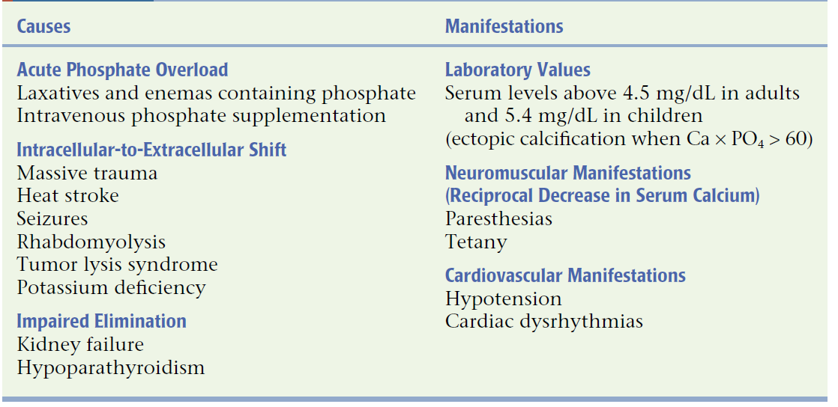

Fluor imbalance
Enamel is the hardest substance in the human body and contains the highest percentage of minerals, 96%, with water and organic material composing the rest. The primary mineral is hydroxyapatite, which is a crystalline calcium phosphate. Enamel is formed on the tooth while the tooth is developing within the gum, before it erupts into the mouth. Once fully formed, it does not contain blood vessels or nerves. Remineralisation of teeth can repair damage to the tooth to a certain degree but damage beyond that cannot be repaired by the body.
In humans, enamel varies in thickness over the surface of the tooth, often thickest at the cusp, up to 2.5 mm, and thinnest at its border with the cementum at the cementoenamel junction
Enamel does not contain collagen, as found in other hard tissues such as dentin and bone, but it does contain two unique classes of proteins: amelogenins and enamelins. While the role of these proteins is not fully understood, it is believed that they aid in the development of enamel by serving as a framework for minerals to form on, among other functions. Once it is mature, enamel is almost totally without the softer organic matter. Enamel is avascular and has no nerve supply within it and is not renewed, however, it is not a static tissue as it can undergo mineralization changes.
Amelogenesis is the formation of enamel on teeth and begins when the crown is forming during the bell stage of tooth development after dentinogenesis, which is the formation of dentin. Amelogenesis is considered to have three stages. The first stage is known as the inductive stage, the second is the secretory stage, and the third stage is known as the maturation stage. During the inductive stage, ameloblast differentiation from the inner enamel epithelium is initiated. Proteins and an organic matrix form a partially mineralized enamel in the secretory stage. The maturation stage completes enamel mineralization.
In the secretory stage, ameloblasts are polarized columnar cells. In the rough endoplasmic reticulum of these cells, enamel proteins are released into the surrounding area and contribute to what is known as the enamel matrix, which is then partially mineralized by the enzyme alkaline phosphatase.
In the maturation stage, the ameloblasts transport substances used in the formation of enamel. Microscopically, the most notable aspect of this phase is that these cells become striated, or have a ruffled border. These signs demonstrate that the ameloblasts have changed their function from production, as in the secretory stage, to transportation. Proteins used for the mineralization process compose most of the material transported into the matrix, importantly amelogenins, ameloblastins, enamelins, and tuftelins. The Ca²⁺ mainly comes from the enamel organ, and not the dental papilla, by either passive, extracellular transportation or active, intracellular transportation.
As enamel is secreted, some mineralization occurs by Ca²⁺ deposition between nanospheres of amelogenins forming crystallites. Tuftelin also is suggested to have a role in directing the initial deposition.
The undermineralised, immature enamel containing long, thin prisms of hydroxyapatite, now matures. As the prisms in the enamel grow in thickness but not length, proteins (amelogenins and most non-amelogenins) are removed from the matrix to give more space for hydroxyapatite deposition - mature crystals are hexagonal and 25x75nm and can run the whole length of the enamel (up to 2.5mm). The mineralizing enamel becomes progressively less porous. During this process, enamelins and tuftelin are left in the enamel (responsible for enamel tufts).
By the end of this stage, the enamel has completed its mineralization. Enamel mineralization only occurs once (as ameloblasts are lost with eruption within the reduced enamel epithelium); therefore after amelogenesis, enamel production has been finalized. This is in contrast to dentin formation which occurs throughout life (secondary dentin production).
Fluorine is a common element in the earth’s crust. Fluorides are naturally present in the soil, rocks, and water throughout the world, with higher concentrations in areas where there have been recent/past pyroclastic activities or geologic uplift. Fluorides are also widely used in many industrial processes. The major sources of systemic fluoride exposure are the diet (food and water) and fluoride-containing dental products. Fluoridation of community drinking water to prevent dental caries is considered as one of the ten most important public health achievements of the 20th century. Concurrent with the decline in dental caries has been an increase in the prevalence of dental fluorosis, a side-effect of fluoride exposure.
Fluor in the human body is present in infirm concentration, but this represent an indispensable element for normal development of the organism and is a remarkable osteotrop agent. Daily fluor requirements are 0,2-0,6 mg. High amount of fluor contain tea leaves, seaweed, ocean fish and rise. In the hard tissues (teeth and bones) there is concentrated about 99% of total fluor from the body and only 1% of fluor can be found in the muscles, brain and blood. Fluor absorption 1is performed totally at the level of small intestine and depends on other accompanying ions. Ions of calcium, magnesium, aluminum and iron form with fluor hard soluble combination, that is why these are very difficult absorbed from the intestine, while fluor combination with sodium and phosphorus are almost totally absorbed from the intestine. Once absorbed, fluor is transported by the blood and is distributed in proportion of 90% at the level of hard tissues (teeth and bones), the remaining being distributed between soft tissues. Diet with high fluor content doesn’t influence the fluor concentration at the level of soft tissue because these have no properties to storage this ion, while at the level of teeth and bones its concentration can increase. Fluor elimination is totally performed through kidneys and just a small percent is eliminated through saliva and sweat.
Bone tissue is a permanent storage for fluor ions, meantime the teeth have just a limited period of fluor uptake. Fluor concentration at the level of teeth enamel increases till the age of 30-40 years, after begins to decrease, while at the level of the teeth cement fluor increases till 50-60 years and remains constant after. At the level of trabecular bone the fluor has anabolic effects by increasing osteoblast activity and formation of osteoid tissue. At molecular level, osteogenic activity of fluor involves increased transmembranary transportation of anorganic phosphate in the osteoblasts, this leading to phosphorilation of tyrosine from proteins, which is the main signal for bone cells proliferation under influence of growth factors. With aluminums ions, fluor forms aminofluoric complexes (ALF₄) which have inhibitory effects on osteoclasts similar to that of calcitonin. At the level of teeth, fluor accumulates in complex with sodium, potassium as fluorapatite (complex combination of fluor with calcium and tricyclic phosphate). At the level of teeth enamel and dentine it concentration reaches level of 116-180mg%. Dentine contains approximately four times more fluor than enamel. Maximal concentration of fluor at the level of dentine is concentrated around odontoblasts and is maintained constantly as long as the teeth is alive.
At the teeth level, enriching with fluor is limited to development stage and has three main stages:
1. During amelogenesis, dentinogenesis and mineralization fluor incorporation is maximal;
2. In the pre-eruptive period, after mineralization of teeth crowns, fluor incorporation is limited, being taken from blood and interstitial liquid;
3. After eruption, fluor uptake is very limited, being determined by salivary mechanisms.
Fluor excess (fluorosis) leads to disorders in many tissues and organs but mainly at the level of teeth and bones. Toxic effect of fluor in adults manifests only when fluor is present in concentration of 5-10 mg/kg, the lethal dose being of 32-64 mg/kg. Acute intoxication can develop in case of involuntary ingestion of insecticide or detergents.
Dental fluorosis is an undesirable developmental defect of tooth enamel attributed to greater-than-optimal systemic fluoride exposure during critical periods of amelogenesis.
Dental fluorosis is s characterized by increased porosity (subsurface hypomineralization) with a loss of enamel translucency and increased opacity. In its mild forms (which are its most common), fluorosis often appears as unnoticeable, tiny white streaks or specks in the enamel of the tooth. In its most severe form, tooth appearance is marred by discoloration or brown markings. The enamel may be pitted, rough and hard to clean. The spots and stains left by fluorosis are permanent and may darken over time.
Etiology. These changes are prone to occur in children who are excessively exposed to fluoride between 20 and 30 months of age. The critical period of exposure is between 1 and 4 years old, and the child is no longer at risk after 8 years of age. The severity of dental fluorosis depends on the amount of fluoride exposure, the age of the child, individual response, weight, degree of physical activity, nutrition, and bone growth. Many well-known sources of fluoride may contribute to overexposure including dentifrice/fluoridated mouthrinse (which young children may swallow), bottled waters which are not tested for their fluoride content, inappropriate use of fluoride supplements, ingestion of foods especially imported from other countries, and public water fluoridation. The last of these sources is directly or indirectly responsible for 40% of all fluorosis. Severe cases can be caused by exposure to water that is naturally fluoridated to levels well above the recommended levels.
Pathogenesis. Enamel formation is a complex process involving cellular proliferation and differentiation through the sequential epithelial-mesenchymal interactions, secretion of the tissue-specific matrix proteins, transport of the ions including calcium and fluoride, and precipitation and alignment of enamel crystals through the multiple interactions between organic and inorganic molecules. The matrix proteins identified so far are amelogenins, ameloblastin, tuftelin, and enamelin. Amelogenins are the major ameloblast-specific gene products, comprising more than 90% of the proteins secreted by the ameloblasts. Extracellular enamel proteins are degraded by a variety of proteases present within the enamel at specific times in development (mainly a matrix metalloproteinase named enamelysin). The most distinctive feature of mammalian amelogenesis, in contrast to dentinogenesis and osteogenesis, is that the secreted matrix proteins are degraded in situ and removed almost completely from the tissue during the secretory through maturation stages. The enzymatic degradation of the amelogenins, as well as other classes of enamel matrix proteins, occurs shortly after their secretion. This allows the enamel layer to attain its high degree of mineralization prior to tooth eruption.
The mechanism underlying dental fluorosis remain obscure, but likely contribute to the observed retention of enamel matrix proteins and may include reduced removal of enamel matrix proteins during enamel maturation, perturbation of extracellular transport, or initiation of the ER stress-response pathway. Ameloblasts in the maturational phase appear to be the cellular target of chronic fluoride exposure.

Causes of reduced fluor level in the body are:
- Insufficient fluor intake by diet;
- Disorders of absorption at the level of the intestine;
- Excessive fluor losses through gastrointestinal tract (diarrhea, vomiting);
- Fluor losses with urine in renal disorders;
In these conditions the amount of fluor which is fixed at the level of tooth structures is reduced, and so the cariostatic effect is lost. Mechanisms of fluor fixation at the level of tooth tissues is similar to mechanisms at the level of bones and has on the basis the ionic exchange at the level of crystals of hydroxide and carboxyapatite by replacing the OH⁻ and CO₃²⁻ groups with fluor ions. By this way are formed crystals of fluorapatite which are most resistance to acid attack. This represents the main cariostatic mechanism. Fluor ions repartition is not homogenous – the concentration is higher at the level of superficial layers, so ensuring a higher resistance to acid attack to a depth of 30 µ. Cariostatic effect has maximum effectiveness at a daily intake of 2 mg of fluor, higher level do not increase the cariostatic effects.
Insufficiency of fluor ions in salivary environment triggers disorders at the level of enamel surface and contributes to development of bacterial plaque. There will develop following disorders:
- Decreased antibacterial effects (anti-plaque effects) by reducing activity of peroxidase and hypothyocianite from saliva;
- There is no breakdown and removal of carbohydrates from enamel surface, followed by increased acid production;
- There is favored the microorganism adhesion on the enamel surface;
- There is reduced enamel remineralization, reduced formation of fluorapatite crystals which are resistant to acid attack.

