**Gastrointestinal tract disorders**

*** Function of the gastrointestinal tract.*** To cover the material and energy demands of the organism food must be swallowed, processed and broken down (digestion) as well as taken up (absorption) by the intestine. Solid foods are chewed by the teeth, each bite being mixed with saliva from the salivary glands. Saliva contains mucin, a lubricant, and antibodies as well as α-amylase to digest polysaccharides. It is the task of the esophagus to rapidly transport the food from the throat to the stomach. The lower esophageal sphincter briefly opens, but otherwise prevents reflux of the potentially harmful gastric juice. The proximal stomach primarily serves to store food taken up during a meal. Its muscle tone determines the supply to the distal stomach, where the food is processed (broken up further and emulsified). Proteins are denatured and broken down by the gastric acid and pepsins, and lipases begin fat digestion. The distal stomach also has the task of apportioning chyme. In addition, the stomach secretes the *intrinsic* *factor* that is essential for the absorption of cobalamines (vitamin B12). The breakdown of food particles is completed in the small intestine by means of *enzymes* from the pancreas and the mucosa of the small intestine. The HCO3– ions of the pancreatic juice are needed to neutralize the acidic chyme. Fat digestion in addition requires bile salts supplied in bile. The products of digestion (monosaccharides, amino acids, dipeptides, monoglycerides, and free fatty acids) as well as water, minerals, and vitamins are absorbed in the small intestine. Together with the bile secreted by the liver, *excretory products* (e.g., bilirubin) reach the stool. The liver has numerous additional metabolic functions: it is the obligatory intermediate station for almost all substances absorbed from the small intestine, and it is able to *detoxify* numerous foreign substances and metabolic end-products and to bring about their excretion. The large intestine is the last station for water and ion absorption. It is colonized by *bacteria* with physiological functions. The large intestine, especially the caecum and rectum, are also storage places for the feces, so that *defecation* is necessary relatively rarely, despite frequent food intake. The two *plexuses* in the wall of the esophagus, stomach, and intestine serve to control motility and secretion, with superregional reflexes and modulating influences of the central nervous system transmitted via the *autononomic nervous system* and *visceral–afferent* *nerve tracts*. In addition, the gastrointestinal tract secretes numerous *peptide hormones* and *transmitters* that participate in controlling and regulating the gastrointestinal tract and its accessory glands. There are many nonspecific and specific mechanisms which defend against pathogenic organisms on the inner surface (ca.100m2) of the gastrointestinal tract. Beginning at the mouth, components in saliva, such as *mucins*, *immunoglobulin A* (*IgA*), and *lysozyme*, inhibit microorganisms invading. *Hydrochloric acid* and *pepsins* have a bactericidal effect, and Peyer’s patches in the gastrointestinal tract are its own immunocompetent lymph tissue. Special *M cells* (“membranous cells”) of the mucosa provide luminal antigens with access to Peyer’s patches, which can respond with release of IgA (oral *immunization* or, as an abnormal process, *allergization*). IgA is combined in the intestinal epithelium with the *secretory component* protects the secreted IgA against digestive enzymes. Macrophages in the intestinal wall and in the sinusoids of the liver (Kupffer cells) form a further barrier against invading pathogenic organisms.

**Neural and hormonal integration.** Endocrine and paracrine hormones and neurotransmitterscontrol GI motility, secretion,perfusion and growth. Reflexes proceed withinthe mesenteric and submucosal plexus (*enteric**nervous system,* ENS ), and external innervationmodulates ENS activity.

*Local reflexes*are triggered by stretch sensors in the walls of the esophagus, stomach and gut or by chemosensors in the mucosal epithelium and trigger the contraction or relaxation of neighboring smooth muscle fibers. *Peristaltic reflexes* extend further towards the oral (ca. 2mm) and anal regions (20–30 mm). They are mediated in part by interneurons and help to propel the contents of the lumen through the GI tract (*peristalsis*).

*External innervation*of the GI tract comes from the parasympathetic nervous system (from lower esophagus to ascending colon) and sympathetic nervous system. Innervation is also provided by *visceral* *afferent fibers* (in sympathetic or parasympathetic nerves) through which the afferent impulses for *supraregional reflexes* flow. ENS function is largely independent of external innervation, but external innervationhas some advantages

(a) rapid transfer of signals between relatively distant parts of the GI tract via the abdominal ganglia (short visceral afferents) or CNS (long visceral afferents);

(b)GI tract function can be ranked subordinate to overall body function;

(c) GI tract activity can be processed by the brain so the body can become aware of them (e.g., stomach ache).

**Neurotransmitters.** *Norepinephrine* (NE) is released by the adrenergic postganglionic neurons, and *acetylcholine* (ACh) is released by pre- and postganglionic (enteric) fibers. *VIP*(*vasoactive intestinal peptide*) mediates the relaxation of circular and vascular muscles of the GI tract. *Met- and leuenkephalin* intensify contraction of the pyloric, ileocecal and lower esophageal sphincters by binding to opioid receptors***.*** *GRP*(*gastrin-releasing peptide*) mediates the release of gastrin. CGRP(*calcitonin gene-related peptide*) stimulates the release of somatostatin ***(****SIH).*

All endocrine hormones effective in the GI tract are *peptides* produced in endocrine cells of the mucosa. (a) *Gastrin* and *cholecystokinin* (CCK) and (b) *secretin* and *GIP*are structurally similar; so are glucagon and *VIP*. High concentrations of hormones from the same family therefore have very similar effects. *Gastrin* occurs in short (G17 with 17 amino acids, AA) and long forms (G34 with 34 AA). G17 comprises 90% of all antral gastrin. Gastrin is secreted in the antrum and duodenum. Its release via *gastrin-releasing peptide* (GRP) is subject to neuronal control; gastrin is also released in response to stomach wall stretching and protein fragments in the stomach. Its secretion is inhibited when the pH of the gastric/duodenal lumen falls below 3.5. The main effects of gastrin are acid secretion and gastric mucosal growth*. Cholecystokinin,**CCK*(33 AA) is produced throughout small intestinal mucosa. Longchain fatty acids, AA and oligopeptides in the lumen stimulate the release of CCK. It causes the gallbladder to contract and inhibits emptying of the stomach. In the pancreas, it stimulates growth, production of enzymes and secretion of HCO3– (via secretin). *Secretin*(27 AA) is mainly produced in the duodenum. Its release is stimulated by acidic chyme. Secretin inhibits acid secretion and gastric mucosal growth and stimulates HCO3– secretion (potentiated by CCK), pancreatic growth and hepatic bile flow . *GIP*(*glucose-dependent insulinotropic peptide*, 42 AA; formerly called gastric inhibitory polypeptide = enterogastrone) is produced in the duodenum and jejunum and released via protein, fat and carbohydrate fragments (e.g., glucose). GIP inhibits acid secretion and stimulates insulin release (this is why oral glucose releases more insulin than intravenous glucose). *Motilin*(22 AA) is released by neurons in the small intestine and regulates interdigestive motility.

**Paracrine transmitters.** Histamine, somatostatin and prostaglandin are the main paracrine transmitters in the GI tract.

***Dental pathological processes***

*Dental caries* is a pathological process characterized by progressive destruction of dental solid tissues (enamel, dentin) and formation of cavity- like defects.

*Etiology.* Very often caries is conditioned by microorganisms from dental sedimentations, which attack the solid substance of the teeth. The group A of streptococci (Streptococcus mutans) has a special significance in the etiology of caries .The etiopathogenetical role of microflora in the appearance of caries is confirmed by the fact that microbelless animals don’t suffer from caries. Disparity between structural and functional features of the jaw and character of alimentation of modern human (food well prepared chemically and thermically, excessive consumption of carbohydrates, alimentary components – mineral substances, amino acids, etc.) contributes to the aggression of microorganisms and dental sedimentations.

*Pathogenesis.* Appearance and development of caries is determined by processes from the enamel’s surface that contact with food and are washed by saliva. Saliva exerts a protective action on enamel (clearance and remineralization, role of chemical buffer, bactericidal action). Disturbances of salivation contribute to formation of dental deposit, which consists mainly of adhesive polyglicans, products of microbial glucose decomposition. At the same time, organic acids formed during the decomposition of glucose, dissolve mineral salts from the enamel (crystals of hydroxyapatite). It was established that disintegration of organic elements from the enamel (lamellae, prisms) by microorganisms precedes the dissolvation of mineral salts. Products of protein decomposition can form complexes, which mobilize calcium from the crystals of hydroxyapatite of the enamel and dentin.

In pathogenesis of caries, besides exogenous factors, the endogenous ones from the pulp and dental solid structures also play an important role. Lymph, which is coming from the pulp and providing the nutrition of dental structures, circulates in the enamel as well as in dentinal tubules where the processes of odontoblasts are located.

In pathogenesis of caries, a specific importance is attributed to dystrophic changes in the cells of pulp’s peripheral layer – odontoblasts, which provide the normal trophism of dentin’s solid tissues.

***Paradontosis*** is an inflammatory–dystrophic process of a complex of structures surrounding the tooth’s root (periodontium, alveolar bone, periosteum, gingiva), which manifests by alveolar resorption, pyorrhea from gingival recesses, weakening of teeth fixation, and their loss.

*Etiology*. Emotional overstrain and stress situations play a significant role in the pathogenesis of paradontosis, and that’s why it was attributed to “diseases of adaptation”. Decrease of general physical and masticatory effort, microflora of gingival recesses, subnutrition, especially lack of vitamins C and P, contribute to the appearance of paradontosis, too. The neurodystrophic factor and dysfunctions of salivary glands possess the decisive role in the development of paradontosis. In case of inadequate trophism, periodontal tissues can be injured by salivary enzymes (kallikrein, RNase, etc.) and active factors released by leukocytes. Insufficiency of saliva and microflora lead to the appearance of dental deposit, which disturbs the blood supply of periodontal tissues, contributing thus to development of paradontosis.

*Pathogenesis.* Paradontosis is generated by the action of bacterial and leukocytal collagenase. Some endocrine disorders, such as hypogonadism, hypothyroidism, hyperparathyroidism and incretory hypofunction of salivary glands, have a definite significance in the pathogenesis of paradontosis.

***Salivary secretions***

 Saliva is secreted by the salivary glands. The salivary glands consist of the parotid, submaxillary, sublingual, and buccal glands. Saliva has three functions. The first is protection and lubrication. Saliva is rich in mucus, which protects the oral mucosa and coats the food as it passes through the mouth, pharynx, and esophagus. The sublingual and buccal glands produce only mucus-type secretions. The second function of saliva is its protective antimicrobial action. The saliva cleans the mouth and contains the enzyme lysozyme, which has an antibacterial action. Third, saliva contains ptyalin and amylase, which initiate the digestion of dietary starches. Secretion from the salivary glands are primarily regulated by the ANS. Parasympathetic stimulation increases flow and sympathetic stimulation decreases flow. The dry mouth that accompanies anxiety attests to the effects of sympathetic activity on salivary secretions.

**Secretion rate.** The rate of saliva secretion varies from 0.1 to 4 mL/min (10–250 μL/min per gram gland tissue), depending on the degree of stimulation. This adds up to about 0.5 to 1.5 L per day. At 0.5 mL/min, 95% of this rate is secreted by the *parotid gland* (serous saliva) and *submandibular gland* (mucin rich saliva). The rest comes from the sublingual glands and glands in the buccal mucosa.

**Saliva secretion** occurs in two steps: The acini (end pieces) produce *primary saliva*which has an electrolyte composition similar to that of plasma. Primary saliva secretion in the acinar cells is the result of *transcellular Cl– transport*: Cl– is actively taken up into the cells (secondary active transport) from the blood by means of a Na+-K+-2Cl– cotransport carrier and is released into the lumen (together with HCO3–) via anion channels, resulting in a lumen-negative transepithelial potential (L**N**TP) that drives Na+ paracellularly into the lumen. Water also follows passively (osmotic effect). Primary saliva is modified in excretory ducts, yielding secondary saliva. As the saliva passes through the excretory ducts, Na+ and Cl– are reabsorbed and K+ and (carbonic anhydrase-dependent) HCO3– is secreted into the lumen. The saliva becomes *hypotonic* (far below 100 mOsm/kg H2O) because Na+ and Cl- reabsorption is greater than K+ and HCO3– secretion and the ducts are relatively impermeable to water. If the secretion rate rises to values much higher than 100μL/(min · g), these processes lag behind and the composition of secondary saliva becomes similar to that of primary saliva.

**Salivant stimuli.** *Reflex stimulation* of saliva secretion occurs in the larger salivary glands. Salivant stimuli include the smell and taste of food, tactile stimulation of the buccal mucosa, mastication and nausea. *Conditioned* *reflexes* also play a role. For instance, the routine clattering of dishes when preparing a meal can later elicit a salivant response. Sleep and dehydration inhibit saliva secretion. Saliva secretion is stimulated via the sympathetic and parasympathetic nervous systems: *Norepinephrine*triggers the secretion of highly viscous saliva with a high concentration of mucin via β2 adrenoreceptors and cAMP. *VIP* also increases the cAMP concentration of acinar cells. *Acetylcholine:* (a) With the aid of M1 cholinoceptors and IP3, acetylcholine mediates an increase in the cytosolic Ca2+ concentration of acinar cells. This, in turn, increases the conductivity of luminal anion channels, resulting in the production of watery saliva and increased exocytosis of salivary enzymes. (b) With the aid of M3 cholinergic receptors, ACh mediates the contraction of *myoepithelial* *cells* around the acini, leading to emptying of the acini. (c) ACh enhances the production of kallikreins, which cleave *bradykinin* from plasma kininogen. Bradykinin and **VIP** dilate the vessels of the salivary glands. This is necessary because maximum saliva secretion far exceeds resting blood flow.

**Hypersalivation**(sialoreea, ptialism) - saliva is secreted abundantly more than 2 l/daily. According to origin it may be:

A)*physiological-* ingestion of dry food and hemi dry, excitation of oral receptors by smoke or gum, in child during teeth eruption, in pregnancy. Salivary secretion is intensely stimulated by the cholinmimetics (pilocarpin, fisostigmine);

B)*pathological* –in different diseases of digestive system and additional glands ( gingival and dental damages, toxic stomatitis provoked by hard metals poisons( Pb, Hg, Bi) or with metalloids (I, As), bad adjusted dentures, tonsillitis , tonsil phlegmon, oral or lingual neoplasm, gastric or duodenum diseases (cardial spasm, gastric ptosis, ulcer, gastric cancer, intestinal parasitosis), hepatic diseases (cirrhosis, chronic colecystitis , bile dyskinesia). Salivary hyper secretion is established also in inflammation of middle ear with chord tympanic irritation.

Consequences of hyper secretion depend by the amount of secreted saliva and if it is swallowed or flows from mouth. If patient swallows saliva, occur disorders of stomach digestion through neutralization of gastric juice by the saliva with high pH. When saliva flows outside (deglutition disorders, bulbar paralysis, peri tonsil phlegmon) occur lips, skin damages, sometime dehydration with excretory acidosis, serious hypovolemia.

***Hyposalivation*** represents decrease till complete interruption of saliva secretion (hyposialia till to asialia), with dry mouth (*xerostomia*). Hypo salivation may be:

A) *physiological-* in old person due to salivary glands involution, some emotional states (anxiety, fright), in ingestion of fluid food and hemi fluid.

B) *pathological –*serious dehydration, abundant sweating, profuse diarrhea, incoercible vomiting, polyuria, fever, cashecthic states, exogenous toxic parotidis (Pb, Hg, Cu poisons) or endogenous toxic (uremia, diabetes, gout), infectious non-specific or specific, allergic. Serious stomatitis, radiotherapy in cervical tumors, initial treatment or after surgical intervention of salivary glands provokes sometime complete interruption of saliva secretion (“*oral achilia*”).

*Xerostomia* is sensation of dry oral mucosa. It may be triggered by the drugs (antagonists histaminic receptors, tryciclic antidepressants, antihipertensiv agents with central action) ,or decreased level of oral tissues hydration.Surgical excision of one major salivary gland increases the decay hazard on respective quadrant, local physiotherapy being indicated and removing subtle carbohydrates.

Local manifestations in hypo salivation are: salivary glands swelling, angular cheilitis, candidiasic glositis, increases incidence of dental caries, xerostomia, dysphagia, and dysphonia. General symptoms are: first sensation, abnormal taste sensations, dry nasal or pharynx mucosa.

Consequences of hyposalivation are: defected mastication and deglutition, activation of pathogenic flora due to decreased content of lysozime, gingivitis, erosions, oral ulcerations, candidiasis, dental caries, and parotiditis. Disorders of alimentary bowl formation are followed by the pharynx-esophagus damages, disorders of gastric digestion and intestinal transit.

**Chewing and swallowing**

Chewing begins the digestive process; it breaks the food into particles of a size that can be swallowed, lubricates it by mixing it with saliva, and mixes starch-containing food with salivary amylase. Although chewing usually is considered a voluntary act, it can be carried out involuntarily by a person who has lost the function of the cerebral cortex. Chewing is disturbed in patients with inflammatory processes in the mouth (gingivitis, stomatitis, glossitis, pulpitis etc..), teeth loss, hyposalivation, malposition of dental prosthesis, mouth malformation (“wolf mouth”), disorders at the level of the temporo-mandibular joint (injury, trauma, dislodgment), trauma of the maxilla or mandible, contraction of the muscle (trismus in tetani), paralysis of the facial or/and trigeminal nerves. Insufficient mastication leads to deficiency in mechanical processing of food in the mouth, such that large food particle which are swallowed can damage the esophageal and/or stomach mucosa. Insufficient mastication can delay gastric empting.

The *swallowing reflex* is a rigidly ordered sequence of events that results in the propulsion of food from the mouth to the stomach through the esophagus. Although swallowing is initiated as a voluntary activity, it becomes involuntary as food or fluid reaches the pharynx. Sensory impulses for the reflex begin at tactile receptors in the pharynx and esophagus and are integrated with the motor components of the response in an area of the reticular formation of the medulla and lower pons called the *swallowing center.* The motor impulses for the oral and pharyngeal phases of swallowing are carried in the *trigeminal (V), glossopharyngeal (IX), vagus (X*), and *hypoglossal (XII)* cranial nerves, and impulses for the esophageal phase are carried by the *vagus nerve*.

 Swallowing consists of three phases: an *oral*, or voluntary phase; *a pharyngeal phase*; and an *esophageal phase* (Fig.1). During the *oral phase,* the bolus is collected at the back of the mouth so the tongue can lift the food upward until it touches the posterior wall of the pharynx. At this point, the *pharyngeal phase* of swallowing is initiated. The soft palate is pulled upward, the palatopharyngeal folds are pulled together so that food does not enter the nasopharynx, the vocal cords are pulled together, and the epiglottis is moved so that it covers the larynx. Respiration is inhibited, and the bolus is moved backward into the esophagus by constrictive movements of the pharynx. Although the striated muscles of the pharynx are involved in the second stage of swallowing, it is an involuntary stage. The third phase of swallowing is the *esophageal stage.* As food enters the esophagus and stretches its walls, local and central nervous system reflexes that initiate peristalsis are triggered. There are two types of peristalsis—primary and secondary. Primary peristalsis is controlled by the swallowing center in the brain stem and begins when food enters the esophagus. Secondary peristalsis is partially mediated by smooth muscle fibers in the esophagus and occurs when primary peristalsis is inadequate to move food through the esophagus. Peristalsis begins at the site of distention and moves downward. Before the peristaltic wave reaches the stomach, the lower esophageal sphincter relaxes to allow the bolus of food to enter the stomach. The pressure in the lower esophageal sphincter normally is greater than that in the stomach, an important factor in preventing the reflux of gastric contents. The lower esophageal sphincter is innervated by the vagus nerve. Increased levels of parasympathetic stimulation increase the constriction of the sphincter. The hormone gastrin also increases constriction of the sphincter. Gastrin provides the major stimulus for gastric acid production, and its action on the lower esophageal sphincter protects the esophageal mucosa when gastric acid levels are elevated.

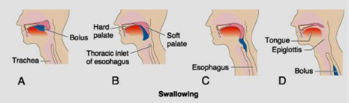

**Figure 1. Swallowing (deglutition)**

**Dysphagia**

*Dysphagia* is defined as difficulty in swallowing. It may coexist with heartburn or vomiting but should be distinguished from both globus sensation (in which anxious people feel a lump in the throat without organic cause) and *odynophagia* (which refers to pain with swallowing, usually resulting from esophagitis due to gastro-oesophageal reflux or candidiasis). Dysphagia can be classified into *oropharyngeal* and *esophageal*. Oropharyngeal disorders result from neuromuscular dysfunction affecting the initiation of swallowing by the pharynx and upper oesophageal sphincter. Damage to the 5th, 9th, or 10th cerebral nerve can cause paralysis of significant portions of the swallowing mechanism (bulbar or pseudobulbar paralysis, brain tumors, brain trauma or bleeding). Also, a few diseases, such as *poliomyelitis* or *encephalitis*, can prevent normal swallowing by damaging the swallowing center in the brain stem. Finally, paralysis of the swallowing muscles, as occurs in *muscle dystrophy* or in failure of neuromuscular transmission in *myasthenia gravis* or *botulism*, can also prevent normal swallowing. When the swallowing mechanism is partially or totally paralyzed, the abnormalities that can occur include (1) complete abrogation of the swallowing act so that swallowing cannot occur, (2) failure of the glottis to close so that food passes into the lungs instead of the esophagus, and risk for aspiration pneumonia (3) failure of the soft palate and uvula to close the posterior nares so that food refluxes into the nose during swallowing with risk for asphyxia.

One of the most serious instances of paralysis of the swallowing mechanism occurs when patients are under deep anesthesia. Often, while on the operating table, they vomit large quantities of materials from the stomach into the pharynx; then, instead of swallowing the materials again, they simply suck them into the trachea because the anesthetic has blocked the reflex mechanism of swallowing. As a result, such patients occasionally choke to death on their own vomitus.

*Esophageal causes* result from either structural disease (benign or malignant strictures) or dysmotility of the oesophagus. Patients with oesophageal disease complain of food “sticking” after swallowing, although the level at which this is felt correlates poorly with the true site of obstruction. Swallowing of liquids is normal until strictures become extreme.

***Disorders of esophagus***

The musculature in the upper third of the esophageal wall is partly made up of striated muscle, partly of smooth muscle. On swallowing (deglutition) the upper esophageal sphincter opens reflexly and a (primary) peristaltic reflex wave moves the bolus of food into the esophagus. Here the dilation by the bolus initiates further (secondary) peristaltic waves that continue until the bolus has reached the stomach. The lower esophageal sphincter is opened by a vagovagal reflex at the beginning of the swallowing action. This receptive relaxation reflex is mediated by the inhibitory *noncholinergic nonadrenergic* (*NCNA*) *neurones* of the myenteric plexus (Fig.2).

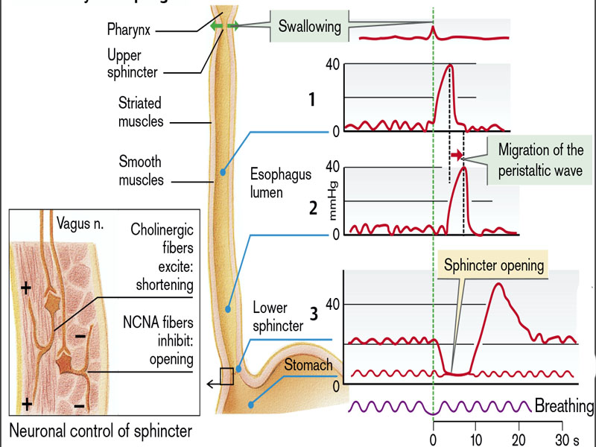

**Fig. 2. Motility of esophagus**

(From Despopoulos, Color Atlas of Physiology, 2003)

Esophageal motility, for example, the progression of the peristaltic wave, is usually tested by pressure measurements in the various segments of the esophagus. The resting pressure within the lower esophageal sphincter is ca. 20–25 mmHg. During receptive relaxation the pressure falls to the few mmHg that prevail in the proximal stomach, indicating opening of the sphincter.

The lower esophageal sphincter is usually closed, just like its upper counterpart. This barrier against reflux of the harmful gastric juice (pepsin and HCl) is strengthened when the sphincter pressure is raised (Fig.3), for example, by the action of acetylcholine liberated from the ganglion cells of the myenteric plexus, or by adrenergic agonists, by hormones, such as gastrin (reflux protection during digestive gastric motility), motilin (reflux protection during interdigestive motility), somatostatin, and substance P, by paracrine action(histamine, PGF2α), by protein-rich food, or by high intra-abdominal pressure (contraction of abdominal muscles, obesity, ascites).

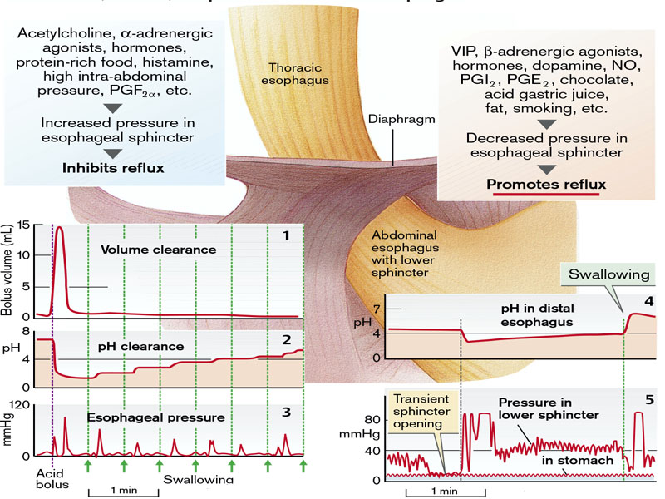

**Figure 3. Pressure, volume, and pH clearance of distal esophagus**

(From S. Silbernagl and F. Lang; Color Atlas of Pathophysiology)

This pressure would tear open the sphincter but for the fact that part of the 3– 4 cm long lower esophageal sphincter lies within the abdominal space. As a consequence, the sphincter pressure is increased (from outside) in proportion to the increase in intra-abdominal pressure. Furthermore, parts of the diaphragm surround the lower esophageal sphincter (left and right crux) in a scissor-like manner, so that the sphincter is automatically clamped when the diaphragm contracts. An intact phrenico-esophageal ligament and a relatively acute angle of His between the end of the esophagus and the stomach are also important in providing reflux protection during swallowing. Factors that lower sphincter pressure will promote reflux. Among these are vasoactive intestinal polypeptide (VIP) and ATP, the transmitters of the inhibitory NCNA neurones as well as dopamine and β-adrenergic agonists, hormones such as secretin, cholecystokinine (CCK), progesterone, and glucose–dependent insulinotropic peptide (GIP = formerly: gastric inhibitory polypeptide), paracrine substances(NO, PGI2, PGE2), a progesterone effect during pregnancy, food with a high fat content, and many others. Sporadic reflux of gastric juice is an everyday physiological event, either from unexpected pressure on a full stomach, or during swallowing (opening of sphincter for a few seconds, or during transient openings of the sphincter that last up to half a minute and are triggered by marked dilation of the stomach wall and not by the act of swallowing. These transient sphincter openings are probably part of the expulsion reflex through which swallowed air and CO2 can be expelled from the stomach. The fact that significant reflux occurs as a consequence can be concluded from the marked drop in pH in the distal esophagus. Three mechanisms are responsible for protecting the esophageal mucosa after reflux (Fig.3):

•*Volume clearance*, i.e., the rapid replacement of reflux volume into the stomach by the esophageal peristalsis reflex. Reflux volume of 15 mL, except for a small residual amount, normally remains in the esophagus for only five to 10 seconds.

• *pH clearance*. Residual gastric juice, left behind by the volume clearance, has an unchanged, low pH. It only rises, step by step, with each act of swallowing, i.e., the *swallowed saliva buffers* the residual reflux volume. pH clearance is dependent on the amount and buffering capacity of saliva.

• The wall of the esophagus contains epithelium with barrier properties. Of its 25–30 cell layers it is particularly the stratum corneum (ca. 10 layers) located at the luminal aspect that is especially dense. This largely prevents the invasion of the harmful components of gastric juice (H+ ions, pepsin, and sometimes bile salts). Additionally, as in the gastric mucosa , H+ ions that have penetrated into the cells are very efficiently removed to the outside (Na+/H+ exchange carrier), and also a small number of HCO3– ions are secreted. The most important functional disorders of the esophagus are caused by abnormal esophageal contraction (hypermotility or hypomotility, disordered coordination) or failure of the protective mechanisms to cope with reflux (gastroesophageal reflux disease).

*Hypermotility* may be caused by a thickened muscular layer, an increased sensitivity of the muscle toward excitatory transmitters (acetylcholine), or hormones (gastrin),or a reduced sensitivity toward inhibitorytransmitters (VIP). Hypermotility mayalso be due to increased neuronal activityofcholinergic neurones or diminished activityof inhibitory NCNA neurones. The latter istrue of achalasia. This is caused by a reductionin the number of intramural NCNAneurones as well as diminished reactivity ofthese neurones to preganglionically liberatedacetylcholine. As a result of this disorder,patients with achalasia have a greatly elevated resting pressure in the lower esophageal sphincter, receptive relaxation sets in late and, most importantly, is too weak, so that during the reflex phase the pressure in the sphincter is markedly higher than thatin the stomach (Fig.4). As a result,swallowed food collects in the esophagus,causing a pressure rise throughout and undercertain circumstances leading to an enormous dilation of the esophagus. Furthermore, propagation of the peristaltic wave ceases. Thus, the symptoms of achalasia are dysphagia (trouble swallowing), regurgitation of food (not vomiting), retrosternal pain, and weight loss. Serious complications of achalasia are esophagitis and pneumonia, caused byaspiration of esophageal contents (containing bacteria).

*Hypomotility of the esophagus* is caused by factors that are the opposite of those described above. In scleroderma, an autoimmune disease, hypomotility in its early stages is due to neuronal defects that later result in atrophy of the smooth muscles of the esophagus, so that peristalsis in the distal portion ultimately ceases altogether. Contrary to achalasia, the lower sphincter pressure is reduced, so that gastroesophageal reflux disease develops.

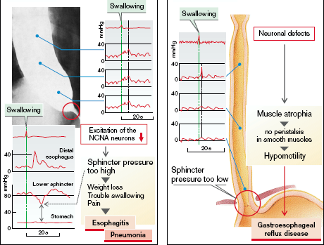

**Figure 4. Achalasia. Sclerodermia**

(From S. Silbernagl and F. Lang; Color Atlas of Pathophysiology)

**Gastroesophageal reflux disease**. Reflux of gastric juice into the esophagus is to some extent a physiological phenomenon (see above); heart burnindicates reflux esophagitis (Fig.5). This can be caused by:

– factors that diminish the pressure in the lower esophageal sphincter;

– increased frequency of transient sphincter opening (swallowing air, drinks containing CO2);

– decreased volume clearance (abnormal distal esophageal peristalsis);

– slowed pH clearance, for example, due to decreased salivary flow (sleep, chronic saliva deficiency [*xerostomia*]), or decreased buffering capacity of the saliva (smoking cigarettes);

– hiatus hernia, in which the abdominal part of the esophagus is displaced into the thorax, so that an important mechanism of sphincter closure, increased intra- abdominal pressure, is absent;

– direct irritation and damage to the esophageal mucosa, for example, by citrus fruits, tomato-based foods, hot spices, highproof alcohol, and nonsteroid anti-inflammatory drugs (NSAIDs); The result of chronic esophageal reflux is epithelial metaplasia in the distal esophagus that, as a precancerous condition, can develop into cancer.

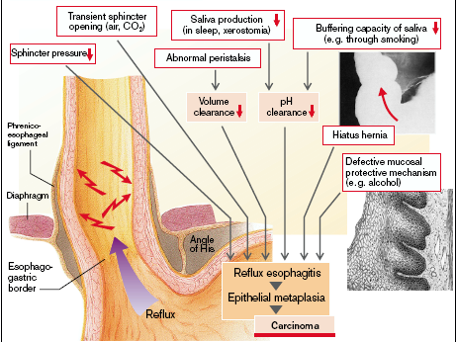

**Figure 5. Gastroesophagial reflux disease**

(From S. Silbernagl and F. Lang; Color Atlas of Pathophysiology)

**Anorexia, nausea and vomiting**

Several signs and symptoms are common to many types of gastrointestinal disorders. These include anorexia, nausea, vomiting, and gastrointestinal bleeding. Because they occur with so many gastrointestinal disorders, they are discussed separately as an introduction to the content that follows.

Anorexia, nausea, and vomiting are physiologic responses that are common to many gastrointestinal disorders. These responses are protective to the extent that they signal the presence of disease and, in the case of vomiting, remove noxious agents from the gastrointestinal tract. They also can contribute to impaired intake or loss of fluids and nutrients.

***Anorexia*** represents a loss of appetite. Several factors influence appetite. One is hunger, which is stimulated by contractions of the empty stomach. Appetite or the desire for food intake is regulated by the hypothalamus and other associated centers in the brain. Smell plays an important role, as evidenced by the fact that appetite can be stimulated or suppressed by the smell of food. Loss of appetite is associated with emotional factors, such as fear, depression, frustration, and anxiety. Many drugs and disease states cause anorexia. In uremia, for example, the accumulation of nitrogenous wastes in the blood contributes to the development of anorexia. Anorexia often is a forerunner of nausea, and most conditions that cause nausea and vomiting also produce anorexia.

*Anorexia nervosa* is self-induced starvation, resulting in marked weight loss; *bulimia* is a condition in which the patient binges on food and then induces vomiting. Bulimia is more common than anorexia nervosa and generally has a better prognosis. It is estimated to occur in 1% to 2% of women and 0.1% of men, with an average onset at 20 years of age. These eating disorders occur primarily in previously healthy young women who have developed an obsession with attaining thinness.

The clinical findings in anorexia nervosa are generally similar to those in severe PEM (protein-energy malnutrition). In addition, effects on the endocrine system are prominent. *Amenorrhea,* resulting from decreased secretion of gonadotropin-releasing hormone (and subsequent decreased secretion of luteinizing and follicle-stimulating hormones), is so common that its presence is a diagnostic feature for the disorder. Other common findings, related to decreased thyroid hormone release, include cold intolerance, bradycardia, constipation, and changes in the skin and hair. In addition, dehydration and electrolyte abnormalities are frequently present. The skin becomes dry and scaly and may be yellow as a result of excess carotene in the blood. Body hair may be increased but is usually fine and pale (lanugo). Bone density is decreased, most likely because of low estrogen levels, which mimics the postmenopausal acceleration of osteoporosis. As expected with severe PEM, anemia, lymphopenia, and hypoalbuminemia may be present. A major complication of anorexia nervosa is an increased susceptibility to cardiac arrhythmia and sudden death, resulting in all likelihood from hypokalemia.

In *bulimia,* binge eating is the norm. Huge amounts of food, principally carbohydrates, are ingested, only to be followed by induced vomiting. Although menstrual irregularities are common, amenorrhea occurs in fewer than 50% of bulimic patients, probably because weight and gonadotropin levels are maintained near normal. The major medical complications are due to continual induced vomiting and chronic use of laxatives and diuretics. These include (1) electrolyte imbalances (hypokalemia), which predispose the patient to cardiac arrhythmias; (2) pulmonary aspiration of gastric contents; and (3) esophageal and stomach rupture. Nevertheless, there are no specific signs and symptoms for this syndrome, and the diagnosis must rely on a comprehensive psychologic assessment of the patient.

***Nausea*** is an ill-defined and unpleasant subjective sensation***.*** Everyone has experienced the sensation of nausea and knows that it is often a prodrome of vomiting. Nausea is the conscious recognition of subconscious excitation in an area of the medulla closely associated with or part of the vomiting center, and it can be caused by (1) irritative impulses coming from the gastrointestinal tract, (2) impulses that originate in the lower brain associated with motion sickness, or (3) impulses from the cerebral cortex to initiate vomiting. Vomiting occasionally occurs without the prodromal sensation of nausea, indicating that only certain portions of the vomiting center are associated with the sensation of nausea.

Nausea usually is preceded by anorexia, and stimuli such as foods and drugs that cause anorexia in small doses usually produce nausea when given in larger doses. A common cause of nausea is distention of the duodenum, or upper small intestinal tract. Nausea frequently is accompanied by autonomic nervous system manifestations such as watery salivation and vasoconstriction with pallor, sweating, and tachycardia. Nausea may function as an early warning signal of disease.

**Vomiting** is the means by which the upper gastrointestinal tract rids itself of its contents when almost any part of the upper tract becomes excessively irritated, overdistended, or even overexcitable. The sensory signals that initiate vomiting originate mainly from the pharynx, esophagus, stomach, and upper portions of the small intestines. And the nerve impulses are transmitted by both vagal and sympathetic afferent nerve fibers to multiple distributed nuclei in the brain stem that all together are called the “*vomiting center*.” From here, motor impulses that cause the actual vomiting are transmitted from the vomiting center by way of the 5th, 7th, 9th, 10th, and 12th cranial nerves to the upper gastrointestinal tract, through vagal and sympathetic nerves to the lower tract, and through spinal nerves to the diaphragm and abdominal muscles.

The vomiting center, located in the medullaoblongata, is reached, amongothers, via chemoreceptors of the *area postrema*on the bottom of the 4th ventricle(*chemoreceptor trigger zone* [CTZ]), wherethe blood–brain barrier is less tight. CTZ isactivated by dopamine agonists such as apomorphine(therapeutic emetic), by numerousdrugs or toxins, for example, digitalisglycosides, nicotine, staphylococcal enterotoxinsas well as hypoxia, uremia, and diabetesmellitus (Fig.6). The CTZ cells also contain receptorsfor neurotransmitters (epinephrine,serotonin, GABA, substance P), allowingneurons access to the CTZ.However, the vomiting center can also beactivated without mediation by the CTZ,such as during unphysiological stimulationof the organs of balance (kinesia [motionsickness]). In addition, diseases of the innerear (vestibule), such as *Ménière’s disease*,cause nausea and vomiting.

The vomiting center is activated from thegastrointestinal tract via vagal afferents:

– on overstretching of the stomach or damage to the gastric mucosa, for example, by alcohol;

– by delayed gastric emptying, brought about by autonomic nervous efferents (also from the vomiting center itself), by food which is difficult to digest as well as by blockage of the gastric exit (pyloric stenosis, tumor), or of the intestine (atresia, Hirschsprung’s disease, ileus);

– by overdistension and inflammation of the peritoneum, biliary tract, pancreas, and intestine.

Finally, visceral afferents from the heart may also cause nausea and vomiting, for example, in coronary ischemia. Nausea and vomiting are common during the first trimester of pregnancy (*vomitus matutinus*). Exceptional disturbances (see below) due to the vomiting may occur (*hyperemesis gravidarum*). Psychogenic vomiting occurs mostly in (nonpregnant) young women, brought about by sexual conflicts, problems in the home environment, loss of parental attention, etc. Vomiting can be precipitated deliberately by putting a finger into the throat (afferent nerves from touch sensors in the pharynx). It may occasionally provide relief, but frequent vomiting by patients with *bulemia* may lead to serious consequences.

Finally, exposure to radiation (e.g., in the treatment of malignancy) and raised intracranial pressure (intracranial bleeding, tumors) are important clinical factors in precipitating nausea and vomiting.

Vomiting***,*** with its precursor warning signs ofnausea and retching, is mainly a protective reflex, but also an important symptom. Chronic vomiting causes severe disorders. The consequences of chronic vomiting are brought about by diminished food intake (malnutrition) and by loss of gastric juice, together with the loss of swallowed saliva, drinks, and sometimes also of small-intestinal secretions. The result is hypovolemia. Release of ADH, initiated by the vomiting center, favors retention of water; the excessive loss of NaCl and relatively small loss of H2O leads to hyponatremia which is exacerbated by increased excretion of NaHCO3. The latter is a response to a nonrespiratory alkalosis. This result from the parietal cells of the stomach passing one HCO3– ion for each H+ ion secreted into the lumen. While the H+ ions (10–100 mmol/L gastric juice) are lost with the vomit, and therefore do not use up any HCO3– to buffer them in the duodenum, HCO3– accumulates in the organism. The alkalosis is made worse by hypokalemia; K+ is lost both with the vomit (food, saliva, and gastric juice) and the urine. The hypovolemia leads to hyperaldosteronism, during which K+ excretion increases in the course of increased absorption of Na+. The act of vomiting and the vomit cause further damage, namely gastric rupture, tears in the esophageal wall (Mallory–Weiss syndrome), dental caries (due to acid), inflammation of the oral mucosa, and aspiration*pneumonia* are the most important potentialconsequences (Fig.6)**.**

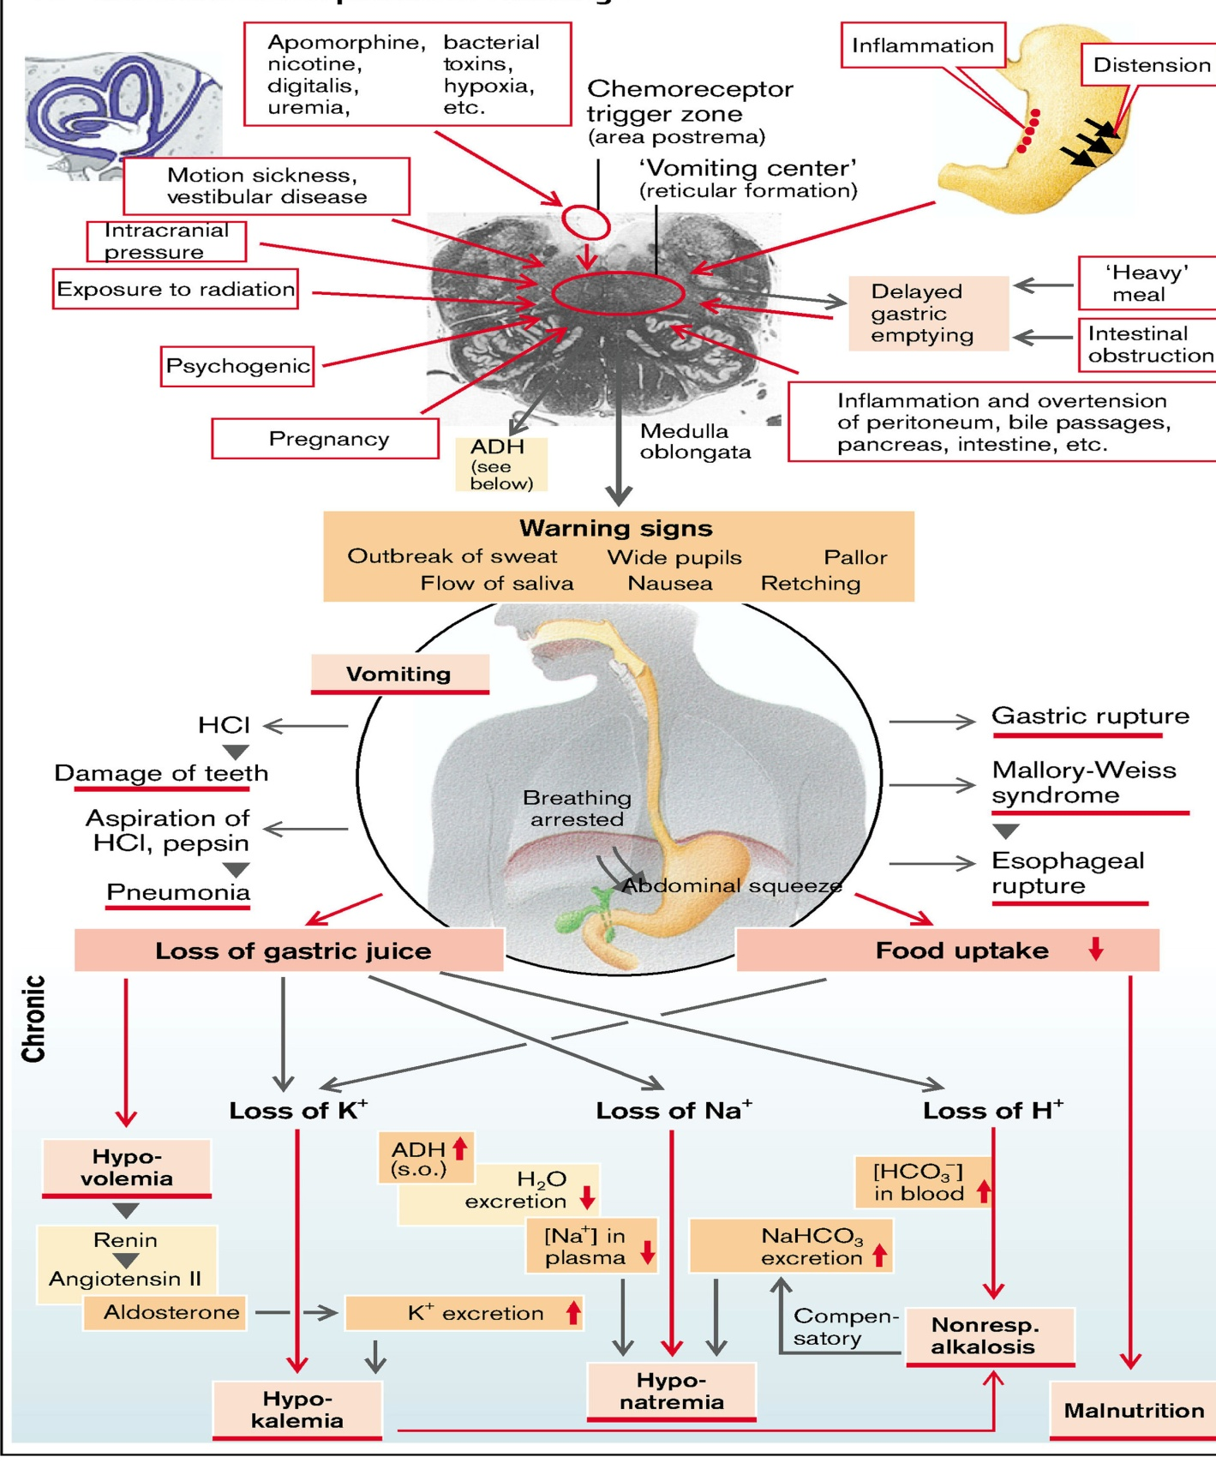

**Figure 6. Causes and consequences of vomiting**

(From S. Silbernagl and F. Lang; Color Atlas of Pathophysiology)

**Dyspepsia**

Dyspepsia (“indigestion”) is a collective term for any symptoms thought to originate from the upper gastrointestinal tract. It encompasses many different symptoms and disorders, including some arising outside the digestive system. Heartburn and other “reflux” symptoms are separate entities and are considered elsewhere.

**Causes of dyspepsia**

(Davidson's principles & practice of Medicine, 20Th edition)

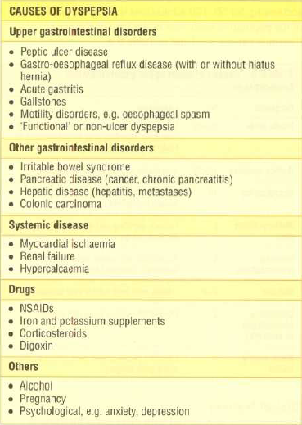

Dyspepsia is extremely prevalent, affecting up to 80% of the population at some time, and very often no abnormality is discovered during investigation, especially in younger patients.

**GASTROINTESTINAL TRACT BLEEDING**

Bleeding from the gastrointestinal tract can be evidenced by blood that appears in the vomitus or the feces. It can result from disease or trauma to the gastrointestinal structures (*e.g.,* peptic ulcers), blood vessel abnormalities (*e.g.,* esophageal varices, hemorrhoids), or disorders in blood clotting. Blood in the stomach usually is irritating and causes vomiting. Hematemesis refers to blood in the vomitus. It may be bright red or have a “coffee-ground” appearance because of the action of the digestive enzymes. Blood that appears in the stool may range in color from bright red to tarry black. Bright red blood usually indicates that the bleeding is from the lower bowel. When it coats the stool, it often is the result of bleeding hemorrhoids. The word *melena* comes from the Greek word for “black” and refers to the passage of black and tarry stools. These stools have a characteristic odor that is not easily forgotten.

Tarry stools usually indicate that the source of the bleeding is above the level of the ileocecal valve, although this is not always the case. Approximately 150 to 200 mL of blood must be present in the stomach to produce a single tarry stool; acute blood loss may produce melena for up to 3 days. With hypermotility of the gastrointestinal tract, bright red blood may be present in the stools even though the bleeding is from the upper gastrointestinal tract. *Ocult* or hidden, blood can only be detected by chemical means. It can be caused by gastritis, peptic ulcer, or lesions of the intestine.

Occult bleeding can be detected by guaiac-based stool tests that make use of the pseudoperoxidase activity of hemoglobin. Guaiac turns blue after oxidation by oxidants or peroxidases in the presence of an oxygen donor such as hydrogen peroxide. The likelihood that a guaiac-based test result will be positive is directly proportional to the quantity of fecal heme, which in turn is related to the size and location of the bleeding lesion. Many factors influence guaiac-based tests, including ingestion of vitamin C and dietary factors such as nonhuman heme derived from eating meat or peroxidases from dietary sources. The blood urea nitrogen (BUN) level frequently is elevated after hematemesis or melena. This results from the breakdown of the blood by the digestive enzymes and the absorption of the nitrogenous end products into the blood. The BUN level usually reaches a peak within 24 hours after the gastrointestinal hemorrhage. It is not elevated when the bleeding is in the colon because digestion does not take place at this level of the digestive system.

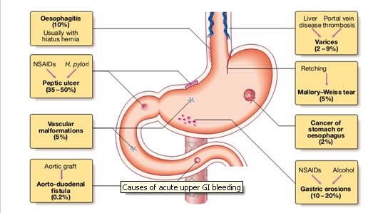

**Figure 7. Causes of acute upper GI bleeding**

(Davidson's principles & practice of Medicine, 20Th edition)

*Clinical features of acute upper gastrointestinal bleeding*

*Haematemesis* may be red with clots when bleeding is profuse, or black (“coffee grounds”) when less severe. Syncope may occur and is due to hypotension from intravascular volume depletion. Symptoms of anaemia suggest chronic bleeding. *Melaena* is the term used to describe the passage of black, tarry stools containing altered blood; this is usually due to bleeding from the upper gastrointestinal tract, although haemorrhage from the right side of the colon is the result of the action of digestive enzymes and of bacteria upon haemoglobin. Severe acute upper gastrointestinal bleeding can sometimes cause maroon or bright red stool.

***DISORDERS OF THE STOMACH***

Disorders of the stomach are a frequent cause of clinical disease, with inflammatory and neoplastic lesions being particularly common. In the United States, diseases related to the stomach account for nearly one third of all health care spending on GI disease. In addition, despite decreasing incidence in certain locales such as the United States, gastric cancer remains a leading cause of death worldwide.

The stomach is divided into four major anatomic regions: the cardia, fundus, body, and antrum. The cardia and antrum are lined mainly with mucin-secreting foveolar cells that form small glands. The antral glands are similar but also contain endocrine cells, such as G cells, that release gastrin to stimulate luminal acid secretion by parietal cells within the gastric fundus and body. The well-developed glands of the body and fundus also contain chief cells that produce and secrete digestive enzymes such as pepsin.

 **Gastric juice**

The *tubular glands* of the gastric fundus and corpus secrete 3–4 L of gastric juice each day. *Pepsinogens* and *lipases* are released by chief cells and *HCl* and *intrinsic factor* by parietal cells. *Mucins* and *HCO3–* are released by mucous neck cells and other mucous cells on the surface of the gastric mucosa. **Pepsins** function as endopeptidases in protein digestion. They are split from pepsinogens exocytosed from chief cells in the glandular and gastric lumen at a pH of <6. Acetylcholine (ACh), released locally in response to H+ (and thus indirectly also to gastrin) is the chief activator of this reaction.

**Gastric acid**. The pH of the gastric juice drops to ca. 0.8 during peak HCl secretion. Swallowed food buffers it to a pH of 1.8–4, which is optimal for most pepsins and gastric lipases. The low pH contributes to the *denaturation* of dietary proteins and has a *bactericidal* *effect*.

**HCl secretion.** The *H+/K+-ATPase* in the luminal membrane of parietal cells drives H+ ions into the glandular lumen in exchange for K+, thereby raising the H+ conc. in the lumen by a factor of ca. 107. K+ taken up in the process circulates back to the lumen via *luminal K+ channels*. For every H+ ion secreted, one HCO3– ion leaves the blood side of the cell and is exchanged for a Cl– ion via an *anion antiporter* . (The HCO3– ions are obtained from CO2+ OH–, a reaction catalyzed by carbonic anhydrase, CA). This results in the intracellular accumulation of Cl– ions, which diffuse out of the cell to the lumen via *Cl– channels*. Thus, one Cl– ion reaches the lumen for each H+ ion secreted.

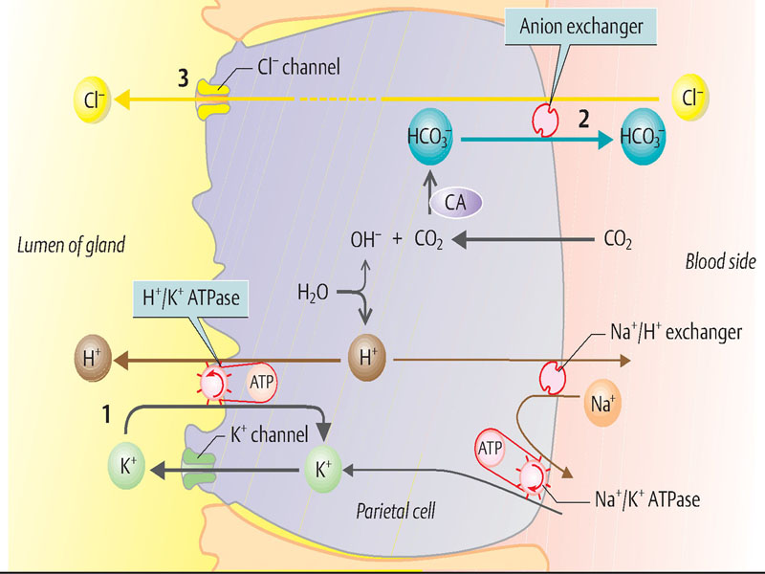

The activation of parietal cells leads to the opening of *canaliculi*, which extend deep into the cell from the lumen of the gland. The canaliculi are equipped with a brush border that greatly increases the luminal surface area which is densely packed with membrane-bound H+/K+ ATPase molecules. This permits to increase the secretion of H+ ions from 2 mmol/hour at rest to over 20 mmol/hour during digestion.

Gastric acid secretion is stimulatedin phases by neural, local gastric and intestinal factors. Food intake leads to reflex secretion of gastric juices, but deficient levels of glucose in the brain can also trigger the reflex. The optic, gustatory and olfactory nerves are the afferents for this partly conditioned reflex, and efferent impulses flow via the *vagus nerve*. *ACh* directly activates parietal cells in the fundus (M3 cholinoceptors). *GRP* (*gastrin-releasing peptide*) released by neurons stimulates *gastrin* secretion from G cells in the antrum. Gastrin released in to the systemic circulation in turn activates the parietal cells via CCKB receptors (= gastrin receptors). The glands in the fundus contain H (histamine) cells or ECL cells (enterochromaffin–like cells), which are activated by gastrin (CCKB receptors) as well as by ACh and β3 adrenergic substances. The cells release *histamine*, which has a paracrine effect on neighboring parietal cells (H2 receptor). Local gastric and intestinal factors also influence gastric acid secretion because chyme in the antrum and duodenum stimulates the secretion of gastrin (Fig.8).

**Factors that inhibit gastric juice secretion:**

**(a)** A pH of < 3.0 in the antral lumen inhibits G cells (negative feedback) and activates antral D cells, which secrete SIH (somatostatin), which in turn has a paracrine effect. SIH inhibits H cells in the fundus as well as G cells in the antrum. CGRP released by neurons activates D cells in the antrum and fundus.

**(b)** Secretin and GIP releasedfrom the small intestine have a retrograde effecton gastric juice secretion. This adjuststhe composition of chyme from the stomachto the needs of the small intestine.

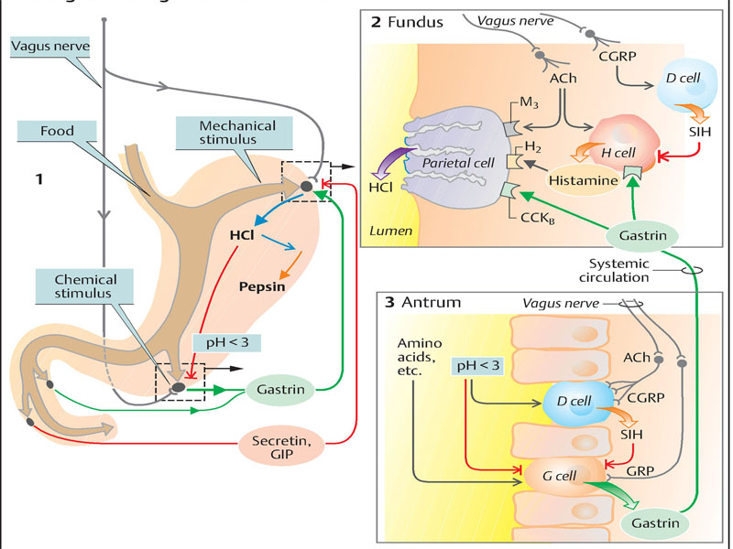

**Figure 8. Regulation of gastric juice secretion**

(From Despopoulos, Color Atlas of Physiology, 2003)

**Protection of the gastric mucosa** from destructive gastric juices is chiefly provided by a *layer of mucus* and *HCO3– secretion* bythe underlying mucous cells of the gastricmucosa. HCO3– diffuses through the layer ofmucus and buffers the acid that diffuses into itfrom the lumen. *Prostaglandins* PGE2 and PGI2promote the secretion of HCO3–. Anti-inflammatorydrugs that inhibit cyclooxygenase 1and thus prostaglandin production impair this mucosal protection and can resultin ulcer development.

***Gastric hypersecretion and hyperchlorhydria***

Some alimentary components (caffeine, ethanol, salts of calcium, amino acids) that intensify the production of gastrin – the humoral stimulator of gastric secretion, can cause hypersecretion and hyperacidity of the stomach. Hyperchlorhydria is characteristic for Zollinger-Ellison’s syndrome - a gastrin-producing tumor located in the pancreas (65-75%) or in other neighboring organs.

Hypergastrinemia provokes two synergic effects:

a) hyperstimulation of gastric parietal cells followed by hyperacid hypersecretion.

b) increase of number of the parietal cells

In one’s turn, the excess of HCl inhibits the secretion of gastrin that represents a protective mechanism against the aggressive action of hyperacidity. At pH equaled to 2,0 secretion of gastrin is stopped and at the same time secretion of alkaline mucus rich in bicarbonates (pH 7,36) intensifies, whereas gastric mucosa absorbs the hydrogen ions. Backflow of duodenal contents rich in bicarbonates into the stomach also participates in the neutralization of hydrochloric acid. It should be mentioned that this mechanism is reduced by pyloric spasm provoked by gastric hyperacidity that leads to chymostasis, pyrosis, eructation, and sometimes, vomiting. Under conditions of gastric hyperacidity, the evacuation of gastric chyme into the duodenum is realized by small portions but chyme itself, being minutely processed chemically and mechanically, leads to excessive intestinal digestion and absorption, insufficient stimulation of intestinal peristalsis by fecal bolus. As a result, the transit of food through the intestine slows down, causing in this way frequent constipations.

***Hyposecretion and hypoacidity. Anacidity. Achlorhydria. Achylia***

Achlorhydria means complete absence of hydrochloric acid in the gastric juice ,which is associated with gastric anacidity – pH in the stomach becomes neutral. Achylia represents complete absence of HCl and enzymes in the gastric juice.

Achlorhydria is met in two forms:

a) *false achlorhydria,* as the result of hypersecretion of mucus and bicarbonates that neutralize the acidity of gastric juice.

b) *true achlorhydria,* which is resistant to the stimulation by histamine, gastrin, insulin, etc.; it is noticed in massive dystrophies of parietal cells, atrophic gastrites, diffuse gastric cancer, and etc.

The causes of achlorhydria are: atrophic or degenerative changes of the gastric mucosa, especially of parietal cells from the fundic glands, noticed frequently in chronic atrophic gastrites, infiltrative forms of gastric cancer, avitaminoses, anemias, operations on stomach, affections of liver, and etc.

In absence of HCl, pepsin becomes inactive that makes the preliminary decomposition of proteins in the stomach and their further disintegration and absorption in the intestine impossible. Finally, maldigestion and malabsorption of proteins develops. Anacidity and hypoacidity of the stomach contribute to an excessive colonization of gastrointestinal tract by bacterial flora (inclusively by pathogenous), which intensifies the fermentation and decay process associated with essential dyspeptic disorders. Evacuation of gastric chyme into the duodenum accelerates, while the pylorus permanently remains a little opened. Insufficiently mechanically and chemically processed gastric chyme, irritating the intestinal mucosa and intensifying the peristalsis, accelerates the passage of intestinal contents that results in maldigestion and malabsorption. Diarrheal syndrome with steatorrhea, hypovitaminoses, metabolic disorder, hidroelectrolitic dysbalance, dehydration of organism, subnutrition and body weight loss develop.

**Gastropathy and acute gastritis**

Gastritis is a mucosal inflammatory process. When neutrophils are present, the lesion is referred to as acute gastritis. When inflammatory cells are rare or absent, the term *gastropathy* is applied; it includes a diverse setof disorders marked by gastric injury or dysfunction.

***Etiology:***Agents that cause gastropathy include NSAIDs, *H. pylori*, alcohol,bile, and stress induced injury. Acute mucosal erosion orhemorrhage, such as Curling ulcers or lesions followingdisruption of gastric blood flow, for example, in portalhypertension, can also cause gastropathy that typicallyprogress to gastritis. The term *hypertrophic gastropathy* isapplied to a specific group of diseases exemplified byMenetrier disease and Zollinger-Ellison Syndrome (discussedlater). Both gastropathy and acute gastritis may be asymptomatic or cause variable degrees of epigastric pain, nausea,and vomiting. In more severe cases there may be mucosalerosion, ulceration, hemorrhage, hematemesis, melena, or,rarely, massive blood loss.

***Pathogenesis.*** The gastric lumen has a pH of close to 1, more than a million times more acidic than the blood. This harsh environment contributes to digestion but also has the potential to damage the gastric mucosa. Multiple mechanisms have evolved to protect the gastric mucosa. Mucin secreted by surface foveolar cells forms a thin layer of mucus and phospholipids that prevents large food particles from directly touching the epithelium. The mucus covering also promotes formation of an “unstirred” layer of fluid over the epithelium that protects the mucosa and has a neutral pH as a result of bicarbonate ion secretion by surface epithelial cells.Beneath the mucus, a continuous layer of gastric epithelial cells forms a physical barrier that limits back diffusion of acid and leakage of other luminal materials, including pepsin, into the lamina propria. Complete replacement of the surface foveolar cells every 3 to 7 days is essential for both the maintenance of the epithelial layer and the secretion of mucus and bicarbonate from these cells. In acid-secreting parts of the stomach, a capillary “alkaline tide” is generated as parietal cells secrete hydrochloric acid into the gastric lumen and bicarbonate into the vessels. In addition to delivering bicarbonate, the rich mucosal vasculature delivers oxygen and nutrients while washing away acid that has back-diffused into the lamina propria. Gastropathy, acute gastritis, and chronic gastritis can occur following disruption of any of these protective mechanisms.

• Nonsteroidal antiinflammatory drugs (NSAIDs) inhibit cyclooxygenase- (COX) dependent synthesis of prostaglandins E2 and I2, which stimulate nearly all of the above defense mechanisms including mucus, bicarbonate, and phospholipid secretion, mucosal blood flow, and epithelial restitution while reducing acid secretion. Although COX-1 plays a larger role than COX-2, both isoenzymes contribute to mucosal protection. Thus, while the risk of NSAID-induced gastric injury is greatest with nonselective inhibitors, for example, aspirin, ibuprofen, and naproxen, selective COX-2 inhibition, for example, by celecoxib, can also result in gastropathy or gastritis.

• The gastric injury that occurs in uremic patients and those infected with urease-secreting *H. pylori* may be due to inhibition of gastric bicarbonate transporters by ammonium ions.

• Reduced mucin and bicarbonate secretion have been suggested as factors that explain the increased susceptibility of older adults to gastritis.

• Decreased oxygen delivery may account for an increased incidence of acute gastritis at high altitudes. Ingestion of harsh chemicals, particularly acids or bases, either accidentally or as a suicide attempt, also results in severe gastric injury, predominantly as a result of direct injury to mucosal epithelial and stromal cells. Direct cellular damage also contributes to gastritis induced by excessive alcohol consumption, NSAIDs, radiation therapy, and chemotherapy. Agents that inhibit DNA synthesis or the mitotic apparatus, including those used in cancer chemotherapy, may cause generalized mucosal damage due to insufficient epithelial renewal.

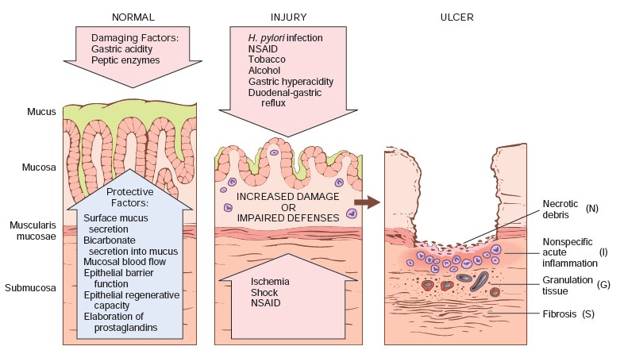

**Figure 9. Mechanisms of gastric injury and protection.**

This diagram illustrates the progression from more mild forms of injury to ulceration that may occur with acute or chronic gastritis. Ulcers include layers of necrosis (N), inflammation (I), and granulation tissue (G), but a fibrotic scar (S), which takes time to develop, is only present in chronic lesions. (From Robbins-Cotran; Pathological basis of disease)

Simplifying the situation somewhat, one can differentiate three main types of gastritis (Fig.10):

– erosive and *hemorrhagic gastritis*

– nonerosive, *chronic active gastritis*

– atrophic (*fundal gland*) *gastritis*

(As complete inflammatory reaction is often absent in many cases of gastritis, the term *gastropathy* is now often used).

**Erosive** and **hemorrhagic gastritis** can have many causes, for example:

– intake of nonsteroidal anti-inflammatory drugs (NSAIDs);

– ischemia (e.g., vasculitis or while running a marathon);

– stress (multi-organ failure, burns, surgery, central nervous system trauma), in which the gastritis is probably in part caused by ischemia;

– alcohol abuse, corrosive chemicals;

– trauma (gastroscope, swallowed foreign body, retching, vomiting, etc.);

– radiation trauma.

This type of gastritis can quickly produce an acute ulcer(e.g., through stress or NSAIDs; with the risk of massive gastric bleeding or perforation of the stomach wall.

**Nonerosive, chronic active gastritis** (*type B)* is usually restricted to the *antrum*. It has become increasingly clear in the last decade that its determining cause is a bacterial colonization of the antrum with *Helicobacter pylori*, which can be effectively treated with antibiotics. Helicobacter colonization not only diminishes mucosal protection, but can also stimulate antral gastrin liberation and thus gastric juice secretion in the fundus, a constellation that favors the development of chronic ulcer.

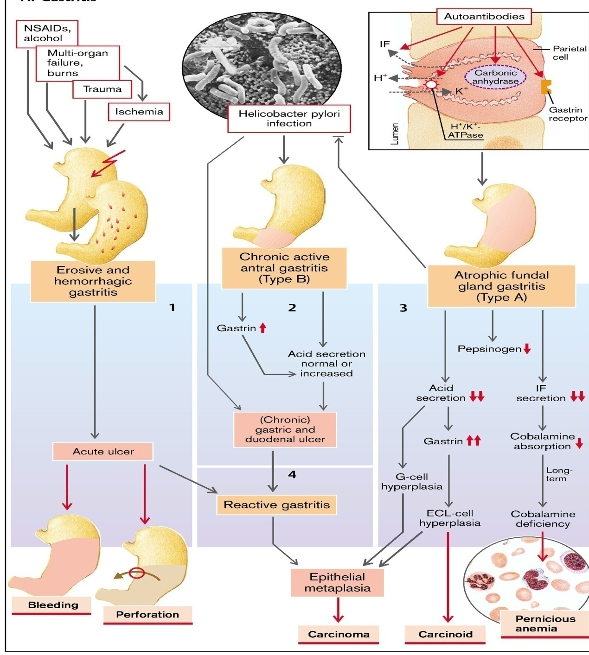

**Figure 10. Gastrites** (From S. Silbernagl and F. Lang; Color Atlas of Pathophysiology)

*Pathogenesis.* H. pylori infection most often presents as a predominantly antral gastritis with normal or increased acid production. Local gastrin production may be increased, but hypergastrinemia (increased serum gastrin) is uncommon. When inflammation remains limited to the antrum, increased acid production results in greater risk of duodenal peptic ulcer (see later). In other patients gastritis may progress to involve the gastric body and fundus. This *multifocal atrophic gastritis* is associated with patchy mucosal atrophy, reduced parietal cell mass and acid secretion, intestinal metaplasia, and increased risk of gastric adenocarcinoma. Thus, there is an inverse relationship between duodenal ulcer and gastric adenocarcinoma that correlates with the pattern of gastritis. The bacterial and host factors that determine which pattern develops in an individual patient are discussed later. *H. pylori* organisms have adapted to the ecologic niche provided by gastric mucus. Its virulence is linked to the following factors:

• *Flagella*, which allow the bacteria to be motile in viscous mucus

• *Urease*, which generates ammonia from endogenous urea and thereby elevates local gastric pH and enhances bacterial survival

• *Adhesins* that enhance bacterial adherence to surface foveolar cells

• *Toxins*, such as cytotoxin-associated gene A *(CagA)*, which may be involved in disease progression

Variation in these and other bacterial factors are strongly linked to outcome. For example, *CagA* gene and the associated 20 gene pathogenicity islands are present in 50% of *H. pylori* isolates overall but in 90% of *H. pylori* isolates found in populations with elevated gastric cancer risk. This may, in part, be because CagA expressing strains can effectively colonize the gastric body and cause multifocal atrophic gastritis. Host factors also play an important role in the outcome of *H. pylori* infection. Genetic polymorphisms that lead to increased expression of the proinflammatory cytokines tumor necrosis factor (TNF) and interleukin-1β (IL-1β) or decreased expression of the antiinflammatory cytokine interleukin-10 (IL-10) are associated with development of pangastritis, atrophy, and gastric cancer. Iron deficiency may also be a risk factor for *H. pylori*–associated gastric cancer. The course of *H. pylori* gastritis is, therefore, the result of interplay between gastroduodenal mucosal defenses, inflammatory responses, and bacterial virulence factors.

A fourth type, *reactive gastritis,*occurs in the surroundings of erosive gastritis (see above), of ulcers or of operative wounds. The latter may partly be caused after operations on the antrum or pylorus by enterogastric reflux *(reflux gastritis*), resulting in pancreatic and intestinal enzymes and bile salts attacking the gastric mucosa. On the other hand, the alkaline milieu of the intestinal juice counteracts gastrin release and is also a hostile medium for Helicobacter pylori. (For similar reasons, Helicobacter colonization is diminished in atrophic gastritis.)

**Autoimmune atrophic** (*fundal gland*) **gastritis** (type A) accounts for less than 10% of cases of chronic gastritis. In contrast to *H. pylori*–associated gastritis, autoimmune gastritis typically spares the antrum and is associated with hypergastrinemi, most often limited to the fundus, has completely different causes. Autoimmune gastritis is characterized by:

• Antibodies to parietal cells and intrinsic factor that can be detected in serum and gastric secretions;

• Reduced serum pepsinogen I concentration;

• Endocrine cell hyperplasia;

• Vitamin B12 deficiency;

• Defective gastric acid secretion (*achlorhydria*);

*Pathogenesis.* Autoimmune gastritis is associated with loss of parietal cells, which are responsible for secretion of gastric acid and intrinsic factor. The absence of acid production stimulates gastrin release, resulting in hypergastrinemia and hyperplasia of antral gastrin-producing G cells. Lack of intrinsic factor disables ileal vitamin B12 absorption, which ultimately leads to vitamin B12 deficiency and a slow-onset megaloblastic anemia *(pernicious* *anemia* (Fig.10). Reduced serum pepsinogen I concentration results from chief cell destruction. Although *H. pylori* infection can cause gastric atrophy and hypochlorhydria, it is not associated with achlorhydria or pernicious anemia. This is because, in contrast to the diffuse atrophy of autoimmune gastritis, the damage in *H. pylori* gastritis is multifocal and leaves patches of residual parietal and chief cells. CD4+ T cells directed against parietal cell components, including the H+,K+-ATPase, are considered to be the principal agents of injury in autoimmune gastritis. This is supported by the observation that transfer of H+,K+- ATPase-reactive CD4+ T cells into naive mice results in gastritis and production of H+,K+-ATPase autoantibodies. There is no evidence of an autoimmune reaction to chief cells, suggesting that these may be lost through gastric gland destruction during autoimmune attack on parietal cells. If autoimmune destruction is controlled by immunosuppression, the glands can repopulate, demonstrating that gastric stem cells survive and are able to differentiate into parietal and chief cells. Autoantibodies to parietal cell components, most prominently the H+,K+-ATPase, or proton pump, and intrinsic factor are present in up to 80% of patients with autoimmune gastritis. However, these antibodies are not thought to be pathogenic because neither secreted intrinsic factor nor the luminally oriented proton pump are accessible to circulating antibodies, and passive transfer of these antibodies does not produce gastritis in experimental animals. Nevertheless, the presence of these autoantibodies is a useful diagnostic tool.

**Uncommon forms of gastritis**

*Eosinophilic gastritis.*This form of gastritis is characterized by tissue damage associated with dense infiltrates of eosinophils in the mucosa and muscularis, usually in the antral or pyloric region. The lesion may also be present at other sites within the GI tract and is associated with peripheral eosinophilia and increased serum IgE levels. Allergic reactions are one cause of eosinophilic gastritis, with cow’s milk and soy protein being the most common allergens in children. Eosinophilic gastritis can also occur in association with immune disorders such as systemic sclerosis and polymyositis, parasitic infections, and even *H. pylori* infection.

*Lymphocytic gastritis****.*** This disease preferentially affects women and produces nonspecific abdominal symptoms. It is idiopathic, but approximately 40% of cases are associated

with celiac disease, suggesting an immune-mediated pathogenesis. Lymphocytic gastritis typically affects the entire stomach and is often referred to as *varioliform* *gastritis* based on the distinctive endoscopic appearance (thickened folds covered by small nodules with central aphthous ulceration). Histologically there is a marked increase in the number of intraepithelial T lymphocytes.

*Granulomatous gastritis****.*** This descriptive term is applied to any gastritis that contains well-formed granulomas or aggregates of epithelioid macrophages. It encompasses a diverse group of diseases with widely varying clinical and pathologic features. Many cases are idiopathic. In Western populations, gastric involvement by Crohn disease is the most common specific cause of granulomatous gastritis, followed by sarcoidosis and infections (including mycobacteria, fungi, CMV, and *H. pylori*). In addition to the presence of histologically evident granulomas, narrowing and rigidity of the gastric antrum may occur secondary to transmural granulomatous inflammation.

***Mechanisms of ulcerogenesis***

**Protection of the gastric and duodenal mucosa**. Because the acid–pepsin mixture ofgastric secretion denatures and digests protein, the protein-containing wall of the stomach and duodenum has to be protected from the harmful action of gastric juice. The following mechanisms are involved in this (Fig.11):

a.A gel-like mucus film, 0.1–0.5mm thick, protects the surface of the gastric epithelium. The mucus is secreted by epithelial cells (and depolymerized by the pepsins so that it can then be dissolved).

b. The epithelium secretes HCO3– ions that are enriched not only in the liquid layer directly over the epithelium, but also diffuse into the mucus film, where they buffer H+ ions that have penetrated from the gastric lumen. *Prostaglandins* are important stimulants of this HCO3– secretion.

c**.** In addition, the epithelium itself(apical cell membrane, tight junctions) has *barrier* *properties* that largely prevent the penetration of H+ ions or can very effectively remove those H+ ions that have already penetrated (Na+/H+ exchange carrier only basolaterally). These properties are regulated, among others, by the *epidermal growth factor* (EGF) contained in saliva and bound to receptors of the apical epithelial membrane. Glutathione-dependent, antioxidative mechanisms are also part of this *cytoprotection*.

d**.** Finally, good mucosal blood flow serves as the last “line of defense” that, among other actions, quickly removes H+ ions and provides a supply of HCO3– and substrates of energy metabolism.

**Epithelial repair and wound healing**. The following mechanisms repair epithelial defects that occur despite the protective factors listed above: The epithelial cells adjoining the defect are flattened and close the gap through sideward migration along the basal membrane. This restitution takes about 30 minutes. Closing the gap by cell growth takes longer (proliferation;). EGF, TGF, insulinlike growth factor (IGF-1), gastrin-releasing peptide (GRP), and gastrin stimulate this process. When the epithelium is damaged, especially those cell types proliferate rapidly that secrete an EGF-like growth factor. If ultimately the basement membrane is also destroyed, acute wound healing processes are initiated: attraction of leukocytes and macrophages; phagocytosis of necrotic cell residua; revascularization (angiogenesis); regeneration of extracellular matrix as well as, after repair of the basement membrane, epithelial closure by restitution and cell division. The danger of epithelial arrosion and subsequent ulcer formation exists whenever the protective and reparative mechanisms are weakened and/or the chemical attack by the acid–pepsin mixture is too strong and persists for too long.

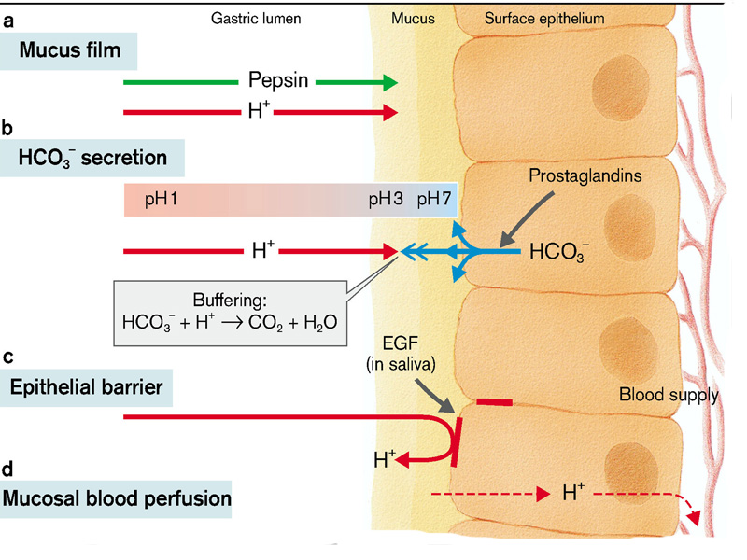

**Figure 11. Mucosal protection**

(From S. Silbernagl and F. Lang; Color Atlas of Pathophysiology)

***Peptic ulcer disease***

Peptic ulcer disease (PUD) refers to chronic mucosal ulceration affecting the duodenum or stomach.

*Etiology.* Nearly all peptic ulcers are associated with *H. pylori* infectionNSAIDs, or cigarette smoking. The most common form of peptic ulcer disease (PUD) occurs within the gastric antrum or duodenum as a result of chronic, *H. pylori* induced antral gastritis, which is associated with increased gastric acid secretion, and decreased duodenal bicarbonate secretion. In contrast, PUD within the gastric fundus or body is usually accompanied by lesser acid secretion as a result of mucosal atrophy (associated with some cases of *H. pylori-*induced or autoimmune chronic gastritis, as discussed earlier). While these patients still secrete more acid than normal individuals, they are incapable of secreting the much larger amounts needed to overcome the defense mechanisms that “protect” the antral and duodenal mucosa. Thus, individuals with gastric mucosal atrophy are generally protected from antral and duodenal ulcers. PUD may also be caused by acid secreted by ectopic gastric mucosa within the duodenum or an ileal Meckel diverticulum. PUD may also occur in the esophagus as a result of gastroesophageal reflux disease or acid secretion by esophageal ectopic gastric mucosa (an inlet patch) (Fig.12).

*Epidemiology*. The incidence of PUD is falling in developed countries along with reduced prevalence of *H. pylori*, infection. However, a new group of duodenal PUD patients older than 60 years of age has emerged as a result of increased NSAID use. This is particularly true when low-dose aspirin (for cardiovascular benefits) is combined with other NSAIDs. This is facilitated if concurrent *H. pylori* infection is also present. PUD has been associated with cigarette use and cardiovascular disease, likely due to reduced mucosal blood flow, oxygenation, and healing.

*Pathogenesis.* PUD results from imbalances between mucosal defense mechanisms and damaging factors that cause chronic gastritis (discussed earlier). Thus, PUD generally develops on a background of chronic gastritis. The reasons why some people develop only chronic gastritis while others develop PUD are poorly understood. However, as with H. pylorigastritis, it is likely that host factors as well as variation between bacterial strains are involved.

*Clinical Features.*Peptic ulcers can be chronic, recurring lesions with significant morbidity. The majority of peptic ulcers come to clinical attention because of *epigastric burning* *or aching pain*, although a significant fraction present with complications such as *iron deficiency anemia*, *hemorrhage*, or *perforation* . The pain tends to occur 1 to 3 hours after meals during the day, is worse at night (usually between 11 PM and 2 AM), and is relieved by alkali or food. Nausea, vomiting, bloating, belching, and significant weight loss are additional manifestations. With penetrating ulcers the pain is occasionally referred to the back, the left upper quadrant, or the chest, where it may be misinterpreted as cardiac in origin. Current therapies for PUD are aimed at *H. pylori* eradication and neutralization of gastric acid, primarily with proton pump inhibitors. It is also important to withdraw other offending agents, such as NSAIDs, including selective COX-2 inhibitors, that may interfere with mucosal healing. While peptic ulcers were previously notorious for their recurrence, the recurrence rate is now less than 20% following successful clearance of H. pylori. A variety of surgical approaches were formerly used to treat PUD, including antrectomy to remove gastrinproducing cells and vagotomy to prevent the acidstimulatory effects mediated by the vagus nerve. However, the success of proton pump inhibitors and H. pylori eradication has relegated surgical intervention to treatment of bleeding or perforated peptic ulcers.

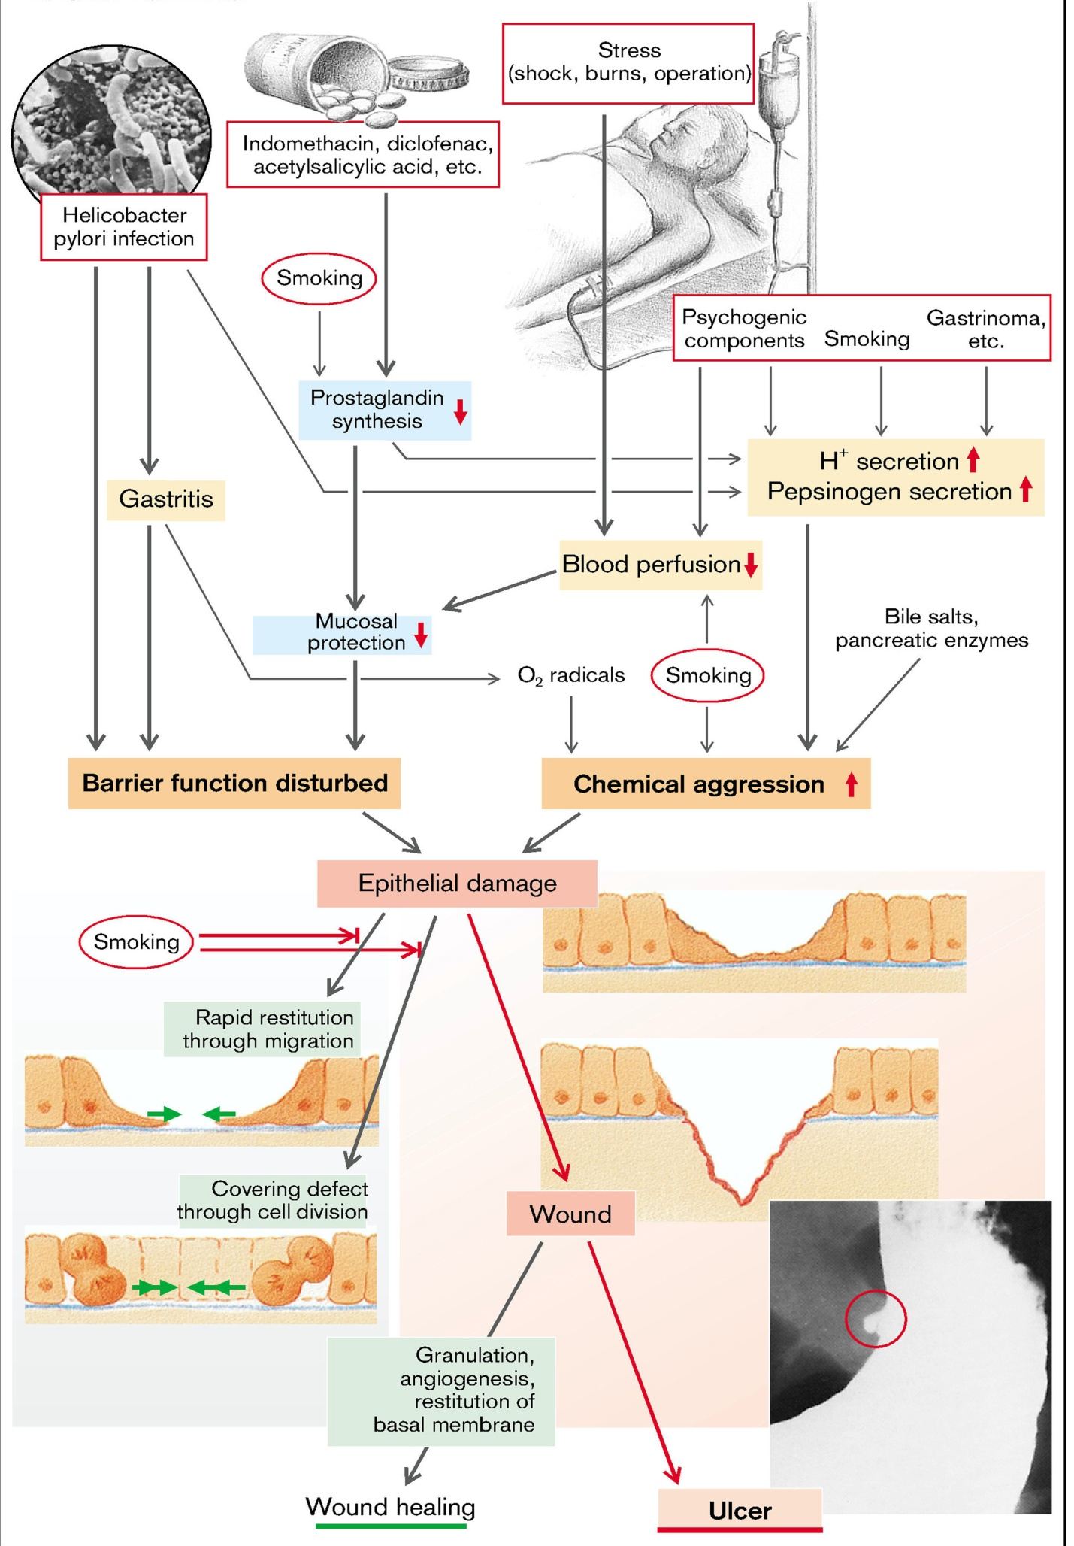

**Figure 12. Ulcer formation**

(From S. Silbernagl and F. Lang; Color Atlas of Pathophysiology)

**Disorders of pancreas**

 The exocrine partof the pancreas secretes 1–2 L of pancreatic juice into the duodenum each day. The pancreatic juice contains *bicarbonate* (HCO3–), which neutralizes (pH 7–8) HCl-rich chyme from the stomach, and mostly inactive precursors of digestive enzymesthat break down proteins, fats, carbohydrates and other substances in the small intestine.

**Pancreatic secretions** are similar to saliva in that they are produced in two stages: (1) Cl– is secreted in the acini by active secondary transport, followed by passive transport of Na+ and water. The electrolyte composition of these *primary secretions* corresponds to that of plasma. Primary pancreatic secretions also contain digestive proenzymes and other proteins (exocytosis). (2) HCO3*–* is added to the primary secretions (in exchange for Cl–) in the secretory ducts; Na+ and water follow by passive transport. As a result, the HCO3– concentration of pancreatic juice rises to over 100 mmol/L, while the Cl– concentration falls. Unlike saliva, the osmolality and Na+/K+ concentrations of the pancreatic juice remain constant relative to plasma. Most of the pancreatic juice is secreted during the digestive phase. HCO3– is secretedfrom the luminal membrane of the ductules via an anion exchanger that simultaneously reabsorbs Cl– from the lumen. Cl– returns to the lumen via a Cl– channel, which is more frequently opened by *secretin* to ensure that the amount of HCO3– secreted is not limited by theavailability of Cl–. In cystic fibrosis (mucoviscidosis),impairment of this CFTR channel (cystic **f**ibrosis **t**ransmembrane **c**onductance **r**egulator) leads to severe disturbances of pancreatic function. The HCO3– involved is the product of the CO2 + OH–reaction catalyzed by carbonic anhydrase (CA). For each HCO3– molecule secreted, one H+ ion leaves the cell on the blood side via an Na+/H+ exchanger.

Pancreatic juice secretion is controlledby cholinergic (vagal) and hormonal mechanisms (CCK, secretin). Vagal stimulation seems to be enhanced by CCKA receptors in cholinergic fibers of the acini. Fat in the chyme stimulates the release of CCK, which, in turn, increases the (pro)enzyme contentof the pancreatic juice. Trypsin in the small intestinal lumen deactivates CCK release via a feedback loop. *Secretin* increases HCO3– and water secretion by the ductules.CCK and acetylcholine (ACh) potentiate this effect by raising the cytosolic Ca2+ concentration. Secretin and CCK also affect the pancreaticenzymes.

**Pancreatic enzymes** are essential for digestion. They have a pH optimum of 7–8. Insufficient HCO3– secretion ( in cystic fibrosis) results in inadequate neutralization of chyme and therefore in impaired digestion.

*Proteolysis* is catalyzed by proteases, which are secreted in their inactive form, i.e., as *proenzymes*: *trypsinogen 1–3, chymotrypsinogen A* and *B, proelastase 1* and *2* and *procarboxypeptidase* *A1, A2, B1* and *B2*. They are not activated until they reach the intestine, where an *enteropeptidase* first converts trypsinogen to *trypsin*, which in turn converts chymotrypsinogen into active *chymotrypsin*. Trypsin also activates many other pancreatic proenzymes including proelastases and procarboxypeptidases. Pathological activation of the proenzymes within the pancreas causes the organ to digest itself (*acute pancreatic necrosis*). Trypsins, chymotrypsins and elastases are *endoproteases*, i.e., they split certain peptide bonds within protein chains. Carboxypeptidases A and B are *exopeptidases*, i.e., they split amino acids off the carboxyl end of the chain.

**Carbohydrate catabolism.** α-*Amylase* is secreted in active form and splits starch and glycogen into maltose, maltotriose and α-limit dextrin. These products are further digested by enzymes of the intestinal epithelium.

**Lipolysis.** *Pancreatic lipase* is the most important enzyme for lipolysis. It is secreted in its active form and breaks triacylglycerol to 2-monoacylglycerol and free fatty acids. Pancreatic lipase activity depends on the presence of *colipases*, generated from pro-colipases in pancreatic secretions (with the aid of trypsin). *Bile salts* are also necessary for fat digestion.

Other important pancreatic enzymes include (pro-) phospholipase A2, RNases, DNases, and a carboxylesterase.

***Pancreatitis***

*Pancreatitis* is inflammation in the pancreas associated with injury to the exocrine parenchyma. The clinical manifestations range in severity from a mild, self-limited disease to a life-threatening acute inflammatory process, and the duration of the disease can range from a transient attack to a permanent loss of function. *Acute pancreatitis* is a severe, life-threatening disorder associated with the escape of activated pancreatic enzymes into the pancreas and surrounding tissues. These enzymes cause fat necrosis, or autodigestion, of the pancreas and produce fatty deposits in the abdominal cavity with hemorrhage from the necrotic vessels. In *acute pancreatitis* the gland can return to normal if the underlying cause of the pancreatitis is removed. By contrast, *chronic pancreatitis* is defined by the irreversible loss of exocrine pancreatic parenchyma.

**Acute pancreatitis**

*Acute pancreatitis* is reversible pancreatic parenchymal injury associated with inflammation. Acute pancreatitis is relatively common, with an annual incidence rate in Western countries of 10 to 20 cases per 100,000 people. Biliary tract disease and alcoholism account for approximately 80% of cases in Western countries. Gallstones are present in 35% to 60% of cases of acute pancreatitis, and about 5% of patients with gallstones develop pancreatitis. The proportion of cases of acute pancreatitis caused by excessive alcohol intake varies from 65% in the United States to 20% in Sweden to 5% or less in southern France and the United Kingdom.The male-to-female ratio is 1:3 in the group with biliary tract disease and 6:1 in those with alcoholism.

***Etiology of acute pancreatitis***

1. Metabolic disorders, such as hypertriglyceridemia, hyperparathyroidism, and other hypercalcemic states (alcoholism, hyperlipoproteinemia, hypercalcemia);
2. Medications. More than 85 drugs have been implicated. These include furosemide, azathioprine, 2-3-dideoxyinosine, estrogens, azathioprine and many others drugs;
3. Genetic **(**mutations in the cationic trypsinogen (*PRSS1*) and trypsin inhibitor (*SPINK1*) genes).
4. Mechanical with obstruction of the pancreatic duct system (gallstones, trauma, iatrogenic injury, operative injury, endoscopic procedures with dye injection). Other reasons for obstruction include periampullary neoplasms (such as pancreatic cancer), pancreas divisum (although its role is controversial), choledochoceles (congenital cystic dilatation of the common bile duct), biliary “sludge,” and parasites (particularly the *Ascaris lumbricoides* and *Clonorchis sinensis* organisms).
5. Ischemic injury from shock, vascular thrombosis, embolism, and vasculitis.
6. Infectious (mumps)
7. Trauma. Both blunt abdominal trauma and iatrogenic injury during surgery or endoscopic retrograde cholangiopancreatography.

***Pathogenesis.*** Most pancreatic enzymes are activated by enteropeptidase only when they reach the intestinal lumen. The activation of trypsinogen to *trypsin*is a key feature in this, because trypsin activates other enzymes. If it is activated in the acinar cells, the pancreatic *trypsin tein* is responsible for trypsin not being effective there. However, if this protective mechanism does not keep up with the trypsin activation, or trypsin becomes active in the lumen of the pancreatic duct, *self-digestion of the pancreas*occurs (*acute pancreatitis*). Pancreatic enzymes, including trypsin, are synthesized in an inactive proenzyme form. If trypsin is inappropriately activated it can in turn activate other proenzymes such as prophospholipase and proelastase, which then degrade fat cells and damage the elastic fibers of blood vessels, respectively.Trypsin also converts prekallikrein to its activated form, thus bringing into play the kinin system and, by activation of Hageman factor (factor XII), the clotting and complement systems as well. In this way inflammation and small-vessel thromboses (which may lead to congestion and rupture of already weakened vessels) are amplified. Thus, the inappropriate activation of trypsinogen is an important triggering event in acute pancreatitis (Fig.14).

The mechanisms by which the activation of pancreatic enzymes is initiated are not entirely clear, but there is evidence for several possible events (Fig.13, Fig.14)).

1. *Pancreatic duct obstruction*. Gallstones or biliary sludge impacted in the region of the ampulla of Vater can raise intrapancreatic ductal pressure and lead to the accumulation of enzyme-rich fluid in the interstitium. Since lipase is one of the few enzymes secreted in an active form, this can cause local fat necrosis. Injured tissues, periacinar myofibroblasts, and leukocytes then release proinflammatory cytokines including IL-1β, IL-6, tumor necrosis factor, platelet-activating factor, and substance P, initiating local inflammation and promoting the development of interstitial edema through a leaky microvasculature. Edema may further compromise local blood flow, causing vascular insufficiency and ischemic injury to acinar cells.

Occlusion of the duct afterthe merging of the bile duct (by a gallstone) also leads to reflux of bile into the pancreas **(***duodenopancreatic reflux)*, where it damages the duct epithelium and accelerates fat digestion.

2. *Primary acinar cell injury*. This mechanism is most clearly involved in the pathogenesis of acute pancreatitis caused by certain viruses (e.g., mumps), drugs, and direct trauma to the pancreas, as well as pancreatitis following ischemia or shock. Alcohol, acetylsalicylic acid, histamine, etc…increase the permeability of the pancreatic duct epithelium, so that larger molecules can pass through it. Enzymes secreted by the acinar cells thus diffuse into periductal interstitial tissue and damage it. In addition, alcohol in the duct system seems to precipitate proteins, causing a rise in upstream pressure.

3. *Defective intracellular transport of proenzymes within acinar cells*.Research on animal models with acute pancreatitis indicates that under some circumstances pancreatic enzymes may also be activated intracellularly. The process of sorting out lysosomal enzymes and H+-ATPase, on the one hand, and the pancreatic proenzymes to be secreted, on the other, as normally normally occurs in the Golgi apparatus, seems to be disturbed. Thus, the proenzymes together with the lysosomal proteases will be incorporated into the same vesicles, so that trypsin will be activated there. Trace amounts are enough for this, because trypsin can activate itself autocatalytically. The role of this mechanism in human acute pancreatitis is not clear.

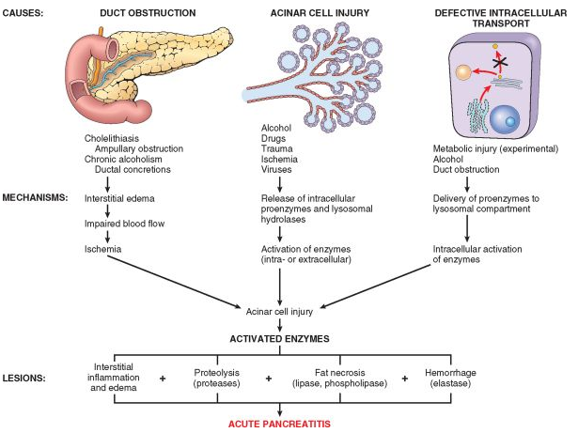

**Figure 13. Pathogenesis of acute pancreatitis**

(From Robbins-Cotran; Pathological basis of disease)

Alcohol consumption may also cause pancreatitis by several mechanisms. Chronic alcohol ingestion results in the secretion of protein-rich pancreatic fluid, which leads to the deposition of inspissated protein plugs and obstruction of small pancreatic ducts. Alcohol also transiently increases pancreatic exocrine secretion and contraction of the sphincter of Oddi (the muscle at the ampulla of Vater), and it has direct toxic effects on acinar cells.

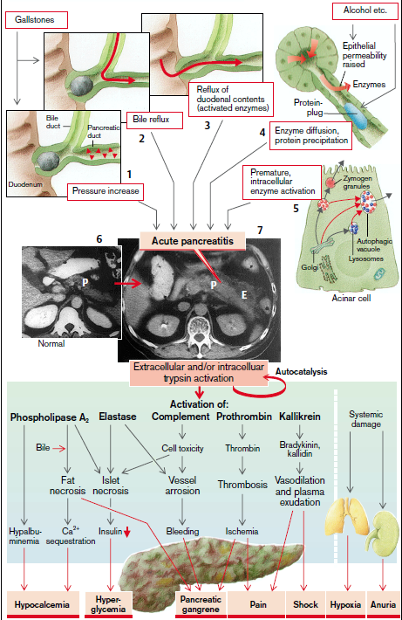

**Figure 14. Consequences of acute pancreatitis**

(From S. Silbernagl and F. Lang; Color Atlas of Pathophysiology)

*Consequences****.*** Trypsin activates other enzymes (phospholipase A2, elastase, etc.), clotting factors (prothrombin to thrombin), tissue hormones (bradykinin and kallidin are activated via kallikrein), and cytotoxic proteins (complement system). In the pancreas there is at first generalized cell swelling (*pancreatic edema)*; Activated elastase, in particular, causes *vessel arrosion* with bleeding (hemorrhagic pancreatitis) and ischemic zones in the organ. These ischemic areas are further enlarged by the formation of thrombi brought about by thrombin activation, the result being necrosis.

The endocrine islet cells are also destroyed, causing insulin deficiency and thus *hyperglycemia*. Fat necrosis develops around the pancreas with accompanying soap formation, a process that uses up Ca2+ (Ca2+ sequestration) and also causes hypocalcemia. Mg2+ ions in the plasma binding to the liberated fatty acids cause *hypomagnesemia*. All this damage can spread to neighboring retroperitoneal organs, i.e., spleen, mesentery, omentum, duodenum, etc. As the activated enzymes appear in plasma, where their presence is of diagnostic significance, hypoalbuminemia develops with resulting hypocalcemia, as well as systemic vasodilation and plasma exudation (triggered by bradykinin and kallidin), ultimately ending in circulatory shock. Phospholipase A2 and free fatty acids (due to increased lipolysis) in plasma destroy the surfactant on the alveolar epithelium, causing arterial hypoxia. Finally, the kidneys will also be damaged (danger of anuria) (Fig.14).

**Chronic pancreatitis**

*Chronic pancreatitis is defined as inflammation of the pancreas with irreversible destruction of exocrine parenchyma, fibrosis, and, in the late stages, the destruction of endocrine parenchyma*.Although chronic pancreatitis may present as repeated bouts of acute pancreatitis, the chief distinction between acute and chronic pancreatitis is the irreversible impairment in pancreatic function that is characteristic of chronic pancreatitis. The prevalence of chronic pancreatitis ranges between 0.04% and 5%.There is significant overlap in the causes of acute and chronic pancreatitis. By far the most common cause of chronic pancreatitis is long-term alcohol abuse (between 70-80% of cases).

***Etiology*** of chronic pancreatitis include the following: and these patients are usually middle-aged males.

● Long-standing *obstruction* of the pancreatic duct by pseudocysts, calculi, trauma, neoplasms, or pancreas divisum. There is often dilation of the pancreatic duct.

● *Tropical pancreatitis*, which is a poorly characterized heterogeneous disease seen in Africa and Asia.Some cases have a genetic basis.

● *Hereditary pancreatitis*, which is caused by germline mutations in *PRSS1* (cationic trypsinogen gene) or *SPINK1* (serine protease inhibitor Kazal type 1 gene), and is associated with the development of both acute and chronic pancreatitis.

● *CFTR gene mutations*. Cystic fibrosis is caused by bi-allelic inherited mutations in the cystic fibrosis transmembrane conductance regulator (*CFTR*) gene. Mutations in *CFTR* decrease bicarbonate secretion by pancreatic ductal cells, thereby promoting protein plugging and the development of chronic pancreatitis.Mutations in the *CFTR* gene occur in 25% to 30% of patients with idiopathic pancreatitis, a rate that is approximately 5 times higher than that of the general population.

*Chronic calcifying pancreatitis* is the most common form (70–80% of cases), caused by chronic alcohol abuse (> 80 g/d over many years) and is characterized by irregularly distributed tissue lesions with intraductal protein plugs and stones as well as atrophy and stenosis of the ductal system.

***Pathogenesis.*** The pathogenesis of chronic pancreatitis is not well understood. Almost all individuals with repeated episodes of acute pancreatitis later develop chronic pancreatitis. It has been proposed that acute pancreatitis initiates a sequence of perilobular fibrosis, duct distortion, and altered pancreatic secretions. Over time and with multiple episodes, this can lead to loss of pancreatic parenchyma and fibrosis.The events that have been proposed to account for the development of chronic pancreatitis include (Fig. 15):

1. *Ductal obstruction by concretions*. Some of the agents responsible for the development of chronic pancreatitis are believed to increase protein concentrations in the pancreatic juice. In chronic pancreatitis, from unkwoun causes in parallel with the stimulation of the acini enzyme-rich secretion there is reduction in secretion of HCO3– and water. As a result, protein concentration in the pancreatic juice is increased, especially when acinar secretion is stimulated. This leads to protein precipitation in the ductal lumens and protein plugs and deposits are thus formed. Calcium salts are deposited on the precipitated protein, resulting in the formation of stonesin the lumen of small ducts, and concentric calcium deposits on the walls of the larger ducts. The cause of all this may be that two components of pancreatic juice are diminished in chronic pancreatitis, namely those that normally prevent the precipitation of calcium salts from pancreatic juice. One of these components is *citrate***,** which binds calcium complexly, the other is the 14 kDa protein*, lithostatin*(= pancreatic stone protein [PSP]), which holds calcium salts in solution during (physiological) hypersaturation.
2. *Toxic effects*. Toxins, including alcohol and its metabolites, can exert a direct toxic effect on acinar cells. Alcohol-induced oxidative stress may generate free radicals in acinar cells, leading to membrane lipid oxidation and the activation of transcription factors, including AP1 and NF-κB, which in turn induce the expression of chemokines that attract mononuclear cells.Oxidative stress may promote the fusion of lysosomes and zymogen.
3. Similar to acute pancreatitis intraductal activation of trypsinoccurs. This not only contributes to the autodigestion of pancreatic tissue, but also activates other aggressive enzymes, such as elastase and phospholipase A2, in the ductal system and, in some circumstances, also interstitially. It is thought that the cause of the premature enzyme activation is that impaired drainage has increased intraductal pressure, resulting in epithelial lesions, together with raised proenzyme content (while the concentration of trypsin inhibitor–protein remains unchanged).

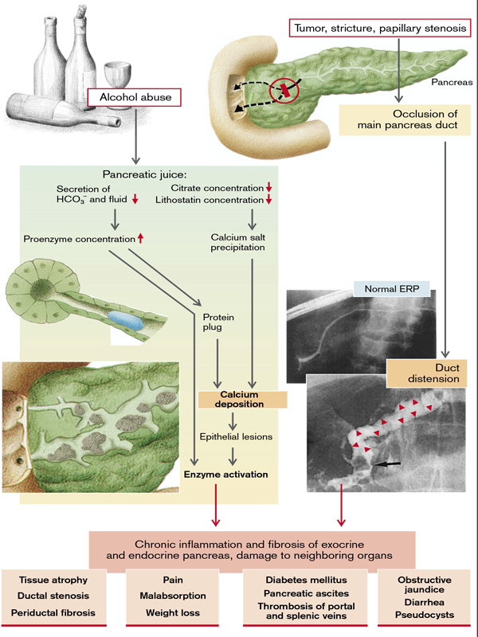

**Fig.15. Causes and consequences of chronic pancreatitis**

(From S. Silbernagl and F. Lang; Color Atlas of Pathophysiology)

A variety of chemokines have been identified in chronic pancreatitis, including IL-8 and monocyte chemoattractant protein.In addition, transforming growth factor β (TGF-β) and platelet-derived growth factor induce the activation and proliferation of periacinar myofibroblasts (pancreatic stellate cells), resulting in the deposition of collagen and ultimately fibrosis.While the chemokines produced during chronic pancreatitis are similar to those produced in acute pancreatitis, the profibrogenic chemokines tend to predominate in chronic pancreatitis (Fig.16).

1. 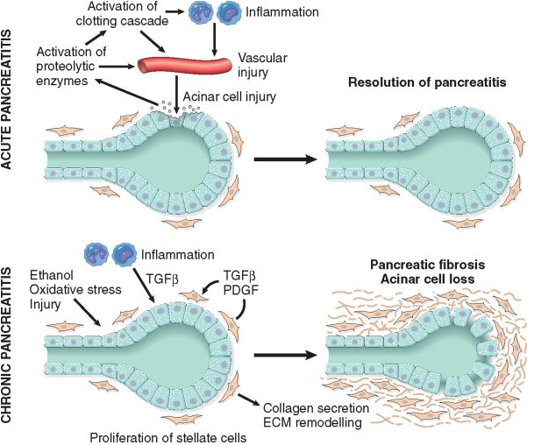

**Figure 16. Comparison of the mediators in acute and chronic pancreatitis**.

In acute pancreatitis acinar injury results in release of proteolytic enzymes, leading to a cascade of events including activation of the clotting cascade, acute and chronic inflammation, vascular injury, and edema. In most patients, complete resolution of the acute injury occurs with restoration of acinar cell mass. In chronic pancreatitis, repeated episodes of acinar cell injury lead to the production of profibrogenic cytokines such as transforming growth factor β (TGF-β) and platelet-derived growth factor (PDGF), resulting in the proliferation of myofibroblasts, the secretion of collagen, and remodeling of the extracellular matrix (ECM). Repeated injury produces irreversible loss of acinar cell mass, fibrosis, and pancreatic insufficiency. (From Robbins-Cotran; Pathological basis of disease)

*Consequences of chronic pancreatitis****.*** The results of chronic pancreatitis are tissue atrophy, ductal stenosis, and periductal fibrosis with scarring. This gradually leads to *loss of parenchyma*, which will cause exocrine and later also endocrine pancreatic insufficiency. Intermittent or continuous *pain*, *malabsorption* , diarrhea , and *weight loss* as well as *diabetes* *mellitus* and *damage to neighboring* *organs* (pancreatic ascites, portal and splenic vein thrombosis, obstructive jaundice,etc.) are associated with this (Fig.15).

Abdominal pain in 50% occurs as episodes of “acute pancreatitis”, although each attack results in a degree of permanent pancreratic damage. Relentless slowly progressive chronic pain without acute exacerbations affects 35% of patients whilst the remainder have no pain, but present with diarrhea*. Pain* is due to a combination of increased pressure within the pancreatic ducts and direct involvement of pancreatric and peripancreatic nerves by the inflammatory process. Pain may be relieved by learning forwards or by drinking alcohol. *Weight* loss is common and results from combination of *anorexia,* avoidance of food because of postprandial pain *, malabsorption* and/or diabetes. *Steatorrhea* occurs when more than 90% of the exocrine tissue has been destroyed, *protein malabsorption* only develops in the most advanced cases.

**Bile production and cholestasis**

 The secretion of bile is essential for digestion of dietary fats and absorption of fats and fat-soluble vitamins from the intestine. The liver produces approximately 600 to 1200 mL of yellow-green bile daily. Bile contains water, bile salts, bilirubin, cholesterol, and certain products of organic metabolism. Of these, only bile salts, which are formed from cholesterol, are important in digestion. The other components of bile depend on the secretion of sodium, chloride, bicarbonate, and potassium by the bile ducts. The liver forms approximately 0.6 g of bile salts daily. Bile salts serve an important function in digestion; they aid in emulsifying dietary fats, and they are necessary for the formation of the micelles that transport fatty acids and fatsoluble vitamins to the surface of the intestinal mucosa for absorption. Approximately 94% of bile salts that enter the intestine are reabsorbed into the portal circulation by an active transport process that takes place in the distal ileum. From the portal circulation, the bile salts pass into the liver, where they are recycled. Normally, bile salts travel this entire circuit approximately 18 times before being expelled in the feces. This system for recirculation of bile salts and other substances is called the *enterohepatic circulation.*

The average intake of fats (butter, oil, margarine, milk, meat, sausages, eggs, nuts etc.) is roughly 60–100 g/day, but there is a wide range of individual variation (10–250 g/day). Most fats in the diet (90%) are neutral fats or

*triacylglycerols* (triglycerides). The rest are phospholipids, cholesterol esters, and fatsoluble vitamins (vitamins A, D, E and K). Over 95% of the lipids are normally absorbed in the small intestine. *2-Monoacylglycerols*, *long-chain free fatty acids* and other lipids aggregate with bile salts to spontaneously form *micelles*in the small intestine. Since short-chain fatty acids are relatively polar, they can be absorbed directly and do not require bile salts or micelles). The micelles are only about 20–50nm in diameter, and their surface-tovolume ratio is roughly 50 times larger than

that of the lipid droplets in emulsions. They facilitate close contact between the products of fat digestion and the wall of the small intestine and are therefore essential for lipid absorption. The polar side of the substances involved

(mainly conjugated bile salts, 2-monoacylglycerol and phospholipids) faces the watery environment, and the non-polar side faces the interior of the micelle. Totally apolar lipids (cholesterol esters, fat-soluble vitamins and lipophilic poisons) are located inside the micelles. Thus, the apolar lipids remain in the lipophilic milieu (*hydrocarbon continuum*) during all these processes until they reach the lipophilic brush border membrane of thecells via dissolution in the membrane or by a passive transport mechanism (e.g., carriers in the case of free fatty acids). Although fat absorption is completed by the time the chyme reaches the end of the jejunum, the *bile* *salts* released from micelles are only absorbed in the terminal ileum and then recycled epithelium. They are then absorbed by the mucosa.

***Cholestasis***

Cholestasis represents a decrease in bile flow through the intrahepatic canaliculi and a reduction in secretion of water, bilirubin, and bile acids by the hepatocytes. As a result, the materials normally transferred to the bile, including bilirubin, cholesterol, and bile acids, accumulate in the blood. The condition may be caused by intrinsic liver disease, in which case it is referred to as *intrahepatic cholestasis,* or by obstruction of the large bile ducts, a condition known as *extrahepatic cholestasis.* A number of mechanisms are implicated in the pathogenesis of cholestasis. Primary biliary cirrhosis and primary sclerosing cholangitis are caused by disorders of the small intrahepatic canaliculi and bile ducts. In the case of extrahepatic obstruction, such as that caused by conditions such as cholelithiasis, common duct strictures, or obstructing neoplasms, the effects begin with increased pressure in the large bile ducts. Genetic disorders involving the transport of bile into the canaliculi also can result in cholestasis. Common to all types of obstructive and hepatocellular cholestasis is the accumulation of bile pigment in the liver. Elongated green-brown plugs of bile are visible in the dilated bile canaliculi. Rupture of the canaliculi leads to extravasation of bile and subsequent degenerative changes in the surrounding hepatocytes. Prolonged obstructive cholestasis leads not only to fatty changes in the hepatocytes but also to destruction of the supporting connective tissue, giving rise to bile lakes filled with cellular debris and pigment. Unrelieved obstruction leads to biliary tract fibrosis and ultimately to end-stage biliary cirrhosis. Pruritus is the most common presenting symptom in persons with cholestasis, probably related to an elevation in plasma bile acids. Skin xanthomas (focal accumulations of cholesterol) may occur, the result of hyperlipidemia and impaired excretion of cholesterol. A characteristic laboratory finding is an elevated serum alkaline phosphatase level, an enzyme present in the bile duct epithelium and canalicular membrane of hepatocytes. Other manifestations of reduced bile flow relate to impaired intestinal absorption, including nutritional deficiencies of fat-soluble vitamins A, D, and K.

**Disorders of the small and large intestine**

**Maldigestion and malabsorption syndrome**

A defect in the processing and enzymatic splitting within the gastrointestinal tract is called *maldigestion*; a disorder of absorption is called *malabsorption*. As both of them are closely intertwined, they are grouped together here as malabsorption (in the wider sense).

Normal digestion and absorptionconsists of the following serial steps:

1. Mechanical processing of food (chewing, distal gastric peristalsis);

2. Luminal digestion (gastric, intestinal, and pancreatic juices; bile);

3. Mucosal digestion by enzymes of the brush border;

4. Absorption by the mucosal epithelium;

5. Processing in the mucosal cell;

6. Transportation into blood and lymph, through which the absorbed substances reach the liver and the systemic circulation, respectively.

The causes of maldigestion and malabsorption can be due to disorders at any level of these processes (Fig.17).

Malabsorption results from disturbance in at least one of the four phases of nutrient absorption: (1) *intraluminal digestion*, in which proteins, carbohydrates, and fats are broken down into forms suitable for absorption; (2) *terminal digestion*, which involves the hydrolysis of carbohydrates and peptides by disaccharidases and peptidases, respectively, in the brush border of the small intestinal mucosa; (3) *transepithelial transport*, in which nutrients, fluid, and electrolytes are transported across and processed within the small intestinal epithelium; and (4) *lymphatic transport* of absorbed lipids. In many malabsorptive disorders a defect in one of these processes predominates, but more than one usually contributes. As a result, malabsorption syndromes resemble each other more than they differ.

*Pancreatic diseases,* for example, chronic pancreatitis, carcinoma of the pancreas, cystic fibrosis, or resection of the pancreas may lead to malabsorption due to a lack of important enzymes (lipase, colipase, trypsin, chymotrypsin, amylase, etc.) as well as of HCO3– which is necessary for buffering acidic chyme. *Atrophic gastritis* with achlorhydria will firstly diminish gastric digestionand secondly favor colonization of the small intestine with bacteria. This may also be caused by stasis in the small intestine due to diverticulosis or a small-intestine shunt (blind loop syndrome). The bacteria deconjugate bile salts and split the binding between cobalamine and intrinsic factor. The resulting cobalamine malabsorption leads to cobalamine deficiency**.**

*Lack of brush-border disaccharidase* causes malabsorption of the corresponding disaccharide. A lack of *lactase*, which splits lactose into glucose and galactose, is common. Lactase deficiency, which goes hand in hand with intolerance to milk and lactosecontaining foods, is rarely congenital, but often develops after weaning. There are marked ethnic differences.

*Defects of specific mucosal carriers*cause specific malabsorption. In *Hartnup disease*, for example, there is a specific carrier defect for certain neutral amino acids; in *cystinuria* for cationic (basic) amino acids and cystine. (The uptake of the affected amino acids as dipeptides

is undisturbed, because the mucosa has its own carrier for dipeptides).

Global defectsof mucosal digestion and absorption occur in *diffuse mucosal diseases*, such as celiac disease, tropical sprue, Crohn’s disease, Whipple’s disease, AIDS, infections (e.g., with Salmonella), *radiation enteritis*, and after *resection* of large portions of the small intestine.

In addition to *alcohol* (pancreatic insufficiency, chronic liver disease), a number of drugscause malabsorption: *colchicine* (inhibits division of crypt cells and disaccharidases), *neomycin* and similar antibiotics (inhibit division of crypt cells and disaccharidases; precipitate bile salts and micellar fatty acids), *methotrexate* (inhibits folate absorption), *cholestyramine* (binds bile salts), certain *laxatives*, *biguanides*, etc.

Especially in fat absorption, processing within the mucosal cells (formation of chylomicrons) is an important partial step whose disturbance in *abetalipoproteinemia* results in fat malabsorption. Another cause is *lymphatic blockage* (lymphangiectasia, lymphoma, etc.).

Finally, malabsorption naturally occurs if blood flow through the intestine is disturbed (ischemia, e.g., in vasculitis).

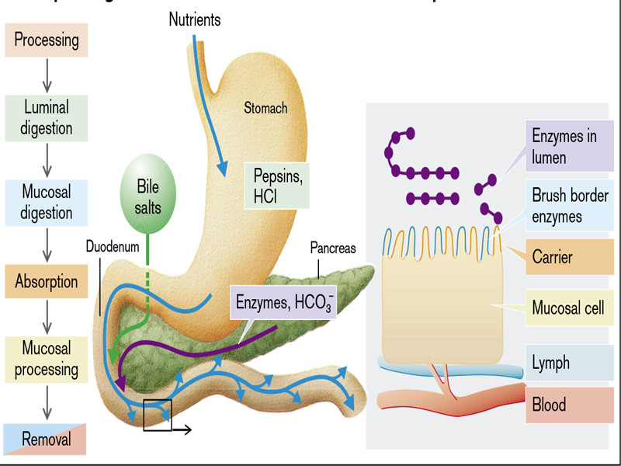

**Fig. 17. Steps in digestion the failure of which leads to maldigestion and malabsorption**

(From S. Silbernagl and F. Lang; Color Atlas of Pathophysiology)

*Malabsorption*, which presents most commonly as chronic diarrhea, is characterized by defective absorption of fats, fat- and water-soluble vitamins, proteins, carbohydrates, electrolytes and minerals, and water. General symptoms include diarrhea (from nutrient malabsorption and excessive intestinal secretion), flatus, abdominal pain, and weight loss (Fig.18).

The *consequences of malabsorption*are dependent on the kind of malabsorbed substance. *Malabsorption of proteins* can lead to muscular atrophy and weight loss, while any resulting hypoproteinemia will result in edema.

*Malabsorption of carbohydrates*in the small intestine means that some of them are metabolized to short-chain fatty acidsand to gases (CO2, H2) resulting in distension and flatulence. If more than 80 g/d of carbohydrates fail to be absorbed, osmosis-induced watery diarrhea occurs (see below).

*Malabsorption of fats* is characterized by fatty stools (*steotorrhea*) and leads to *weight loss* from a lack of these high-calorie components of food (Fig.19). Malabsorption of the fat-soluble vitamins A, D, E, and K occurs especially if fat malabsorption is caused by a *lack of bile salts* or by other reasons of abnormal formation of micelles. This is because these vitamins can only reach the absorbing mucosa in an uninterrupted lipophilic milieu for which micelles are essential. If vitamin K deficiency occurs, the glutamyl residues of prothrombin and other blood

clotting factors cannot be carboxylated in the liver, and thus *bleeding* may occur. Vitamin D deficiency causes *rickets* in children and *osteomalacia* in adults. In vitamin A deficiency *hyperkeratosis* and *night blindness* develops.

Malabsorption of the water-soluble vitamin cobalamine (B12) (for causes, see above) and folate (in global malabsorption or methotrexate administration) leads to macrocytic anemia, termed *pernicious* *anemia* if there is a cobalamine deficiency, to glossitis and aphthous ulcersas well as neurological defects (nerve degeneration) if there is a cobalamine deficiency. *Iron malabsorption* leads to hypochromic anemia.

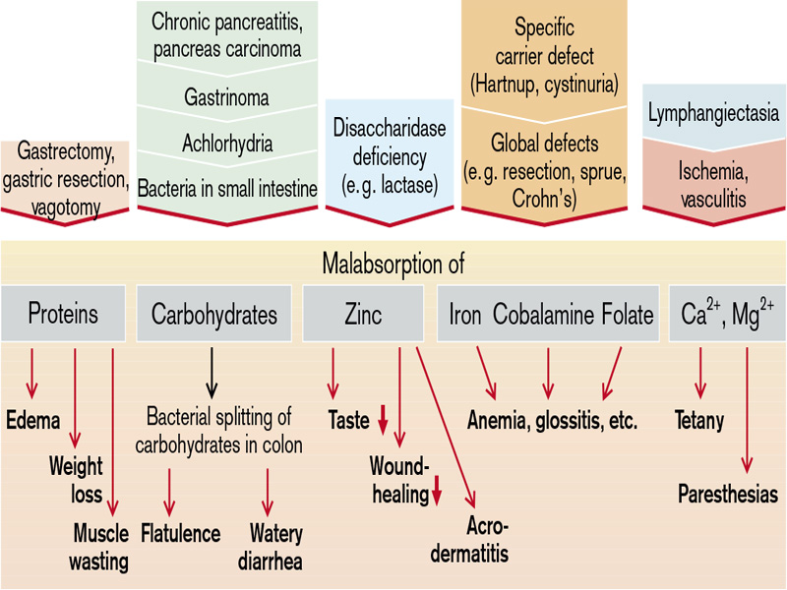

**Fig. 18. Causes and consequences of maldigestion and malabsorption**

(From S. Silbernagl and F. Lang; Color Atlas of Pathophysiology)

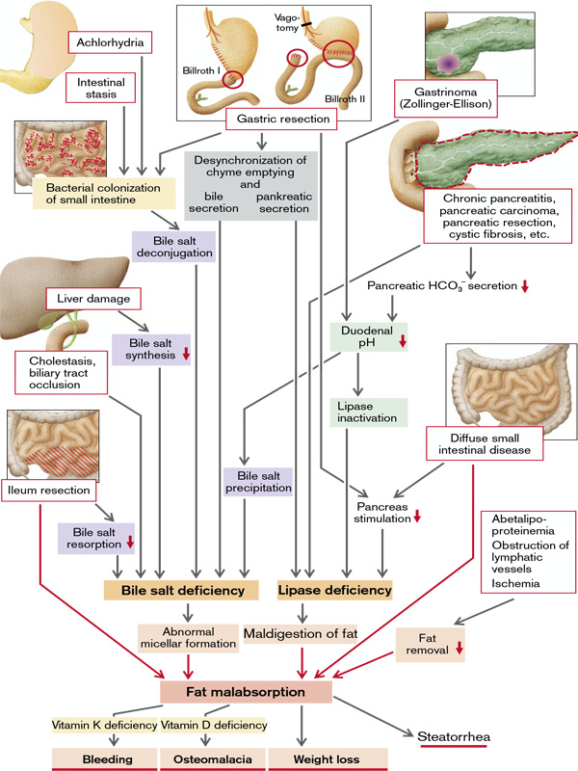

**Fig. 19. Maldigestion and malabsorbtion of fats**

(From S. Silbernagl and F. Lang; Color Atlas of Pathophysiology)

***Diarrhea*** is defined as an increase in stool mass, frequency, or fluidity, typically greater than 200 g per day. In severe cases stool volume can exceed 14 L per day and, without fluid resuscitation, result in death. Painful, bloody, small-volume diarrhea is known as *dysentery*. Diarrhea can be classified according to four major categories:

1. *Secretory diarrhea* is characterized by isotonic stool and persists during fasting.
2. *Osmotic diarrhea*, such as that which occurs with lactase deficiency, is due to the excessive osmotic forces exerted by unabsorbed luminal solutes. The diarrhea fluid is over 50 mOsm more concentrated than plasma and abates with fasting.
3. *Malabsorptive diarrhea* follows generalized failures of nutrient absorption and is associated with steatorrhea and is relieved by fasting.
4. *Exudative diarrhea* is due to inflammatory disease and characterized by purulent, bloody stools that continue during fasting.

**Secretory diarrhea** occurs when Cl– secretion of the small intestinal mucosa is activated (Fig.20). Within the mucosal cells Cl– is secondarily actively enriched by a basolateral Na+-K+-2Cl– symport carrier and is secreted via luminal Cl– channels. These open more frequently when the intracellular concentration of cAMP rises. cAMP is formed in greater amounts in the presence of, for example, certain laxatives and bacterial toxins (Clostridium difficile, Vibrio cholerae). Cholera toxin causes massive diarrhea (up to 1000 mL/h) that can rapidly become life-threatening because of the loss of water, K+, and HCO3– (hypovolemic shock, hypokalemia, nonrespiratory acidosis). Overproduction of VIP (vasoactive intestinal peptide) by pancreatic islet cell tumor also causes high cAMP levels in intestinal mucosa cells leading to copious, life threatening diarrhea: pancreatic “cholera” or watery diarrhea syndrome.

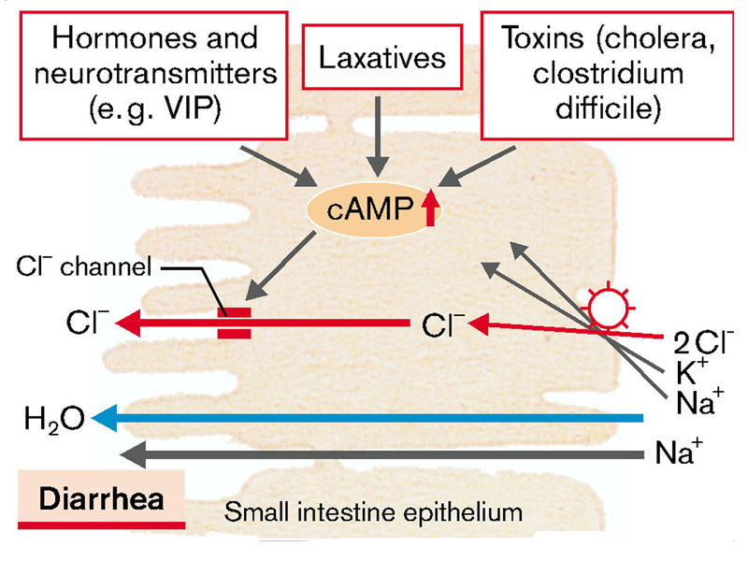

**Figure 20. Raised Cl- secretion**

(From S. Silbernagl and F. Lang; Color Atlas of Pathophysiology)

There are several reasons why diarrhea occurs after resection of the ileum and of part of the colon. Bile salts, normally absorbed in the ileum, cause accelerated passage through the colon (reduced water absorption). In addition, the nonabsorbed bile salts are dehydroxylated by the bacteria in the colon. The resulting bile salt metabolites stimulate the secretion of NaCl and H2O in the colon. Finally, there is also a lack of active absorption of Na+ in the resected intestinal segments (Fig.21).

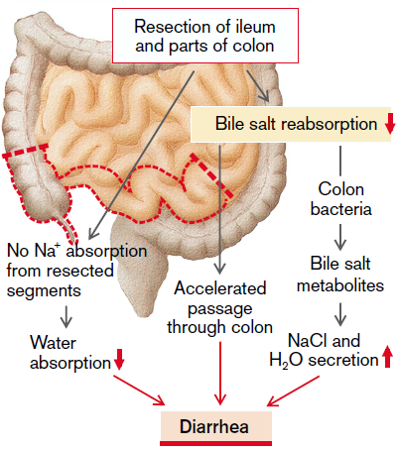

**Figure 21.Diarrhea in partial intestinal resection**

(From S. Silbernagl and F. Lang; Color Atlas of Pathophysiology)

**Osmotic diarrhea** results from the intake of a large number of substances that are poorly absorbable even normally, or in malabsorption. Among the first group are *sorbitol* (in “sugar-free” medications and sweets or certain fruits), *fructose* (in lemonades, diverse fruits, honey), *magnesium* *salts* (antacids, laxatives) as well as poorly absorbed *anions* such as sulfate, phosphate, or citrate. Nonabsorbed substances are osmotically active in the small intestine and therefore “suck” water into the lumen.

In *malabsorption of carbohydrates* the reduced Na+ absorption in the upper small intestine (diminished Na+ symport with glucose and galactose) leads to reduced water absorption. The osmotic activity of the nonabsorbed carbohydrates additionally results inwater secretion. However, bacteria in the large intestine can metabolize up to 80 g/d (divided over four meals) of nonabsorbed carbohydrates into organic acidsuseful for providing energy that together with water are absorbed in the colon. It is only the large amounts of marked gas produced (flatulence) that provide evidence of carbohydrate malabsorption. However, if > 80 g/d (i.e., > 1⁄4 of normal carbohydrate supply) is not absorbed or the intestinal bacteria are decimated by antibiotics, diarrhea occurs.

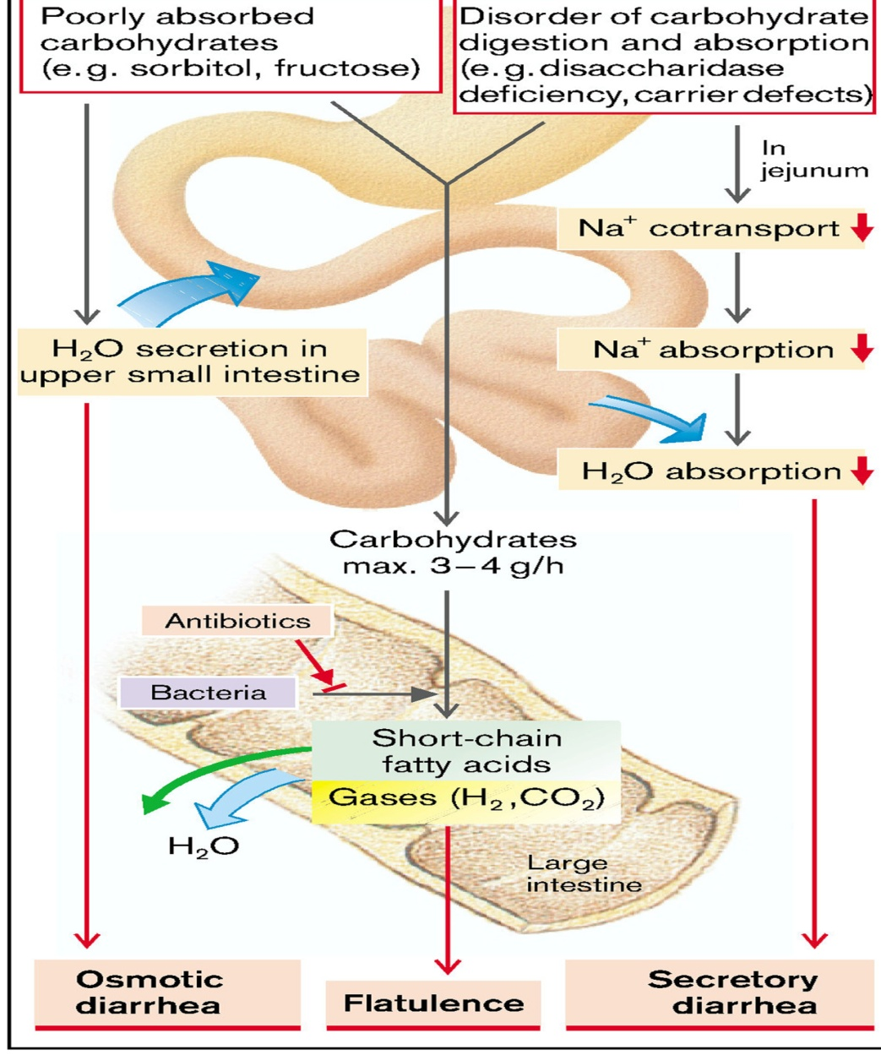

**Figure 19. Malabsorption of carbohydrates and osmotic diarrhea**

(From S. Silbernagl and F. Lang; Color Atlas of Pathophysiology)

***Exudative diarrhea*** commonly is associated with acute or chronic inflammation or intrinsic disease of the colon, such as ulcerative colitis or Crohn disease. Small-volume diarrhea usually is evidenced by frequency and urgency and colicky abdominal pain. It commonly is accompanied by tenesmus (*i.e.,* painful straining at stool), fecal soiling of clothing, and awakening during the night with the urge to defecate

**DISORDERS OF LARGE INTESTINE**

 The terminal end of the gastrointestinal tract includes the *large intestine* (*cecum*and *colon*, ca. 1.3m in length) and *rectum*. The large intestinal mucosa has characteristic pits (crypts), most of which are lined with mucus-forming cells (*goblet cells*). Some of the surface cells are equipped with a brush border membrane and reabsorb ions and water. The large intestine has two main functions: (1) It serves as a *reservoir* for the intestinal contents (cecum, ascending colon, rectum). (2) It absorbs water and electrolytes, so the ca. 500–1500 mL of chyme that reaches the large intestine can be reduced to about 100– 200 mL. The large intestine is not an essential organ; therefore, large segments of the intestine can be removed—e.g., for treatment of cancer.

Water instilled into the rectumvia an *enema* is reabsorbed. Anally delivered drugs (*suppositories*) also diffuse through the intestinal wall into the bloodstream. Substances administered by this route bypass the liver and also escape the effects of gastric acid and digestive enzymes.

*Maximum absorption capacity of the large intestine***.** The large intestine can absorb a maximum of 5 to 8 liters of fluid and electrolytes each day. When the total quantity entering the large intestine through the ileocecal valve or by way of large intestine secretion exceeds this amount, the excess appears in the feces as diarrhea. As noted earlier in the chapter, toxins from cholera or certain other bacterial infections often cause the crypts in the terminal ileum and in the large intestine to secrete 10 or more liters of fluid each day, leading to severe and sometimes lethal diarrhea.

The intestinal tract is initially sterile at birth, but later becomes colonized with orally introduced anaerobic bacteria during the first few weeks of life. The large intestine of a healthy adult contains 1011 to 1012 bacteria per mL of intestinal contents; the corresponding figure for the ileum is roughly 106/mL. The low pH inside the stomach is an important barrier against pathogens. Consequently, there are virtually no bacteria in the upper part of the small intestine (0–104/mL). Intestinal bacteria increase the activity of intestinal immune defenses (*“physiological inflammation”*), and their metabolic activity is useful for the host. The bacteria synthesize vitamin K and convert indigestible substances (e.g. cellulose) or partially digested saccharides (e.g. lactose) into absorbable shortchain fatty acids and *gases* (methane, H2, CO2).

*Composition of the feces* The average adult excretes 60–80 g of feces/day. Diarrhea can raise this over 200 g/d.**.** The feces normally are about three-fourths water and one-fourth solid matter that itself is composed of about 30 per cent dead bacteria, 10 to 20 per cent fat, 10 to 20 per cent inorganic matter, 2 to 3 per cent protein, and 30 per cent undigested roughage from the food and dried constituents of digestive juices, such as bile pigment and sloughed epithelial cells. The brown color of feces is caused by stercobilin and urobilin, derivatives of bilirubin. The odor is caused principally by products of bacterial action; these products vary from one person to another, depending on each person’s colonic bacterial flora and on the type of food eaten. The actual odoriferous products include indole, skatole, mercaptans, and hydrogen sulfide.

Weakening of intestinal peristalsis, independing on its character, leads to atonic constipations which result from the relaxation of intestinal muscles. Constipation, meteorism and intestinal autointoxication are the consequences of large intestine's hypotonia.

Gases, called *flatus*, can enter the gastrointestinal tract from three sources: (1) swallowed air, (2) gases formed in the gut as a result of bacterial action, or (3) gases that diffuse from the blood into the gastrointestinal tract.

Most gases in the stomach are mixtures of nitrogen and oxygen derived from swallowed air. In the typical person these gases are expelled by belching. Only small amounts of gas normally occur in the small intestine, and much of this gas is air that passes from the stomach into the intestinal tract.

In the large intestine, most of the gases are derived from bacterial action, including especially carbon dioxide, methane, and hydrogen. When methane and hydrogen become suitably mixed with oxygen, an actual explosive mixture is sometimes formed. Use of the electric cautery during sigmoidoscopy has been known to cause a mild explosion.

Certain foods are known to cause greater expulsion of flatus through the anus than others - beans, cabbage, onion, cauliflower, corn, and certain irritant foods such as vinegar. Some of these foods serve as a suitable medium for gas-forming bacteria, especially unabsorbed fermentable types of carbohydrates. For instance, beans contain an indigestible carbohydrate that passes into the colon and becomes a superior food for colonic bacteria. But in other instances, excess expulsion of gas results from irritation of the large intestine, which promotes rapid peristaltic expulsion of gases through the anus before they can be absorbed.

The amount of gases entering or forming in the large intestine each day averages 7 to 10 liters, whereas the average amount expelled through the anus is usually only about 0.6 liter. The remainder is normally absorbed into the blood through the intestinal mucosa and expelled through the lungs.

*Meteorism* is the excessive accumulation of gases in the intestine accompanied by intestinal bloating. Meteorism appears in case of weakening of the intestinal peristalsis, intensification of the fermentation and putrfaction processes with following accumulation of gases (methane, hydrogen sulphide, ammonia, and etc.). Gases accumulated in the intestine represent a foamy mass consisting of lots of small and covered by a viscous mucus bubbles. This foam covers the mucosa with a thin layer, disturbing in this way the parietal digestion, decreasing the activity of digestive enzymes and reducing the intestinal absorption (of water inclusively).

From etiopathogenetical point of view, meteorism can be: alimentary, digestive, dysbiotic, mechanical, dynamic, circulatory, psychogenous, and high-altitude.

*Alimentary meteorism* develops in case of ingestion of products, whose digestion is followed by excessive elimination of gases (cellulose, pectin, hemicellulose), consumption of aerated drinks, products that intensify the processes of intestinal fermentation (mutton, black bread), aerophagy.

*Digestive meteorism* is the consequence of disorders of the digestive processes — maldigestion and malabsorption, by means of accumulation of incompletely digested products which under the action of intestinal microflora produce gases in excess.

*Dysbiotic meteorism* represents the result of changes in the composition of large intestine's microflora (*dysbacteriosis*). Excess of microflora in small intestine intensifies the degradation of products with simultaneous excessive release of gases in the proximal portions of the intestinal tract.

*Mechanical meteorism* represents the retention of intestinal gases’ elimination by adherences, stenoses, and tumors.

*Circulatory meteorism* is conditioned by disturbances of local or general blood circulation (ischemic colites, venous stasis in the systemic circulation, portal hypertension). In the result, motor and evacuating functions of the intestine are unsettled, and intestinal dysbiosis develops.

*High-altitude meteorism* manifests under the conditions of decreased atmospheric pressure. In conditions of hypobaria, gases from closed cavities of the body, especially from the intestine, enlarge that leads to increase of their partial pressure. In consequence, intestinal meteorism, abdominal bloating and raising of the diaphragm (that provokes dyspnea) ensue. Deviation of the diaphragm irritates the phrenic nerve and causes unpleasant feelings in the region of the heart and reflex disturbances of the cardiac rhythm.

*Dynamic meteorism* appears in intestinal hypotonia and hypokinesia and manifests by reduced intestinal transit, intensification of fermentation processes, excessive formation and accumulation of gases in the intestine. It can be traced in postoperative intestinal pareses, intoxications with salts of heavy metals, peritonitis, vagotomy, irritated bowel syndrome, associated with disorders of the motility and co-ordination of different segments of the intestine.

**Gastrointestinal autointoxication**

Numerous bacteria, especially colon bacilli, are present even normally in the absorbing colon. They are capable of digesting small amounts ofcellulose, in this way providing a few calories of extranutrition for the body. In herbivorous animals, thissource of energy is significant, although it is of negligibleimportance in human beings.Other substances formed as a result of bacterial activityare vitamin K, vitamin B12, thiamine, riboflavin, andvarious gases that contribute to *flatus* in the colon, especiallycarbon dioxide, hydrogen gas, and methane.The bacteria-formed vitamin K is especially importantbecause the amount of this vitamin in the daily ingestedfoods is normally insufficient to maintain adequateblood coagulation. Coli bacilli, lactic-acid bacteria, streptococci compose about 10 % of the intestinal microflora. Simultaneously with the symbiotic activity, intestinal flora maintains the fermentation and putrefaction processes, which are followed by release of toxic substances. Amino acids are transformed into toxic products — hydrogen sulphide, skatol, indol, cresol, phenol, and etc. Decarboxylation of amino acids leads to excessive formation of biogenic amines: histamine, cadaverine, putrescine. Toxic products in their majority are eliminated with excrements, partially are neutralized by amino oxidases of the intestinal wall, and the rest being absorbed into the blood, undergoes the detoxication processes in the liver or is eliminated with urine.

Intoxication with intestinal toxic products *(intestinal autointoxication*) develop due to the intensification of fermentation and putrefaction processes and overloading of detoxication functions of the liver (excessive consumption of proteins), prolonged retention of faeces in the intestine (constipations, ileus), insufficiency of liver's detoxication functions, or incapacity of kidneys to excrete the toxic substances. In consequence, general autointoxication of the organism occurs. The manifestations of the intestinal autointoxication are: headache, decrease of appetite, anemia, arterial hypotonia, reduction of glycogen reserves in the liver and hypoglycemia, muscle weakness, dystrophic changes in the myocardium, diminution of heart's contractile force, and ,in severe cases, coma with lethal outcome.