**Cardiovasculary system**

[](http://www.google.md/imgres?imgurl=http://www.dotcrush.com/wp-content/uploads/2011/05/things-to-remember.jpg&imgrefurl=http://www.dotcrush.com/things-to-remember-to-make-life-easier/&usg=__B7n3pY2QrascXDx8cmdMR0EYP1Q=&h=336&w=351&sz=22&hl=mo&start=23&zoom=1&tbnid=3h73Z1HRq8TSbM:&tbnh=115&tbnw=120&ei=hT82T5GiIOOr0QW97uiKAg&prev=/images?q=remember+picture&start=20&hl=mo&sa=N&gbv=2&tbm=isch&itbs=1) The main function of the *circulatory system,* which consists of the heart and blood vessels, is transport. The circulatory system delivers oxygen and nutrients needed for metabolic processes to the tissues, carries waste products from cellular metabolism to the kidneys and other excretory organs for elimination, and circulates electrolytes and hormones needed to regulate body function (fig 1). This process of nutrient delivery is carried out with exquisite precision so that the blood flow to each tissue of the body is exactly matched to tissue need.

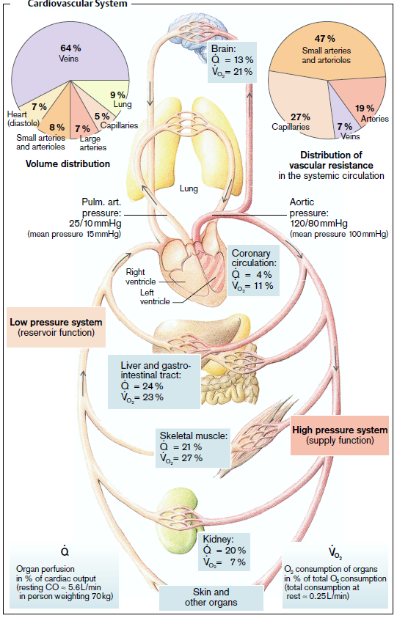

Fig.1. Systemic and pulmonary circulations. The right side of the heart pumps blood to the lungs, and the left side of the heart pumps blood to the systemic circulation. Color Atlas of Pathophysiology, Stefan Silbernagl.

The term *hemodynamics* refers to the principles that govern blood flow in the circulatory system. Blood circulation is determined by several factors:

* heart muscle function,
* vascular tone,
* volume of circulating blood
* blood rheological properties.

To determine the total and regional blood flow states are used the following parameters (table 1).

Table 1

|  |  |
| --- | --- |
| **Indices** | **Value** |
| Diastolic arterial pressure, mm of Hg | 65-85 |
| Systolic arterial pressure, mm of Hg | 110-120 |
| Stroke volume (ml) | 60-75 |
| Cardiac output (l) | 3,5-8,0 |
| Blood circulation speed in large arteries, cm/second | 13-15 |
| Blood circulation speed in capillaries, mm/second | 0,3 |
| Blood circulation speed in inferior vena cava, m/second | 0,2 |
| Blood circulation time, sec. | 20-23 |

Disorders of the cardiac functions, vascular tone, changes in the blood system may lead to the hypoperfusion of the organs and development of circulatory failure (shock). *Circulatory failure* is a common condition when the cardiovascular system doesn’t provide normal supply of oxygenated blood to the organs and tissues, with simultaneous waste products excretion from the tissues.

We distinguish the following pathogenetic forms of circulatory failure:

1. circulatory failure due to heart failure
2. circulatory failure due to vascular insufficiency
3. circulatory failure due to impaired of venous return to the heart

**Regulation of Cardiac Performance**

The efficiency and work of the heart as a pump often is measured in terms of *cardiac output* or the amount of blood the heart pumps each minute. The cardiac output (CO) is the product of the *stroke volume* (SV) and the *heart rate* (HR) and can be expressed by the equation CO= SV × HR. The heart rate is regulated by a balance between the activity of the sympathetic nervous system, which produces an increase in heart rate, and the parasympathetic nervous system, which slows it down, whereas the stroke volume is a function of preload, afterload, and myocardial contractility.

The cardiac output varies with body size and the metabolic needs of the tissues. It increases with physical activity and decreases during rest and sleep. The average cardiac output in normal adults ranges from 3.5 to 8.0 L/minute. In the highly trained athlete, this value can increase to levels as high as 32 L/minute during maximum exercise. The *cardiac reserve* refers to the maximum percentage of increase in cardiac output that can be achieved above the normal resting level. The normal young adult has a cardiac reserve of approximately 300% to 400%. Cardiac performance is influenced by the work demands of the heart and the ability of the coronary circulation to meet its metabolic needs. The heart’s ability to increase its output according to body needs mainly depends on four factors: the *preload* or ventricular filling, the *afterload* or resistance to ejection of blood from the heart, *cardiac contractility*, and the *heart rate*. Heart rate and cardiac contractility are strictly cardiac factors, meaning they originate in the heart, although they are controlled by various neural and humoral mechanisms. Preload and afterload, on the other hand, are mutually dependent on the behavior of the heart and blood vessels.

**Preload**

The preload represents the volume work of the heart. It is called the *preload* because it is the work or load imposed on the heart before the contraction begins. It is the amount of blood that the heart must pump with each beat and represents the volume of blood stretching the ventricular muscle fibers at the end of diastole (i.e., end-diastolic volume ≈ 120ml) and is the sum of the blood remaining in the heart at the end of systole (end-systolic volume ≈ 50 ml) and the venous return to the heart.The increased force of contraction that accompanies an increase in ventricular end-diastolic volume is referred to as the *Frank-Starling mechanism* or Starling law of the heart. The anatomic arrangement of the actin and myosin filaments in the myocardial muscle fibers is such that the tension or force of contraction is greatest when the muscle fibers are optimally stretched just before the heart begins to contract. The maximum force of contraction and cardiac output is achieved when venous return produces an increase in left ventricular enddiastolic filling (i.e., preload) such that the muscle fibers are stretched about two and one-half times their normal resting length. When the muscle fibers are stretched to this degree, there is optimal overlap of the actin and myosin filaments needed for maximal contraction.The Frank-Starling mechanism allows the heart to adjust its pumping ability to accommodate various levels of venous return.

**Afterload**

The afterload is the pressure or tension work of the heart. It is the pressure that the heart must generate to move blood into the aorta. It is called the *afterload* because it is the work presented to the heart after the contraction has commenced. The systemic arterial blood pressure is the main source of afterload work for the left heart and the pulmonary arterial pressure is the main source of afterload work for the right heart. The afterload work of the left ventricle is also increased with narrowing (i.e., stenosis) of the aortic valve. For example, in the late stages of aortic stenosis, the left ventricle may need to generate systolic pressures as great as 300 mm Hg to move blood through the diseased valve.

**Myocardial Contractility.**

Myocardial contractility, also known as *inotropy,* refers to the contractile performance of the heart, or the ability of the contractile elements (actin and myosin filaments) of the heart muscle to interact and shorten against a load. Contractility increases cardiac output independent of preload and afterload. The interaction between the actin and myosin filaments during cardiac muscle contraction (i.e., cross-bridge attachment and detachment) requires the use of energy supplied by the breakdown of adenosine triphosphate (ATP) and the presence of calcium ions (Ca2+). The long action potential duration in cardiac muscle is due to a slow inward Ca++current through a ***voltage-gated L-type Ca++ channel*** in the sarcolemma. The amount of Ca++ coming into the cardiac muscle cell is relatively small and serves as a trigger for release of Ca++ from the SR trough activation of ***ryanodine receptors****(****RYRs)***. In the absence of extracellular Ca++, one is still able to initiate an action potential in cardiac muscle, although it is considerably shorter in duration and unable to initiate a contraction. Thus, influx of Ca++ during the action potential is critical for triggering release of Ca++ from the SR and thus initiating contraction.

Relaxation of skeletal muscle simply requires reaccumulation of Ca++ by the SR through the action of the ***SR Ca++ pump (SERCA).*** Although SERCA plays a key role in the decrease in cytosolic Ca++ in cardiac muscle, the process is more complex than that in skeletal muscle because some trigger Ca++ enters the cardiac muscle cell through the sarcolemmal Ca++ channels during each action potential. Another mechanism that can extruded Ca++ from the cardiac muscle cell is ***3Na+/1Ca++ antiporter*** and a ***sarcolemmal Ca++ pump*** (Fig.2). These pumps transport calcium out of the cell, thereby preventing the cell from becoming overloaded with calcium.

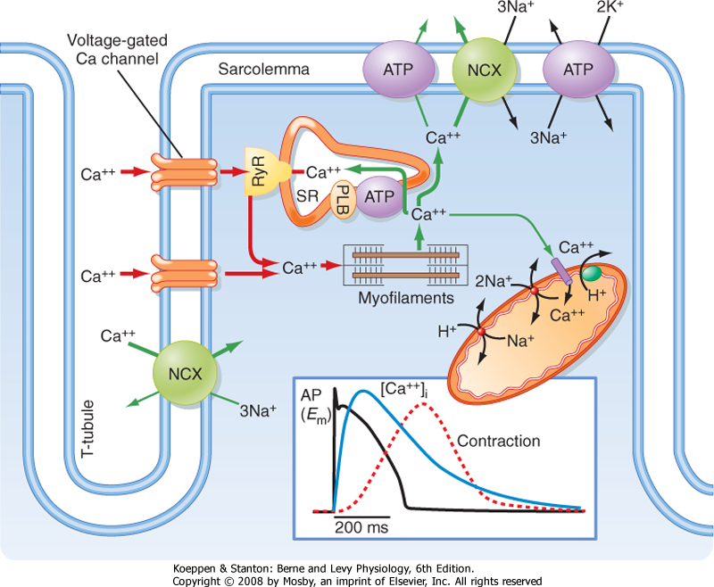

Fig 2. Excitation-contraction coupling in the heart requires Ca++ influx through L-type Ca++ channels in the sarcolemma and T tubules. Koeppen and Stanton, Physiology, 6th Edition.

An *inotropic* influence is one that modifies the contractile state of the myocardium independent of the Frank-Starling mechanism. For instance, sympathetic stimulation (via β-adrenergic receptors) produces a positive inotropic effect by increasing the calcium that is available for interaction between the actin and myosin filaments. Sympathetic stimulation of the heart activates ***adenylate cyclase***, increases **cAMP** and hence phosphorylation of several proteins by protein kinase A (PKA). Both voltage-gated L-type Ca++ channels (responsible for the trigger Ca++) and possibly nearby SR Ca++ channels (RyR) and another protein associated with SERCA, called ***phospholamban*** (PLB), are phosphorylated by cAMP-dependent protein kinase. The combined action of these phosphorylations increases the amount of Ca++ in the SR. Specifically, phosphorylation of the sarcolemmal Ca++ channel results in more trigger Ca++ entering the cell, and phosphorylation of phospholamban increases the activity of SERCA, thereby allowing the SR to accumulate more Ca++ before it is extruded by the 3Na+-1Ca++ antiporter and sarcolemmal Ca++ pump. The net result is that the SR releases more Ca++ into the cytosol during the next action potential, which promotes more actin-myosin interactions and hence greater force of contraction (fig. The increased activity of SERCA after sympathetic stimulation also results in a shortened contraction because of the rapid reaccumulation of Ca++ by the SR. This in turn allows the heart to increase its rate of relaxation. An additional consequence of sympathetic stimulation is an increase in heart rate through a direct effect on the pacemaker cells.Typically, there is also an increase in the rate of relaxation accompanying this β-adrenergic stimulation that results in a shorter contraction. The increase in the rate of muscle relaxation is termed ***positive lusitropy*.** The frequency of contractions of the heart also increases with β-adrenergic stimulation and is termed ***positiv*e *chronotropy*.** Thus, β-adrenergic stimulation of the heart produces stronger, briefer, and more frequent contractions.

Digitalis and related cardiac glycosides are *inotropic agents* that exert their effects by inhibiting the Na+/potassium ion (K-) -ATPase pump in the myocardial cell membrane, thereby leading to an increase in intracellular calcium through the Na+/Ca2+ exchange pump.

Muscarinic agonists (e.g., acetylcholine [ACh]), on the other hand, inhibit this sympathetic cascade by inhibiting the production of cAMP by adenylate cyclase.

Hypoxia exerts a negative inotropic effect by interfering with the generation of adenosine triphosphate (ATP), which is needed for muscle contraction.

**Heart Rate**

The heart rate influences cardiac output and the work of the heart by determining the frequency with which the ventricle contracts and blood is ejected from the heart. Heart rate also determines the time spent in diastolic filling. Although systole and the ejection period remain fairly constant across heart rates, the time spent in diastole and filling of the ventricles becomes shorter as the heart rate increases. This leads to a decrease in stroke volume and, at high heart rates, may produce a decrease in cardiac output. One of the dangers of ventricular tachycardia is a reduction in cardiac output because the heart does not have time to fill adequately.

**Heart Failure**

Adequate perfusion of body tissues depends on the pumping ability of the heart, a vascular system that transports blood to the tissues of the body and back to the heart, sufficient blood to fill the circulatory system, and tissues that are able to extract and use oxygen and nutrients from the blood. Heart failure and circulatory shock are separate conditions that reflect failure of the circulatory system. Both conditions exhibit common compensatory mechanisms even though they differ in terms of pathogenesis and causes.

***Heart failure*** *is a complex syndrome resulting from functional or structural impairment of ventricular filling or ejection of blood into the circulation*. *Heart failure* denotes the failure of the heart to pump enough blood to meet the metabolic needs of the body.

The efficiency of the heart as a pump is determined by the amount of blood that it ejects each minute. The heart has the amazing capacity to adjust its output to meet the varying needs of the body. During sleep, the output declines, and during exercise, it increases markedly. The ability of the heart to increase its output during increased activity is called the *cardiac reserve.* For example, competitive swimmers and long-distance runners have large cardiac reserves. During exercise, the cardiac output of these athletes rapidly increases to as much as five to six times their resting level. In sharp contrast with healthy athletes, persons with heart failure often use their cardiac reserve at rest. For them, just climbing a flight of stairs may cause shortness of breath because they have exceeded their cardiac reserve.

The syndrome of heart failure can be produced by any heart condition that reduces the pumping ability of the heart. Among the most common causes of heart failure are coronary artery disease, hypertension, dilated cardiomyopathy, and valvular heart disease. Heart failure can occur in any age group but primarily affects the elderly. Although morbidity and mortality rates from other cardiovascular diseases have decreased over the past several decades, the incidence of heart failure is increasing at an alarming rate. This change undoubtedly reflects improved treatment methods and increased survival from other forms of heart disease.

***Etiology***

*a.* *Cardiac factors:*

* pathological processes in the myocardium and their consequences (heart mechanical injuries, inflammation, dystrophy, ischemia, infarction, sclerosis);
* pathological processes in the endocardium and their consequences (congenital defects, inflammation, sclerosis, thrombosis, valve stenosis, valve deformation and insufficiency);
* pathological processes in the pericardium and their consequences (pericarditis, cardiac tamponade, sclerosis);
* pathologic processes of the coronary vessels (atherosclerosis, stenosis, vascular tone disturbances, thrombosis, embolism);
* pathologic processes of cardiac conduction and their consequences (inflammation, dystrophy, ischemia, infarction, sclerosis);

*b. Extracardiac factors:*

* pathologic processes of central nervous system (CNS) (commonly negative emotions, over function or exhaustion of nervous system);
* pathologic processes of endocrine glands (hyper- or hypo secretion of thyroid gland, adrenal glands);
* pathologic processes of blood system (changes of total blood volume, blood composition and blood rheological properties);
* pathologic processes of respiratory system (inflammation, emphysema, pneumosclerosis);

**Pathophysiology of Heart Failure**

The ***pathophysiological factors***, which lead to the heart failure development, may be divided into three large groups:

1. Factors that cause direct damage of the myocardium and subsequent decrease of heart contractility; (***systolic* and *metabolic heart failure***):
2. physical factors (myocardial trauma, action of the electric current );
3. chemical factors, including biochemical (increased concentrations of biologically active substances (adrenaline, thyroxin);
4. overdoses of drugs, substances that impair coupling of oxidation and phosphorylation processes in mitochondria;
5. enzyme’s inhibitors or inhibitors of trans membrane transport of Ca2+ ions in cardiomyocytes,
6. sympathomimetic drugs;
7. electron transport blockers in mitochondrial respiratory chain);
8. biological factors (microorganisms and/or their toxins, parasites);
9. lack of factors which are necessary for normal functioning of the heart: oxygen, substrates for oxidation, enzymes, vitamins.
10. Factors that cause direct damage of the heart and disturb the diastolic filling;(***diastolic heart failure*):**
11. myocardium (infiltrative diseases, cardiac fibrosis, cardiac amyloidosis, hemochromatosis, cardiac hypertrophy),
12. endocardium (fibroelastosis),
13. pericardium with impaired cardiac filling during diastole, in case of constrictive pericarditis, cardiac tamponade.
14. Factors that cause the myocardiumwork overload (pressure - afterload and volume - preload); (***hemodynamic heart failure***):
15. Factors that increase afterload: arterial hypertension, aorta and pulmonary artery stenosis, hemoconcentration.
16. Factors that increase preload: hypervolemia, mitral or aortic regurgitation, ventricular septal defect.

There are also mixed forms when myocardium injury (e.g. myocarditis) is accompanied by cardiac work overload (e.g. valve insufficiency).

***General pathogenesis of cardiac failure***

Heart failure, that develops *primary* as a result of direct myocardium alteration, is characterized by decrease of cardiac tension manifested by decreased power and velocity of heart muscle contraction and relaxation.

Heart failure, which develops *secondary* as a result of heart functional overloading is characterized by decreased powerful and velocity of heart contraction and relaxation. But, despite the diversity of causes and peculiarities of heart failure the general pathogenetical mechanisms (at the molecular and cellular level) and consequences are the same.

The pathogenetic mechanisms of heart failure are (fig. 3):

1. disturbance of heart energy supply;
2. alteration of cardiomyocyte membrane and enzymatic systems;
3. Hydroelectrolitic imbalance of cardiomyocytes;
4. Disturbance of neurohumoral cardiac regulation.

Cardiac lesions

Cardiac overload

Energy supply disturbance in cardiac hystiocyte

Cellular membrane and enzyme alteration

Ion and liquid imbalance in cardiomycytes

Myocardial neurohumoral regulation disturbance

nce

Power and speed of contraction and relaxation decrease

**Heart failure**

Extra- and intracardiac compensatory mechanisms

Fig 3. Pathogenesis of cardiac failure

*1***. *Disturbance of heart energy supply.***

The heart requires a continuous supply of energy (in the form of ATP) not only to perform its mechanical pumping functions, but also to regulate intracellular and transsarcolemmal ionic movements and concentration gradients. Among its pumping functions, the development of tension, the frequency of contraction, and the level of myocardial contractility are the principal determinants of the heart’s substantial energy needs, making its O2 requirements approximately 15% of that of the entire organism.

Most ATP production (fig. 4) depends on the oxidation of substrate [glucose and free fatty acids (FFAs)]. Myocardial FFAs are derived from circulating FFAs, which result principally from lipolysis in adipose tissue, whereas the myocyte’s glucose derives from plasma as well as from the cell’s breakdown of its glycogen stores (glycogenolysis). These two principal sources of acetyl *coenzyme A* in cardiac muscle vary reciprocally. Glucose is broken down in the cytoplasm into a three-carbon product, pyruvate, which passes into the mitochondria, where it is metabolized to the two-carbon fragment, acetyl-Co-A, and undergoes oxidation. FFAs are higher source of energy, from 1 molecule of palmitic acid, which contain 16 carbon atoms, produce 130 molecules of ATP. FFAs are converted to acyl-CoA in the cytoplasm and acetyl-CoA in the mitochondria. Acetyl-CoA enters the citric acid (Krebs) cycle to produce ATP by oxidative phosphorylation within the mitochondria; ATP then enters the cytoplasm from the mitochondrial compartment. Intracellular ADP, resulting from the breakdown of ATP, enhances mitochondrial ATP production. Myocardial energy is stored as creatine phosphate (CP), which is in equilibrium with ATP, the immediate source of energy. In states of reduced energy availability, the CP stores decline first.

Energy supply disturbances is one of the main pathological processes, which occur in cardiomyocytes, develops as a result of:

* alteration of ATP re-synthesis mechanisms,
* alteration of ATP carrier mechanisms to the effector structures of heart cells,
* decreased utilization of high-energy compounds’ energy.

ATP re-synthesis decreases, due to suppression of aerobic oxidative processes. The actions of the majority of pathogenic factors break down the mitochondrial functions. As a result of myocardial alteration or its long-term overload, oxidation of FFAs in mitochondria is disturbed, and ATP synthesis decreases. The main ATP source in these conditions is glycolytic pathway (anaerobic), which is about 18 times less efficient than aerobic glycolysis, and can’t adequate compensate the deficiency of high-energy compounds.

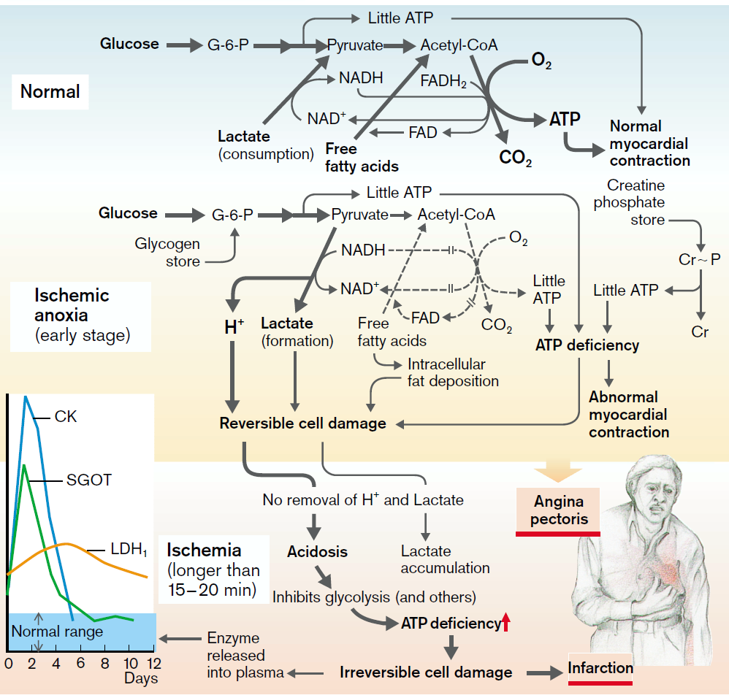

Fig.4 Myocardial energy metabolism in healthy state and during the ischemia. Color Atlas of Pathophysiology, Stefan Silbernagl.

Heart insufficiency may develop during normal or insignificantly decrease level of ATP. This occurs due to destruction of energy carrier system from the place of its production toward effector structures, which use energy primarily to the myofibrils and sarcoplasmic reticulum. Energy transport to the effector structures is supplied with the help of phosphocreatine (PC), by way of 2 enzymes:

*-ATP-ADP translocase* (which realizes ATP energy transport from mitochondrial matrix through their interior membrane),

*-phosphocreatine kinase* – it is localized on the exterior side of inner mitochondrial membrane (supplies transport of high-energy bond on creatine with formation of phosphocreatine). Then phosphocreatine goes to cytosol. The presence of phosphocreatine kinase in myofibrils and other effector structures supplies effective utilization of phosphocreatine for maintaining necessary ATP concentration. During the action of pathogenic factors, which develop heart failure first phosphocreatine concentration decreases, then ATP concentration decreases. Development of heart failure is accompanied by massive loss of phosphocreatine kinase by cardiomyocytes, which can be noticed by increased its concentration in the blood.

Heart failure due to myocardium energy supply disturbance may develop also in conditions when synthesis and transport of energy are normal, but is altered the enzymatic mechanisms of energy usage in cardiomyocytes, mainly due to decrease of ATP-ase activity. This refers, to myosin ATP-ase, K+-Na+-ATP-ase of sarcolemma, Mg2+-dependent ATP-ase of “calcium pump” in sarcoplasmic reticulum. As a result, ATP energy isn’t used by effector apparatus of cardiac cells.

Considering that about 90% of total energy is used in the reactions that ensures the contractile process (about 70% is used for myocardium contraction, 15% for Ca2+ ions transport in sarcoplasmic reticulum and cationic exchange in mitochondria, 5% - for active Na+ ion transport through sarcolemma), so the disturbance of ATP assurance mechanisms of cardiomyocytes leads to fast and markedly decreased myocardial contractile properties.

So, disturbance of heart energy supply at the stages of synthesis, transporting and using of it, can be a trigger mechanism of decreasing cardiac contractile function, or an essential factor which worsens the contractility.

***2 Disturbance of cardiomyocyte membrane apparatus and enzyme system.***

There are several main mechanisms of membrane and enzyme disturbance incardiomyocyte.

1. *Excessive formation of free radicals* followed by lipid peroxidation of membranes and their cardiotoxic action. Main factors of lipid peroxidation in the myocardium are:

* increase concentration of peroxidative factors in myocardium (products of ATP hydrolysis, of catecholamines, of metabolites and coenzymes, metals with variable valence, such as myoglobinic iron);
* decrease activity or concentration of cardyomiocites antioxidant systems, enzymatic or non-enzymatic nature (catalase, glutathione peroxidase, superoxide dismutase, tocopherol, selenium compounds, ascorbic acid);
* Excess of lipid peroxidative substrates like as higher fatty acids, phospholipids, amino acids.

2*. Excessive activation of cardiomyocyte’s hydrolases*, which occurs as a result of:

* H+ ion accumulation, which contribute to releasing and activation of lysosomal hydrolases;
* Ca2+ ion accumulation which activate free and membrane-bound lipases, phospholipases, proteases;
* Excess of catecholamines and higher fatty acids, lipid peroxidative products (FRLP), which activate phospholipases.

1. *Detergent action of FRLP and lipid hydrolysis products*. End products of these reactions are included in membranes, inducing their conformational changes and contributing to replacement from membrane of integral and peripheral proteins, lipids, and forming of cluster-channels for trans-membranous permeability.
2. Inhibition the re-synthesis processes of protein and lipid molecules of denatured membranes, and their *de novo* synthesis.
3. Conformational changing of protein and lipoprotein molecules, as a result of cardiomyocyte’s energy supply deficiency.
4. Hyper-stretching and micro-alterations of cardiomyocyte sarcolemma and organelles membranes, due to increased intracellular oncotic and osmotic pressure; which is determined by excess of hydrophilic cations (Na+,Ca2+) and several organic substances (lactate, pyruvate, glucose, and others).

Finally, membrane and enzymatic alteration of cardiomyocyte are the main link, often are initial for pathogenesis of heart failure. Physicochemical and conformational changes of proteins (structural and enzymatic), lipids, phospholipids and lipoproteins provide significant, often irreversible structural and functional alterations of heart cells.

***3 Hydroelectrolitic imbalance of cardiomyocytes***

Ionic imbalance are characterized by disturbance of ratio between certain ions in hyaloplasm and cellular organelles (mitochondria, sarcoplasmic reticulum, myofibrils) from one side, and in hyaloplasm itself – from the other side. Different factors, which lead to heart insufficiency, disturb energy supply processes and alter cardiac cells membrane. As a consequence, membrane permeability is changed notably for different ions. Also activity of enzymes is changed, which provide transmembrane transport of cations, due to what, balance and concentration of ions is disturbed. Especially this relates to sodium, potassium, calcium, magnesium ion transport; the ions which provide the realization of excitation, electromechanical conjugation, contraction and relaxation of the myocardium.

In case of heart failure decrease activity of K+-Na+ dependent ATP-ase pump, that leads to K+ ions loss by hyaloplasm and accumulation in cardiac cells of Na2+ ions. Increased intracellular Na2+ concentration provides accumulation of Ca2+ ions in cytoplasm. This phenomenon is a consequence of Na+-Ca2+ ion exchange disturbance. This mechanism provides exchange of 2 Na+ ions, which enter the cell, with one Ca2+ ion, which leaves the cell, and is realized due to the common transmembrane carrier for sodium and calcium ions. Intracellular sodium concentration increase, which competes with calcium for common carrier, blocks Ca2+ output, inducing accumulation of Ca2+ ions in the cell.

In case of main types of cardiac failure, increased intracellular Ca2+ concentration is induced by following factors:

1. increased sarcolemmal permeability, which in normal conditions blocks Ca2+ influx into the cell by concentration gradient;
2. decreased calcium pump activity in sarcoplasmic reticulum (SERCA), which accumulates Ca2+ ions;
3. decrease of energy dependent mechanisms, which provide Ca2+ elimination from sarcolemma. (see “*Cellular injuy*”).

Excessive accumulation of Ca2+ ions in hyaloplasm, has several important consequences:

* Disturbance of myofibril relaxation, manifested by increased enddiastolic pressure and even cardiac arrest during systole (irreversible myocardium contracture);
* Ca2+ ions capture by mitochondria is increased, that leads to uncoupling of oxidative phosphorylation followed by decreased ATP concentration. ATP deficiency activates anaerobe glycolysis, and as a consequence H+ ions is accumulated, and lead to elimination of Ca2+ from sarcoplasmic reticulum that impede normal contractile function of myocardium.
* Activation of Ca2+ dependent proteases and lipases, which worsens cardiac contractility due to alteration of cardiomyocytes membrane and enzymatic system.

Accumulation of Na+ and Ca2+ ions lead to overhydration of cardiomyocytes hyaloplasm and organelles. As a consequence, excessive membrane expanding develops, energy supply of the cells is decreased (related to mitochondrial intumescence, rupture of their membranes, additional disturbance of ATP utilization and transport mechanisms), that aggravates membrane alteration.

***4. Disturbance of neurohumoral cardiac regulation***

Nervous and humoral regulation of the myocardium cells is to maintain their activity. In physiological conditions they provide achievement and mobilization of adaptive reactions, early and late adjustment of cardiac functions according to the body needs.

In case of heart failure an important role have nervous influence on heart (sympathetic and parasympathetic) in forming of adaptive or pathologic reactions. Heart insufficiency also is characterized by decreased concentration of sympathetic nervous system neuromeditor (noradrenaline) in cardiac tissue.

This is provided mainly by two factors:

* Primary - decrease noradrenaline synthesis in the neurons of sympathetic nervous system (normally, 80% of noradrenaline founded in myocardium is synthesized in neurons of sympathetic nervous system);
* Secondary – disturbance of noradrenaline reuptake from synaptic gap.

One of the most significant causes of neuromediator synthesis disturbance is decreasing of tyrosine hydroxylase activity - enzyme, which is responsible for catecholamine biosynthesis. Decreasing of noradrenaline reuptake is provided mainly by ATP deficiency (process of reuptake is energy dependent), biochemical changes in myocardium (acidosis, increased intracellular K+ concentration), and by alteration of nervous endings membranes.

Heart insufficiency is conducted by decreasing of cardiac effects (which are provided by noradrenaline), by decreasing of adrenal-reactive heart properties.

One of the main consequences of reduced sympathetic influence on myocardium – is the decreased control and the efficiency of heart regulation, especially in extreme situations.

Acetylcholine concentration – neuromediator of parasympathetic nervous system, as well as cholinereactive properties of the heart, at different stages of heart failure, are normal or insignificant tend to increase.

**Types of Heart Failure**

According to pathological factors that lead to heart failure (HF), there are several types of it:

1. Heart failure due to decreased heart contractility (*systolic dysfunction or metabolic heart failure*)
2. HF due to diastolic filling of the ventricles(*diastolic dysfunction*),
3. HF due to the myocardiumwork overload (afterload and preload) (*hemodynamic heart failure*).

**Heart failure due to myocardium injury**

**Systolic Dysfunction.** In systolic ventricular dysfunction, myocardial contractility is impaired, leading to a decrease in the ejection fraction (percentage of the end-diastolic volume that the heart ejects with each contraction).

Systolic dysfunction is primarily defined as a decrease in myocardial contractility, characterized by an ejection fraction of less than 40%. A normal heart ejects approximately 65% of the blood that is present in the ventricle at the end of diastole. In systolic heart failure, the ejection fraction declines progressively with increasing degrees of myocardial dysfunction. Systolic dysfunction commonly results from conditions that impair the contractile performance of the heart (e.g., ischemic heart disease or *coronary artery disease*  and cardiomyopathy), produce a volume overload (e.g., valvular insufficiency and anemia), or generate a pressure overload (e.g., hypertension and valvular stenosis) on the heart.

The term *coronary artery disease* (CAD) describes heart disease caused by impaired coronary blood flow. Diseases of the coronary arteries can cause a spectrum of disorders ranging from myocardial ischemia and angina to myocardial infarction or heart attack, conduction defects, heart failure, and sudden death.

**Coronary Circulation disorders**

[](http://www.google.md/imgres?imgurl=http://www.dotcrush.com/wp-content/uploads/2011/05/things-to-remember.jpg&imgrefurl=http://www.dotcrush.com/things-to-remember-to-make-life-easier/&usg=__B7n3pY2QrascXDx8cmdMR0EYP1Q=&h=336&w=351&sz=22&hl=mo&start=23&zoom=1&tbnid=3h73Z1HRq8TSbM:&tbnh=115&tbnw=120&ei=hT82T5GiIOOr0QW97uiKAg&prev=/images?q=remember+picture&start=20&hl=mo&sa=N&gbv=2&tbm=isch&itbs=1)The blood vessels of the heart comprise the coronary arteries and coronary veins, which carry blood to and from most of the myocardium (Fig. 5). Even under normal resting conditions, the heart extracts and uses 60% to 80% of oxygen in blood flowing through the coronary arteries, compared with the 25% to 30% extracted by skeletal muscle.The blood vessels of the heart, normally embedded in fat, travel across the surface of the heart just under the epicardium. There are two main coronary arteries, the left and the right, which arise from the coronary sinus just above the aortic valve.The left coronary artery extends for approximately 3.5 cm as the *left main coronary artery* and then divides into the left anterior descending and circumflex branches. The *right coronary* *artery* lies in the right atrioventricular groove, and its branches supply the right ventricle. The right coronary artery usually moves to the back of the heart, where it forms the *posterior descending artery,* which normally supplies the posterior portion of the heart, interventricular septum, sinoatrial (SA) and atrioventricular (AV) nodes, and posterior papillary muscle. With gradual occlusion of the larger vessels, the smaller collateral vessels increase in size and provide alternative channels for blood flow.

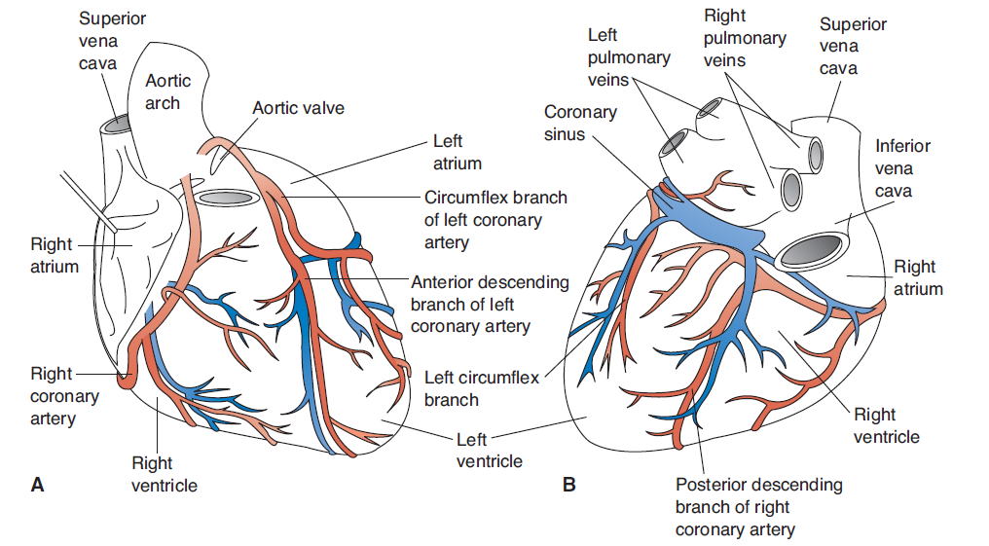

Fig. 5 Coronary circulation

Coronary heart disease is commonly divided into two types of disorders:

* the acute coronary syndromes;
* chronic ischemic heart disease.

The acute coronary syndromes represent the spectrum of acute CAD ranging from unstable angina to myocardial infarction that is caused by acute plaque disruption, whereas chronic ischemic heart disease is caused by atherosclerotic or vasospastic obstruction of the coronary arteries.

**Etiology and pathogenesis of coronary artery disease**

Etiological factors of coronary insufficiency may be divided into two categories:

1. Factors, which determine the development of ***absolute coronary artery disease***(determined by the impaired blood flow to the myocardium). These factors cause constriction or complete closure of artery’s coronary lumen and considerable decrease of arterial blood flow to the myocardium. These factors are also called *coronary*.

The most frequently meeting factors are:

1. atherosclerotic plaque;
2. coronary flow obstruction;
3. thrombus formation;
4. emboli
5. trauma or congenital abnormalities of coronary arteries;
6. arteritis (lupus eritematous)
7. amiloidosis.

*Atherosclerosis* is by far the most common cause of CAD (fig. 6). Atherosclerosis can affect one or all three of the major epicardial coronary arteries and their branches. Clinically significant lesions may be located anywhere in these vessels, but tend to predominate in the first several centimeters of the left anterior descending and left circumflex or the entire length of the right coronary artery. Sometimes the major secondary branches also are involved.

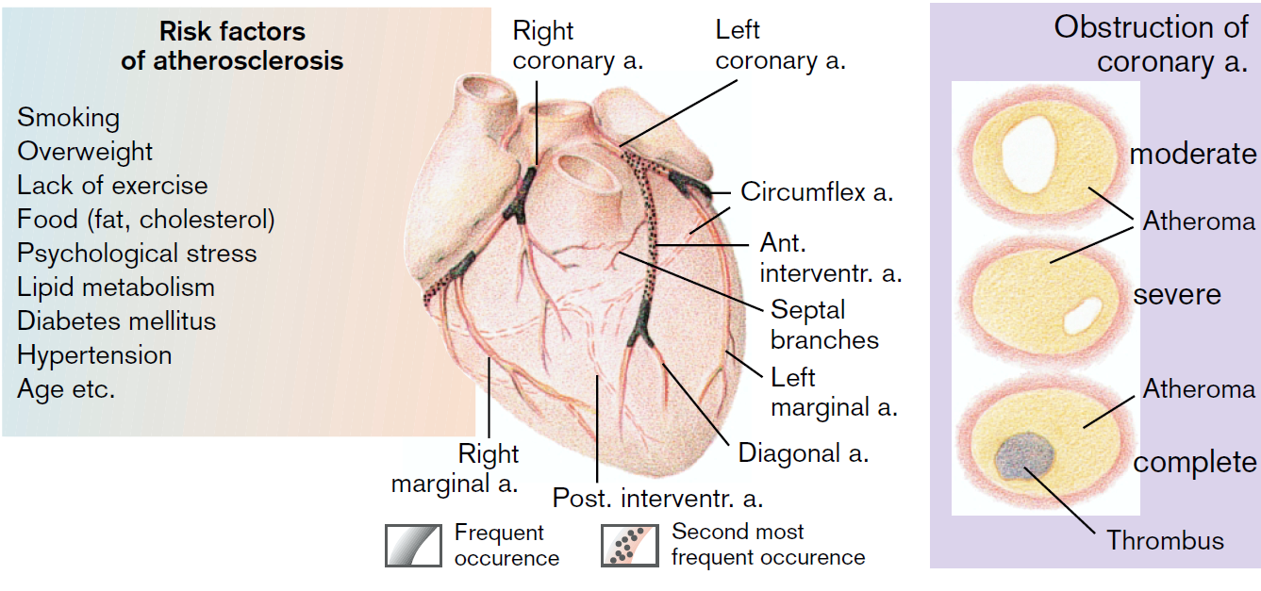

Fig. 6 Atherosclerosis of Coronary Arteries. Color Atlas of Pathophysiology, Stefan Silbernagl.

1. Factors, which determine the development of ***relative coronary artery disease***. These factors cause considerable increase myocardial oxygen demand, accompanied by the adequate coronary blood flow.

The main factors that cause this type of coronary disease are:

1. *significant increase of cardiac function*.

This factor could be caused by excessive physical activity, persistent tachycardia, hypertonic crisis, evident hemoconcentration, hypervolemia. Factors, which lead to the notably increased cardiac work, usually are caused by the activation of sympathoadrenal system.

1. *increase of catecholamine levels into the blood*

May be observed during stress, pheochromocytoma. The excess of catecholamines (especially adrenaline) in myocardium lead to cardiotoxic effects, which is result of following processes:

- excessive consumption of oxygen and metabolic substrates by myocardium in case of heart work overload ;

- energy deficiency and impaired consumption of oxygen and metabolic substrates;

-decrease of coronary blood flow, caused by the increased heart rate and reduced diastole, leading to less time for the ventricles filling.

Heart is an organ, whose energetic necessities almost completely are compensated by aerobic processes, that’s why it is very sensitive to hypoxia. Significant increase in oxygen demand, and substrates for oxidation, metabolites and biological active storage as a result of blood flow disorders lead to general, universal (typical) *mechanisms of myocardium alteration*.

The *pathophysilogical mechanisms* of coronary circulation (see above their descriptions) are:

1. cardiomyocyte energy depletion;
2. generation of free radicals and membrane alteration;
3. alteration in enzyme systems of cardiac myocytes;
4. water-electrolytic imbalances;
5. disorders of neuroendocrine regulation of cardiac functions.

*Manifestations of systolic dysfunction*

The principal clinical manifestations of systolic dysfunction result from an inadequate cardiac output or ventricular dilation. With a decrease in ejection fraction and cardiac output, there is a resultant increase in endsystolic and end-diastolic volumes, ventricular dilation, and wall tension, and a rise in ventricular end-diastolic pressure. This increased volume, added to the normal venous return, leads to an increase in ventricular preload. The rise in preload is thought to be a compensatory mechanism to help maintain stroke volume through the Frank-Starling mechanism despite a drop in ejection fraction (discussed in the section on compensatory mechanisms). Although it serves as a compensatory mechanism, increased preload can also lead to one of the most deleterious consequences of systolic ventricular dysfunction - accumulation of blood in the atria and the pulmonary venous system (which empties into the atria), causing pulmonary congestion. The extent of systolic ventricular dysfunction can be estimated by measuring the cardiac output and ejection fraction and by assessment for manifestations of left-sided heart failure, particularly pulmonary congestion.

***Diastolic Dysfunction.***

Although heart failure is commonly associated with impaired systolic function, in approximately 40% to 50% of cases systolic function has been preserved and heart failure results from an inability of the left ventricle to fill sufficiently during diastole. Among the conditions that cause diastolic dysfunction are:

* those that impede expansion of the ventricle (e.g., pericardial effusion, constrictive pericarditis),
* those that increase ventricular wall thickness and reduce chamber size (e.g., myocardial hypertrophy, hypertrophic cardiomyopathy),
* or those that delay diastolic relaxation of the ventricle (e.g., aging, ischemic heart disease).

The prevalence of diastolic failure increases with age and is higher in women than men, and in persons with obesity, hypertension, and diabetes. Aging is often accompanied by a delay in relaxation of the heart during diastole such that diastolic filling begins while the ventricle is still stiff and resistant to stretching. A similar delay occurs in myocardial ischemia, resulting from a lack of energy to break the rigor bonds that forms between the actin and myosin filaments and to move calcium out of the cytosol and back into the sarcoplasmic reticulum. With diastolic dysfunction ventricular relaxation and distensibility are impaired, leading to an increase in intraventricular pressure at any given volume. The elevated pressures are transmitted backward from the left ventricle into the left atrium and pulmonary venous system, causing pulmonary congestion and a decrease in lung compliance, which increases the work of breathing and evokes symptoms of dyspnea. Cardiac output is decreased, not because of a reduced ventricular ejection fraction as seen with systolic dysfunction, but because of a decrease in ventricular filling. Diastolic function is further influenced by the heart rate, which determines how much time is available for ventricular filling. An increase in heart rate shortens the diastolic filling time. Thus, diastolic dysfunction can be aggravated by tachycardia and improved by a reduction in heart rate, which allows the heart to fill over a longer period of time.

***Heart failure due to work overload***

The work that the heart performs consists mainly of ejected blood that has returned to the ventricles during diastole into the pulmonary or systemic circulation, or what are called the *preload* and *afterload.* Cardiac work overload may become evident due to increase of volume and pressure.

**Overload factors**

Factors, which increase ***preload***

Hypervolemia

Polycythemia

Cardiac valve insufficiency

Hemoconcentration

Factors, which increase ***afterload***

Arterial hypertension

Aorta and pulmonary artery stenosis

Atrioventricular orifice stenosis

*Afterload* represents the force of heart contraction that must generate blood ejection from the filled heart. The main components of afterload are the systemic (peripheral) vascular resistance and ventricular wall tension. When the systemic vascular resistance is elevated, as with arterial hypertension, an increased left intraventricular pressure must be generated to first open the aortic valve and then move blood out of the ventricle and into the systemic circulation. This increased pressure equates to an increase in ventricular wall stress or tension. As a result, excessive afterload may impair ventricular ejection and increase wall tension.

*Preload* reflects the volume or loading conditions of the ventricle at the end of diastole, just before the onset of systole. It is the volume of blood stretching the heart muscle at the end of diastole and is normally determined by the venous return to the heart. During any given cardiac cycle, the maximum volume of blood filing the ventricle is present at the end of diastole. Known as the end-diastolic volume or preload increases, this volume causes an increase in the length of the myocardial muscle fibers. Within limits, as end-diastolic volume or preload increases, the stroke volume increases in accord with the Frank-Starling mechanism.

In case of chronic cardiac overload compensatory mechanisms are activated, which are directed towards maintaining level of blood flow according to metabolic needs. In such cases, cardiac pathology is compensated, and circulatory shock doesn’t develop. Only in case of impaired compensatory abilities, heart failure develops, and, as a consequence, circulatory shock is developed.

During circulatory shock and decrease of oxygen supply in tissues, extracardiac (peripheral) compensatory mechanisms are activated, and are directed towards oxygen supply of the tissues.

In case of acute work overload (e.g. multiple pulmonary embolisms) compensatory mechanisms don’t manage to develop themselves and are inefficient, and, as a result, cardiac failure develops spontaneously, and acute circulatory shock sets up.

**Compensatory Mechanisms**

In heart failure, the cardiac reserve is largely maintained through compensatory mechanisms (fig. 7) such as:

**a) *Emergent (immediate) mechanisms:***

1. *Cardiac (central):*

- Tachycardia;

- Homeometric compensatory mechanism;

- Heterometric compensatory mechanism or Frank – Starling mechanism.

2. *Extracardiac (peripheral):*

- Redistribution of cardiac output;

-increased hemoglobin desaturation;

-pulmonary hyperventilation.

***b) Long-term (late) mechanisms:***

1. *Cardiac (central):*

- myocardial hypertrophy.

2. *Extracardiac (peripheral):*

- increase of erythropoiesis;

- retention of water and salts.

3. Neurohumoral compensatory mechanisms, which supply integration of cardiac and extracardiac mechanisms.

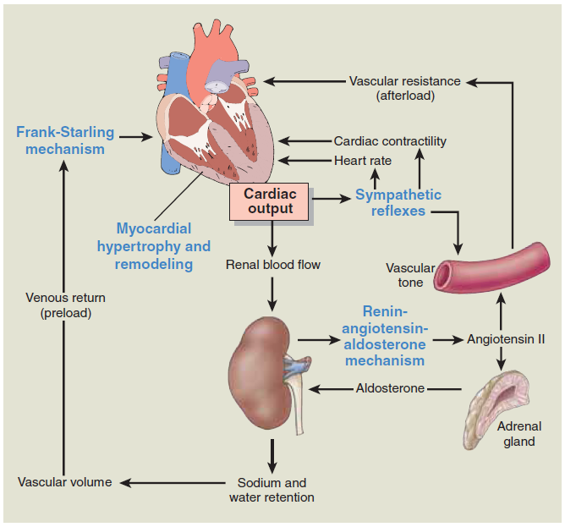

Fig.7 Compensatory mechanisms in heart failure. The Frank-Starling mechanism, sympathetic reflexes, reninangiotensin- aldosterone mechanism, and myocardial hypertrophy function in maintaining cardiac output for the failing heart. Essentials of Pathophysiology. Concepts of altered health states, Carol Mattson Porth.

***Emergent (immediate) compensatory mechanisms***

***Cardiac (central):***

**Tachycardia** (increased heart rate) is the most quick to act compensatory mechanism. It is mainly due to reflexive stimulation of baroreceptors in vena cava and due to increased pressure in atria (Bainbridge reflex) and also as a consequence of sympathetic stimulation. Tachycardia is the faster mechanism than others that compensates decreased stroke volume (≈ 70ml) and to maintain the optimal cardiac output (CO ꞊ SV×HR). In such cases that stroke volume is decreased, the cardiac output, as a result of increased heart contraction frequency, is maintained on normal level. Thereby compensation is realized and circulatory shock doesn’t develop. However, tachycardia is less effective compensatory mechanism and energetic expansive, because with increasing heart rate, increases the O2 consumption in myocardium. In addition, as the heart rate increases, the time spent in diastole is reduced, and there is less time for the ventricles to fill. In normal condition at a heart rate of 75 beats per minute, one cardiac cycle lasts 0,8 second, of which approximately 0,3 second is spent in systole and approximately 0,5 second in diastole. In severe tachycardia (more than 150 beats/min), with shortening of the diastole, decrease the diastolic filling of the ventricles ( normal end-diastolic volume ≈120 -140 ml). These leads to decreased stretching of muscle fibers in diastole, as the result, decrease the effectiveness of systole, of SV and consecutively CO. So tachycardia, for one hand, in certain limits maintains CO, but for the other hand, is unfavorable, with limited effectiveness and uneconomically.

***Heterometric compensatory mechanism*** (Franc-Starling). The Frank-Starling mechanism describes the process whereby the heart increases its stroke volume through an increase in *end-diastolic volume or preload*, is inserted in blood volume overload. With increased diastolic filling, there is increased stretching of the myocardial fibers, more optimal approximation of the actin and myosin filaments, and a resultant increase in the force of the next contraction (tonogenic dilation). As a result, increase SV and CO. It is known that in physiological conditions the EDV (end-diastolic volume ≈ 120- 140 ml), and after ejection, at the end of the systole, the ventricular volume is reduced with 70% but volume of the residual blood is 40-50 ml (ESV).

When the heart contracts stronger, is ejected much more quantity of blood, due what ESV decreased till 10 -20 ml, the ejection fraction increase (EF more than 70%). In physiological conditions the EDV can increase till 160 – 180 ml. These lead to double increased of stroke volume, so is realized compensation. But this compensatory mechanism is limited by the optimal length of sarcomeres (2,2 -2,3 µm). If their lengthening not exceeds 25% from the initial value, we observe equilibrium between diastolic feeling and contractile forces of the heart. But in case of exceeding this optimal limits of sarcomeres, lead to uncoupling of actin and myosin filaments with decreasing contractile forceses.

***Homeometric compensation mechanism*** works during the increase of resistance to cardiac output (increased afterload - aortic stenosis, pulmonary artery stenosis, atrio-ventricular orifice stenosis)*.*Length of muscle heart fibers during diastole augments not so significant change in this case, but high intraventricular pressure and effort that happened by reason of contraction of muscle at the end of systole. Force of cardiac contractions augments not at once, but gradually with each following heart contraction, while will not arrive at level, necessary for safety of constancy of minute volume-heart. Although in lesser degree, in homeometric hyperfunction, is included the Frank – Starling mechanism. In case of essential hypertension the pressure in aorta during diastole remains elevated. As a consequence, normal systole of left ventricle will not eject a normal stroke volume, due what will increase end-systolic volume. As venous return is stable, end-diastolic volume will increase evident with every subsequent systole. So, adaptation to the overload by resistance is realized also on account of Frank-Starling mechanism. But unlike work overload by volume, in this case greater stretching of fibrils leads to a *more powerful contraction.*

From the point of view of energy consumption, these mechanisms (homeometric and heterometric) are not identically. At the same volume of work heart consumes much more oxygen in case of hyperfunction by resistance (increased afterload), than in case of increased volume with normal resistance (increased preload). For example, if volume of work was doubled due to double increasing of end-diastolic volume; oxygen utilization by myocardium will increase about 25%. If volume of work will increase due to double increasing of resistance against ejection, the oxygen utilization will increase with 200%. These is explained by way that homeometric compensatory mechanism to exceed resistance against ejection needs a grater systolic pressure, which can be achieved by increasing degree and speed myofibril tension development. So, homeometric contraction, which is the most energy expansive, represents the main factor which determines increased consumption of ATP and oxygen utilization by myocardium. Thus, heterometric compensatory mechanism is more economically than homeometric mechanism. This explains the favorable clinical evolution of cardiac disease, where is included Frank-Starling mechanism, for example, valvular insufficiency in comparison with orifice stenosis.

***Extracardiac (peripheral) compensatory mechanisms:***

**Redistribution of cardiac output and circulatory centralization**

In heart failure cardiac output and arterial pressure decrease, due what will be activated SNS via baroreceptors. As vessels that supply muscles, organs, skin have sympathetic enervation, mostly α1- adrenoreceptors, activation of SNS leads to vasoconstriction of these regions and redistribution of cardiac output concomitant with blood supplying of main important organs predominantly with β – adrenoreceptors (brain, heart). Increased blood influx of these vital organs ensures their metabolic needs in these conditions.

***Increase of oxyhemoglobin dissociation****.*

As a result of decreased cardiac output, blood circulation disturbance occurs, with subsequent circulatory hypoxia. Oxygen insufficiency in tissues leads to metabolic disturbances and raises of H+ ions concentration, which increases oxyhemoglobin dissociation and stimulates more effective oxygen utilization by the tissues.

***Pulmonary hyperventilation***

As a result of cardiac insufficiency, in the body develops circulatory hypoxia that leads to increase concentration of carbon dioxide and hydrogen ions. These factors directly and reflexively stimulate respiratory center with development of lung hyperventilation. Thereby, is restored balance between metabolic needs and oxygen supply.

***Pulmonary arterioles constriction***

This mechanism is activated in case of left ventricle insufficiency, and is one of the main mechanisms, which are directed to prevention of pulmonary edema development in such situations. As a result of increased pressure in the left atrium and pulmonary veins, will be activated baroreceptors from these areas that lead to reflexive constriction of pulmonary arterioles. As a consequence of reflector pulmonary arterioles spasm, the blood volume, which flows to the left atrium decreases, so, preload of functionally weakened heart decreases, too (F. Kitaev reflex). At the same time this reflex increases pressure in pulmonary artery and stimulates the overload of right ventricle.

**Long term (late) compensatory mechanisms**

**Cardiac compensatory mechanism**

***Myocardial Hypertrophy and Remodeling***

The development of myocardial hypertrophy constitutes one of the principal mechanisms by which the heart compensates for an increase in workload through increasing myocites size. Myocardial hypertrophy and remodeling involve a series of complex events at both the molecular and cellular levels.

There are three basic steps in the molecular pathogenesis of cardiac hypertrophy (fig.8):

• The integrated actions of mechanical sensors (that are triggered by increased workload), growth factors (including TGF-β, insulin-like growth factor 1 [IGF1], fibroblast growth factor (FGF), platelet-derived growth factor (PDGF), insulin in type II diabetes)), and vasoactive agents (e.g., α-adrenergic agonists, endothelin-1, and angiotensin II, ADH,) and decrease in growth inhibitors (NO and PGI2). Indeed, mechanical sensors themselves induce production of growth factors and agonists.

• These signals originating in the cell membrane activate a complex web of signal transduction pathways. Two such biochemical pathways involved in muscle hypertrophy are the phosphoinositide 3-kinase (PI3K)/ AKT pathway (postulated to be most important in physiologic, e.g., exercise-induced, hypertrophy) and signaling downstream of G-protein–coupled receptors (induced by many growth factors and vasoactive agents, and thought to be more important in pathologic hypertrophy).

• These signaling pathways activate a set of transcription factors such as GATA4, nuclear factor of activated T cells (NFAT), and myocyte enhancer factor 2 (MEF2). These transcription factors work coordinately to increase the synthesis of muscle proteins that are responsible for hypertrophy. Hypertrophy is also associated with a switch of contractile proteins from adult to fetal or neonatal forms. For example, during muscle hypertrophy, the α isoform of myosin heavy chain is replaced by the β isoform, which has a slower, more energetically economical contraction. In addition, some genes that are expressed only during early development are reexpressed in hypertrophic cells, and the products of these genes participate in the cellular response to stress. For example, the gene for atrial natriuretic factor is expressed in both the atrium and the ventricle in the embryonic heart, but it is down-regulated after birth. Cardiac hypertrophy is associated with increased atrial natriuretic factor (ANF) gene expression. Atrial natriuretic factor is a peptide hormone that causes salt secretion by the kidney, decreases blood volume and pressure, and therefore serves to reduce hemodynamic load.

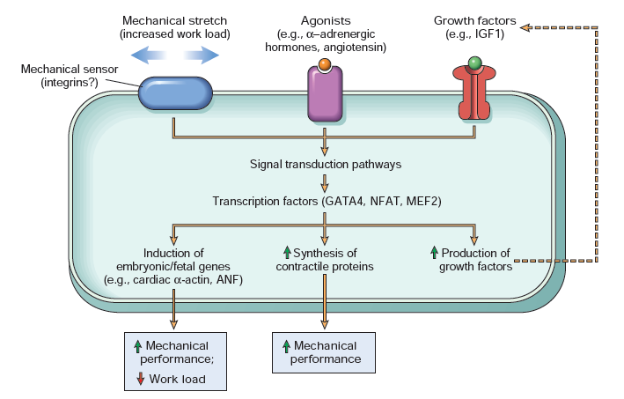

Fig.8 Molecular pathogenesis of cardiac hypertrophy. Robbins and Cotran, Pathologic Basis of Disease.

Although ventricular hypertrophy improves the work performance of the heart, it is also an important risk factor for subsequent cardiac morbidity and mortality. Inappropriate hypertrophy and remodeling can result in changes in structure (i.e., muscle mass, chamber dilation) and function (i.e., impaired systolic or diastolic function) that often lead to further pump dysfunction and hemodynamic overload. The dynamics of these changes could be defined in 3 main stages (according to F. Meerson):

1. *Emergency stage*, that develops immediately, concomitantly with increased workload.

During this period the intensity of myocardial functional structure (MFS) increases, due to hyperfunction without hypertrophy. Because of increased MFS, energy formation is intensified, cellular genetic apparatus is activated, and simultaneously synthesis of nucleic acids increases and protein synthesis occurs. The consumption of oxygen by myocardium units increases, oxidative phosphorylation increases, resynthesis of ATP by aerobe pathway. Though, this elevation of ATP synthesis doesn’t cover myocardial necessities in oxygen, because energy is also used for increased function supply, and for accelerated protein synthesis supply. Also are activated anaerobic ways of energy re-synthesis. Glycogen is removed from cardiomyocytes, phosphocreatine level decreases, intracellular potassium concentration decreases, and sodium is accumulated into cell. As a result of anaerobic glycolysis, lactate is accumulated in myocardium. Direct consequence of increased protein synthesis, during several weeks, rises heart’s mass and function that is distributed to much more area of effector structures, that’s why MFS gradually returns to its normal level. Cardiac hypertrophy leads to decrease of functional overload, which is gained by every myocardium unit till its normal indices. MFS returns to its initial level, as a result, metabolic processes in myocardium become normal.

1. *Stage of completed hypertrophy and relative stable hyperfunction.*

This stage is characterizes by ending of hypertrophy process. Myocardium mass is increased above 100-200%. MFS becomes normal. Pathologic changes in heart muscle metabolism and structure aren’t revealed, oxygen consumption, energy synthesis, concentration of high-energy compounds don’t differ from normal evidence. Hemodynamic signs are normal. MFS normalization allows hypertrophic heart to resist high overloads and to compensate blood circulation (e.g. during compensated cardiac defects).

Hypertrophic heart differs from normal one by series of *metabolic, functional, and structural* peculiarities, which on one hand, allow it to compensate increased overload for a long period of time, but on other hand, create conditions for some pathologic processes. In the hypertrophic heart growth of different morpho-functional structures are disturbed.

In case of myocardium hypertrophy development, cardiac nervous apparatus is engaged. Is noticed the functioning of intra- and extracardiac nervous elements will increase, but the growth of nervous endings slows down as contractile myocardium mass increases. Trophic influences are disturbed, noradrenaline concentration in myocardium is decreased, that leads to worsening of contractile properties – cardiac reserves mobilization is slowed down.

Increasing of muscular fibers mass is not preceded by adequate rising of coronary capillary network, due what installs relative coronary insufficiency, and respectively relative hypoxia – coronary reserve at effort decreases.

Growth of heart mass occurs as a result of increased each muscular fibers volume that is associated with changes of correlation between intracellular structures. Cellular volume increases *proportionally to cube* and cellular membrane surface – *proportionally to linear cell size square* (refashion between fiber volume and surface is increased), that leads to *cellular surface decrease, related to cell mass unit*. Considering that in sacolema are localized protein receptors, enzymes that ensure transmembrane transport of cations and metabolic substrates, indicated changes lead to ionic, metabolic and functional imbalance.

Cellular membrane has a great importance in propagation of excitation, in coupling processes of excitation and contraction, realized through the tubular system and sarcoplasmic reticulum. Because their growth also is decreased, will be disturb processes of contraction and relaxation of cardiomyocytes: as a result of decreased outflow of Ca2+ is disturb contraction, but due to hardly reuptake of Ca2+  in sarcoplasmic reticulum will be disturb relaxation.

During developing of hypertrophy, in the initial phase, the mitochondrial mass increases faster than mass of contractile proteins. So, is created conditions for sufficient energy supplying of the functional overload heart. But, with progressing process, growth of mitochondrial mass lags behind of cytoplasm mass growing. Mitochondria start to work with a maximum overload, inside of them occurs destructive changes, their functional effectiveness decreases and oxidative phosphorylation is disturbed. These lead to diminishes energy supply of hypertrophic cell.

The hypertrophy heart, at the initial phases, has a powerful contractile apparatus and with energy well supplied. This is making possible for a long time to work with a higher performance, at a normal metabolic rate. But adaptive capacity for overload working is limited in the hypertrophy heart. Unbalanced intracellular and tissular structures make the hypertrophy heart to become more vulnerable in unfavorable conditions, that could lead to reducing contractile cardiac forces and in turn to cardiac insufficiency.

1. *Stage of gradual exhaustion and progressive cardiosclerosis.*

This stage is characterized by profound metabolic and structural changes, which in turn accumulates in contractile and energo -generative elements of cardiomyocytes. As was mentioned previously, the muscular mass growths more than capillary network, the same increases the distance between capillary and oxygen using elements. Increases consumption of oxygen in condition of unchanged coronary meshwork, due what in the myocardium installs a relative hypoxia. Hypoxia is one of the most important factors that will lead to metabolic and structural changes, characteristic or this phase. In cardiomyocytes will develop pathological process like dystrophy, necrobiosis and necrosis. One part of muscular fibers die and they are replaced by connective tissue, that is the main mechanism of cardiosclerosis.

As a result of cardiosclerosis, the mass of contractile elements decreases, due what MFS again increases, that once more will cause hypertrophy of still functional cardiomyocytes. In finally, these will lead to progressive exhaustion of compensatory mechanisms that in turn will lead to chronic heart failure.

Compensatory myocardium hypertrophy

Imbalance of myocardium structures and its consequences

Microvascular growth lags behind myocardium mass growth

Mitochondrial quantity growth lags behind myofibril mass growth

Myosin ATP-ase activity lags behind myocardium energy necessities

Intensified cardiac hystiocyte’s structure synthesis don’t supply needs of the cell

Fig. 9 Main decompensatory mechanisms of hypertrophic heart

Recent research has focused on the type of hypertrophy that develops in persons with heart failure. At the cellular level, cardiac muscle cells respond to stimuli from stress placed on the ventricular wall by pressure and volume overload by initiating several different processes that lead to hypertrophy. These include stimuli that: produce a *symmetric hypertrophy* with a proportionate increase in muscle length and width, as occurs in athletes. *Concentric hypertrophy* occurs in hypertension (stimulus for hypertrophy is *pressure overload*)leads to parallel replication of myofibrils, thickening of the individual myocytes. Concentric hypertrophy may preserve systolic function for a time, but eventually the work performed by the ventricle exceeds the vascular reserve, predisposing to ischemia. And *eccentric hypertrophy* as occurs in dilated cardiomyopathyor *ventricular volume overload,* the increase in wall stress leads to replication of myofibrils in series, elongation of the cardiac muscle cells, and eccentric hypertrophy. Eccentric hypertrophy leads to a decrease in ventricular wall thickness with an increase in diastolic volume and wall tension

***Extracardiac late compensatory mechanisms:***

***Increases of erythropoiesis***

Tissular hypoxia in heart failure leads to synthesis of erythropoietin (80 -90% are synthesized in the kidney), that increases production of erythrocytes. As a consequence, oxygenic capacity of the blood increases oxygen concentration in the arterial blood increases, so ensure the compensation of circulatory hypoxia. But also this mechanism is relative useful. Concomitantly with increasing number of erythrocytes, increases also hematocrit and blood viscosity that lead to additional overload of the heart.

***Retention of water and salts (Renin-Angiotensin-Aldosterone) mechanism***

One of the most important effects of lowered cardiac output in heart failure is a reduction in renal blood flow and glomerular filtration rate, which leads to sodium and water retention. With decreased renal blood flow, there is a progressive increase in renin secretion by the kidneys with parallel increases in circulating levels of angiotensin II. The increased concentration of angiotensin II contributes directly to a generalized and excessive vasoconstriction, as well as facilitating norepinephrine release and inhibiting reuptake of norepinephrine by the sympathetic nervous system. Angiotensin II also provides a powerful stimulus for aldosterone production by the adrenal cortex. Aldosterone increases tubular reabsorption of sodium, with an accompanying increase in water retention. Because aldosterone is metabolized in the liver, its levels are further increased when heart failure causes liver congestion. Angiotensin II also increases the level of antidiuretic hormone (ADH), which serves as a vasoconstrictor and inhibitor of water excretion. In addition to their individual effects on sodium and water balance, angiotensin II and aldosterone are also involved in regulating the inflammatory and reparative processes that follow tissue injury. They stimulate inflammatory cytokine production (e.g., tumor necrosis factor [TNF] and interleukin-6), attract inflammatory cells (e.g., neutrophils and macrophages), activate macrophages at sites of injury and repair, and stimulate the growth of fibroblasts and synthesis of collagen fibers. Fibroblast and collagen deposition results in ventricular hypertrophy and myocardial wall fibrosis, which decreases compliance (i.e., increases stiffness), ultimately causing inappropriate remodeling of the heart and progression of both systolic and diastolic ventricular dysfunction.

***Natriuretic Peptides***

The heart muscle produces and secretes a family of related peptide hormones, called the *natriuretic peptides* (NPs) ,that have potent diuretic, natriuretic, vascular smooth muscle, and other neurohumoral actions that affect cardiovascular function. Two of the four known NPs most commonly associated with heart failure are atrial natriuretic peptide (ANP) and brain natriuretic peptide (BNP). As the name indicates, ANP is released from atrial cells in response to atrial stretch, pressure, or fluid overload. BNP, so named because it was originally found in extracts of the porcine brain, is primarily secreted by the ventricles as a response to increased ventricular pressure or fluid

overload. Although the NPs are not secreted from the same chambers in the heart, they have very similar functions. In response to increased chamber stretch and pressure, they promote rapid and transient natriuresis and diuresis through an increase in the glomerular filtration rate and an inhibition of tubular sodium and water reabsorption. The NPs also facilitate complex interactions with the neurohormonal system, inhibiting the sympathetic nervous system, the renin-angiotensin-aldosterone system, and vasopressin. In addition, the NPs directly affect the central nervous system and the brain, inhibiting the secretion of the antidiuretic hormone (ADH) and the function of the salt appetite and thirst center. Circulating levels of both ANP and BNP are elevated in persons with heart failure. The concentrations are well correlated with the extent of ventricular dysfunction, increasing up to 30-fold in persons with advanced heart disease. Assays of BNP are used clinically in the diagnosis of heart failure and to predict the severity of the condition. Human BNP, synthesized by recombinant deoxyribonucleic acid (DNA) technology, is now available for treatment of persons with acutely decompensated heart failure.

***Endothelins***

The endothelins, released from the endothelial cells throughout the circulation, are potent vasoconstrictors. Like angiotensin II, endothelin can also be synthesized and released by a variety of cell types, such as cardiac myocytes. Four endothelin peptides (endothelin-1 [ET-1], ET-2, ET-3, and ET-4) have been identified. In addition to vasoconstrictor actions, the endothelins induce vascular smooth muscle cell proliferation and cardiac myocyte hypertrophy; increase the release of ANP, aldosterone, and catecholamines; and exert antinatriuretic effects on the kidneys. They also have been shown to have a negative inotropic action in patients with heart failure. Production of ET-1 is regulated by many factors that are significant for cardiovascular function and have implications for heart failure; for example, it is enhanced by angiotensin II, ADH, and norepinephrine and by factors such as shear stress and endothelial stretching.21 Plasma ET-1 levels also correlate directly with pulmonary vascular resistance, and it is thought that the peptide may play a role in mediating pulmonary hypertension in persons with heart failure. An endothelin receptor antagonist is now available for use in persons with pulmonary arterial hypertension due to severe heart failure.

***Neurohumoral compensatory mechanisms* (*Sympathetic Nervous System Activity)***

Stimulation of the sympathetic nervous system plays an important role in the compensatory response to decreased cardiac output and in the pathogenesis of acute heart failure (fig.10). Both cardiac sympathetic tone and catecholamine (epinephrine and norepinephrine) levels are elevated during the late stages of most forms of heart failure. By direct stimulation of heart rate and cardiac contractility (via β - adrenoreceptors), regulation of vascular tone, and enhancement of renal sodium and water retention, the sympathetic nervous system initially helps to maintain perfusion of the various body organs. In persons who progress to more severe heart failure, blood is diverted to the more critical cerebral and coronary circulations. Although the sympathetic nervous system response is meant to maintain blood pressure and cardiac output, it quickly becomes maladaptive and contributes to the deterioration of heart function. An increase in sympathetic activity can lead to tachycardia, vasoconstriction, and cardiac arrhythmias. Acutely, tachycardia significantly increases the workload of the heart, thus increasing myocardial oxygen demand and leading to cardiac ischemia, myocyte damage, and decreased contractility (inotropy). An increase in systemic vascular resistance causes an increase in cardiac afterload and ventricular wall stress. By promoting arrhythmias, the catecholamines released with sympathetic nervous system stimulation also may contribute to the high rate of sudden death seen with heart failure. Other effects include decreased renal perfusion and additional augmentation of the renin-angiotensin-aldosterone system, as well as decreased blood flow to skin (the symptom being pallor), muscle (the symptom being fatigue), and abdominal organs.

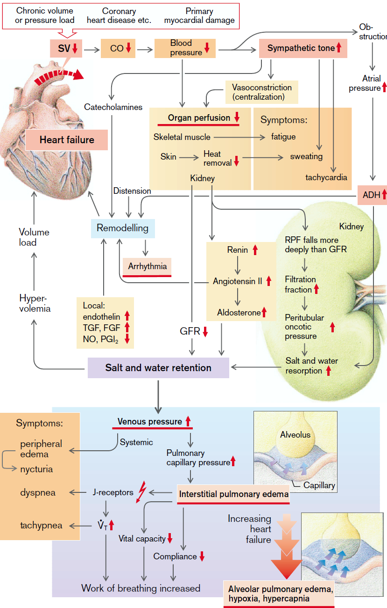

Fig.10Heart Failure: Neurohumoral Consequences, Color Atlas of Pathophysiology, Stefan Silbernagl

***Consequences of heart failure***

The consequences of heart failure depend upon which heart chamber (i.e., the left or right) is primarily affected. (Fig. 11). An important feature of the circulatory system is the fact that the left and right ventricles act as two pumps that are connected in series. To function effectively, the left and right ventricles must maintain equal outputs. Although the initial event that leads to heart failure may be primarily left or right ventricular in origin, long-term heart failure usually involves both ventricles.

**Left Ventricular Dysfunction.**

The clinical features of left-sided heart failure primarily result from a diminished cardiac output with a resultant decrease in peripheral blood flow and a progressive accumulation of blood within the pulmonary circulation. With impairment of left ventricular function, there is a decrease in ejection of blood into the systemic circulation, an increase in left ventricular and left atrial end-diastolic pressures, and congestion of the pulmonary circulation.When the filtration pressure in the pulmonary capillaries (normally approximately 10 mm Hg) exceeds the capillary osmotic pressure (normally approximately 25 mm Hg), there is a shift of intravascular fluid into the interstitium of the lung and development of pulmonary edema. An episode of pulmonary edema often occurs at night, after the person has been reclining for some time and the gravitational forces have been removed from the circulatory system. It is then that the edema fluid that had been sequestered in the lower extremities during the day is returned to the vascular compartment and redistributed to the pulmonary circulation. The most common causes of left ventricular dysfunction are hypertension and acute myocardial infarction. Left ventricular heart failure and pulmonary congestion can develop very rapidly in persons with acute myocardial infarction. Even when the infarcted area is small, there may be a surrounding area of ischemic tissue. This may result in large areas of ventricular wall hypokinesis or akinesis and rapid onset of pulmonary congestion and edema. Another cause of left heart failure is valvular defects such as stenosis or regurgitation of the aortic or mitral valve. These valvular defects increase the work of the left heart and eventually lead to heart failure if untreated.

**Right Ventricular Dysfunction.**

The major clinical features of right heart failure differ from those of left heart failure in that pulmonary congestion is minimal, while engorgement of the systemic and hepatic venous systems is pronounced. Right-sided heart failure is usually the consequence of left-sided heart failure, in which an increase in pulmonary blood volume eventually produces an increased burden on the right side of the heart. Isolated right-sided heart failure is less common and occurs in persons with intrinsic lung disease or pulmonary vasculature resistance that results from pulmonary hypertension. It can also occur in persons with pulmonic or tricuspid valvular disease, right ventricular infarction, and cardiomyopathy. Congenital heart defects with right to- left cardiac shunt can cause isolated right heart failure as well. When the right heart failure occurs in response to chronic pulmonary disease, it is referred to as *cor pulmonale*. Right heart failure impairs the ability to move blood from the systemic venous circulation into the pulmonary circulation. Consequently, when the right ventricle fails, there is a reduction in the amount of blood that is moved forward from the systemic venous circulation into the pulmonary circulation and then into the left side of the heart. This causes an increase in right ventricular enddiastolic, right atrial, and systemic venous pressures. A major effect of right-sided heart failure is the development of peripheral edema (see Fig.10). Because of the effects of gravity, the edema is most pronounced in the dependent parts of the body—in the lower extremities when the person is in the upright position and in the area over the sacrum when the person is supine. The accumulation of edema fluid is evidenced by a gain in weight (i.e., 1 pint [568 mL] of accumulated fluid results in a 1-lb [0.45-kg] weight gain). Daily measurement of weight can be used as a means of assessing fluid accumulation in a patient with chronic heart failure. As a rule, a weight gain of more than 2 lb (0.91 kg) in 24 hours or 5 lb (2.25 kg) in 1 week is considered a sign of worsening failure. Right-sided heart failure also produces congestion of the viscera. As venous distention progresses, blood backs up in the hepatic veins that drain into the inferior vena cava and the liver becomes engorged. This may cause hepatomegaly and right upper quadrant pain. In severe and prolonged right-sided failure, liver function is impaired and hepatic cells may die. Congestion of the portal circulation also may lead to engorgement of the spleen and the development of ascites. Congestion of the gastrointestinal tract may interfere with digestion and absorption of nutrients, causing anorexia and abdominal discomfort. In severe right-sided failure, the external jugular veins become distended and can be visualized when the person is sitting up or standing

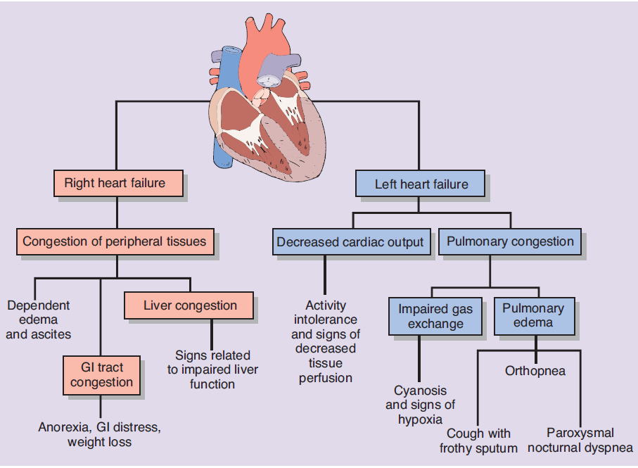Fig.11Manifestations of right and left ventricular failure. GI, gastrointestinal. Essentials of Pathophysiology. Concepts of altered health states, Carol Mattson Porth