**PATHOPHYSIOLOGY OF CNS**

The nervous system, in coordination with the endocrine system, provides the means by which cell and tissue functions are integrated into a solitary, surviving organism. It controls skeletal muscle movement and helps to regulate cardiac and visceral smooth muscle activity.The nervous system enables the reception, integration, and perception of sensory information; it provides the substratum necessary for intelligence, anticipation, and judgment; and it facilitates adjustment to an ever-changing external environment. No part of the nervous system functions independently from other parts. In humans, who are thinking and feeling creatures, the effects of emotion can exert a strong influence on neural and hormonal control of body function. However, alterations in neural and endocrine function, particularly at the biochemical level, also can exert a strong influence on psychological behavior.

All portions of the nervous system can be divided into two basic components: *the central nervous system (CNS)* and *the peripheral nervous system (PNS).* The CNS consists of the brain and spinal cord, which are protected by the skull and vertebral column, whereas the PNS is found outside these structures. In this design, the PNS functions as an input–output system for relaying information to the CNS and for transmitting output messages that control effector organs, such as muscles and glands.

Nervous tissue contains two types of cells*: neurons* and *supporting cells*. The neurons are the functional cells of the nervous system. They exhibit membrane *excitability* and *conductivity* and secrete neurotransmitters and hormones, such as epinephrine and antidiuretic hormone. The supporting cells, such as *Schwann cells* in the PNS and the *glial cells* in the CNS, protect the nervous system and provide metabolic support for the neurons.

**NEURONS.** Neurons, which are the functioning cells of the nervous system, have three distinct parts: the cell body and its cytoplasm- filled processes, the *dendrites* and *axons*. These processes form the functional connections, or *synapses*, with other nerve cells, with receptor cells, or with effector cells. Axonal processes are particularly designed for rapid communication with other neurons and the many body structures innervated by the nervous system. *Afferent,* or *sensory, neurons* transmit information from the PNS to the CNS. *Efferent neurons*, or *motoneurons,* carry information away from the CNS. Interspersed between the afferent and efferent neurons is a network of *interconnecting neurons* (interneurons or internuncial neurons) that modulate and control the body’s response to changes in the internal and external environments.The cell body, or *soma*, of a neuron contains a large, vesicular nucleus with one or more distinct nucleoli and a well-developed rough endoplasmic reticulum. A neuron’s nucleus has the same DNA and genetic code content present in other cells of the body, and its nucleolus, which is composed of portions of several chromosomes, produces RNA associated with protein synthesis. The cytoplasm contains large masses of ribosomes that are prominent in most neurons. *Dendrites* (i.e., “treelike”) are multiple, branched extensions of the nerve cell body; they conduct information toward the cell body and are the main source of information for the neuron. The dendrites and cell body are studded with synaptic terminals that communicate with axons and dendrites of other neurons. *Axons* are long efferent processes that project from the cell body and carry impulses away from the cell. Most neurons have only one axon; however, axons may exhibit multiple branchings that result in many axonal terminals. The cytoplasm of the cell body extends to fill the dendrites and the axon. Proteins and other materials used by the axon are synthesized in the cell body and then flow down the axon through its cytoplasm. The cell body of the neuron is equipped for a high level of metabolic activity. This is necessary because the cell body must synthesize the cytoplasmic and membrane constituents required to maintain the function of the axon and its terminals. Some of these axons extend for a distance of 1 to 1.5 m and have a volume that is 200 to 500 times greater than the cell body itself.

***SUPPORTING CELLS.*** Supporting cells of the nervous system, the Schwann and satellite cells of the PNS and the several types of glial cells of the CNS, give the neurons protection and metabolic support. The supporting cells segregate the neurons into isolated metabolic compartments, which are required for normal neural function. *Astrocytes* and the tightly joined endothelial cells of the capillaries in the CNS contribute to what is called the *blood–brain barrier*. This term is used to emphasize the impermeability of the nervous system to large or potentially harmful molecules.Recent information suggests that many glial cells have functions other than protection and support. Evidence suggests that Schwann cells release developmental signals in embryonic nervous tissue that are crucial for the survival of neonatal neurons. Postnatally, Schwann cells synthesize and release self-regulating autocrine substances that bind to receptors on their cell surface, enabling them to survive without axons. The survival of Schwann cells is essential for the successful regeneration of damaged peripheral nerves. Schwann cells and astrocytes respond to neuronal activity by elevating their internal calcium (Ca2+) ion concentrations, triggering the release of glial neurotransmitters and thus influencing feedback regulation of neuronal function and synaptic activity.The many-layered myelin wrappings of Schwann cells of the PNS and the *oligodendroglia* of the CNS produce the myelin sheaths that serve to increase the velocity of nerve impulse conduction in axons. Myelin has a high lipid content, which gives it a whitish color, and the name *white matter* is given to the masses of myelinated fibers of the spinal cord and brain. Besides its role in increasing conduction velocity, the myelin sheath is essential for the survival of larger neuronal processes, perhaps by the secretion of neurotrophic compounds. In some pathologic conditions, such as multiple sclerosis in the CNS and Guillain-Barré syndrome in the PNS, the myelin may degenerate or be destroyed. This degeneration leaves a section of the axonal process without myelin while leaving the nearby Schwann or oligodendroglial cells intact. Unless remyelination takes place, the axon eventually dies.

**Supporting Cells of the Peripheral Nervous System.** *Schwann cells* and *satellite cells* are the two types of supporting cells in the PNS. Normally, the nerve cell bodies in the PNS are collected into ganglia, such as the dorsal root and autonomic ganglia. Each of the cell bodies and processes of the peripheral nerves is separated from the connective tissue framework of the ganglion by a single layer of flattened capsular cells called *satellite cells.* Satellite cells secrete a basement membrane that protects the cell body from the diffusion of large molecules.The processes of larger afferent and efferent neurons are surrounded by the cell membrane and cytoplasm of Schwann cells, which are close relatives of the satellite cells. During myelination, the Schwann cell wraps around each nerve process several times in a “jelly roll” fashion. Schwann cells line up along the neuronal process, and each of these cells forms its own discrete myelin segment. The end of each myelin segment attaches to the cell membrane of the axon by means of intercellular junctions. Successive Schwann cells are separated by short extracellular fluid gaps called the *nodes of Ranvier*, where the myelin is missing and voltage-gated sodium channels are concentrated. The nodes of Ranvier increase nerve conduction by allowing the impulse to jump from node to node through the extracellular fluid in a process called *saltatory conduction* (from the Latin saltare, “to jump”). In this way, the impulse can travel more rapidly than it could if it were required to move systematically along the entire nerve process. This increased conduction velocity greatly reduces reaction time, or time between the application of a stimulus and the subsequent motor response. The short reaction time is especially important in peripheral nerves with long distances (sometimes 1 to 1.5 m) for conduction between the CNS and distal effector organs.Each of the Schwann cells along a peripheral nerve is encased in a continuous tube of basement membrane, which in turn is surrounded by a multilayered sheath of loose connective tissue known as the *endoneurium.* These endoneurial sheaths, which are essential to the regeneration of peripheral nerves, provide a collagenous tube through which a regenerating axon can again reach its former target. The endoneurial sheath does not penetrate the CNS. The absence of the endoneurial sheaths is thought to be a major factor in the limited axonal regeneration of CNS nerves compared with those of the PNS. Endoneurial sheaths are bundled with blood vessels into small bundles or clusters of nerves called *fascicles*. In the nerve, the fascicles consisting of bundles of nerve fibers are surrounded by another protective covering called the *perineurium*. Usually, several fascicles are further surrounded by the heavy, protective epineurial sheath of the peripheral nerve. The protective layers that surround the peripheral nerve processes are continuous with the connective tissue capsule of the sensory nerve endings and the connective tissue that surrounds the effector structures, such as the skeletal muscle cell. Centrally, the connective tissue layers continue along the dorsal and ventral roots of the nerve and fuse with the meninges that surround the spinal cord and brain.

Myelin formation is essentially the same in both the PNS and CNS; both contain *myelin basic protein*, and both involve the winding of plasma membranes around the nerve fiber. During the wrapping of myelin, the cytoplasm between two adjacent inner leaflets of the plasma membrane is expelled. The two adjacent inner leaflets and any remaining cytoplasm appear as a dark line called the *major dense line*. Likewise, during the wrapping of the plasma membranes to form myelin, adjacent outer plasma membrane leaflets become opposed, creating the interperiod or *minor dense line*. Linking proteins, *proteolipid protein* (PLP) found only in the CNS and *protein 0* (P0) found only in the PNS, help stabilize adjacent plasma membranes of the myelin sheath.

**Supporting Cells of the Central Nervous System.** Supporting cells of the CNS consist of the *oligodendroglia, astroglia, microglia*, and *ependymal cells*. *Oligodendroglial cells* form the myelin in the CNS. Instead of forming a myelin covering for a single axon, these cells reach out with several processes, each wrapping around and forming a multilayered myelin segment around several different axons. The coverings of axons in the CNS function in increasing the velocity of nerve conduction, similar to the peripheral myelinated fibers. A second type of glial cell, the *astroglia*, is particularly prominent in the gray matter of the CNS. These large cells have many processes, some reaching to the surface of the capillaries, others reaching to the surface of the nerve cells, and still others filling most of the intercellular space within the CNS. The astrocytic linkage between the blood vessels and the neurons may provide a transport mechanism for the exchange of oxygen, carbon dioxide, and metabolites. Astrocytes also have an important role in sequestering cations such as calcium, hydrogen and potassium from the intercellular fluid (*buffer cells*). Astrocytes can fill their cytoplasm with microfibrils (i.e., *fibrous astrocytes*), and masses of these cells form the special type of scar tissue called *gliosis* that develops in the CNS when tissue is destroyed. A third type of glial cell, the *microglia*, is a small phagocytic cell that is available for cleaning up debris after cellular damage, infection, or cell death. The fourth type of cell, the *ependymal cell*, forms the lining of the neural tube cavity, the ventricular system. In some areas, these cells combine with a rich vascular network to form the *choroid plexus*, where production of the cerebrospinal fluid (CSF) takes place.

**DISORDERS OF NEURONAL EXCITABILITY. NEURONAL INJURY.**

Neurons are characterized by the ability to communicate with other neurons and body cells through electrical signals called *impulses*. An impulse, or action potential, represents the movement of electrical charge along the axon membrane. This phenomenon, sometimes called *conductance*, is based on the rapid flow of charged ions through the plasma membrane. Nerve signals are transmitted by action potentials, which are abrupt, pulsatile changes in the membrane potential that last a few ten-thousandths to a few thousandths of a second. Action potentials can be divided into three phases: the resting or polarized state, depolarization, and repolarization. The *resting membrane potential* for large nerve fibers is approximately −90 mV. However, in small neurons and in many neurons in the CNS, the resting membrane potential is often as little as −40 to −60 mV. The resting phase of the membrane potential continues until some event causes the membrane to increase its permeability to sodium. A *threshold potential* represents the membrane potential at which neurons or other excitable tissues are stimulated to fire. In large nerve fibers, the sodium channels open at approximately −60 mV, which is the threshold for initiation of an action potential. When the threshold potential is reached, the gatelike structures in the ion channels open. Below the threshold potential, these gates remain tightly closed. These gates are either fully open or fully closed. Under ordinary circumstances, the threshold stimulus is sufficient to open many ion channels, triggering massive depolarization of the membrane (*the action potential*). *Depolarization* is characterized by the flow of electrically charged ions. During the depolarization phase, the membrane suddenly becomes permeable to sodium ions; the rapid inflow of sodium ions produces local currents that travel through the adjacent cell membrane, causing the sodium channels in this part of the membrane to open. In neurons, sodium ion gates remain open for approximately one fourth of a millisecond. During this phase of the action potential, the inner face of the membrane becomes positive (approximately +30 to +45 mV). *Repolarization* is the phase during which the polarity of the resting membrane potential is reestablished. This is accomplished with closure of the sodium channels and opening of the potassium channels. The outflow of positively charged potassium ions across the cell membrane returns the membrane potential to negativity. The sodium–potassium pump gradually reestablishes the resting ionic concentrations on each side of the membrane. Membranes of excitable cells must be sufficiently repolarized before they can be reexcited. During repolarization, the membrane remains refractory (i.e., does not fire) until repolarization is approximately one-third complete. This period, which lasts approximately one half of a millisecond, is called the *absolute refractory period*. During one portion of the recovery period, the membrane can be excited, although only by a stronger-than-normal stimulus. This period is called the *relative refractory period* (Fig.1).

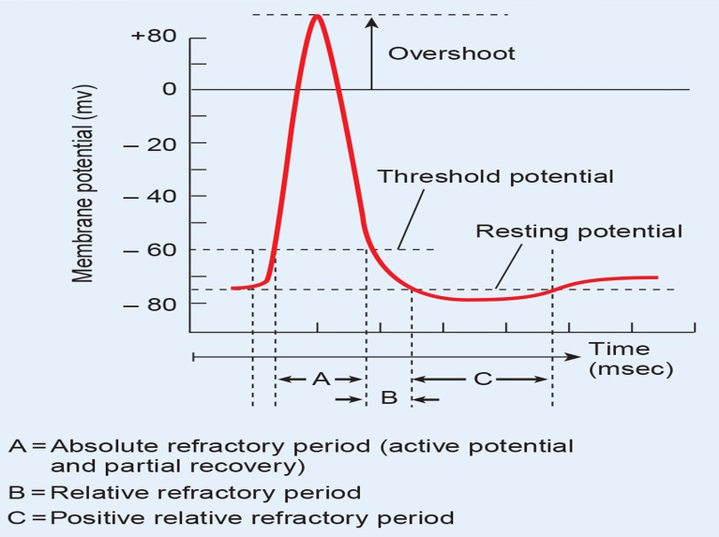

**Fig.1. Neuronal action potential** (From Porth; Pathophysiology)

Nervous tissue has a high rate of metabolism. Although the brain constitutes only 2% of the body’s weight, it receives approximately 15% of the resting cardiac output and consumes 20% of its oxygen. Despite its substantial energy requirements, the brain can neither store oxygen nor effectively engage in anaerobic metabolism. An interruption in the blood or oxygen supply to the brain rapidly leads to clinically observable signs and symptoms. Without oxygen, brain cells continue to function for approximately 10 seconds. Unconsciousness occurs almost simultaneously with cardiac arrest, and the death of brain cells begins within 4 to 6 minutes. Interruption of blood flow also leads to the accumulation of metabolic byproducts that are toxic to neural tissue. Glucose is the major fuel source for the nervous system, but neurons have no provision for storing glucose. Ketones can provide for limited temporary energy requirements; however, these sources are rapidly depleted. Unlike muscle cells, neurons have no glycogen stores and must rely on glucose from the blood or the glycogen stores of supporting glial cells. Persons receiving insulin for diabetes may experience signs of neural dysfunction and unconsciousness (i.e., insulin reaction or shock) when blood glucose drops because of insulin excess.

Neurons of different types and in different locations have distinct properties, including functional roles, distribution of their connections, neurotransmitters used, metabolic requirements, and levels of electrical activity at a given moment. A set of neurons, not necessarily clustered together in a region of the brain, may thus show selective vulnerability to various insults because it shares one or more of these properties. Since different regions of the brain participate in different functions, the pattern of clinical signs and symptoms that follow injury depend as much on the region of brain involved as on the pathologic process. Mature neurons are incapable of cell division, so destruction of even a small number of neurons essential for a specific function may leave the individual with a neurologic deficit. Neural progenitor populations are present in certain regions of the brain and have been shown to respond to injury by generating new neurons. For this reason, there is continuing interest in whether expansion of endogenous progenitors or delivery of exogenously derived progenitor cells might be a useful therapeutic approach for repair after injury or in the setting of degenerative diseases.

The components of the CNS are affected by a number of unique neurologic disorders and also respond to common insults (e.g., ischemia, infection) in a manner that is distinct from other tissues. Neuronal injury may be an acute process, often a consequence of depletion of oxygen or glucose or trauma, or a slower process, often associated with accumulation of abnormal protein aggregates, as occurs in degenerative disorders of the brain. Neurons require a continuous supply of oxygen and glucose to meet metabolic needs. This satisfies essential physiologic and anatomic requirements of the cells, including maintaining membrane gradients that are essential for action potentials, and supporting the extensive cytoplasmic dendritic arborization of neurons and of axons, which may extend over great distances from the cell body. As most mature neurons are maintained for the life span of an individual, protein turnover and quality have to be carefully regulated to ensure cellular integrity. Not surprisingly, many neurologic diseases result from the injurious effects of accumulated misfolded proteins (*proteinopathies*) (see cell dystrophy).

In order to fulfill their function, neurons must be able to receive information from other cells and then pass it on to yet other cells. As a rule the information is received via membrane receptors that are activated by neurotransmitters. The activity of ionic channels is influenced directly or via intracellular mechanisms of transmission. Thus, in suitable target cells acetylcholine (ACh) opens nonspecific cation channels that will then allow the passage of Na+ and K+. This will lead to depolarization of the cell membrane and thus to opening of the voltage-gated Na+ and Ca2+ channels. Ca2+ ions then mediate the release of neurotransmitters by the target cell. In the long term, cell metabolism and gene expression of the target cell, and thus the formation of synapses and the synthesis and storage of neurotransmitters are also regulated. Abnormalities can interfere with each element of this cascade (Fig.2). For example, receptor density can be reduced by *down-regulation*. Also, certain mechanisms of intracellular transmission can be blocked. An example is the blocking of G proteins by, among others, pertussis toxin. Ionic channels can be blocked by drugs, or their activity changed by Ca2+, Mg2+, or H+. Furthermore, their effect on the membrane potential can be distorted by a change in ionic gradients, such as an increase or a decrease in the intracellular or, more importantly, extracellular K+ concentration. Both occur when Na+/K+-ATPase is inhibited, for example, due to energy deficiency. Axonal transport as well as formation, storage, release, and inactivation of neurotransmitters can be impaired, for example, by genetic defects or drugs. Functional abnormalities can be reversible once the damage is no longer effective. Lesions may also lead to irreversible destruction of neurons. In addition to cell death by direct damage to it (*necrosis*, e.g., due to energy deficiency or mechanical destruction), so called programmed cell death (*apoptosis*) may also play a role in this. Neurons cannot be renewed in adults. Thus, the destruction of neurons will cause an irreversible impairment of function, even if other neurons can partly take over the function of the dead cell. Deleterious substances must pass the blood–brain barrier if they are to reach the neurons of the central nervous system (CNS). An intact blood–brain barrier impedes the passage of most substances and prevents pathogens and immunocompetent cells entering. However, some toxins (e.g., *pertussis* and *botulinus toxins*) reach neurons in the spinal cord through retrograde axonal transport via peripheral nerves, and thus avoid the blood–brain barrier. Some viruses also reach the CNS in this way.

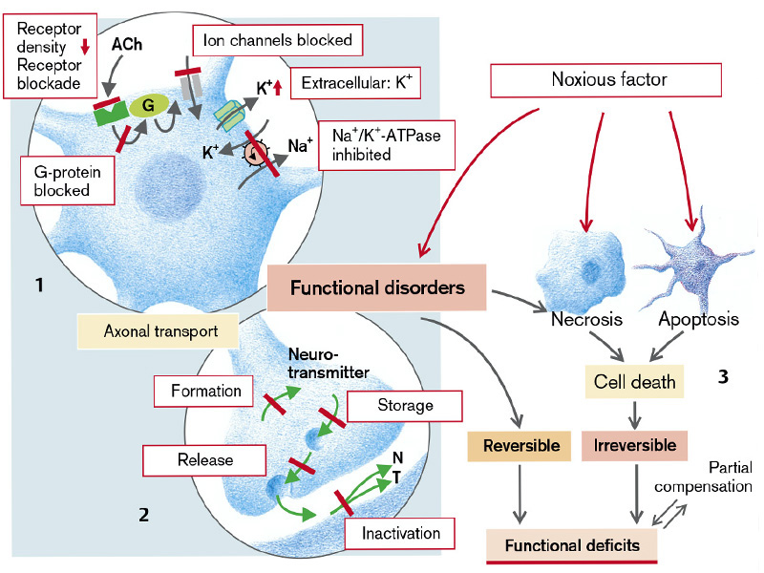**Fig.2. General overview on neuronal damage and death.**

(From S. Silbernagl and F. Lang; Color Atlas of Pathophysiology)

Injury to the neurons can result from a number of conditions, including trauma, infections, tumors, stroke, metabolic derangements, and degenerative disorders. Brain damage resulting from these disorders involves several common pathways, including:

(1) - effects of hypoxia/ischemia;

(2) - injury induced by excitatory amino acid;

(3) - development of cerebral edema;

(4) - injury due to increased intracranial pressure (ICP);

(5) – death of the neurons in axonal damage.

In many cases, the mechanisms of injury are interrelated.

**Hypoxic and ischemic neuronal injury**

The energy requirements of the brain are provided mainly by adenosine triphosphate (ATP); the ability of the cerebral circulation to deliver oxygen in sufficiently high concentrations to facilitate metabolism of glucose and generate ATP is essential to brain function. Although the brain makes up only 2% of the body weight, it receives one sixth of the resting cardiac output and accounts for 20% of the oxygen consumption. Thus, deprivation of oxygen or blood flow can have a deleterious effect on brain structures.

By definition, *hypoxia* denotes a deprivation of oxygen with maintained blood flow, whereas *ischemia* is a situation of greatly reduced or interrupted blood flow. The brain tends to have different sensitivities to the two conditions. Whereas hypoxia interferes with the delivery of oxygen, ischemia interferes with delivery of oxygen and glucose as well as the removal of metabolic wastes. Hypoxia usually is seen in conditions such as exposure to reduced atmospheric pressure, carbon monoxide poisoning, severe anemia, and failure to oxygenate the blood. Because hypoxia indicates decreased oxygen levels in all brain tissue, it produces a generalized depressant effect on the brain. Contrary to popular belief, neurons are capable of substantial anaerobic metabolism and are fairly tolerant of pure hypoxia; it commonly produces euphoria, listlessness, drowsiness, and impaired problem solving. Unconsciousness and convulsions may occur when hypoxia is sudden and severe. However, the effects of severe hypoxia (i.e., *anoxia*) on brain function seldom are seen because the condition rapidly leads to cardiac arrest and ischemia.

Ischemia can be *focal* (atherosclerosis or embolism of cerebral arteries), as in stroke, or *global*, when blood flow is inadequate to meet the metabolic needs of the entire brain, as in cardiac arrest or circulatory shock. Bleeding (due to trauma, vascular aneurysm, hypertension) also causes ischemia by compressing neighboring vessels.

Persons with *global ischemia* have no collateral circulation during the ischemic event. The result is a spectrum of neurologic disorders reflecting global brain dysfunction. Unconsciousness occurs within seconds of severe global ischemia, such as that resulting from complete cessation of blood flow, as in cardiac arrest, or with marked decrease in blood flow, as in serious cardiac dysrhythmias (heart block, severe tachycardia). If circulation is restored immediately, consciousness is regained quickly. However, if blood flow is not promptly restored, severe pathologic changes take place. Energy sources, glucose and glycogen, are exhausted in 2 to 4 minutes, and cellular ATP stores are depleted in 4 to 5 minutes. In contrast to global ischemia, during *focal ischemia* collateral circulation provides blood flow to uninvolved brain areas. The collateral perfusion may even provide sufficient substrates to the focal ischemic region to maintain a low level of metabolic activity, thereby preserving membrane integrity. At the same time, the delivery of glucose under these anaerobic conditions may result in additional lactic acid production and worsening of lactic acidosis.

*Mechanisms of neuronal injury*. Approximately 50% to 75% of the total energy requirement of neuronal tissue is spent on mechanisms for maintenance of ionic gradients across the cell membrane (e.g., sodium–potassium pump, Ca2+ pump). The basic mechanism of damage is always energy deficiency caused by ischemia or hypoxia. By inhibiting Na+/K+-ATPase, energy deficiency causes the cellular accumulation of Na+ and Ca2+ as well as an increased extracellular concentration of K+, and thus depolarization. Excessive accumulation of Na+ in the neurons leads to intracellular hyperosmolarity and development of neuronal edema and interstitial edema. The influx of calcium initiates a cascade of events, including activation of intracellular enzymes (proteases, phospholipases, dezoxyribonucleases, ATP-ases) that cause cell destruction (see also mechanisms of cell injury) (Fig.3.). Ischemia also promotes the release of *glutamate*, which accelerates cell death via the entry of Na+ and Ca2+ (see below *excitotoxicity*). Cell death leads to inflammation that also damages cells at the edge of the ischemic area (*penumbra*). Cell swelling, release of vasoconstrictor mediators, and occlusion of vessel lumina by granulocytes sometimes prevent reperfusion, despite the fact that the primary cause has been removed. When ischemia is sufficiently severe or prolonged, infarction or death of all the cellular elements of the brain occurs.

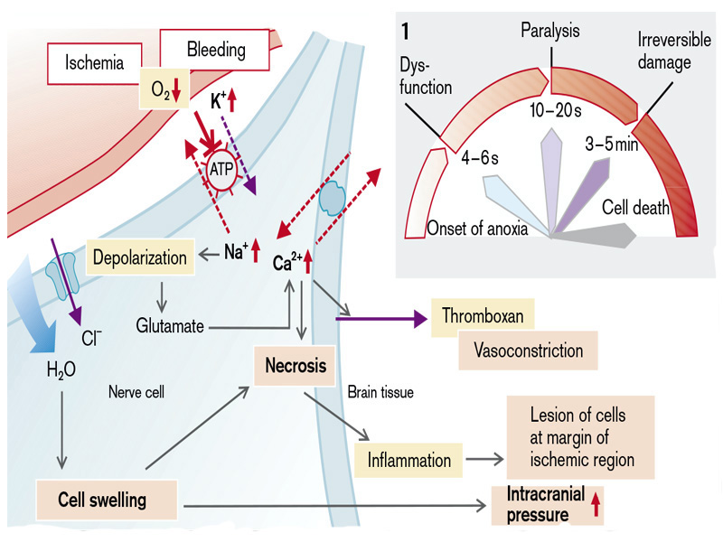

**Fig.3. Effects of reduced brain perfusion**

(From S. Silbernagl and F. Lang; Color Atlas of Pathophysiology)

Another mechanism of neuronal injury in hypoxia and ischemia is development of *peroxidative stress* which leads to ionic pump inactivity. In the four-electron process of restoration of the oxygen molecule in the mitochondrial respiratory chain occurs the formation of several intermediate toxic products to cells. The resulting intermediate products belong to a class of "free radicals" that can bind to lipids, proteins, nucleic acids, disrupting their function. The neurons of the brain are extremely susceptible to oxidative damage due to high concentrations of polyunsaturated fatty acids and low levels of anti-oxidant protection. Most susceptible to the damaging action of free radicals are unsaturated fatty acids of lipid bilayer of membranes resulting in the formation of organic peroxides and hydroperoxides. This leads to an increase in viscosity of the membrane, partial loss of barrier function, and malfunction of membrane channels. Also, accumulation of lipid peroxides disturbs mechanisms of enzymatic inactivation of neurotransmitters with subsequent neuronal hyperexcitability. Oxidative stress plays an important role not only in the development of ischemic brain damage, but also in the pathogenesis of neurological diseases such as Alzheimer's, Parkinson's disease, and amyotrophic lateral sclerosis.

**Role of excitatory amino acids in neuronal injury**

In many neurologic disorders, injury to neurons may be caused by overstimulation of receptors for specific amino acids such as *glutamate* and *aspartate* that act as excitatory neurotransmitters. These neurologic conditions range from acute insults such as stroke, hypoglycemic injury, and trauma to chronic degenerative disorders such as Huntington’s disease and possibly Alzheimer’s dementia.

The term *excitotoxicity* has been coined for the final common pathway for neuronal cell injury and death associated with excessive activity of the excitatory neurotransmitters and their receptor-mediated functions.

Glutamate is the principal excitatory neurotransmitter in the brain, and its interaction with specific receptors is responsible for many higher-order functions, including memory, cognition, movement, and sensation. Many of the actions of glutamate are coupled with receptor-operated ion channels. One subtype in particular, called the *glutamate N-methyl-D-aspartate (NMDA) receptor,* has been implicated in causing neuronal injury. This subtype of glutamate receptor opens a large-diameter calcium channel that permits calcium and sodium ions to enter the cell and allows potassium ions to exit, resulting in prolonged (seconds) action potentials. The intracellular concentration of glutamate is approximately 16 times that of the extracellular concentration. Normally, extracellular concentrations of glutamate are tightly regulated, with excess amounts removed and actively transported into astrocytes and neurons. During prolonged hypoxia or ischemia, these transport mechanisms become immobilized, causing extracellular glutamate to accumulate. The uncontrolled opening of NMDA receptor–operated channels produces an increase in intracellular calcium and leads to a series of calcium-mediated processes called the *calcium cascade* (Fig.4). Activation of the calcium cascade leads to the release of intracellular enzymes that cause protein breakdown, free radical formation, lipid peroxidation, fragmentationof DNA and nuclear breakdown.

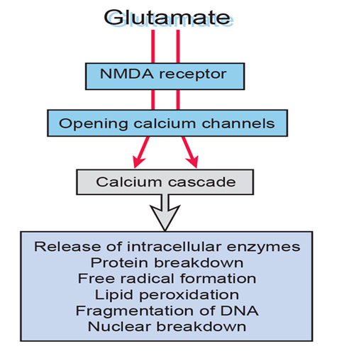

**Fig.4. The role of the glutamate-NMDA receptor in brain cell injury.**

(From Porth; Pathophysiology)

In the case of cell injury and death, intracellular glutamate is released also from the damaged cells, causing injury to surrounding cells. Activation of the calcium cascade eventually causes cell death within several hours after exposure to glutamate.

The effects of acute glutamate toxicity do not necessarily lead to cell death; they are reversible if excess glutamate can be removed or if its effects can be blocked. Drugs called *neuroprotectants* are being developed to interfere with the glutamate - NMDA pathway and thus reduce brain cell injury. These pharmacologic strategies may protect viable brain cells from irreversible damage in the setting of excitotoxicity. Pharmacologic strategies that are being explored include those that inhibit the synthesis or release of excitatory amino acid transmitters; block the NMDA receptors; stabilize the membrane potential to prevent initiation of the calcium cascade using lidocaine and certain barbiturates; and specifically block certain intracellular proteases, endonucleases, and lipases that are known to be cytotoxic. The drug *riluzole*, which acts presynaptically to inhibit glutamate release, currently is being used in the treatment of amyotrophic lateral sclerosis. *Nimodipine*, a calcium channel blocker that acts at the level of the NMDA receptor–operated channels, is being investigated for use in subarachnoid hemorrhage and acquired immunodeficiency syndrome dementia.

Central nervous system neurons can be divided into two major categories: *macroneurons* and *microneurons. Macroneurons* are large cells with long axons that leave the local network of intercommunicating neurons to send action potentials to other regions of the nervous system at distances of centimeters to meters (e.g., upper motoneurons that communicate with lower motoneurons that control leg movement). *Microneurons* are very small cells that are intimately involved in local circuitry. Their axons transmit action potentials to other members of the same local network. In contrast to macroneurons, which number in the thousands, microneurons account for most of the many billions of CNS neurons. Many macroneurons use glutamate as a neurotransmitter in their excitatory communication with microneurons. It is the microneuron network that provides the analytic, integrative, and learning circuitry that is the basis for the higher-order function of the CNS. The microneurons of the cerebral cortex and hippocampus are particularly vulnerable to excessive stimulation of the glutamate NMDA receptors and the neurotoxic effects of increased intracellular calcium levels. Because of their increased vulnerability, many of the small interneurons that make up essential parts of the complex control and memory functions of the brain are selectively damaged, even if the remainder of the brain survives the insult. This pattern may account for the long-term effects of brain insult, which frequently include subtle and noticeable reductions in cognitive and memory functions.

**Neuronal damage due to increased intracranial volume and pressure**

The brain is enclosed in the rigid confines of the skull, orcranium, making it particularly susceptible to increases in *intracranial pressure* (ICP). Increased ICP is a common pathway for neuronal injury from different types of insults and agents. The cranial cavity contains blood (approximately 10%), brain tissue (approximately 80%), and cerebrospinal fluid (CSF) (approximately 10%) in the rigid confines of a non-expandable skull. Each of these three volumes contributes to the ICP, which normally is maintained within a range of 0 to 15 mm Hg when measured in the lateral ventricles. The volumes of each of these components can vary slightly without causing marked changes in ICP. This is because small increases in the volume of one component can be compensated for by a decrease in the volume of one or both of the other two components. This association is called the *Monro-Kellie hypothesis* (Fig.5). Normal fluctuations in ICP occur with respiratory movements and activities of daily living such as straining, coughing, and sneezing. Changes in intracranial volumes occur also during cardiac cycle. The brain intravascular space is momentarily increased with each systolic pulse wave, and synchronously with the pulse a small volume of CSF escapes through the foramen magnum into the spinal CSF space, by this way, the intravascular space is increased at the expense of the CSF space (Fig.5).

According to the Monro-Kellie hypothesis, reciprocal compensation occurs among the three intracranial compartments of the three intracranial volumes but tissue volume is relatively restricted in its ability to undergo change; CSF and blood volume are best able to compensate for changes in ICP. Initial increases in ICP are buffered by a translocation of CSF to the spinal subarachnoid space and increased reabsorption of CSF. The compensatory ability of the blood compartment is limited by the small amount of blood that is in the cerebral circulation. The cerebral blood vessels contain less than 10% of the intracranial volume, most of which is contained in the low-pressure venous system. As the volume-buffering capacity of this compartment becomes exhausted, venous pressure increases, and cerebral blood volume and ICP rise.

Also, cerebral blood flow is highly controlled by auto-regulatory mechanisms, which affect its compensatory capacity. Conditions such as ischemia and an elevated partial pressure of carbon dioxide (PaCO2) in the blood produce a compensatory vasodilation of the cerebral blood vessels. A decrease in PaCO2 has the opposite effect; for this reason, hyperventilation, which results in a decrease in PaCO2 levels, is sometimes used in the treatment of ICP.

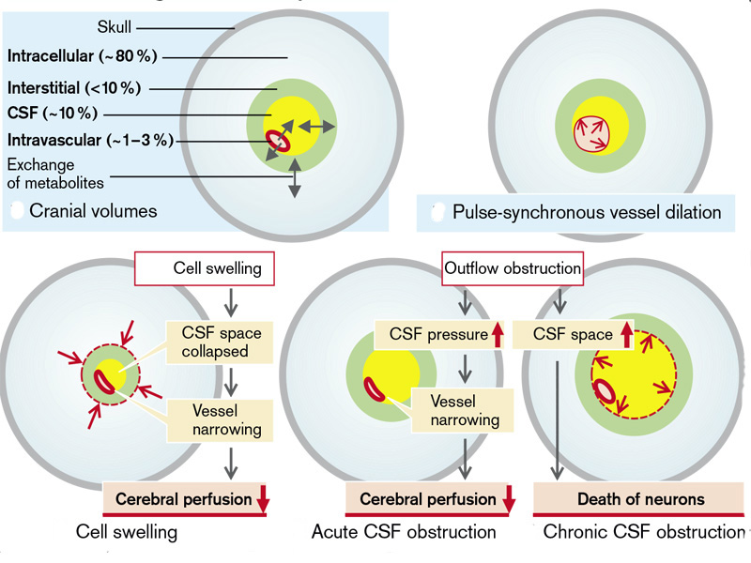

**Fig.5. Volume change of brain compartments** (Monroe-Kelly hypothesis)

(From S, Silbernagl and F. Lang; Color Atlas of Pathophysiology)

Abnormal variation in intracranial volume with subsequent changes in ICP can be caused by a volume change in any of the three intracranial components. For example, an increase in tissue volume can result from a brain tumor, brain edema, or bleeding into brain tissue. An increase in blood volume develops when there is vasodilatation of cerebral vessels or obstruction of venous outflow. Excess production, decreased absorption, or obstructed circulation of CSF *(hydrocephalia*) affords the potential for an increase in the CSF component. When the change in volume is caused by a brain tumor, it tends to occur slowly and usually is localized to the immediate area, whereas the increase resulting from head injury usually develops rapidly.

CSF congestion also increases cerebral pressure. An acute disorder of CSF drainage causes a rise in pressure that, via narrowing of the vessel lumen, impairs cerebral perfusion. Chronic drainage abnormality, by bringing about the death of neurons, i.e., a decrease in intracellular space, will ultimately result in a decrease in cerebral mass. Tumors and bleeding take up intracranial volume at the expense of other compartments, especially the CSF space (Fig.5).

*Impact of intracranial pressure on cerebral perfusion pressure*. The *cerebral perfusion pressure* (CPP), which represents the difference between the mean arterial blood pressure (MABP) and the ICP (CPP = MABP − ICP), is the pressure perfusing the brain. CPP is determined by the pressure gradient between the internal carotid artery and the subarachnoid veins. The MABP and ICP are monitored frequently in persons with brain conditions that increase ICP and impair brain perfusion. Normal CPP ranges from 70 to 100 mm Hg. Brain ischemia develops at levels below 40 mm Hg. When the pressure in the cranial cavity approaches or exceeds the MABP, tissue perfusion becomes inadequate, cellular hypoxia results, and, if the pressure is maintained, neuronal death may occur. The highly specialized cortical neurons are the most sensitive to oxygen deficit; a decrease in the level of consciousness is one of the earliest and most reliable signs of increased ICP. The continued cellular hypoxia leads to general neurologic deterioration; the level of consciousness may deteriorate from alertness through confusion, lethargy, obtundation, stupor, and coma.

*Cerebral Edema*

*Cerebral edema*, or brain swelling, is an increase in tissue volume secondary to abnormal fluid accumulation. There are two types of brain edema: vasogenic and cytotoxic. *Vasogenic edema* occurs when integrity of blood–brain barrier is disrupted, allowing fluid to escape into the extracellular fluid that surrounds brain cells. *Cytotoxic edema* involves the actual swelling of brain cells themselves. The impact of brain edema depends on the brain’s compensatory mechanisms and the extent of the swelling (Fig.6).

*Vasogenic Edema (edema of vascular origin).* Vasogenic edema occurs with conditions that impair the function of the blood–brain barrier and allow transfer of water and protein from the vascular into the interstitial space (due to increased capillary permiability). It occurs in conditions such as tumors, prolonged ischemia, hemorrhage, brain injury, and infectious processes (e.g., meningitis). Vasogenic edema occurs primarily in the white matter of the brain, possibly because the white matter is more compliant than the gray matter. Vasogenic edema can displace a cerebral hemisphere and can be responsible for various types of herniation. The functional manifestations of vasogenic edema include focal neurologic deficits, disturbances in consciousness, and severe intracranial hypertension. Water can also accumulate in the interstitial space when the blood–brain barrier is intact but the osmolarity of the interstitial space is higher than that of blood (also known as *interstitial cerebral edema*). This can happen for example, if there is a rapid fall in the concentration of blood sugar (during treatment of diabetes mellitus), of urea (dialysis), or of Na+. In those conditions the increase of interstitial space may be accompanied by cell swelling (Fig.6.).

*Cytotoxic Edema*. Cytotoxic edema involves an increase in intracellular fluid. It can result from hypoosmotic states such as water intoxication or severe ischemia that impair the function of the sodium-potassium membrane pump (accumulation of sodium ions with hyperosmolarity inside the neurons). The altered osmotic conditions result in water entry and cell swelling. Ischemia also results in the inadequate removal of anaerobic metabolic end products such as lactic acid, producing extracellular acidosis (Fig.6). If blood flow is reduced to low levels for extended periods or to extremely low levels for a few minutes, cellular edema can cause the cell membrane to rupture, allowing the escape of intracellular contents into the surrounding extracellular fluid. This leads to damage of neighboring cells. Major changes in cerebral function, such as stupor and coma, occur with cytotoxic edema. The edema associated with ischemia may be severe enough to produce cerebral infarction with necrosis of brain tissue.

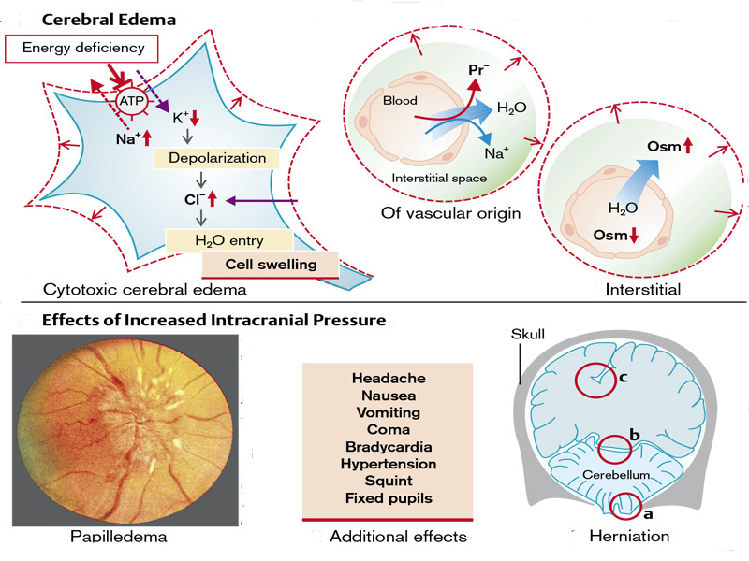

**Fig.6. Mechanisms of cerebral edema and effects of high intracranial pressure**

(From S. Silbernagl and F. Lang; Color Atlas of Pathophysiology).

*Symptoms of increased ICP*. Due to the increased cerebral pressure, lymph from the back of the eye can no longer flow toward the intracranial space via the lymphatic canal at the center of the optic nerve. Lymph thus collects at the exit of the optic nerve and causes bulging of the papilla *(papilledema).* Other consequences of increased CSF pressure are headache, nausea, vomiting, dizziness, impaired consciousness (due to decreased perfusion), bradycardia and arterial hypertension (by pressure on the brain stem), squinting (compression of the abducens nerve), and dilated pupils which are unresponsive to light (compression of the oculomotor nerve) (Fig.6). One of the late reflexes seen with a marked increase in ICP is the CNS ischemic response, which is triggered by ischemia of the vasomotor center in the brain stem. Neurons in the vasomotor center respond directly to ischemia by producing a marked increase in MABP, sometimes to levels as high as 270 mm Hg, accompanied by a widening of the pulse pressure and reflex slowing of the heart rate. These three signs, sometimes called the *Cushing reflex*, are important but late indicators of increased ICP. The ischemic reflex is a last-ditch effort by the nervous system to maintain the cerebral circulation. The Cushing reflex seldom is seen in modern clinical settings since the advent of ICP monitoring.

The pressure gradients bear an increasing risk of herniation of parts of the brain through the cerebellar tentorium or the foramen magnum. The herniated parts compress the brain stem causing immediate death. If the increase in CSF pressure is unilateral, the cingulate gyrus may herniate under the falx cerebri, causing compression of the anterior cerebral vessels with corresponding deficits in cerebral functions (Fig.6).

**Death of the neurons in axon transection**. If an axon is transected, the distal parts of the axon die (*Waller degeneration*). Axons of central neurons as a rule do not grow outward again, rather the affected neuron dies by apoptosis. Causes include absence of the *nerve growth factor* (NGF), which is normally released by the innervated, postsynaptic cell and, via the axon, keeps the presynaptic cell alive. Interruption of the retrograde axonal transport in an otherwise intact axon also leads to death of the neuron. The proximal stump of the peripheral axon can grow out again. The proteins that are necessary for this to happen are formed within the cell body and are transported to the place of injury by axonal transport. A possible reason for survival of the affected cell is that macrophages migrating into the peripheral nerve, via the formation of interleukin 1, stimulate the Schwann cells to produce NGF. Macrophages are not, however, able to enter the CNS. Transection of an axon not only causes death of the primarily damaged neuron, the absence of innervation often leads to death of the target cell *(anterograde transneuronal degeneration*) and sometimes also of cells that innervate the damaged cell (*retrograde transneuronal degeneration).*

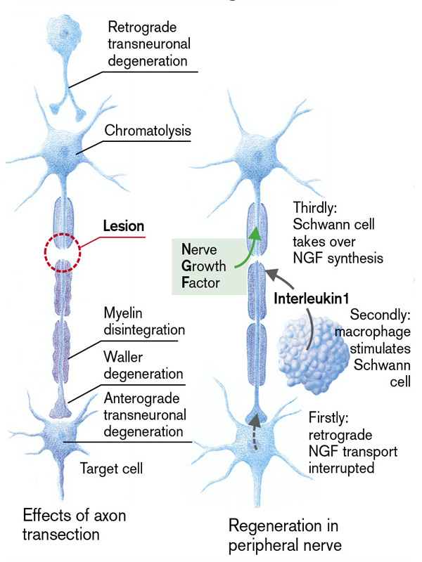

**Fig.7. Axon transection and regeneration**

(From S. Silbernagl and F. Lang; Color Atlas of Pathophysiology)

**Reactions of Astrocytes to Injury**

The astrocyte derives its name from its star-shaped appearance. These cells have multipolar, branching cytoplasmic processes that emanate from the cell body and contain *glial fibrillary acidic protein* (GFAP), a cell type-specific intermediate filament. Astrocytes act as metabolic buffers and detoxifiers within the brain. Additionally, through the foot processes, which surround capillaries or extend to the subpial and subependymal zones, they contribute to barrier functions controlling the flow of macromolecules between the blood, the cerebrospinal fluid (CSF), and the brain.

*Gliosis* is the most important histopathologic indicator of CNS injury, regardless of etiology, and is characterized by both hypertrophy and hyperplasia of astrocytes. In gliosis, the nuclei of astrocytes enlarge, become vesicular, and develop prominent nucleoli; these cells are called *gemistocytic astrocytes*.

Acute cell injury, as occurs in hypoxia, hypoglycemia, and toxic injuries, is manifested by cellular swelling, as in other cells. The Alzheimer type II astrocyte (unrelated to Alzheimer disease but first described by the same individual) is a gray matter cell with a large (two to three times normal) nucleus, an intranuclear glycogen droplet, and a prominent nuclear membrane and nucleolus. This type of change is mainly seen in individuals with long-standing hyperammonemia due to chronic liver disease or hereditary metabolic disorders of the urea cycle.

**Reactions of Microglia to Injury**

Microglia are mesoderm-derived phagocytic cells that serve as the resident macrophages of the CNS. They share many surface markers with peripheral monocytes/macrophages (e.g., CR3 and CD68). They respond to injury by (1) proliferating; (2) developing elongated nuclei (*rod cells*); (3) forming aggregates around small foci of tissue necrosis (*microglial nodules*); or (4) congregating around cell bodies of dying neurons (*neuronophagia*). In addition to resident microglia, blood-derived macrophages may also be present in inflammatory foci.

**Reactions of Other Glial Cells to Injury**

*Oligodendrocytes* are cells that wrap their cytoplasmic processes around axons and form myelin. Each oligodendrocyte myelinates numerous internodes on multiple axons, in contrast to the myelinating Schwann cell in peripheral nerve, which has a one-to-one correspondence between cells and internodes. Injury or apoptosis of oligodendroglial cells is a feature of acquired *demyelinating disorders* (see demyelination) and *leukodystrophies*.

*Ependymal cells,* the ciliated columnar epithelial cells lining the ventricles, do not have specific patterns of reaction. When there is inflammation or marked dilation of the ventricular system, disruption of the ependymal lining is paired with proliferation of subependymal astrocytes to produce small irregularities on the ventricular surfaces (*ependymal granulations*).

However, neither oligodendrocytes nor ependymal cells mediate significant responses to most forms of injury in the CNS.

**DISORDERS IN SYNAPTIC TRANSMISSION**

Neurons communicate with each other through structures known as *synapses*. Two types of synapses are found in the nervous system: electrical and chemical.

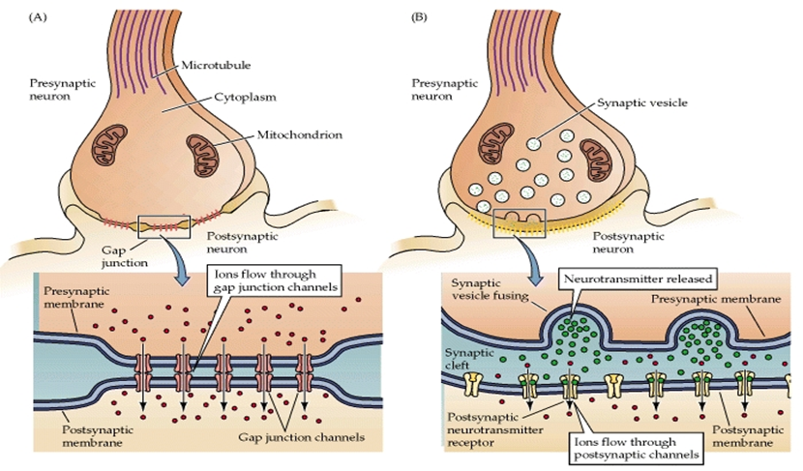

**Fig.8. Types of synapses**

*Electrical synapses* permit the passage of current-carrying ions through small openings called *gap junctions* that penetrate the cell junction of adjoining cells and allow current to travel in either direction. The gap junctions allow an action potential to pass directly and quickly from one neuron to another. They may link neurons having close functional relationships into circuits.

The most common type of synapse is the *chemical synapse*. Chemical synapses involve special presynaptic and postsynaptic membrane structures, separated by a synaptic cleft. In contrast to an electrical synapse, a chemical synapse serves as a rectifier, permitting only *one-way communication*. One-way conduction is a particularly important characteristic of chemical synapses. It is this specific transmission of signals to discrete and highly localized areas of the nervous system that allows it to perform the myriad functions of sensation, motor control, and memory. Chemical synapses are the slowest component in progressive communication through a sequence of neurons, such as in a spinal reflex. In contrast to the conduction of electrical action potentials, each successive event at the chemical synapse - transmitter secretion, diffusion across the synaptic cleft, interaction with postsynaptic receptors, and generation of a subsequent action potential in the postsynaptic neuron - consumes time. On the average, conduction across a chemical synapse requires approximately 0.3 milliseconds.

A neuron’s cell body and dendrites are covered by thousands of synapses, any or many of which can be active at any moment. Because of the interaction of this rich synaptic input, each neuron resembles a little integrator, in which circuits of many neurons interact with one another. Chemical synapses exhibit several relationships. Axons can synapse with dendrites (*axodendritic*), with the cell body (*axosomatic*), or to the axon (*axoaxonic*). Dendrites can synapse with axons *(dendroaxonic*), other dendrites (*dendrodendritic*), or the soma of other neurons (*dendrosomatic*). Synapses between the nerve cell body and axons *(somatoaxonic synapses*) also have been observed. Synapses occurring between the soma of neighboring neurons (*somasomatic*) are uncommon, except between some efferent nuclei. The mechanism of communication between the presynaptic and the postsynaptic neuron is similar in all types of synapses; the action potential sweeps into the axonal terminals of the afferent neuron and triggers the rapid release of neurotransmitter molecules from the axonal, or presynaptic, surface. Conversion of action potentials into neurotransmitter release is called *coupling*, and although it is not completely understood, it is believed that the release of calcium ions is involved.

**Excitatory and Inhibitory Postsynaptic Potentials**

Presynaptic terminals secrete one and often several chemical messenger molecules (*neurotransmitters* or *neuromodulators*) into the synaptic cleft. Neurotransmitters diffuse into the synaptic cleft and unite with receptors on the postsynaptic membrane; this causes excitation or inhibition of the postsynaptic neuron by producing either *depolarization* or *hyperpolarization* of the postsynaptic membrane.

Many CNS neurons possess thousands of synapses on their dendritic or somatic surfaces, each of which can produce partial excitation or inhibition of the postsynaptic neuron. When the combination of a neurotransmitter with a receptor site causes partial *depolarization* of the postsynaptic membrane, it is called an *excitatory postsynaptic potential* (EPSP). In other synapses, the combination of a transmitter with a receptor site is inhibitory in the sense that it causes the local nerve membrane to become hyperpolarized and less excitable. This is called an *inhibitory postsynaptic potential* (IPSP).

Action potentials do not begin in the membrane adjacent to the synapse. They begin in the initial segment of the axon, near the *axon hillock*, that lies just before the first myelin segment. The initial segment of the axon is more excitable than the rest of the neuron. The local currents resulting from an EPSP (sometimes called a *generator potential*) are usually insufficient to reach threshold and cause depolarization of the axon’s initial segment. However, if several EPSPs occur simultaneously, the area of depolarization can become large enough and the currents at the initial segment can become strong enough to exceed the threshold potential and initiate an action potential. Action potentials permit rapid communication over long distances. However, it is the capacity for integration of excitatory and inhibitory synaptic bombardment of the soma and dendrites that gives the neuron and the nervous system the capability for complexity, memory, and intelligence.

*Neurotransmitters* are the chemical messenger molecules of the nervous system. The process of neurotransmission involves the synthesis, storage, and release of a neurotransmitter; the reaction of the neurotransmitter with a receptor; and termination of the receptor action. Newer research methods, including staining techniques and the use of radiolabeled antibodies, have allowed scientists to study and gain answers in each of these areas.

Both the nervous system and the endocrine system use chemical molecules as messengers. As more information is obtained about the chemical messengers of these systems, the distinction between them becomes less evident. Many neurons, such as those in the adrenal medulla, secrete transmitters into the bloodstream, and it has been found that other neurons possess receptor sites for hormones. Many hormones have turned out to be neurotransmitters. *Vasopressin* (also known as antidiuretic hormone), a peptide hormone released from the posterior pituitary gland, acts as a hormone in the kidney and as a neurotransmitter for nerve cells in the hypothalamus. More than a dozen of these cell-to-cell and bloodborne messengers can relay signals in the nervous system or the endocrine system.

Neurotransmitters are synthesized in the cytoplasm of the axon terminal. The synthesis of transmitters may require one or more enzyme-catalyzed steps (e.g., one for acetylcholine and three for norepinephrine). Neurons are limited as to the type of transmitter they can synthesize by their enzyme systems. After synthesis, the neurotransmitter molecules are stored in the axon terminal in tiny, membrane-bound sacs called *synaptic vesicles*. Thousands of vesicles may be present in a single terminal, each containing 10,000 to 100,000 transmitter molecules. The vesicle protects the neurotransmitters from enzyme destruction in the nerve terminal. The arrival of an impulse at a nerve terminal causes the vesicles to move to the cell membrane and release their transmitter molecules into the synaptic space. Neurotransmitters exert their actions through specific proteins, called receptors, embedded in the postsynaptic membrane. These receptors are tailored precisely to match the size and shape of the transmitter. In each case, the interaction between a transmitter and receptor results in a specific physiologic response. The action of a transmitteris determined by the type of receptor to which it binds. For example, acetylcholine is excitatory when it is released at a myoneural junction, and it is inhibitory when it is released at the sinoatrial node in the heart. Receptors are named according to the type of neurotransmitter with which they interact. For example, a *cholinergic receptor* is a receptor that binds acetylcholine.

Rapid removal of a transmitter, once it has exerted its effects on the postsynaptic membrane, is necessary to maintain precise control of neural transmission. A released transmitter can undergo one of three fates: it can be broken down into inactive substances by enzymes; it can be taken back up into the presynaptic neuron in a process called *reuptake*; or it can diffuse away into the intercellular fluid until its concentration is too low to influence postsynaptic excitability. Acetylcholine, for example, is rapidly broken down by *acetylcholinesterase* into *acetic acid* and *choline,* with the choline being taken back into the presynaptic neuron for reuse in acetylcholine synthesis. The catecholamines are largely taken back into the neuron in an unchanged form for reuse. Catecholamines also can be degraded by enzymes in the synaptic space or in the nerve terminals.

Neurotransmitters are small molecules that incorporate a positively charged nitrogen atom; they include several peptides, amino acids, and monoamines. Peptides are low-molecular-weight molecules made up of two or more amino acids. They include *substance P* and the *endorphins* and *enkephalins*, which are involved in pain sensation and perception. Amino acids are the building blocks of proteins and are present in body fluids. A monoamine is an amine molecule containing one amino group (NH2). *Serotonin, dopamine, norepinephrine*, and *epinephrine* are monoamines synthesized from amino acids. Fortunately, the blood–brain barrier protects the nervous system from circulating amino acids and other molecules with potential neurotransmitter activity.

Much needs to be learned about the role of amino acids and peptides as neurotransmitters. For example, several amino acids (especially *glutamic acid* and *aspartic acid*) appear to exert powerful excitatory effects on synaptic transmission; they are often called *excitatory amino acids*. *Glycine*, another amino acid, is known to have strong inhibitory effects. One of the most common inhibitory transmitters is *γ-aminobutyric acid (GABA*). This amino acid is unique in that it is synthesized almost exclusively in the brain and spinal cord. It has been established that almost one third of the synapses use GABA. Adding to the already complicated nature of neurotransmitters, it is puzzling that the same amino acid can function as both a neurotransmitter and as a building block for protein synthesis.

Other classes of messenger molecules, known *neuromodulators*, also may be released from axon terminals. Neuromodulator molecules react with presynaptic or postsynaptic receptors to alter the release of or response to neurotransmitters. Neuromodulators may act on postsynaptic receptors to produce slower and longer-lasting changes in membrane excitability. This alters the action of the faster-acting neurotransmitter molecules by enhancing or decreasing their effectiveness. By combining with autoreceptors on its own presynaptic membrane, a transmitter can act as a neuromodulator to augment or inhibit further nerve activity. In some nerves, such as the peripheral sympathetic nerves, a messenger molecule can have both transmitter and modulator functions. For example, *norepinephrine* can activate an α1-adrenergic postsynaptic receptor to produce vasoconstriction, or stimulate an α2-adrenergic presynaptic receptor to inhibit further norepinephrine release.

*Neurohumoral mediators* reach their target cells through the bloodstream and produce an even slower action than the neuromodulators. Neurotrophic or *nerve growth factors* are required to maintain the long-term survival of the postsynaptic cell and are secreted by axon terminals independent of action potentials. Examples include lower motoneurons (LMNs) to muscle cell trophic factors and neuron-to-neuron trophic factors in the sequential synapses of CNS sensory neurons. Trophic factors from target cells that enter the axon and are necessary for the long-term survival of presynaptic neurons have also been demonstrated.

**DISORDERS OF SYNAPTIC TRANSMISSION**

The actions of most neurotransmitters are localized in specific clusters of neurons with axons that project to highly specific brain regions. As more has been learned about the location and mechanism of action of the various neurotransmitters, many disease conditions clearly have their origin in altered neurotransmitter physiology. Occasionally, there is evidence of degeneration or dysfunction of the neurons producing the neurotransmitters; in other cases, there is an apparent alteration in the postsynaptic response to the neurotransmitter. For example, the neurons containing dopamine are concentrated in regions of the midbrain known as the *substantia nigra* and *ventral tegmentum*. Many of these dopamine-containing neurons project their axons to areas of the forebrain thought to be involved in regulation of emotional behavior. Other dopamine fibers terminate in regions near the middle of the brain called the *corpus striatum*. The latter fibers are thought to play an essential role in the performance of complex motor movements. Degeneration of the dopamine fibers in this area of the brain leads to the tremor and rigidity that are characteristic of *Parkinson’s disease*. Some forms of mental illness, such as schizophrenia, are thought to involve abnormal release of or response to neurotransmitters in the brain. Pharmacologic methods of supplying neurotransmitters (e.g., in Parkinson’s disease) or modifying their actions (e.g., with psychoactive drugs) are used to treat some of these disorders.

Undoubtedly, more specific treatment methods will become available as more is learned about the transmission of neural information.

Disruption of synaptic transmission can be induced by various pathogens, either exogenous or endogenous, which act at the level of presynaptic neurons or postsynaptic structures (Fig.9).

At the level of the *presynaptic neurons* can be affected the following processes:

a. Synthesis of chemical mediators and modulators;

b. Impaired axonal transport of the mediator;

c. Storage of chemical mediators;

d. Release of chemical mediators;

e. Reuptake of chemical mediators;

At the level of the *postsynaptic neurons* may be affected by the following processes:

a. Formation of active mediator-receptor complex;

b. Inactivation of chemical mediator;

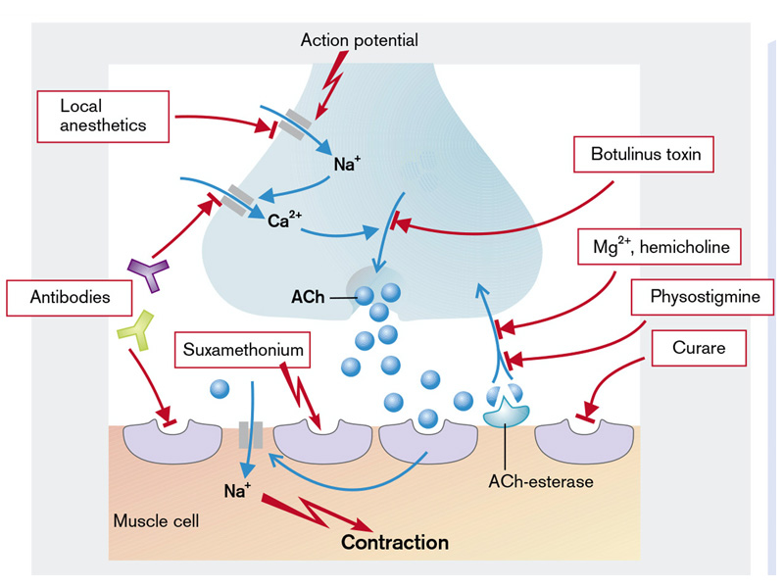

**Fig.9. Disorders of synaptic transmission**

(From S. Silbernagl and F. Lang; Color Atlas of Pathophysiology)

*Presynaptic mechanisms in synaptic transmission disorders*

* *Synthesis of chemical mediators* may be disturbed by factors that alter either the concentration of mediator precursor in the neurons or activity of the enzymes involved in it synthesis.

Precursor concentration can be changed by:

a. Increased intake of exogenous precursor (ex. administration of L-dopa, the precursor of dopamine, increase its incorporation into dopaminergic neurons with following increased synthesis of dopamine);

b. Stimulation of neurons which lead to increased reuptake of precursors (stimulation of cholinergic neurons favors capture of choline with subsequent synthesis of acetylcholine);

d. Reduced energy potential caused by hypoxia disturb the synaptic transmission by suppressing synaptic energy-dependent processes.

Mediator synthesis requires the action of specialized enzyme. The activity of enzyme which is involved in synthesis of neuromediators may be disturbed in different genetic disorders, mutations induced by ionizing radiation or chemotherapeutic drugs.

* *Impaired axonal transport of the mediator***.** Two axonal transport systems, one *slow* and one *rapid*, move molecules from the cell body through the cytoplasm of the axon to its terminals by specialized protein – *tubulin, ankyrin, dynein* etc... Replacement proteins and nutrients slowly diffuse from the cell body, where they are synthesized, down the axon, moving at the rate of approximately 1 mm/day. Other molecules, such as some neurosecretory granules or their precursors, are conveyed by a rapid, energy-dependent active transport system, moving at the rate of approximately 400 mm/day. Often, membrane-bound vesicles containing neurosecretory granules (e.g., neurotransmitters, neuromodulators, and neurohormones) are moved to the axon synaptic terminals by the active transport process. For example, rapid axonal transport carries antidiuretic hormones and oxytocin from hypothalamic neurons through their axons to the posterior pituitary, where the hormones are released into the blood. A reverse rapid (retrograde) axonal transport system moves materials, including target cell messenger molecules, from axonal terminals back to the cell body.

Anesthetics, proteolytic enzymes, colchicine and others substances and toxins destroy these formation such disturbing axonal transport and reducing the amount of mediators and nutritive substances at the level of presynaptic elements.

* *Impaired mediator storage in nerve endings***.** Mediators are stored in presynaptic vesicles (*sinaptosomes*) in molecular complex with ATP and proteins. Some substances can disrupt the storage of mediator. So, for example, *reserpine* prevents storage of norepinephrine and serotonin in presynaptic vesicles. Impaired dopamine storage contributes to the pathogenesis of Parkinson’s disease.
* *Impaired mediator release***.** Sometimes although the synaptic vesicles are normal and postsynaptic membrane is sensitive to chemical mediators, the synaptic transmission is affected due to problems in the release of mediators. This occurs in the following situations:

a. Botulinus toxin leads to blockage of acetylcholine release at the level of neuromuscular synapse by inactivation of *synaptobrevin*, the protein responsible for binding the acetylcholine-containing vesicles to the plasma membrane and thus contributing to release of acetylcholine. (Fig.8).

b*. Paraneoplastic myasthenic syndrome* (*Eaton-Lambert syndrome* or *pseudomyasthenic syndrome*)*.* This condition often arises in patients affected by a small-cell carcinoma of the lungs. Ca2+ channels in the plasma membrane of the tumor cells sensitize the immune system and stimulate the formation of antibodies that also react with the Ca2+ channels at the level of the presynaptic membrane of the endplate such blocking the release of acetylcholine (Fig.10). Due to inhibition of the Ca2+channels, the summated muscle action potential is at first small, but is progressively normalized, because with the repetitive stimulation increasing amounts of Ca2+ are accumulated in the nerve endings.

c. *Imipramine* and *amitriptyline* reduce spontaneous release of norepinephrine, which accumulates in synaptic vesicles and by this way act as antidepressants;

d. *Guanethidine* block release of norepinephrine in the axonal endings, thereby it is used as an antihypertensive drug;

e. *Local anesthetics* (lidocaine, bupivacaine, etc..) inhibit the voltage-gated Na+ channels of the neuron and thus interrupt nerve transmission to the end-plate impeding mediator release from the presynaptic button.

* *Disorders in the reuptake of chemical mediators*

The reuptake of choline into the nerve ending can be inhibited by *Mg2+* and *hemicholine*, such leading to reduced resynthesis of acetylcholine in the body of the neurons.

*Postsynaptic mechanisms in synaptic transmission disorders*

* *Disorders in formation of mediator-receptor complex*

Given the central role of acetylcholine receptors in mediating muscles contraction at neuromuscular junction in numerous species, it is not surprising that a large number of natural toxins interfere with transmission at the synapse.

The most important disease affecting the end-plates is *myasthenia gravis*, a muscle paralysis that results from blockage of neuromuscular transmission (Fig.10). It is caused by antibodies against the acetylcholine receptors in the postsynaptic membrane which accelerate the breakdown of the receptors. The immune response also reduced the number of functional receptors at the level of neuromuscular junction and diminishes the efficiency of synaptic transmission; muscle weakness thus occurs because motor neurons are less capable of exciting the postsynaptic muscle cells. This causal sequence also explains why cholinesterase inhibitors alleviate the signs and symptoms of myasthenia gravis (many patients are treated with combinations of immunosuppression and cholinesterase inhibitors). This autoimmune disease can be caused by infection with viruses that have an acetylcholine-receptor-like structure. Myasthenia may also occur in patients with a benign tumor of the thymus. The formation of such antibodies is favored in those who express special subtypes (DR3 and DQw2) of the major histocompatibility complex (MHC class II). In patients with myasthenia gravis, repetitive stimulation of a motor nerve will at first cause the production of a normal summated muscle action potential whose amplitude will, however, decrease through progressively increasing “fatigue” of neuromuscular transmission

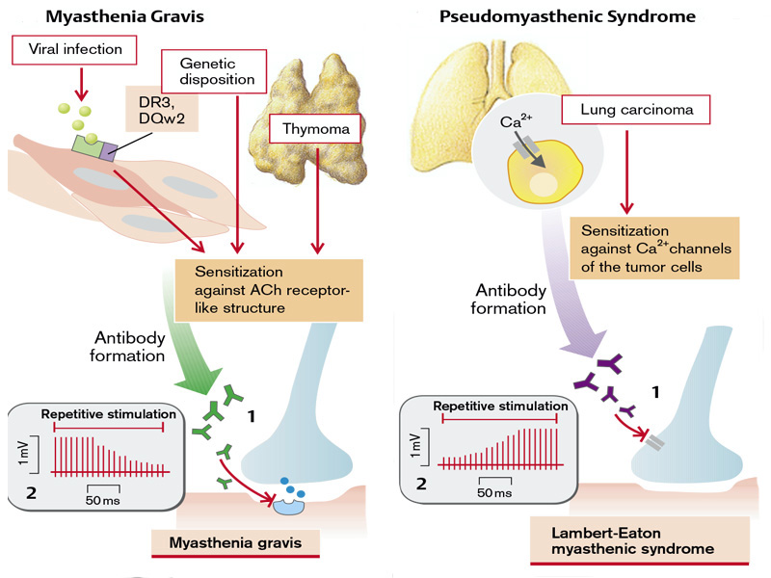

**Fig. 10. Pathogenetic mechanisms of myasthenia gravis and pseudomyasthenic syndrome** (From S. Silbernagl and F. Lang; Color Atlas of Pathophysiology)

The postsynaptic receptors can also be blocked by *curare* that, without itself having an effect, competitively inhibits the binding of acetylcholine to the receptors (*indirect myorelaxant*). *Succinylcholine* (suxamethonium chloride) leads to continuous stimulation of the receptors, continuous depolarization of the postsynaptic membrane, and thus to an inactivation of the postsynaptic Na+ channels. In this way it can, like curare, block neuromuscular transmission (*direct myorelaxant*) (Fig.9)

* *Disorders in the process of mediator inactivation*

Various agents block the enzymes that inactivate the mediator thus slowing down or making impossible the dissociation of mediator-receptor complex, by this way the action and physiologic effects of the mediator will last longer. In low concentrations, substances that inhibit acetylcholinesterase (e.g., *anticholinesterasic* drugs like physostigmine, proserine) increase neuromuscular transmission by increasing the availability of acetylcholine in the synaptic cleft (Fig.9). In high doses, however, they inhibit neuromuscular transmission because high concentrations of acetylcholine cause continuous depolarization of the postsynaptic membrane and so inactivate the postsynaptic Na+ channels.

**DEMYELINATION**

In myelinated nerves, the axon between two nodes of Ranvier (*internodal segment*) is surrounded by a myelin sheath. This is a precondition for saltatory conduction of the action potentials - the “jumping” propagation of excitation from one nodal constriction (R1) to the next (R2). The internodal segment itself cannot generate an action potential, i.e., depolarization of the second node (R2) is completely dependent on the current from the first node (R1). However, the current is usually so strong that it can even jump across the nodes.

Nevertheless, on the way along the internodal segment the amplitude of the current will diminish. First of all, the membrane in the internodal segment must change its polarity, i.e., the membrane capacitance must be discharged, for which a current is needed (green arrow) (Fig.11). Secondly, current can also escape through individual ionic channels in the axonal membrane (orange arrow). However, myelination of the internodal segment causes the *membrane resistance* (Rm) to be elevated and the *membrane capacity* (Cm) of the membrane condensor to be reduced. The resistance of the axonal membrane of the internodal segment is very high because of the low density of ionic channels there. Furthermore, the perimembranous space is insulated by a layer of fat from the free extracellular space. The low capacitance of the condenser is due to the large distance between the interior of the axon and the free extracellular space as well as the low polarity of the fatty material in the space between them.

Demyelination can be caused by degenerative, toxic, or inflammatory damage to the nerves, or by a deficiency of vitamins B6 or B12. If this happens, Rm will be reduced and Cm raised in the internodal segment. As a result, more current will be required to change the polarity of the internodal segment (green arrow) and, through opening up the ionic channels, large losses of current may occur (orange arrow).

If, after the losses in the internodal segment, the current generated at R1 is not adequate to depolarize R2 to the threshold level, excitation is interrupted, even though the axon is completely intact. High frequency of action potentials and low temperature favor interruption of conduction because of decreasing sensitivity of the node R2. Minor lesions of the internodal segment can lead to slowing of conduction, because it can no longer jump across nodes and the next node has to be depolarized to its threshold before the excitation is passed to the after next nodes. The resulting slowing may not be the same in different fibers, so that temporal dispersion of the signal may occur. Lastly, the damaged site may itself trigger action potentials, especially when the axon has concomitantly suffered spontaneous damage or is under mechanical pressure; excitation can jump across two neighboring damaged nerve fibers (*ephaptic transmission*), or conduction may run retrogradely.

Genetic defects of the myelin-sheath protein (*protein 0*), of peripheral myelin protein 22 (PMP 22)]) or of gap junctions in the Schwann cells (*connexin 22*) lead to certain hereditary peripheral neuropathies (Charcot-Marie-Tooth syndrome, Dejerine-Sottas syndrome, Pelizaeus-Merzbacher disease).

The most important demyelinating disease is *multiple sclerosis*. It is more common in women than men, familial aggregation sometimes occurs, and it has a higher incidence among carriers of HLA3 and HLA7. It is an autoimmune disease that may be triggered by a viral infection and is characterized by demyelinating inflammatory foci. The typical feature ofmultiple sclerosis is the temporally unrelated occurrence of completely different neuronal deficits, caused by lesions in different parts of the brain. Some of the lesions may partly regress when the local inflammatory process has subsided and the nerves (in the case of intact axons) have been remyelinated.

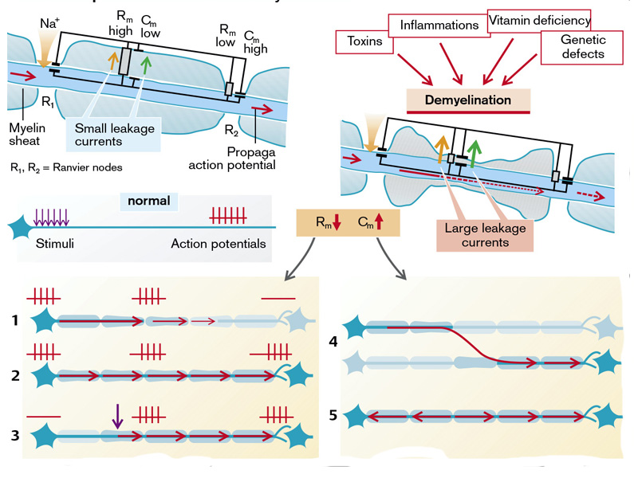

**Fig.11. Development and effects of demyelination**

(From S. Silbernagl and F. Lang; Color Atlas of Pathophysiology)

**Disorders of the autonomic nervous system**

** The Autonomic nervous system.** The ability to maintain homeostasis and perform the activities of daily living in an ever-changing physical environment is largely vested in the autonomic nervous system (ANS). This portion of the nervous system functions at the subconscious level and is involved in regulating, adjusting, and coordinating vital visceral functions such as blood pressure and blood flow, body temperature, respiration, digestion, metabolism, and elimination. The ANS is strongly affected by emotional influences and is involved in many of the expressive aspects of behavior. Blushing, pallor, palpitations of the heart, clammy hands, and dry mouth are several emotional expressions mediated through the ANS. Biofeedback and relaxation exercises have been used for modifying the subconscious functions of the ANS.

As with the somatic nervous system, the ANS is represented in both the CNS and the PNS. Traditionally, the ANS has been defined as a general efferent system innervating visceral organs. The efferent outflow from the ANS has two divisions: *the sympathetic nervous system* and *the parasympathetic nervous system*. The afferent input to the ANS is provided by visceral afferent neurons, usually not considered a part of the ANS.

The functions of the *sympathetic nervous system* include maintaining body temperature and adjusting blood flow and blood pressure to meet the changing needs of the body that occur with activities of daily living, such as moving from the supine to the standing position. The *sympathoadrenal system* also can discharge as a unit when there is a critical threat to the integrity of the individual - the so-called *fight-or-flight response*. During a stress situation, the heart rate accelerates; blood pressure rises; blood flow shifts from the skin and gastrointestinal tract to the skeletal muscles and brain; blood sugar increases; the bronchioles and pupils dilate; the sphincters of the stomach and intestine and the internal sphincter of the urethra constrict; and the rate of secretion of exocrine glands involved in digestion diminishes. Emergency situations often require vasoconstriction and shunting of blood away from the skin and into the muscles and brain, a mechanism that, should a wound occur, provides for a reduction in blood flow and preservation of vital functions needed for survival. Sympathetic function is often summarized as catabolic in that its actions predominate during periods of pronounced energy expenditure, such as when survival is threatened.

In contrast to the sympathetic nervous system, the functions of the *parasympathetic nervous system* are concerned with conservation of energy, resource replenishment and storage (i.e., anabolism), and maintenance of organ function during periods of minimal activity. The parasympathetic nervous system slows heart rate, stimulates gastrointestinal function and related glandular secretion, promotes bowel and bladder elimination, and constricts the pupil, protecting the retina from excessive light during periods when visual function is not vital to survival. The two divisions of the ANS are usually viewed as having opposite and antagonistic actions (i.e., if one activates, the other inhibits a function). Exceptions are functions, such as sweating and regulation of arteriolar blood vessel diameter, controlled by a single division of the ANS, in this case the sympathetic nervous system.

The sympathetic and parasympathetic nervous systems are continually active. The effect of this continual or basal (baseline) activity is referred to as *tone*. The tone of an effector organ or system can be increased or decreased and is usually regulated by a single division of the ANS. For example, vascular smooth muscle tone is controlled by the sympathetic nervous system. Increased sympathetic activity produces local vasoconstriction from increased vascular smooth muscle tone, and decreased activity results in vasodilatation due to decreased tone. In structures such as the sinoatrial node and atrioventricular node of the heart, which are innervated by both divisions of the ANS, one division predominates in controlling tone. In this case, the tonically active parasympathetic nervous system exerts a constraining or braking effect on heart rate, and when parasympathetic outflow is withdrawn, the heart rate increases. The increase in heart rate that occurs with vagal withdrawal can be further augmented by sympathetic stimulation.

**AUTONOMIC EFFERENT PATHWAYS**. The outflow of both divisions of the ANS follows a two neuron pathway. The first motoneuron, called the *preganglionic neuron*, lies in the intermediolateral cell column in the ventral horn of the spinal cord or its equivalent location in the brain stem. The second motoneuron, called the *postganglionic neuron*, synapses with a preganglionic neuron in an autonomic ganglion in the PNS. The two divisions of the ANS differ as to location of preganglionic cell bodies, relative length of preganglionic fibers, general function, nature of peripheral responses, and preganglionic and postganglionic neuromediators. This two-neuron outflow pathway and the interneurons in the autonomic ganglia that add further modulation to ANS function are features distinctly different from the arrangement in somatic motor innervation.

Most visceral organs are innervated by both sympathetic and parasympathetic fibers. Exceptions include structures such as blood vessels and sweat glands that have input from only one division of the ANS. The fibers of the sympathetic nervous system are distributed to effectors throughout the body, and as a result, sympathetic actions tend to be more diffuse than those of the parasympathetic nervous system, in which there is a more localized distribution of fibers. The preganglionic fibers of the sympathetic nervous system may traverse a considerable distance and pass through several ganglia before synapsing with postganglionic neurons, and their terminals contact many postganglionic fibers. In some ganglia, the ratio of preganglionic to postganglionic cells may be 1:20; because of this, the effects of sympathetic stimulation are diffuse. Considerable overlap exists, and one ganglion cell may be supplied by several preganglionic fibers. In contrast to the sympathetic nervous system, the parasympathetic nervous system has its postganglionic neurons located very near or in the organ of innervation. Because the ratio of preganglionic to postganglionic communication is often 1:1, the effects of the parasympathetic nervous system are much more circumscribed.

**Sympathetic nervous system**. The neurons of the sympathetic nervous system are located primarily in the thoracic and upper lumbar segments (*T1 to L2*) of the spinal cord; hence, the sympathetic nervous system is often called the *thoracolumbar division* of the ANS. These preganglionic neurons, located primarily in the ventral horn intermediolateral cell column, have axons that are largely myelinated and relatively short. The postganglionic neurons of the sympathetic nervous system are located in the paravertebral ganglia of the *sympathetic chain* of ganglia that lie on either side of the vertebral column, or in prevertebral sympathetic ganglia such as the *celiac ganglia*. Besides postganglionic efferent neurons, the sympathetic ganglia contain neurons of the internuncial, short-axon type, similar to those associated with complex circuitry in the brain and spinal cord. Many of these inhibit and others modulate preganglionic-to postganglionic transmission. The full significance of these modulating circuits awaits further investigation.

The axons of the preganglionic neurons leave the spinal cord through the ventral root of the spinal nerves (T1 to L2), enter the ventral primary rami, and leave the spinal nerve through white rami of the rami communicantes to reach the paravertebral ganglionic chain. In the sympathetic chain of ganglia, preganglionic fibers may synapse with neurons of the ganglion they enter, pass up or down the chain and synapse with one or more ganglia, or pass through the chain and move outward through a splanchnic nerve to terminate in prevertebral ganglia (i.e., *celiac, superior mesenteric*, or *inferior mesenteric*) scattered along the dorsal aorta and its branches.

Preganglionic fibers from the thoracic segments of the cord pass upward to form the cervical chain connecting the inferior, middle, and superior *cervical sympathetic ganglia* with the rest of the sympathetic chain at lower levels. Postganglionic sympathetic axons of the cervical and lower lumbosacral chain ganglia spread further through nerve plexuses along continuations of the great arteries. Cranial structures, particularly blood vessels, are innervated by the spread of postganglionic axons along the external and internal carotid arteries into the face and the cranial cavity. The sympathetic fibers from T1 usually continue up the sympathetic chain into the head; those from T2 pass into the neck; those from T1 to T5 travel to the heart; those from T3, T4, T5, and T6 proceed to the thoracic viscera; those from T7, T8, T9, T10, and T11 pass to the abdominal viscera; and those from T12, L1, and L2 pass to the kidneys and pelvic organs. Many preganglionic fibers from the fifth to the last thoracolumbar segment pass through the paravertebral ganglia to continue as the splanchnic nerves. Most of these fibers do not synapse until they reach the celiac or superior mesenteric ganglion; others pass to the adrenal medulla.

The adrenal medulla, which is part of the sympathetic nervous system, contains postganglionic sympathetic neurons that secrete sympathetic neurotransmitters directly into the bloodstream. Some postganglionic fibers, all of which are unmyelinated, exit the paravertebral ganglionic chain and reenter the segmental nerve through unmyelinated branches, called *gray rami*. These segmental nerves are then distributed to all parts of the body wall in the spinal nerve branches. These fibers innervate the sweat glands, piloerector muscles of the hair follicles, all blood vessels of the skin and skeletal muscles, and the CNS *itself*.

**Parasympathetic nervous system**. The preganglionic fibers of the parasympathetic nervous system, also called the *craniosacral division* of the ANS, originate in some segments of the brain stem and sacral segments of the spinal cord. The central regions of origin are the midbrain, pons, medulla oblongata, and sacral part of the spinal cord. The midbrain outflow passes through the *oculomotor nerve* (cranial nerve III) to the *ciliary ganglion* that lies in the orbit behind the eye; it supplies the pupillary sphincter muscle of each eye and the ciliary muscles that control lens thickness for accommodation. From the caudal pontine outflow originate the preganglionic fibers of the intermedius component of the *facial nerve* (cranial nerve VII) complex. This outflow synapses in the *submandibular ganglia*, which sends postganglionic fibers to supply the submandibular and sublingual glands. In addition, preganglionic fibers are distributed to the *pterygopalatine ganglia* to synapse on postganglionic neurons. These postganglionic fibers emanating from the pterygopalatine ganglia supply the lacrimal and nasal glands. The medullary outflow develops from cranial nerves VII, IX, and X. Fibers in the *glossopharyngeal nerve* (cranial nerve IX) synapse in the *optic ganglia*, which supply the parotid salivary glands. Approximately 75% of parasympathetic efferent fibers are carried in the *vagus nerve* (cranial nerve X). The vagus nerve provides parasympathetic innervation for the heart, trachea, lungs, esophagus, stomach, small intestine, proximal half of the colon, liver, gallbladder, pancreas, kidneys, and upper portions of the ureters.

Sacral preganglionic axons leave the S2 to S4 segmental nerves by gathering into the *pelvic nerves*, also called the *nervi erigentes*. The pelvic nerves leave the sacral plexus on each side of the cord and distribute their peripheral fibers to the bladder, uterus, urethra, prostate, distal portion of the transverse colon, descending colon, and rectum. Sacral parasympathetic fibers also supply the venous outflow from the external genitalia to facilitate erectile function.

Excepting cranial nerves III, VII, and IX, which synapse in discrete ganglia, the long parasympathetic preganglionic fibers pass uninterrupted to short postganglionic fibers within the organ wall. In the walls of these organs, postganglionic neurons send axons to smooth muscle and glandular cells that modulate their functions.

The gastrointestinal tract has its own intrinsic network of ganglionic cells found between the smooth muscle layers, called the *enteric plexus* (or intramural), which controls local peristaltic movements and secretory functions. This network of parasympathetic postganglionic neurons and interneurons runs from the lower two thirds of the esophagus to the internal anal sphincter. Local afferent sensory neurons respond to mechanical and chemical stimuli and communicate these influences to motor fibers in the enteric plexus. The number of neurons in the enteric neural network is so large that it approximates that of the spinal cord. It is thought that this enteric nervous system is capable of independent function without control from CNS fibers. The CNS has a modulating role, by way of preganglionic innervation of the plexus, converting local peristalsis to longer-distance movements, thereby speeding the transit of intestinal contents.

**CENTRAL INTEGRATIVE PATHWAYS.** General visceral afferent fibers accompany the sympathetic and parasympathetic outflow into the spinal and cranial nerves, bringing chemoreceptor, pressure, organ capsule stretch, and nociceptive information from organs of the viscera to the brain stem, thoracolumbar cord, and sacral cord. Local reflex circuits relating visceral afferent and autonomic efferent activity are integrated into a hierarchic control system in the spinal cord and brain stem. Progressively greater complexity in the responses and greater precision in their control occur at each higher level of the nervous system.

For most autonomic-mediated functions, *the hypothalamus* serves as the major control center. The hypothalamus, having connections with the cerebral cortex, the limbic system, and the pituitary gland, is in a prime position to receive, integrate, and transmit information to other areas of the nervous system. Neurons concerned with thermoregulation, thirst, and feeding behaviors are also found in the hypothalamus. The hypothalamus also is the site for integrating neuroendocrine function. Hypothalamic releasing and inhibiting hormones control the secretion of anterior pituitary hormones (i.e., *thyroidstimulating hormone, corticotropin, growth hormone, luteinizing hormone, follicle-stimulating hormone,* and *prolactin*). The supraoptic nuclei of the hypothalamus are involved in water metabolism through synthesis of *antidiuretic hormone* and its release from the posterior pituitary gland. *Oxytocin*, which causes contraction of the pregnant uterus and milk letdown during breast-feeding, is synthesized in the hypothalamus and released from the posterior pituitary gland similar to that of antidiuretic hormone.

The organization of many life-support reflexes occurs in the *reticular formation* of the medulla and pons. These areas of reflex circuitry, often called centers, produce complex combinations of autonomic and somatic efferent functions required for the respiration, gag, cough, sneeze, swallow, and vomit reflexes, and for the more purely autonomic control of the cardiovascular system. At the hypothalamic level, these reflexes are integrated into more general response patterns such as rage, defensive behavior, eating, drinking, voiding, and sexual function. Forebrain and especially *limbic system* control of these behaviors involves inhibiting or facilitating release of the response patterns according to social pressures during learned emotion-provoking situations.

Reflex adjustments of cardiovascular and respiratory function occur at the level of the brain stem. A prominent example is the carotid sinus baroreflex. Increased blood pressure in the carotid sinus results in increased discharge from afferent fibers that travel by way of the ninth cranial nerve to cardiovascular centers in the brain stem. These centers increase the activity of descending efferent vagal fibers that slow heart rate, while inhibiting sympathetic fibers that increase heart rate and blood vessel tone. Striking features of ANS function are the rapidity and intensity with which it can change visceral function. Within 3 to 5 seconds, it can increase heart rate to approximately twice its resting level. Bronchial smooth muscle tone is largely controlled by parasympathetic fibers carried in the vagus nerve. These nerves produce mild to moderate constriction of the bronchioles.

Other important ANS reflexes are located at the level of the spinal cord. As with other spinal reflexes, these reflexes are modulated by input from higher centers. When a loss of communication exists between the higher centers and the spinal reflexes, as occurs in spinal cord injury, these reflexes function in an unregulated manner. This results in uncontrolled sweating, vasomotor instability, and reflex bowel and bladder function.

**AUTONOMIC NEUROTRANSMISSION**. The generation and transmission of impulses in the ANS occur in the same manner as in other neurons. There are self-propagating action potentials with transmission of impulses across synapses and other tissue junctions by way of neurohumoral transmitters. However, the somatic motoneurons that innervate skeletal muscles divide into many branches, with each branch innervating a single muscle fiber; in contrast, the distribution of postganglionic fibers of the ANS forms a diffuse neural plexus at the site of innervation. The membranes of the cells of many smooth muscle fibers are connected by conductive protoplasmic bridges, called *gap junctions*, that permit rapid conduction of impulses through whole sheets of smooth muscle, often in repeating waves of contraction. Autonomic neurotransmitters released near a limited portion of these fibers provide a modulating function extending to many effector cells. Smooth muscle layers of the gut and of the bladder wall are examples. Sometimes, isolated smooth muscle cells are individually innervated by the ANS, such as the piloerector cells that elevate the hair on the skin during cold exposure.

The main neurotransmitters of the autonomic nervous system are *acetylcholine* and the *catecholamines,* epinephrine and norepinephrine. *Acetylcholin*e is released at all preganglionic synapses in the autonomic ganglia of both sympathetic and parasympathetic nerve fibers and from postganglionic synapses of all parasympathetic nerve endings. It also is released at sympathetic nerve endings that innervate the sweat glands and cholinergic vasodilator fibers found in skeletal muscle. *Norepinephrine* is released at most sympathetic nerve endings. The adrenal medulla, which is a modified prevertebral sympathetic ganglion, produces epinephrine along with small amounts of norepinephrine. *Dopamine*, which is an intermediate compound in the synthesis of norepinephrine, also acts as a neurotransmitter. It is the principal inhibitory transmitter of internuncial neurons in the sympathetic ganglia. It also has vasodilator effects on renal, splanchnic, and coronary blood vessels when given intravenously and is sometimes used in the treatment of shock.

**Acetylcholine and cholinergic receptors**. Acetylcholine is synthesized in the cholinergic neurons from *choline* and *acetyl coenzyme A* (acetyl CoA). After acetylcholine is secreted by the cholinergic nerve endings, it is rapidly broken down by the enzyme *acetylcholinesterase.* The choline molecule is transported back into the nerve ending, where it is used again in the synthesis of acetylcholine.

Receptors that respond to acetylcholine are called *cholinergic receptors*. Two types of cholinergic receptors are known: *muscarinic* and *nicotinic.* *Muscarinic receptors* are present on the innervational targets of postganglionic fibers of the parasympathetic nervous system and the sweat glands, which are innervated by the sympathetic nervous system. *Nicotinic receptors* are found in autonomic ganglia and the end plates of skeletal muscle. Acetylcholine is excitatory to most muscarinic and nicotinic receptors, except those in the heart and lower esophagus, where it has an inhibitory effect. The drug atropine is an antimuscarinic or muscarinic cholinergic-blocking drug that prevents the action of acetylcholine at excitatory and inhibitory muscarinic receptor sites. Because it is a muscarinic-blocking drug, it exerts little effect at nicotinic receptor sites.

**Catecholamines and adrenergic receptors**. The catecholamines, which include *norepinephrine*, *epinephrine*, and *dopamine*, are synthesized in the axoplasm of sympathetic nerve terminal endings from the amino acid *tyrosine.* During catecholamine synthesis, tyrosine is hydroxylated (i.e., has a hydroxyl group added) to form DOPA, and DOPA is decarboxylated (i.e., has a carboxyl group removed) to form dopamine. Dopamine in turn is hydroxylated to form norepinephrine. In the adrenal gland, an additional step occurs during which norepinephrine is methylated (i.e., a methyl group is added) to form epinephrine. Each step in sympathetic neurotransmitter synthesis requires a different enzyme, and the type of neurotransmitter produced depends on the types of enzymes that are available in a nerve terminal. For example, the postganglionic sympathetic neurons that supply blood vessels synthesize norepinephrine, but postganglionic neurons in the adrenal medulla produce epinephrine or norepinephrine. Epinephrine accounts for approximately 80% of the catecholamines released from the adrenal gland. The synthesis of epinephrine by the adrenal medulla is influenced by the glucocorticoid secretion from the adrenal cortex. These hormones are transported through an intra-adrenal vascular network from the adrenal cortex to the adrenal medulla, where they cause the sympathetic neurons to increase their production of epinephrine through increased enzyme activity. Thus, any stress situation sufficient to evoke increased levels of glucocorticoids also increases epinephrine levels. As the catecholamines are synthesized, they are stored in vesicles. The final step of norepinephrine synthesis occurs in these vesicles. When an action potential reaches an axon terminal, the neurotransmitter molecules are released from the storage vesicles. The storage vesicles provide a means for concentrated storage of the catecholamines and protect them from the cytoplasmic enzymes that degrade the neurotransmitters. Besides neuronal synthesis, a second major mechanism exists for the replenishment of norepinephrine in sympathetic nerve terminals. This mechanism consists of the active recapture or reuptake of the released neurotransmitter into the nerve terminal. Between 50% and 80% of the norepinephrine released during an action potential is removed from the synaptic area by an active reuptake process. This process stops the action of the neurotransmitter and allows it to be reused by the neuron. The remainder of the released catecholamines diffuses into the surrounding tissue fluids or is degraded by two special enzymes: *catechol-O-methyltransferase*, which is diffusely present in all tissues, and *monoamine oxidase* (MAO), which is found in the nerve endings. Some drugs, such as the tricyclic antidepressants, are thought to increase the level of catecholamines at the site of nerve endings in the brain by blocking the reuptake process. Others, such as the MAO inhibitors, decrease the enzymatic degradation of the neurotransmitters and increase their levels.

Catecholamines can cause excitation or inhibition of smooth muscle contraction, depending on the site, dose, and type of receptor present. Norepinephrine has potent excitatory activity and low inhibitory activity. Epinephrine is potent as both an excitatory and an inhibitory agent. The excitatory or inhibitory responses of organs to sympathetic neurotransmitters are mediated by interaction with special structures in the cell membrane called receptors. In 1948, Ahlquist proposed the designations α and β for the receptor sites where catecholamines produce their excitatory (α) and inhibitory (β) effects. In vascular smooth muscle, excitation of α receptors causes vasoconstriction, and excitation of β receptors causes vasodilatation. Endogenously and exogenously administered norepinephrine produces marked vasoconstriction of the blood vessels in the skin, kidneys, and splanchnic circulation that are supplied with α receptors. The β receptors are most prevalent in the heart, the blood vessels of skeletal muscle, and the bronchioles. Blood vessels in skeletal muscle have α and β receptors. In these vessels, high levels of norepinephrine produce vasoconstriction; low levels produce vasodilatation. The low levels are thought to have a diluting effect on norepinephrine levels in the arteries of these blood vessels so that the β effect predominates. With respect to vessels having few receptors, such as those that supply the brain, norepinephrine has little effect. α-Adrenergic receptors have been further subdivided into α1 and α2 receptors, and β-adrenergic receptors into β1 and β2 receptors. β1-Adrenergic receptors are found primarily in the heart and can be selectively blocked by β1 receptor– blocking drugs. β2-Adrenergic receptors are found in the bronchioles and in other sites that have β-mediated functions. The α1 receptors are found primarily in postsynaptic effector sites; they mediate responses in vascular smooth muscle. The α2 receptors are mainly located presynaptically and can inhibit the release of norepinephrine from sympathetic nerve terminals. The α2 receptors are abundant in the CNS and are thought to influence the central control of blood pressure. The various classes of adrenergic receptors provide a mechanism by which the same adrenergic neurotransmitter can have many selective effects on different effector cells. This mechanism also permits neurotransmitters carried in the bloodstream, whether from neuroendocrine secretion by the adrenal gland or from subcutaneously or intravenously administered drugs, to produce the same effects.

*Vegetative disbalance* represents disorders of elementary vegetative functions of the body as well as disorders of sympatho-parasympathetic integration which ensure the homeostasis of the body.

Disorders of the ANS may result from pathology of either the CNS or the peripheral nervous system (PNS). Signs and symptoms may result from interruption of the afferent limb, CNS processing centers, or efferent limb of reflex arcs controlling autonomic responses. For example, a lesion of the medulla produced by a posterior fossa tumor can impair BP responses to postural changes and result in orthostatic hypotension (OH). OH can also be caused by lesions of the spinal cord or peripheral vasomotor nerve fibers (diabetic autonomic neuropathy).

*Etiology of vegetative disorders*

Etiologic factors are many: mechanic and physical factors (these interrupt vegetative reflex arch at different levels), chemical factors (exogenous toxins, heavy metals, mediators, biological active substances, some drugs like agonists, antagonists blockers, endogenous toxins – uremia, intestinal autointoxication, ammonia), endocrine disorders (diabetes mellitus, adrenal insufficiency), immune and autoimmune diseases (myasthenia, autoimmune encephalitis), inflammatory processes (encephalitis, encephalomyelitis, AIDS, herpes, syphilis), psychic disorders (neurosis, acute and chronic stress), hereditary disorders ( Raily-Dei syndrome, Bredberry syndrome).

*Classification of vegetative disorders*

Vegetative disorders develop as result of suprasegmentary and subsegmentary injury of the CNS.

A. *Suprasegmentary vegetative dysorders* – these involve predominantly syndromes related to injuries at different levels of SNC mainly that of hypothalamus and reticular formation. These can be:

*- Cortical*  (cortical vegetative areas are deeply involved in integration and coordination of different somato-vegetative functions like digestion, urinary secretion, stimulation of uterus contraction, sexual behavior and many others)

- Brain stem (*truncular*) (at this level are the best conditions for integration of the information supplied by nervous or hormonal pathways by means of organo-vegetative centers).

*- Thalamic,*

*- Hypothalamic*

*- Reticular*

**Hypothalamic disorders**

The hypothalamus integrates the body’s autonomic, endocrine, and somatomotor functions. Neurons in the hypothalamus are responsible for regulating various homeostatic functions such as food intake, electrolyte and water metabolism, temperature regulation, and circadian rhythm. In addition, the functions are adapted in the hypothalamus to the required behavioral patterns, such as the fight and flight reaction, nutritive or sexual behavior. The programs required for the particular behavioral patterns are stored in the hypothalamus and are called up as needed, in particular by the neurons of the limbic system. Circumscribed lesions in the hypothalamus can occur as the result of tumors, trauma, or inflammation, and they can produce profound disorders of autonomic regulation (Fig.12).

A lesion in the *anterior hypothalamus* (including the preoptic region) leads to disturbances of temperature regulation and circadian rhythm (destruction of the suprachiasmal nucleus). It expresses itself, for example, in insomnia. Also, as a result of lesions in the supraoptic and paraventricular nuclei, the antidiuretic hormone (ADH) and oxytocin are no longer formed, and there is no sense of thirst.

A lesion in the *medial hypothalamus* also results in disorders of temperature control and the sense of thirst. At the same time there may be marked impairment of food intake. A lesion in the lateral part of the medial hypothalamus stops the sensation of hunger. Such patients no longer have the urge to eat (*aphagia*), their food intake is inadequate, and they lose weight (*anorexia*). Conversely, lesions of the medial hypothalamus cause a craving for food (*hyperphagia*) and, because of the intake of hypercaloric food, lead to obesity. However, obesity or anorexia are only rarely due to a hypothalamic lesion, but rather have psychological causes. Damage to the medial hypothalamus also brings about disorders of memory acquisition and emotions.

Lesions in the *posterior hypothalamus* lead to poikilothermia, narcolepsy and memory gaps, along with other complex autonomic and emotional disorders.

Abnormal release of hypophyseal hormones occurs with lesions in different parts of the hypothalamus. As a result, the peripheral functions regulated by the hormones are affected when ADH is not released - *diabetes insipidus* develops in which the kidney can no longer produce concentrated urine and may excrete as much as 20 l of urine daily. Abnormal release of gonadotropin can cause hyperfunction or hypofunction of the peripheral hormonal glands. Increased release of sex hormones can result in premature sexual maturation (precocious puberty), while reduced release brings about delayed sexual maturity and infertility

Longitudinal growth is promoted by the sex hormones, somatotropin and the thyrotropin-regulated thyroid hormones. A reduced concentration of these hormones delays growth, reduced release of the sex hormones retarding the fusion of the epiphyseal plates which may eventually cause gigantism, despite the slower growth. Corticotropin inhibits longitudinal growth via the action of cortisol. The main hormones that affect metabolism are *somatotropin, thyroid hormones,* and the *adrenocortical hormones* which are regulated by corticotropin. Abnormal release of the latter hormones can have massive metabolic effects. Thyroid and adrenocortical hormones also have a profound effect on the circulation. The adrenocortical hormones also have an influence on the blood cells. They cause an increase in erythrocytes, thrombocytes and neutrophils, while decreasing the number of lymphocytes, plasma cells, and eosinophils. They thus affect O2 transport in blood, blood clotting, and immune defense.

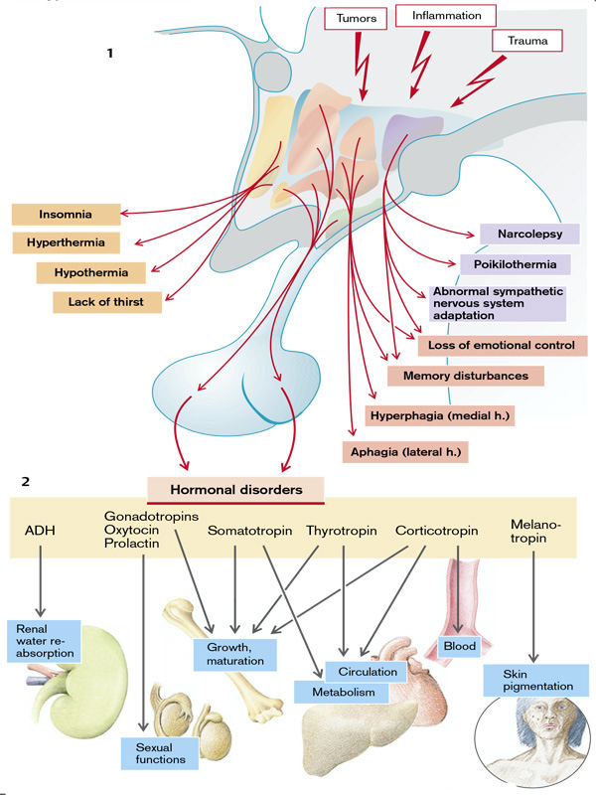

**Fig.12. Hypothalamic vegetative disorders**

(From S. Silbernagl and F. Lang; Color Atlas of Pathophysiology)

B. *Segmentary vegetative disorders* develop in case of simpathetic-parasympathetic disequilibrium and can be:

*- Mesencephalic* (disorders of pupilary reflex, accomodation to distance and light as well as statokinetic reflexes).

- *Bulbar* (disorders of cardio-vascular and ventilatory reflexes, as well as disorders of deglution, salivation , vomiting, hiccup).

*- Medulary* (disorders of defecation and micturion reflexes, erection and ejaculation; disorders of vascular tonus – general vasodilation, manifestations of spinal shock; cardiovascular reactions, sweating, piloerection and neuro-psychyc tension).

*- Ganglionar*

*- Jonctional*

The sympathetic and parasympathetic nervous systems are complementary regulators of manifold autonomic functions. Both systems can become overactive or inactive as a result of disease of the autonomic nervous system.

The sympathetic nervous system can be activated (sympathicotonia) by:

- emotions;

- fall in blood pressure (hypovolemic shock);

- hypoglycemia.

Furthermore, a tumor of the cells in the adrenal medulla (*pheochromocytoma*) can form and release epinephrine. Lastly, some drugs can trigger sympathetic nerve activity.

When pain occurs activation of sympathetic nerves may produce autonomic side effects.

Activation of the sympathetic nervous system will, via β1-receptors, increase the:

- excitability of the heart (bathmotropism),

- cardiac contractility (inotropism),

- heart rate (chronotropism) as well as

- the conduction velocity of the action potential (dromotropism).

Blood vessels in the skin, lung, kidney, gut, and sex organs are constricted via α1-receptors, while those in the heart, muscle, and liver are dilated by β2-receptors. The circulatory effects of the sympathetic nerves are to raise the blood pressure, the skin becomes pale through vasoconstriction.The sympathetic nerves stimulate sweat (cholinergic) and salivary secretion, hair becomes erect (arrectores pilorum muscle), eyelids are raised (levator palpebrae muscle), and the pupils dilated (dilator papillae muscle). In addition, bronchial and uterine musculature is dilated, the activity of the intestinal musculature is inhibited, and the intestinal and bladder sphincters contracted. Contraction of the seminal vesicle and the ductus deferens triggers ejaculation. Sympathetic nerves also promote muscular tremor, stimulate the breakdown of glycogen in the liver and muscles, lipolysis as well as the release of, among others, glucagon, corticotropin, somatotropin, and renin. They also inhibit insulin and histamine release. Finally, they aid in mobilization of leukocytes and in aggregating platelets (Fig.13).

Sympathetic stimulation may cease partly or completely (a rare event) because of degeneration of the autonomic nerves (autonomic failure or idiopathic orthostatic hypotension).

Additionally, some drugs block sympathetic action, causing effects that are a mirror image of the consequences of excessive sympathetic stimulation.

The main effect is a

- drop in blood pressure;

- dysfunction of the sex organs;

- abnormal thermoregulation due to the absence of sweat secretion;

The airway may be narrowed in those who are susceptible to this.

Loss of sympathetic innervation of the eye causes *Horner’s syndrome*, which is characterized by constricted pupils *(miosis*) and lid droop *(ptosis*) as well as eyeball retraction (*endophthalmos*). Loss of parasympathetic stimulation (e.g., as a result of cholinergic receptor blockers) leads to tachycardia and dilated pupils. Furthermore, bronchial, intestinal, and bladder muscles, erection (in the male), vasocongestion (in the female), and tear, salivary, bronchial, and gastrointestinal secretions are inhibited. If there is an anticholinergic action, sweat secretion is also inhibited.

***Symptoms of autonomic dysfunction*.** Clinical manifestations can result from loss of function, overactivity, or dysregulation of autonomic circuits. Disorders of autonomic function should be considered in all patients with unexplained orthostatic hypotension, syncope, sleep dysfunction, altered sweating (hyperhidrosis or hypohidrosis), constipation, upper gastrointestinal symptoms (bloating, nausea, vomiting of old food), impotence, or bladder disorders (urinary frequency, hesitancy, or incontinence). Symptoms may be widespread or regional in distribution. An autonomic history focuses on systemic functions (BP, heart rate, sleep, fever, sweating) and involvement of individual organ systems (pupils, bowel, bladder, sexual function). Autonomic symptoms may vary dramatically, reflecting the dynamic nature of autonomic control over homeostatic function. For example, OH might be manifest only in the early morning, following a meal, with exercise, or with raised ambient temperature, depending upon the regional vascular bed affected by dysautonomia.

Early symptoms may be overlooked. Impotence, although not specific for autonomic failure, often heralds autonomic failure in men and may precede other symptoms by years. Bladder dysfunction may appear early in men and women, particularly in those with CNS involvement. Cold feet may indicate peripheral vasomotor constriction. Brain and spinal cord disease above the level of the lumbar spine results first in urinary frequency and small bladder volumes and eventually in incontinence (upper motor neuron or spastic bladder). By contrast, PNS disease of autonomic nerve fibers results in large bladder volumes, urinary frequency, and overflow incontinence (lower motor neuron flaccid bladder). Measurement of bladder volume (postvoid residual) is a useful bedside test for distinguishing between upper and lower motor neuron bladder dysfunction in the early stages of dysautonomia. Gastrointestinal autonomic dysfunction typically presents as severe constipation. Diarrhea occurs occasionally (as in diabetes mellitus) due to rapid transit of contents or uncoordinated small-bowel motor activity, or on an osmotic basis from bacterial overgrowth associated with small-bowel stasis. Impaired glandular secretory function may cause difficulty with food intake due to decreased salivation or eye irritation due to decreased lacrimation. Occasionally, temperature elevation and vasodilation can result from anhidrosis because sweating is normally important for heat dissipation. Lack of sweating after a hot bath, during exercise, or on a hot day can suggest sudomotor failure.

OH (also called *orthostatic* or *postural hypotension*) is perhaps the most disabling feature of autonomic dysfunction. The prevalence of OH is relatively high, especially when OH associated with aging and diabetes mellitus is included. OH can cause a variety of symptoms, including dimming or loss of vision, lightheadedness, diaphoresis, diminished hearing, pallor, and weakness. Syncope results when the drop in BP impairs cerebral perfusion. Other manifestations of impaired baroreflexes are supine hypertension, a heart rate that is fixed regardless of posture, postprandial hypotension, and an excessively high nocturnal BP. Many patients with OH have a preceding diagnosis of hypertension or have concomitant supine hypertension, reflecting the great importance of baroreflexes in maintaining postural and supine normotension. The appearance of OH in patients receiving antihypertensive treatment may indicate overtreatment or the onset of an autonomic disorder. The most common causes of OH are not neurologic in origin; these must be distinguished from the neurogenic causes

**Postural orthostatic tachycardia syndrome**

This syndrome is characterized by symptomatic orthostatic intolerance (not OH) and by either an increase in heart rate to >120 beats/min or an increase of 30 beats/min with standing that subsides on sitting or lying down. Women are affected approximately five times more often than men, and most develop the syndrome between the ages of 15 and 50. Approximately half of affected patients report an antecedent viral infection. Syncopal symptoms (lightheadedness, weakness, blurred vision) combined with symptoms of autonomic overactivity (palpitations, tremulousness, nausea) are common. Recurrent unexplained episodes of dysautonomia and fatigue also occur. The pathogenesis is unclear in most cases; hypovolemia, deconditioning, venous pooling, impaired brainstem regulation, or receptor supersensitivity may play a role. In one affected individual, a mutation in the NE transporter, which resulted in impaired NE clearance from synapses, was responsible. Some cases are due to an underlying limited autonomic neuropathy. Although 80% of patients improve, only one-quarter eventually resume their usual daily activities (including exercise and sports).

**Primary hyperhidrosis**

This syndrome presents with excess sweating of the palms of the hands and soles of the feet. The disorder affects 0.6–1.0% of the population; the etiology is unclear, but there may be a genetic component. While not dangerous, the condition can be socially embarrassing (shaking hands) or disabling (inability to write without soiling the paper). Onset of symptoms is usually in adolescence; the condition tends to improve with age. Topical antiperspirants are occasionally helpful. More useful are potent anticholinergic drugs such as glycopyrrolate. T2 ganglionectomy or sympathectomy is successful in >90% of patients with palmar hyperhidrosis.

**Acute autonomic syndromes**

The physician may be confronted occasionally with an acute autonomic syndrome, either acute autonomic failure (acute AAN syndrome) or a state of sympathetic overactivity. An autonomic storm is an acute state of sustained sympathetic surge that results in variable combinations of alterations in blood pressure and heart rate, body temperature, respiration, and sweating. Causes of autonomic storm are brain and spinal cord injury, toxins and drugs, autonomic neuropathy, and chemodectomas (pheochromocytoma).

Brain injury is most commonly a cause of autonomic storm following severe head trauma and in postresuscitation encephalopathy following anoxic-ischemic brain injury. Autonomic storm can also occur with other acute intracranial lesions such as hemorrhage, cerebral infarction, rapidly expanding tumors, subarachnoid hemorrhage, hydrocephalus, or (less commonly) an acute spinal cord lesion. Lesions involving the diencephalon may be more prone to present with dysautonomia, but the most consistent setting is that of an acute intracranial catastrophe of sufficient size and rapidity to produce a massive catecholaminergic surge. The surge can cause seizures, neurogenic pulmonary edema, and myocardial injury. Manifestations include fever, tachycardia, hypertension, tachypnea, hyperhidrosis, pupillary dilatation, and flushing. Lesions of the afferent limb of the baroreflex can result in milder recurrent autonomic storms; many of these follow neck irradiation.

Drugs and toxins may also be responsible, including sympathomimetics such as phenylpropanolamine, cocaine, amphetamines, and tricyclic antidepressants; tetanus; and, less often, botulinum. Phenylpropanolamine, now off the market, was in the past a potent cause of this syndrome. Cocaine, including "crack," can cause a hypertensive state with CNS hyperstimulation. Tricyclic overdose, such as amitriptyline, can cause flushing, hypertension, tachycardia, fever, mydriasis, anhidrosis, and a toxic psychosis. Neuroleptic malignant syndrome refers to a syndrome of muscle rigidity, hyperthermia, and hypertension in psychotic patients treated with phenothiazines.

Section of the spinal cord causes the loss of autonomic nervous system regulation (Fig.13). Spinal cord lesions from any cause may result in focal autonomic deficits or autonomic hyperreflexia (spinal cord transection or hemisection) affecting bowel, bladder, sexual, temperature-regulation, or cardiovascular functions. Quadriparetic patients exhibit both supine hypertension and OH after upward tilting. At first, as described with respect to somatomotor functions *spinal shock* occurs. Below the level of the lesion in the spinal cord the cutaneous blood vessels are dilated and autonomic functions, for example, defecation and micturition, are lost. Normally the wall tension of the bladder is measured by tension receptors. If the tension reaches a certain threshold, bladder emptying is initiated via a pontine “micturition center”. In spinal shock micturition ceases. If bladder emptying is not ensured by catheterization, an “overflow bladder” results, along with urinary congestion and infection. However, autonomic nervous function recovers in one to six months because new synapses are formed in the spinal cord below the lesion, and the deprived cells are sensitized. A bladder-emptying reflex can be established (“*automatic bladder*”) by tapping on the abdominal wall above the bladder. Nevertheless, supraspinal control of bladder emptying is no longer possible.

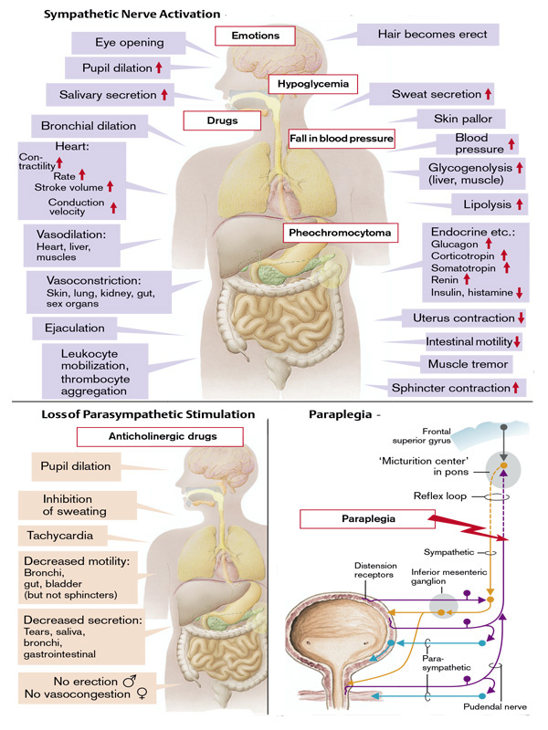

**Fig.13. Disorders of vegetative nervous system**

(From S. Silbernagl and F. Lang ; Color Atlas of Pathophysiology)

.